Transcribe alternating each line as follows;
Original text in Bold fonts: Thou still unravish’d bride of quietness,
Current simplified English translation: You are a pure and quite wife,
Explanation in Italics with simple words:

[Romeo He jests at scars that never felt a wound. [Romeo sees light coming from an upper window] But, soft! What light through yonder window breaks? It is the east, and Juliet is the sun. Arise, fair sun, and kill the envious moon, Who is already sick and pale with grief, That thou, her maid, art far more fair than she. Be not her maid since she is envious. Her vestal livery is but sick and green, And none but fools do wear it. Cast it off. [Juliet appears at the window] It is my lady, O, it is my love! O, that she knew she were! She speaks, yet she says nothing. What of that? Her eye discourses; I will answer it. I am too bold, 'tis not to me she speaks. Two of the fairest stars in all the heaven, Having some business, do entreat her eyes To twinkle in their spheres till they return. What if her eyes were there, they in her head? The brightness of her cheek would shame those stars, As daylight doth a lamp. Her eye in heaven Would, through the airy region, stream so bright That birds would sing and think it were not night. See, how she leans her cheek upon her hand. O, that I were a glove upon that hand, That I might touch that cheek! Juliet Ay me! Romeo She speaks. O, speak again, bright angel, for thou art As glorious to this night, being o'er my head, As is a wingèd messenger of heaven Unto the white upturnèd wond'ring eyes Of mortals that fall back to gaze on him When he bestrides the lazy puffing clouds And sails upon the bosom of the air. Juliet O Romeo, Romeo! Wherefore art thou Romeo? Deny thy father and refuse thy name; Or, if thou wilt not, be but sworn my love, And I'll no longer be a Capulet. Romeo [Aside] Shall I hear more, or shall I speak at this? Juliet 'Tis but thy name that is my enemy; Thou art thyself, though not a Montague. What's Montague? It is nor hand, nor foot, Nor arm, nor face, nor any other part Belonging to a man. O, be some other name! What's in a name? That which we call a rose, By any other word would smell as sweet. So Romeo would — were he not Romeo called — Retain that dear perfection which he owes Without that title. Romeo, doff thy name, And for that name, which is no part of thee, Take all myself. Romeo [Aloud] I take thee at thy word. Call me but love, and I'll be new baptized; Henceforth I never will be Romeo. Juliet What man art thou that, thus bescreened in night, So stumblest on my counsel? Romeo By a name I know not how to tell thee who I am. My name, dear saint, is hateful to myself, Because it is an enemy to thee. Had I it written, I would tear the word. Juliet My ears have not yet drunk a hundred words Of that tongue's uttering, yet I know the sound. Art thou not Romeo and a Montague? Romeo Neither, fair maid, if either thee dislike. Juliet How camest thou hither, tell me, and wherefore? The orchard walls are high and hard to climb, And the place death, considering who thou art, If any of my kinsmen find thee here. Romeo With love's light wings did I o'erperch these walls, For stony limits cannot hold love out; And what love can do, that dares love attempt. Therefore thy kinsmen are no stop to me. Juliet If they do see thee, they will murder thee. Romeo Alack, there lies more peril in thine eye Than twenty of their swords. Look thou but sweet, And I am proof against their enmity. Juliet I would not for the world they saw thee here. Romeo I have night's cloak to hide me from their eyes, And but thou love me, let them find me here. My life were better ended by their hate, Than death proroguèd, wanting of thy love. Juliet By whose direction found'st thou out this place? Romeo By love, that first did prompt me to inquire. He lent me counsel, and I lent him eyes. I am no pilot, yet wert thou as far As that vast shore washed with the farthest sea, I would adventure for such merchandise. Juliet Thou knowest the mask of night is on my face, Else would a maiden blush bepaint my cheek For that which thou hast heard me speak tonight. Fain would I dwell on form; fain, fain deny What I have spoke. But farewell, compliment. Dost thou love me? I know thou wilt say 'Ay,' And I will take thy word; yet if thou swear'st, Thou mayst prove false. At lovers' perjuries They say Jove laughs. O gentle Romeo, If thou dost love, pronounce it faithfully; Or if thou thinkest I am too quickly won, I'll frown and be perverse and say thee nay, So thou wilt woo, but else not for the world. In truth, fair Montague, I am too fond, And therefore thou mayst think my behavior light. But trust me, gentleman, I'll prove more true Than those that have more coying to be strange. I should have been more strange, I must confess, But that thou overheard'st, ere I was ware, My true-love passion. Therefore pardon me, And not impute this yielding to light love, Which the dark night hath so discoverèd. Romeo Lady, by yonder blessèd moon I vow, That tips with silver all these fruit-tree tops — Juliet O, swear not by the moon, th'inconstant moon, That monthly changes in her circled orb, Lest that thy love prove likewise variable. Romeo What shall I swear by? Juliet Do not swear at all, Or, if thou wilt, swear by thy gracious self, Which is the god of my idolatry, And I'll believe thee. Romeo If my heart's dear love — Juliet Well, do not swear. Although I joy in thee, I have no joy of this contract tonight. It is too rash, too unadvised, too sudden, Too like the lightning, which doth cease to be Ere one can say 'It lightens.' Sweet, good night. This bud of love, by summer's ripening breath, May prove a beauteous flower when next we meet. Good night, good night. As sweet repose and rest Come to thy heart, as that within my breast! Romeo O, wilt thou leave me so unsatisfied? Juliet What satisfaction canst thou have tonight? Romeo The exchange of thy love's faithful vow for mine. Juliet I gave thee mine before thou didst request it. And yet I would it were to give again. Romeo Wouldst thou withdraw it? For what purpose, love? Juliet But to be frank, and give it thee again, And yet I wish but for the thing I have. My bounty is as boundless as the sea, My love as deep; the more I give to thee, The more I have, for both are infinite. [Nurse calls from within the house] I hear some noise within; dear love, adieu! [To Nurse] Anon, good nurse! [To Romeo] Sweet Montague, be true. Stay but a little, I will come again. [Exit, above] Romeo O blessèd, blessèd night! I am afeard, Being in night, all this is but a dream, Too flattering sweet to be substantial. [Re-Enter Juliet, above] Juliet Three words, dear Romeo, and good night indeed. If that thy bent of love be honorable, Thy purpose marriage, send me word tomorrow, By one that I'll procure to come to thee, Where and what time thou wilt perform the rite, And all my fortunes at thy foot I'll lay, And follow thee, my lord, throughout the world. Nurse [Within] Madam! Juliet I come, anon. [To Romeo] But if thou meanest not well, I do beseech thee — Nurse [Within] Madam! Juliet By and by, I come! [To Romeo] To cease thy strife, and leave me to my grief. Tomorrow will I send. Romeo So thrive my soul. Juliet A thousand times good night! [Exit, above] Romeo A thousand times the worse, to want thy light. Love goes toward love, as schoolboys from their books, But love from love, toward school with heavy looks. [Romeo retiring slowly. Re-Enter Juliet, above] Juliet Hist, Romeo, hist! O, for a falc'ner's voice To lure this tassel-gentle back again! Bondage is hoarse, and may not speak aloud; Else would I tear the cave where Echo lies, And make her airy tongue more hoarse than mine, With repetition of my 'Romeo.' Romeo It is my soul that calls upon my name. How silver-sweet sound lovers' tongues by night, Like softest music to attending ears! Juliet Romeo! Romeo My nyas? Juliet At what o'clock tomorrow Shall I send to thee? Romeo By the hour of nine. Juliet I will not fail; 'tis twenty year till then. I have forgot why I did call thee back. Romeo Let me stand here till thou remember it. Juliet I shall forget, to have thee still stand there, Remembering how I love thy company. Romeo And I'll still stay, to have thee still forget, Forgetting any other home but this. Juliet 'Tis almost morning, I would have thee gone; And yet no farther than a wanton's bird, Who lets it hop a little from his hand, Like a poor prisoner in his twisted gyves, And with a silk thread plucks it back again, So loving-jealous of his liberty. Romeo I would I were thy bird. Juliet Sweet, so would I, Yet I should kill thee with much cherishing. Good night, good night! Parting is such sweet sorrow, That I shall say good night till it be morrow. [Exit above] Romeo Sleep dwell upon thine eyes, peace in thy breast. Would I were sleep and peace, so sweet to rest. Hence will I to my ghostly Friar’s close cell, His help to crave, and my dear hap to tell.]
Chat GPT
Thou still unravish’d bride of quietness,
You are a pure and quiet wife,
An unravished bride is a woman who has not yet been touched or spoiled. Here it means something pure and untouched by noise or chaos.
[Romeo
He jests at scars that never felt a wound.
He jokes about wounds because he never felt one,
Romeo says this about someone who can laugh at him for being hurt by love because they’ve never been hurt.
[Romeo sees light coming from an upper window]
Romeo sees light in the window,
But, soft! What light through yonder window breaks?
But wait! What light is coming from that window?
Romeo is surprised to see light coming from Juliet's window.
It is the east, and Juliet is the sun.
It’s like the sunrise, and Juliet is the sun.
Romeo compares Juliet to the sun rising in the east, meaning she is bright and beautiful.
Arise, fair sun, and kill the envious moon,
Rise, beautiful sun, and outshine the jealous moon,
He asks Juliet to rise and be more beautiful than the moon.
Who is already sick and pale with grief,
Who is already sick and pale with sadness,
The moon is described as being envious and sickly compared to Juliet.
That thou, her maid, art far more fair than she.
Because you, her maid, are much more beautiful than she is.
Romeo says Juliet is more beautiful than the moon, which is like her maid.
Be not her maid since she is envious.
Don’t be her maid because she is jealous.
Romeo suggests Juliet should not serve the moon because it is jealous of her beauty.
Her vestal livery is but sick and green,
Her uniform is sickly and green,
The moon's appearance is described as pale and sickly.
And none but fools do wear it. Cast it off.
Only fools wear it. Take it off.
He implies that Juliet should not associate with the moon and its jealous nature.
[Juliet appears at the window]
Juliet appears at the window.
It is my lady, O, it is my love!
It’s my lady, oh, it’s my love!
Romeo is delighted to see Juliet and acknowledges her as his love.
O, that she knew she were!
Oh, I wish she knew she was!
Romeo wishes Juliet knew how much he loves her.
She speaks, yet she says nothing. What of that?
She speaks, but says nothing. So what?
Romeo observes Juliet speaking without words.
Her eye discourses; I will answer it.
Her eyes speak; I will answer them.
Romeo decides to respond to the expressions in Juliet's eyes.
I am too bold, 'tis not to me she speaks.
I am too bold; she’s not speaking to me.
Romeo realizes he might be too forward, as she isn’t talking to him.
Two of the fairest stars in all the heaven,
Two of the brightest stars in the sky,
Romeo imagines Juliet’s eyes are as bright as stars.
Having some business, do entreat her eyes
Being busy, ask her eyes
The stars have left their place to her eyes for a while.
To twinkle in their spheres till they return.
To twinkle in their place until they return.
He imagines the stars have asked Juliet’s eyes to take their place.
What if her eyes were there, they in her head?
What if her eyes were there, and they in her head?
Romeo wonders how the stars and her eyes would look if they switched places.
The brightness of her cheek would shame those stars,
Her cheeks’ brightness would outshine those stars,
Juliet's cheeks are so bright they would put the stars to shame.
As daylight doth a lamp. Her eye in heaven
Like daylight outshines a lamp. Her eyes in the sky
Just as daylight outshines a lamp, Juliet's eyes would outshine stars.
Would, through the airy region, stream so bright
Would shine so brightly through the sky
Her eyes would light up the sky with their brightness.
That birds would sing and think it were not night.
That birds would sing, thinking it is day.
Her eyes would be so bright that birds would mistake it for day.
See, how she leans her cheek upon her hand.
See, how she rests her cheek on her hand.
Romeo notices Juliet leaning her cheek on her hand.
O, that I were a glove upon that hand,
Oh, I wish I were a glove on that hand,
Romeo wishes he were a glove so he could touch her cheek.
That I might touch that cheek!
So I could touch that cheek!
He desires to be close to her and touch her cheek.
Juliet
Juliet
Ay me!
Oh my!
Juliet sighs deeply.
Romeo
Romeo
She speaks.
She speaks.
Romeo notices Juliet speaking.
O, speak again, bright angel, for thou art
Oh, speak again, bright angel, for you are
Romeo addresses Juliet as a bright angel.
As glorious to this night, being o'er my head,
As glorious as an angel to this night, above my head,
He compares her to a glorious angel above him.
As is a wingèd messenger of heaven
Like a winged messenger from heaven
Juliet is compared to a heavenly angel.
Unto the white upturnèd wond'ring eyes
To the white, upturned, wondering eyes
People gaze up in wonder at her.
Of mortals that fall back to gaze on him
Of mortals who fall back to look at him
Mortals fall back and gaze in awe at the angel.
When he bestrides the lazy puffing clouds
When he rides the lazy puffing clouds
The angel rides gently on the clouds.
And sails upon the bosom of the air.
And sails through the air.
The angel sails smoothly through the sky.
Juliet
Juliet
O Romeo, Romeo! Wherefore art thou Romeo?
Oh Romeo, Romeo! Why are you Romeo?
Juliet questions why Romeo has to be a Montague, her family’s enemy.
Deny thy father and refuse thy name;
Deny your father and refuse your name;
She asks him to give up his family name.
Or, if thou wilt not, be but sworn my love,
Or, if you won’t, just swear to be my love,
If he won’t change his name, he should swear to love her.
And I'll no longer be a Capulet.
And I’ll stop being a Capulet.
Juliet says she will give up her family name if he loves her.
Romeo
Romeo
[Aside] Shall I hear more, or shall I speak at this?
[Aside] Should I listen more, or speak now?
Romeo wonders if he should keep listening or respond.
Juliet
Juliet
'Tis but thy name that is my enemy;
It’s just your name that is my enemy;
Juliet believes only his name, Montague, is the problem.
Thou art thyself, though not a Montague.
You are yourself, not a Montague.
Romeo is still Romeo, even without his name.
What's Montague? It is nor hand, nor foot,
What is Montague? It’s not a hand, nor foot,
She questions what a name really is, it’s not a part of him.
Nor arm, nor face, nor any other part
Nor arm, nor face, nor any other part
His name isn’t a physical part of him.
Belonging to a man. O, be some other name!
Belonging to a man. Oh, be some other name!
She wishes he had a different name.
What's in a name? That which we call a rose,
What’s in a name? A rose by any other name,
She says a name doesn’t change what something is.
By any other word would smell as sweet.
Would smell just as sweet if called something else.
A rose would still smell sweet even with a different name.
So Romeo would — were he not Romeo called —
So Romeo would, if he were not called Romeo,
Romeo would still be himself even with a different name.
Retain that dear perfection which he owes
Keep that same dear perfection he has
He would still have his good qualities.
Without that title. Romeo, doff thy name,
Without the name. Romeo, drop your name,
She asks him to get rid of his name.
And for that name, which is no part of thee,
And for that name, which isn’t part of you,
The name isn’t really part of who he is.
**Take all myself.
2/2
4o
ChatGPT:
ChatGPT
**
Take all of me.
She wants to be with him completely.
Romeo
Romeo
[Aloud] I take thee at thy word.
[Out loud] I accept your offer.
He accepts her love.
Call me but love, and I'll be new baptized;
Just call me love, and I’ll change my name;
He says he will accept any name.
Henceforth I never will be Romeo.
From now on, I won’t be Romeo.
He says he will give up his name forever.
Juliet
Juliet
What man art thou that, thus bescreened in night,
Who are you that’s hiding in the dark like this,
Juliet asks who Romeo is, hiding in the dark.
So stumblest on my counsel?
And hear what I have to say?
She asks why he’s listening to her private thoughts.
Romeo
Romeo
By a name I know not how to tell thee who I am.
I can’t tell you my name, but I’ll tell you who I am.
He doesn’t want to reveal his true identity.
My name, dear saint, is hateful to myself,
My name, dear saint, is something I hate,
He hates his own name.
Because it is an enemy to thee.
Because it’s your enemy.
His name is a problem for their relationship.
Had I it written, I would tear the word.
If it was written down, I would tear up the paper.
He hates seeing his own name written down.
Juliet
Juliet
My ears have not yet drunk a hundred words
I haven’t heard a hundred words
She hasn’t heard enough from him.
Of that tongue's uttering, yet I know the sound.
But I know your voice.
She recognizes his voice.
Art thou not Romeo and a Montague?
Aren’t you Romeo and a Montague?
She asks if he’s Romeo, from the family that is her enemy.
Romeo
Romeo
Neither, fair maid, if either thee dislike.
Neither, fair maid, if you don’t like either one.
He says he’s neither, if she doesn’t like him.
Juliet
Juliet
How camest thou hither, tell me, and wherefore?
How did you get here, and why?
She asks how and why he came to her.
The orchard walls are high and hard to climb,
The garden walls are high and difficult to climb,
She explains why her relatives can find her.
-------------------------------------------------------------------------------------------------------
Create a set of tasks based on Scene 2 Act 2 of Romeo and Juliet. You are a 10th grade teacher, who teaches English literature. You specialise in Shakespeare's plays. Create 4 tasks for my students; Use Bloom's Taxonomy to develop the tasks. Write them with a reading age of 15 years old. Write these in a familiar and fun tone.
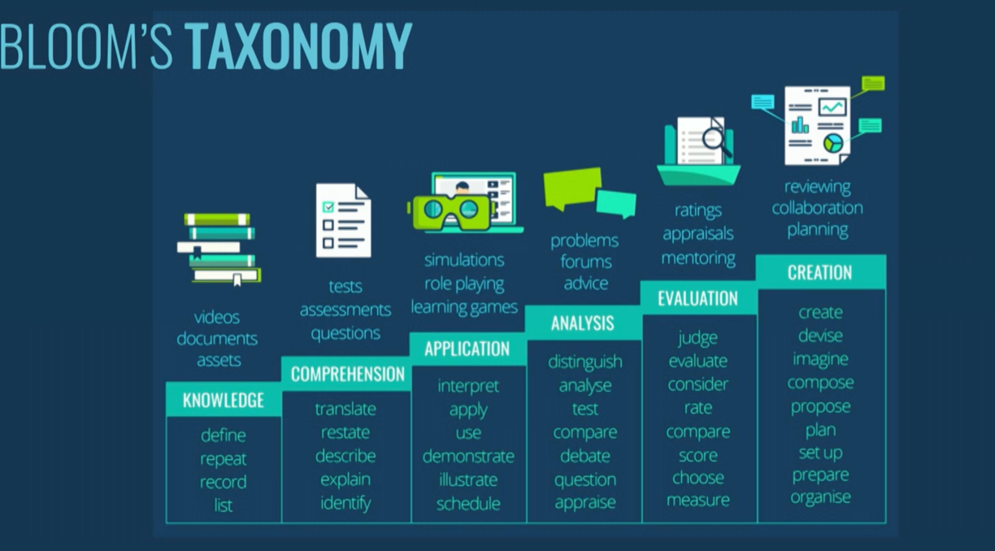
Sure, here are four tasks based on Scene 2 Act 2 of Romeo and Juliet, tailored for 10th-grade students:
- Remembering (Knowledge): Imagine you are Juliet writing in her diary after Romeo leaves. Write a journal entry expressing Juliet's feelings about meeting Romeo for the first time. Include at least three emotions she might have felt and explain why.
- Understanding (Comprehension): Create a comic strip or a series of Instagram story panels depicting the balcony scene between Romeo and Juliet. Include dialogue bubbles that capture their conversation about names and love. Make sure to highlight their emotions through facial expressions and gestures.
- Applying (Application): Pretend you are a modern-day advice columnist like "Dear Abby" or "Ask Amy". Write a letter to Juliet advising her on how to navigate her relationship with Romeo, considering the challenges posed by their feuding families. Provide at least three practical tips based on her situation.
- Analyzing (Analysis): Compare and contrast Romeo and Juliet's perspectives on names and identity. Create a Mind Map that outlines their beliefs about the importance of names. In a paragraph, explain how their views on identity influence their actions and decisions throughout the play.
These tasks are designed to engage students with the text while encouraging them to think critically and creatively about the themes and characters in Romeo and Juliet. Enjoy exploring Shakespeare's world of love and tragedy!
3.5
Hai detto:
Execute the 4 tasks;
ChatGPT ha detto:
ChatGPT
Certainly! Here are the executed tasks based on Scene 2 Act 2 of Romeo and Juliet:
- Remembering (Knowledge): Imagine you are Juliet writing in her diary after Romeo leaves. Write a journal entry expressing Juliet's feelings about meeting Romeo for the first time. Include at least three emotions she might have felt and explain why.
Journal Entry: Dear Diary,
Tonight, my heart raced like never before as I met Romeo, the one I never thought I would love. At first, I felt overwhelmed with curiosity, wondering who this mysterious young man could be. As he spoke, his words were like music to my ears, filling me with a deep sense of admiration and affection. But amidst all this excitement, I couldn't shake the fear of our families' rivalry tearing us apart. Despite the danger, I couldn't deny the thrill of forbidden love stirring in my heart.
Love, Juliet
- Understanding (Comprehension): Create a comic strip or a series of Instagram story panels depicting the balcony scene between Romeo and Juliet. Include dialogue bubbles that capture their conversation about names and love. Make sure to highlight their emotions through facial expressions and gestures.
Comic Strip: [Panel 1: Juliet on balcony] Juliet: O Romeo, Romeo! Wherefore art thou Romeo?
[Panel 2: Romeo below balcony] Romeo: (thinking) She speaks. But soft, what light through yonder window breaks?
[Panel 3: Close-up of Juliet] Juliet: Deny thy father and refuse thy name.
[Panel 4: Close-up of Romeo] Romeo: I take thee at thy word.
[Panel 5: Juliet leaning closer] Juliet: If thou dost love, pronounce it faithfully.
[Panel 6: Romeo gazing up] Romeo: (smiling) A thousand times good night!
Caption: Romeo and Juliet express their love and desire to be together despite their families' feud.
- Applying (Application): Pretend you are a modern-day advice columnist like "Dear Abby" or "Ask Amy". Write a letter to Juliet advising her on how to navigate her relationship with Romeo, considering the challenges posed by their feuding families. Provide at least three practical tips based on her situation.
Dear Juliet,
I've heard about your beautiful but complicated love story with Romeo, and I understand the challenges you face with your families' rivalry. Here are three tips to help you navigate this difficult situation:
  - Communication is Key: Keep open and honest communication with Romeo. Discuss your fears, hopes, and dreams together. Understanding each other deeply will strengthen your bond amidst external pressures.
  - Choose Your Allies Wisely: Identify trustworthy friends or family members who can support and protect your relationship discreetly. Their guidance and assistance can be invaluable in times of trouble.
  - Stay Patient and Resilient: Love can be challenging, especially when it defies expectations. Stay strong during difficult times and believe in the power of your love. Patience and resilience will help you overcome obstacles and find happiness together.
Wishing you all the best, [Your Name]
- Analyzing (Analysis): Compare and contrast Romeo and Juliet's perspectives on names and identity. Create a Mind Map that outlines their beliefs about the importance of names. In a paragraph, explain how their views on identity influence their actions and decisions throughout the play.
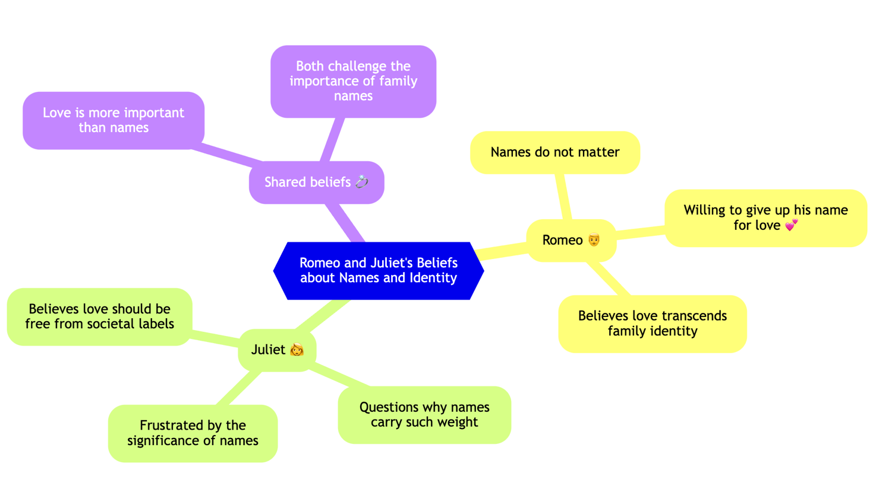

Paragraph Explanation:
Romeo and Juliet both grapple with the significance of names and identity, but their perspectives differ in critical ways. Romeo sees names as mere labels that shouldn't define one's essence, as shown when he declares, "What's in a name? That which we call a rose by any other name would smell as sweet." In contrast, Juliet's identity is deeply intertwined with her family name of Capulet, which becomes a barrier to their love. She acknowledges the impact of names on social standing and familial loyalty, refusing to let go of her identity as a Capulet even as she falls in love with a Montague. These conflicting views drive their actions and decisions throughout the play, highlighting the tension between personal desire and societal expectations.
These tasks encourage students to engage deeply with the themes, characters, and emotions in Romeo and Juliet while applying critical thinking skills and creativity. Enjoy exploring Shakespeare's timeless tale of love and tragedy!
3.5
Hai detto:
Create a set of tasks based on Scene 2 Act 2 of Romeo and Juliet. You are a 10th grade teacher, who teaches English literature. You specialise in Shakespeare's plays. Create 4 tasks for my students; Use Bloom's Taxonomy to develop the tasks.
Assign one of the following methods to each task:
Reflective assignment (fosters meta cognition) Collaborative project (Ensures individual contribution)
Gamification (engages students in active learning)
Flipped classroom (involve students in creating presentations)
For each activity suggest the type Generative AI tools to be used (text to text, text to image, text to slides, text to video, image to text and so on) Specify how to use each tool; Write them with a reading age of 15 years old. Write these in a familiar and fun tone.
2/2
ChatGPT ha detto:
ChatGPT
Certainly! Here are four tasks based on Scene 2 Act 2 of Romeo and Juliet, tailored for 10th-grade students using different methods and Generative AI tools:
- Reflective Assignment (fosters meta cognition) Task: Write a reflective essay where you explore how the themes of love and identity are presented in the balcony scene. Consider how Romeo and Juliet's dialogue reveals their characters' inner thoughts and feelings. Discuss how their understanding of these themes evolves throughout the scene.
Generative AI Tool: Text to Text
  - How to use: Use a text generation tool like ChatGPT to brainstorm ideas and gather different perspectives on the themes. Start by asking the AI for summaries of the scene, then dive deeper by asking specific questions about the characters' thoughts and emotions.
  - Example: "ChatGPT, summarize the balcony scene in Romeo and Juliet. How do Romeo and Juliet express their feelings about love and identity in this scene?"
- Collaborative Project (Ensures individual contribution) Task: In groups, create a digital storyboard for the balcony scene. Each group member will be responsible for a different part of the scene. Combine your parts to create a cohesive visual representation. Make sure to include key quotes and explain their significance.
Generative AI Tool: Text to Image
  - How to use: Use a text-to-image tool like DALL-E to generate images based on specific descriptions of each part of the scene. Each group member can describe their assigned part and use the generated images to illustrate it.
  - Example: "DALL-E, generate an image of Juliet on her balcony looking at the stars while Romeo hides below, listening."
- Gamification (engages students in active learning) Task: Create a quiz game based on the balcony scene. Design questions that test your classmates' knowledge of the scene, its themes, and the characters' motivations. You can use multiple-choice questions, true/false statements, and short answer questions.
Generative AI Tool: Text to Slides
  - How to use: Use a text-to-slides tool like Google Slides' AI-powered feature to create engaging and interactive quiz slides. Input your questions and let the AI help format them into a polished quiz presentation.
  - Example: "Google Slides, create a quiz slide with the question: 'What does Juliet mean when she says, "Wherefore art thou Romeo?"' Provide options: A) Where are you, Romeo? B) Why are you Romeo? C) When will you come, Romeo?"
- Flipped Classroom (involve students in creating presentations) Task: Prepare a video presentation analyzing the significance of the balcony scene in the context of the entire play. Focus on its impact on the plot and character development. Share your video with the class and be ready to answer questions and lead a discussion.
Generative AI Tool: Text to Video
  - How to use: Use a video editor like Clipchamp to create your presentation. Input your script and let the AI generate a video with images, animations, and text overlays to highlight your key points.
  - Example: "With Clipchamp create a video presentation summarizing the balcony scene and discussing how it sets the stage for the rest of Romeo and Juliet's story."
These tasks are designed to engage students with different learning styles and encourage them to use AI tools to enhance their understanding and presentation of Shakespeare's play. Have fun exploring the timeless love story of Romeo and Juliet!
Example
Chat GPT - Text Analysis + Tasks
https://chatgpt.com/c/b2398af8-aba8-47bf-ad0a-82c4049586bc
GPTs - Diagrams Show Me
https://chatgpt.com/g/g-5QhhdsfDj-diagrams-show-me-for-presentations-code-excel/c/ebfa6052-d3ba-4efd-8341-9bfafcbd8708
Video Editing with Clipchamps
https://chatgpt.com/c/4589ec7d-73e5-4295-acc8-bf8946a0ad7c
Artifact
https://drive.google.com/file/d/1WDwm2LwJi254ShAeEq9DSaLTgm0MbGCW/view

