MEETING NEW FRIENDS
1/ Watch the video and follow the instructions
https://en.islcollective.com/video-lessons/greetings-and-vocabulary
2/ a) Complete the dialogue.


Lucas: Hello! _____________ morning!
Raquel: _______! Good ____________________!
Lucas: What ______ your ________________?
Raquel: ________ name ________ Raquel.
Lucas: I _______ Lucas.
Raquel: _____________ to meet __________.
Lucas: Nice to ___________ __________, ___________.
Raquel: Where ________ you from?
Lucas: _________ am ___________ Turkey. And _________?
Raquel: I __________ from China.

b) Complete the interview with Shakira.

Reporter : Good morning. What’s your name?
Shakira : My………………………………………………….
Reporter : Where ……………………..………………………?
Shakira : I am from ………………………………………….
Reporter : How old……………………………………………?
Shakira : I ……………………..………………………….

c) Read the dialogue and complete the form.
MUNICIPAL Library

First name: ………………………….……..
Last name: …………………..……….……
Address : ………………………………….
Telephone number: ……………………….

Receptionist : What is your name?
Girl : My name is Cinthia Barrientos.
Receptionist : What is your address?
Girl : 621 Jazmin street.
Receptionist : What is your telephone number?
Girl : It’s 44791034

d) Write the greetings according at the moment of the day under each picture.



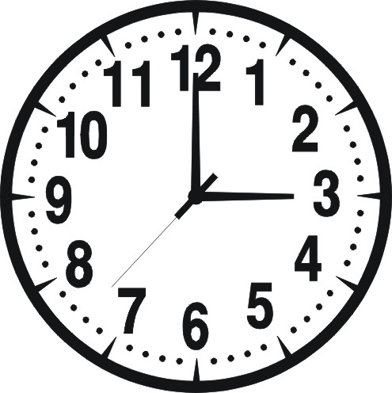

My score: My time:
minutes seconds

