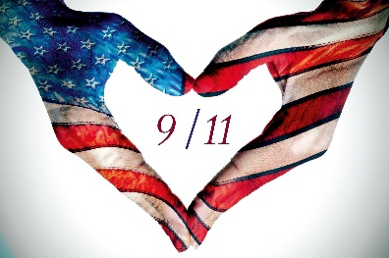
Webquest – 9/11

- 9/11 – What happened ?
Click here to watch the video about 9/11 and answer the following questions.

- What happened on September 11th 2001? ______________________________________________________
- Where exactly did it take place? ______________________________________________________________
- What time did it start? ______________________________________________________________________
- How many planes were there? _______________________________________________________________
- Fill in the grid below.
Plane number | Where did it take off? | Where was it supposed to go? | How many passengers? | What was its target? | When did the plane hit its target?

- The terrorists
Click here to learn more about 9/11 and answer the following questions.
Focus first on the first paragraph.
- How many hijackers in total were involved in the 9/11 attacks? ____________________________________
- What is the name of the terrorist group they belonged to? ________________________________________
Focus on the part about Osama Bin Laden.
- Where did the hijackers come from? __________________________________________________________
- Who was Osama Bin Laden? What was his role in the 9/11 attacks? _________________________________
________________________________________________________________________________________

- The victims
Click here and answer the following questions.
Focus on the part entitled “How Many People Died in the 9/11 Attacks?”.
- How many people were killed in the 9/11 terrorist attacks? ________________________________________
- How many countries did the victims come from? ________________________________________________
Click here and answer the following questions.
- How many police officers were killed? _________________________________________________________
- How many firefighters died? _________________________________________________________________

- Impact of the attacks in the world
Click here and answer the following questions.
Focus on the part entitled “America Responds to the Attacks”.
- What was the American response to the attacks? ________________________________________________
- Pick 2 expressions / words showing that the USA was backed by other countries.
____________________________________ ____________________________________
- Who did the USA and the coalition fight against? ________________________________________________
- How long did Osama Bin Laden remain at large? _________________________________________________
- What finally happened to Osama Bin Laden? ____________________________________________________
- When did the all American troops finally leave Afghanistan? _______________________________________

Click here to watch another video and answer the following question.
- In your opinion, why was it such a traumatising event that shocked people all over the world?
________________________________________________________________________________________________________________________________________________________________________________
________________________________________________________________________________________

- In your opinion, why is it important to remember what happened on September 11th 2001?
________________________________________________________________________________________________________________________________________________________________________________
________________________________________________________________________________________

