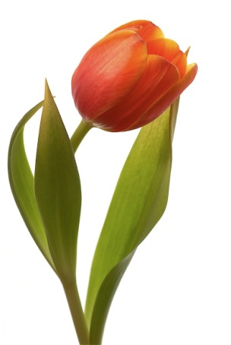 | TULIPE
T – L – P – U – I – E | TULIPE
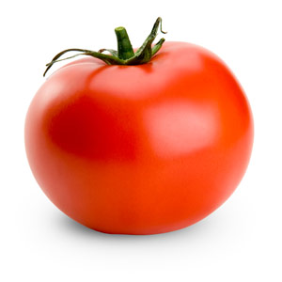 | TOMATE
T – O – T – M – A – E | TOMATE
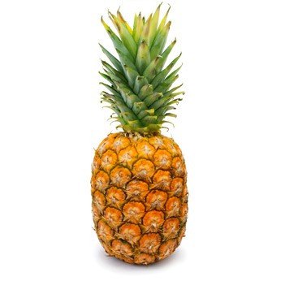 | ANANAS
A – A – A – N – N –S | ANANAS
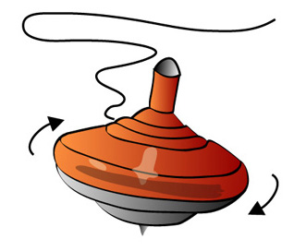 | TOUPIE
T – P – I – O – U | TOUPIE
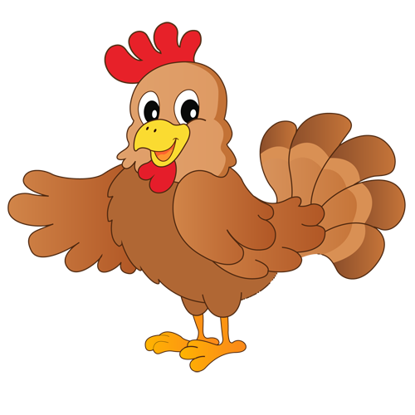 | POULE
P – L – O – E – U | POULE

 | PLUME
P – M – L – U – E | PLUME
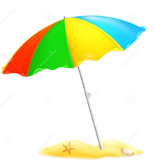 | PARASOL
P – R – S – O – A – L | PARASOL
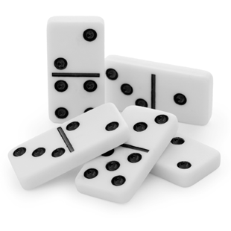 | DOMINO
M – N – D – I – O – O | DOMINO
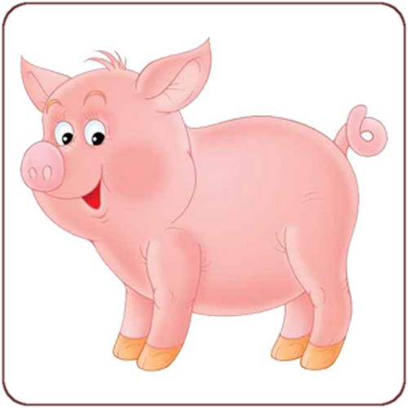 | COCHON
C – C – H – O – O – N | COCHON
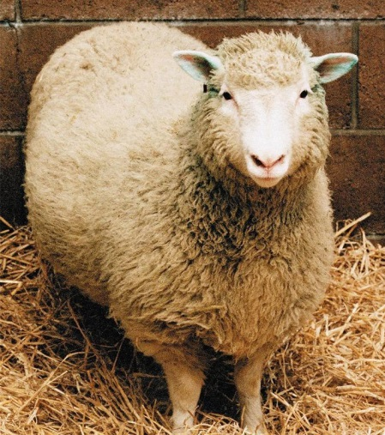 | BREBIS
R – B - I – S - B – E | BREBIS
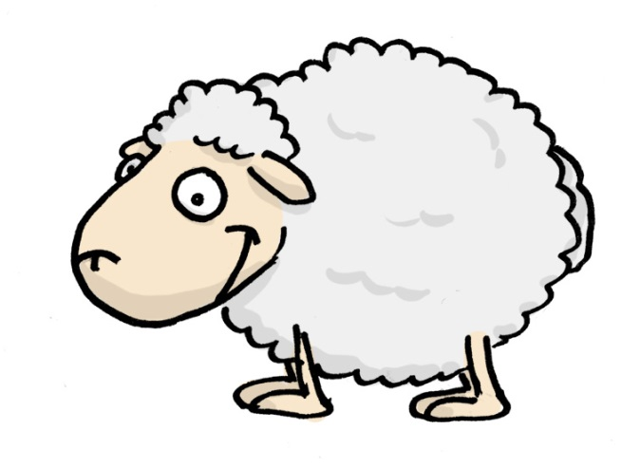 | MOUTON
T – U – O – M – N – O | MOUTON
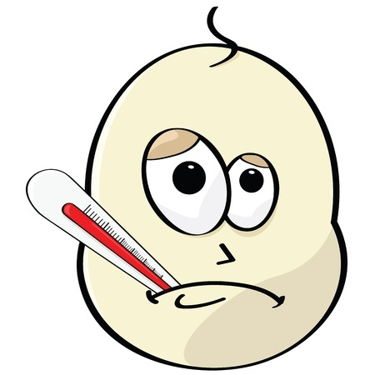 | MALADE
M – D – L – A – E – A | MALADE
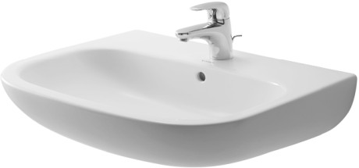 | LAVABO
L – V – B – O – A – A | LAVABO
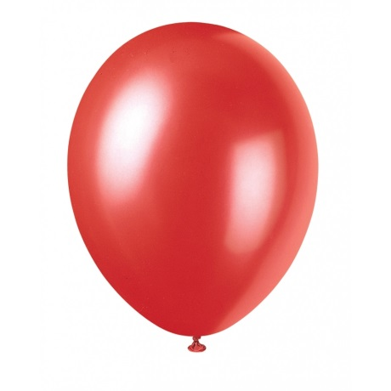 | BALON
L – B – N – O – A | BALON

