 | MUR
U – R - M | MUR
 | RUE
R – E- U | RUE
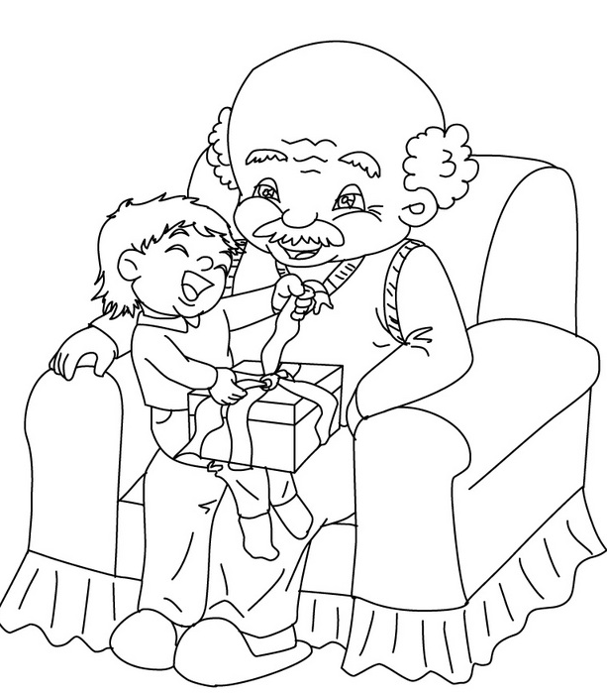 | PAPI
P – P – A – I | PAPI
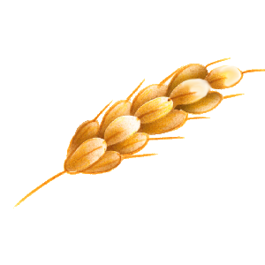 | EPI
P – I – E | EPI
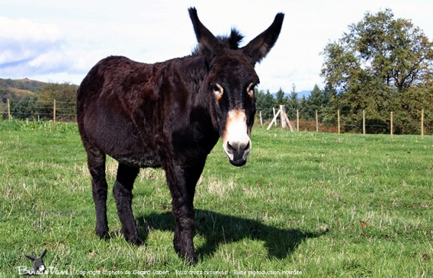 | ANE
N – A – E | ANE
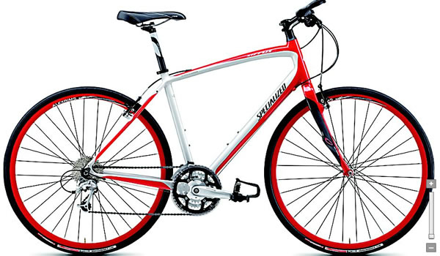 | VELO
V – L – E – O | VELO

 | ILE
L – E – I | ILE
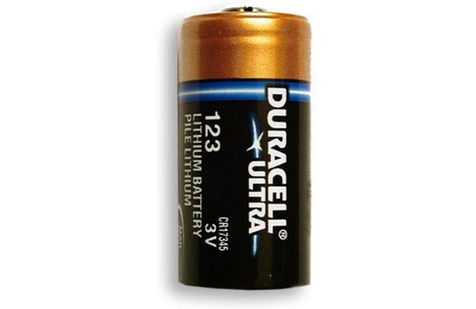 | PILE
P – L – I – E | PILE
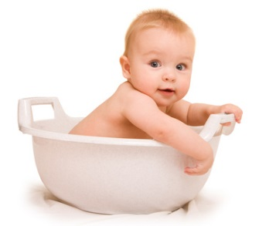 | BEBE
B – B – E – E | BEBE
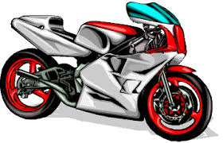 | MOTO
M – T – O – O | MOTO
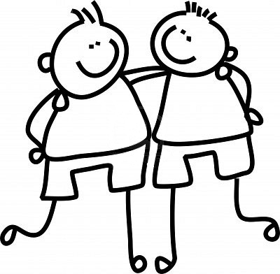 | AMI
A – I – M | AMI
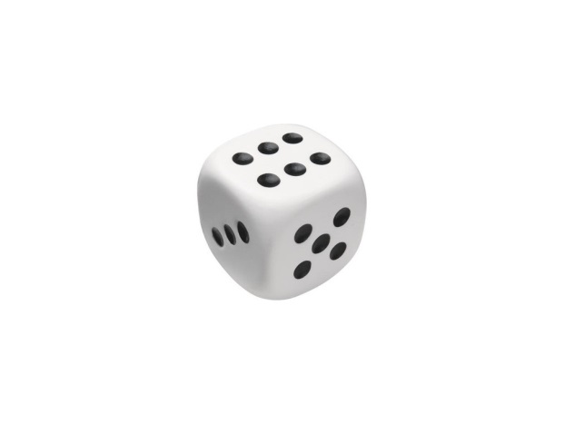 | DE
E – D | DE
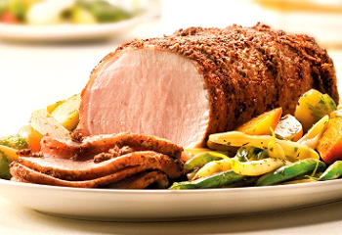 | ROTI
R – T – O – I | ROTI
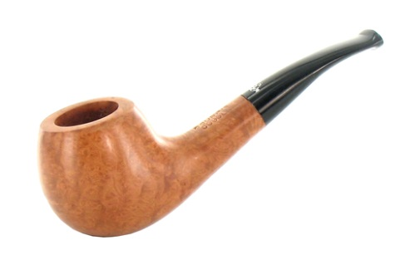 | PIPE
P – E – P – I | PIPE
 | LUNE
N – L – U - E | LUNE

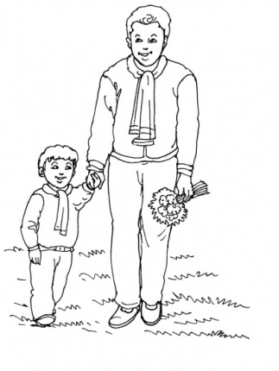 | PAPA
A – A – P – P | PAPA

