 | ROBOT
B – R – T – O – O | ROBOT
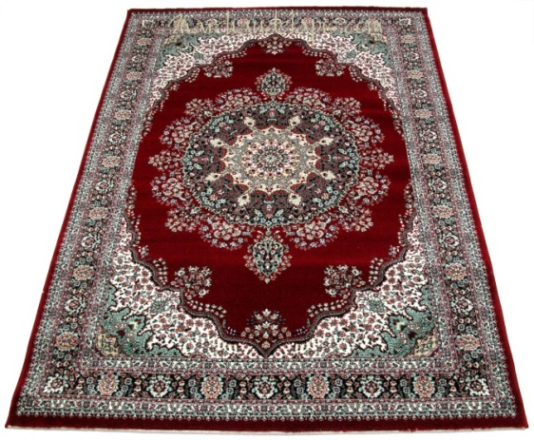 | TAPIS
T – I – A – S – P | TAPIS
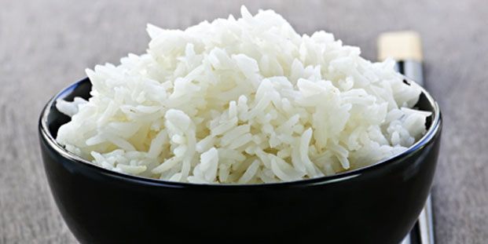 | RIZ
I – R – Z | RIZ
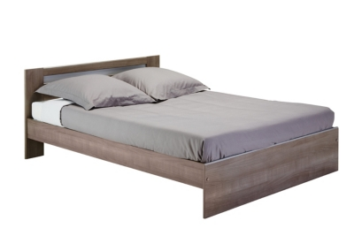 | LIT
T – L – I | LIT
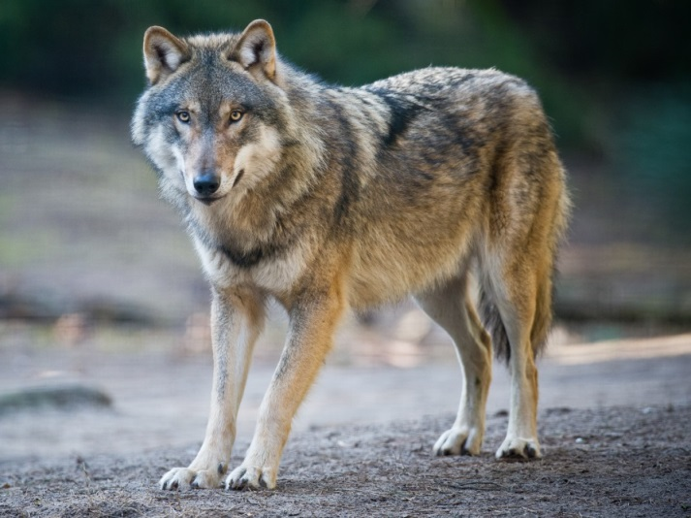 | LOUP
L – P – U – O | LOUP

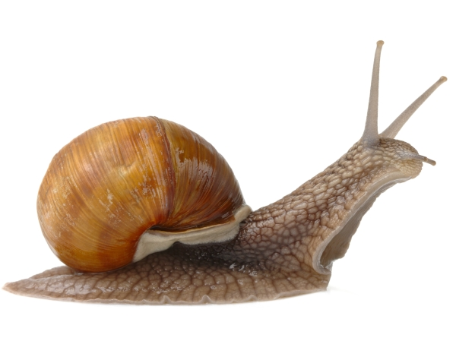 | ESCARGOT
S – E – G – C- R -  A – O – T | ESCARGOT
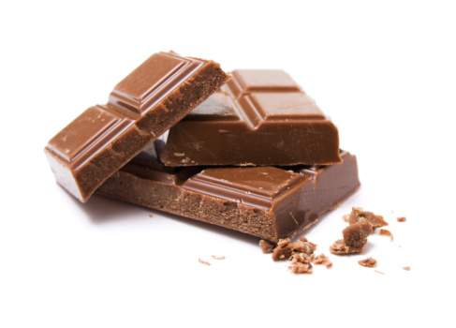 | CHOCOLAT
C – H – L – T – C – O – O – A | CHOCOLAT
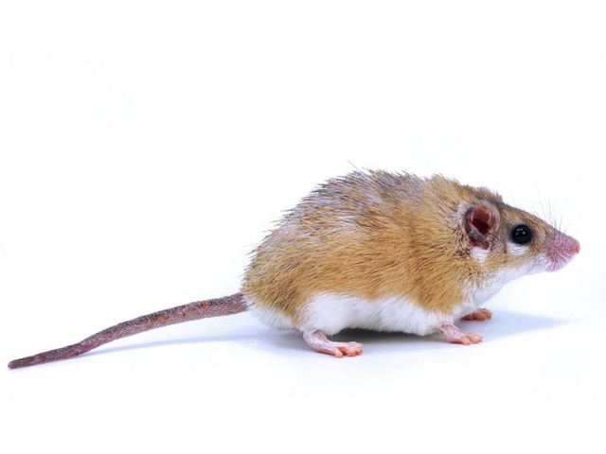 | SOURIS
S – R – S – I – O – U | SOURIS
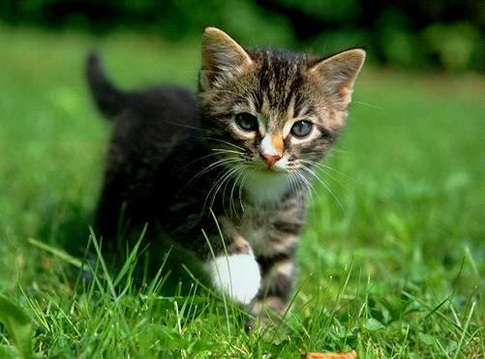 | CHAT
C – T – H – A | CHAT
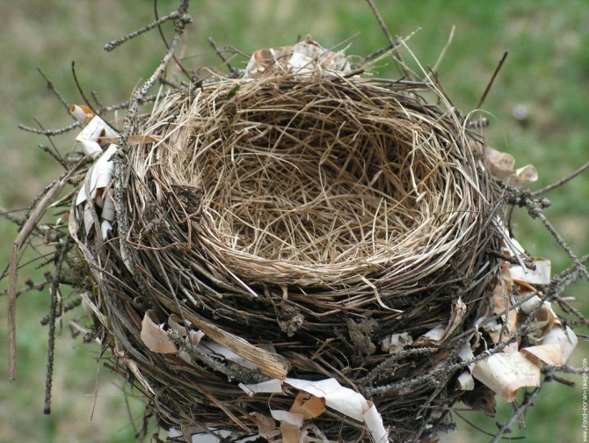 | NID
N – D – I | NID
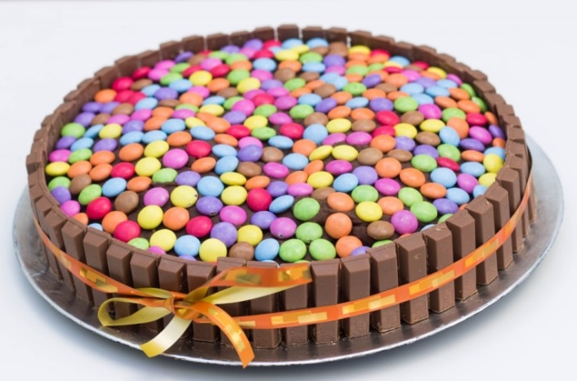 | GATEAU
G – T – A – E – A – U | GATEAU
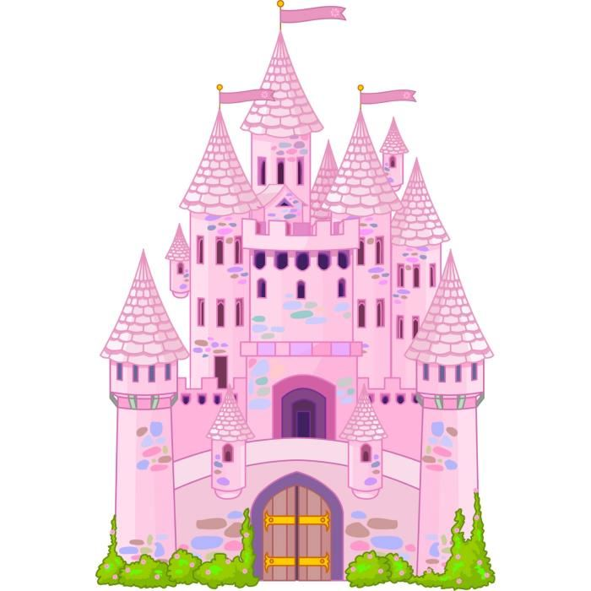 | CHATEAU
C – T – H – A – E – A – U | CHATEAU
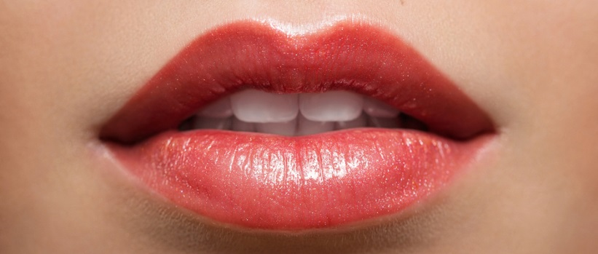 | BOUCHE
B – C – H – O – E – U | BOUCHE

