Project Two Lesson: 06

Full name: ................................................................... Class: 3MS.........

Task one: Match the road signs with their right meaning.
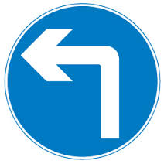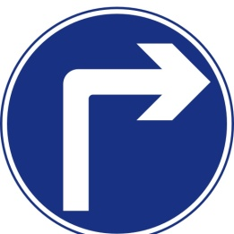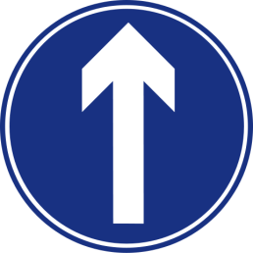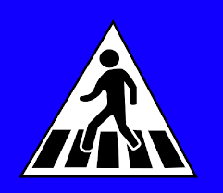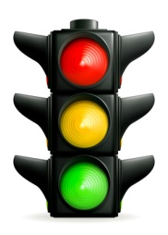

Go along/ straight .ahead.
Cross the street.
Turn left.
Take the roundabout.
Traffic light.
Turn right.

Task two: Look at the map and answer these questions.
- Where are you? ...............................................................................................................................
- Are there places of travel in this city? ....................................................................................
- What amenities are vailable in this city? ..................................................................................
Task three: Look at the map. Then say if these statements are « true » or « false ». Correct the wrong statments.
- The hospital is on the left, next to police station. .................................................................
- The factory is on the right behind the museum. ....................................................................
- The underground station is at the roundabout corner. ........................................................
Task four: Look at the map and complete the dialogue between you and a passer by. You want to go to the bus station. Then listen and check your answers.
You: Excuse me, could you show me the ..................................to the bus station, ........................?
Passer by: Certainly. Go .................................Bond Street, then ........................past .........................right turning. After that, ........................... .................................King’s Road; the bus station is .................................
You: ......................................, sir.
Passer by: Not at all.
Task five: Work in pairs. Ask and answer about directions to the following places.

Where’s the hospital?
..........................................................................................................................................................................................................................................................................................................................................................................................................................................................................................
Where’s the Italian restaurant?
.........................................................................................................................................................................................................................................................................................................................................................................................................................................................................................................................................................................
Where’s the post office?
..........................................................................................................................................................................................................................................................................................................................................................................................................................................................................................
Where’s the cinema?
.........................................................................................................................................................................................................................................................................................................................................................................................................................................................................................................................................................................

The teacher’s script
You: Excuse me, could you show me the way to the bus station, please?
Passer by: Certainly. Go along/ straight Bond Street, and then walk past the first right turning. After that, turn right King’s Road; the bus station is down.
You: Thank you, sir.
Passer by: Not at all.

