Appearances - How to describe someone in English

Height
 | 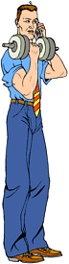 | 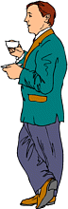 | 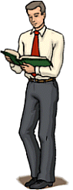
 | He is tall. | He is short. | He is normal height.
+ | He is very tall. | He is quite short. | He is relatively normal height.

Build
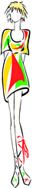 | 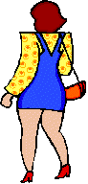
She is skinny. (negative) | She is fat. (negative)
She is anorexic. (medical) | She is tubby. (negative)
She is underweight. (negative) | She is overweight. (negative)
She is thin. (negative) | She is plump. (neutral)
She is slim. (positive) | She is stocky. (neutral)
She is slender. (positive) | She is bonny. (positive)
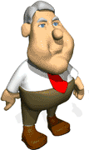
!Note - if a man is fat (especially round the waist) we often say he has a beer belly.

Hair
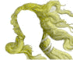 | 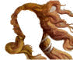 | 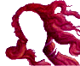 | 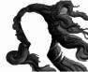 | 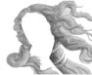
blonde/fair hair | brown hair | red hair | black hair | grey hair
blonde | brunette | redhead | - | -

Eyes
 | grey eyes | green eyes | blue eyes | brown eyes | dark eyes
 |  |  | 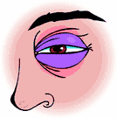 | !Note!  This is a black eye!

Type of hair
 | 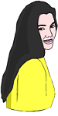 |  | 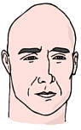 | 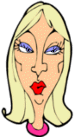 | 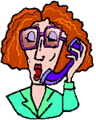 | 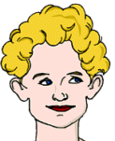
 | She has long hair. | She has short hair. | He has no hair. = He is bald. | She has medium length hair. | She has medium length hair. | She has short hair.
+ | She has long, black hair. | She has short, black hair. | - | She has medium length , blonde hair. | She has medium length, red hair. | She has short, blonde hair.
++ | She has long, straight, black hair. | She has short, straight, black hair. | - | She has medium length, straight, blonde hair. | She has medium length, wavy, red hair. | She has short, curly, blonde hair.
or | Her hair is long, straight and black. | Her hair is short, straight and black. | - | Her hair is medium length, straight and blonde. | Her hair is medium length, wavy and red. | Her hair is short, curly and blonde.
+ |  |  |  |  | She wears glasses.

Type of complexion
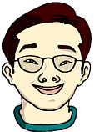
He is asian. He has light-brown skin. | She is black. She has dark skin. | He is white. He has fair skin. | She is white. She has lightly tanned skin. | She is white. She has very pale skin.

Other features
Point your cursor over the named feature, if you're correct the word will appear.
 | 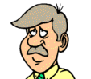 | 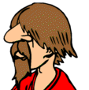 |  | 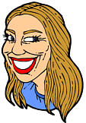
 | moustache | beard | chin | forehead | nostrils
 |  |  | 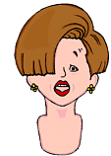
 | eyebrows | cheeks | fringe | lips | teeth

