Bobruisk – population 207,351
Task
- Product image – what can you emphasise about the product to make it attractive.
- Target market – who will buy it?
- Budget – where is the best way to advertise it and why?
- Style – what will the adverts be like? Describe your ads.

budgets for each product:

5000 BYN for advertising

Prices
- Zefir FM 400000 people listen to this radio (Bobruisk, Rogachev, Zhlobin, Glusk, Kirovsk)
Advertising (Monday-Friday)
Hours | 1 minute | 1 second
7:00 – 10:00,12:00-15:00,  17:00 – 21:00 | 26,46 BYN | 44 kop,
10:00 – 12:00, 15:00-17:00,  21:00 – 00:00 | 10,71 BYN. | 18 kop.
Advertising (Monday-Friday) (Saturday, Sunday)
Hours | 1 minute | 1 second
7:00-9:00, 20:00-00:00 | 6,30 BYN | 11 kop
9:00-10:00,15:00-20:00 | 12,60 BYN | 21 kop
10:00 – 15:00 | 17,01 BYN | 28 kop

- Newspaper «Бабруйскае жыцце»
1,80 BYN for 1 square centimetre
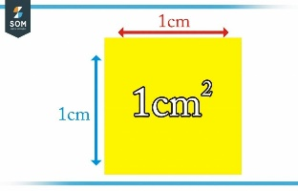

- Buses
100 Buses /200 flyers 30 days - 465 BYN
- Trolleybuses
35 trolleybuses /50 flyers , 30 days - 355 BYN.
- LED display
270,00 BYN a day .

- Lifts
440 lifts - 235 BYN
- Advertising on housing and communal services receipts
Bobruisk (5х4 centimeter ), 100 000 copies 434 BYN
Bobruis region, 13000 copies - 120 BYN

- Instagram
- BYN – 5 days

 | Group 1 | Group 2 | Group 3 | Group 4
Language (1-10)
Image (1-10)
Presentation (1-10)
I will Buy (1-10)

