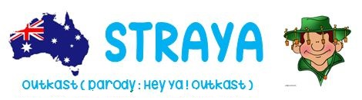

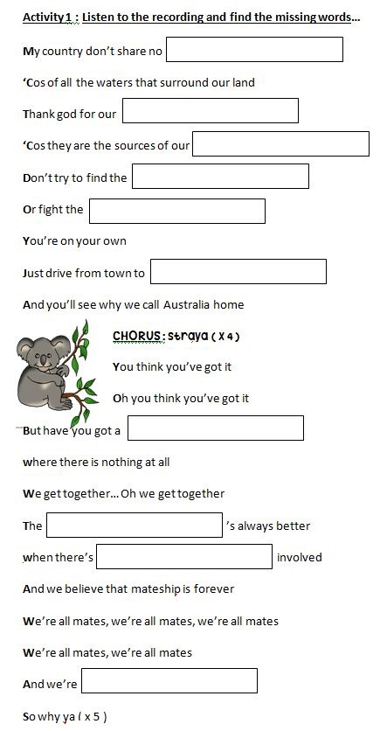

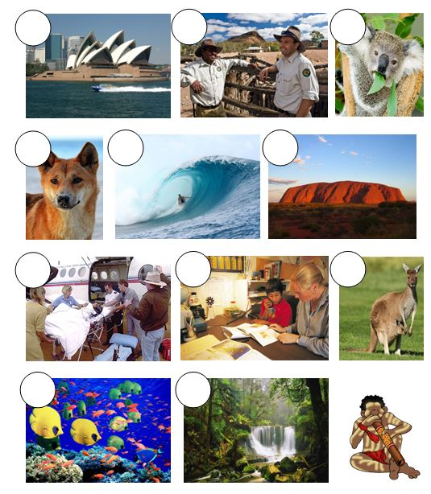

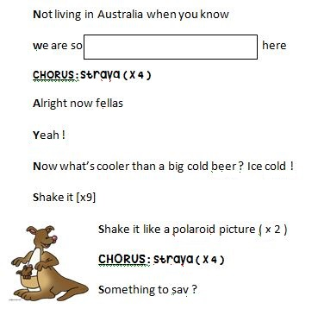

Activity 2 : Fill in the map with the missing details…

Tasmania - Canberra - Northern territory - Queensland - Melbourne Victoria - Tasman Sea - South Australia - Coral Sea - Sydney
Western Australia - New South Wales - Perth - Indian Ocean
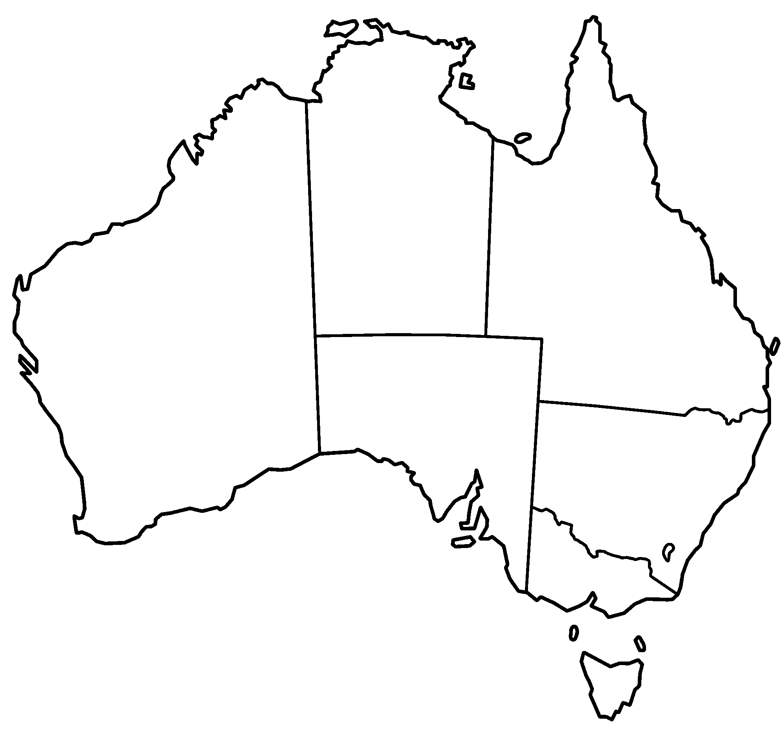

Activity 3 : These expressions are Australian English. Find their meaning in British English…

a) G’day mate ! Would you like a cup of tea ?
b) Aussie a barbecue
c) Wanna cuppa ? Yes, absolutely !
d) I reckon ! Australia
e) a barbie Good-morning !

Activity 4 : Surf the web to find what these pictures correspond to… a) Bondi Beach - b) a dingo - c) the Royal flying Doctors
d) Sydney Opera House - e) Ayers Rock - f) Great Barrier Reef
g) a kangaroo - h) the rainforest - i) the school of the air - j) a koala
k) Rangers in the Bush

