Задание 2

Паспорт задания
Класс | 5
Тема | Город и деревня
Развиваемые компетенции | Умение выделять информацию, необходимую для нахождения доказательств или подтверждения выводов.  Умение оценивать содержание и формы текста
Уровень | Средний
Дидактические единицы | Окружающая среда
Формат вопроса | Задание с кратким ответом

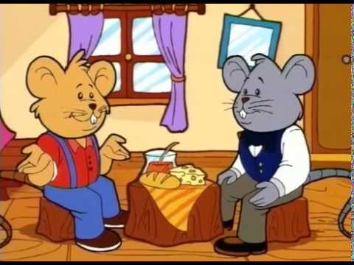

Task: write down the advantages and disadvantages of living in the town and in the country in the pictures of clouds.

Once upon a time there lived two cousins. They were called (их звали) Country Mouse and Town Mouse. Country Mouse lived in a little hole (нора) in a country house. Town Mouse lived in a hole in a big town house.
One day Country Mouse visited his cousin in town. “Hello! Come in,” said Town Mouse. “I think, you’ll love the town. It’s so interesting here!”
Town Mouse made a fantastic dinner of jam, biscuits and cola, chocolate cake and ice cream. Country Mouse didn’t like the food – it was too sweet for him. At night Country Mouse didn’t sleep. “It’s too noisy and there are too many lights!” he thought.
The next day the cousins went to the amusement park. Country Mouse saw swings, slides, a big wheel, and a merry-go-round. They were horrible! Country Mouse didn’t like the big wheel. It was too big. He didn’t like the merry-go-round. It was too noisy.
He didn’t like the amusement park. There were too many people, dogs and cats. He was very tired.
At night Country Mouse had a dream. He saw his nice little hole and beautiful green fields.
In the morning he said goodbye to his cousin and went home.

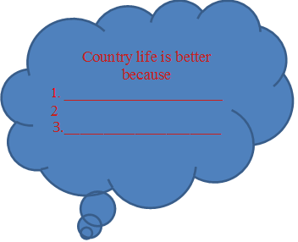

Town life is better
because
1. _________________
2._________________
3.____________________





Country life is worse Town life is worse
because
because 1._________________
1.____________________ 2._________________
2.____________________ 3.__________________
3._____________________

Task completion algorithm:
- Read the text carefully;
- while reading the text, note important ideas that relate to life in the countryside and in the city;
- you can make notes or write out key phrases.
- Define the comparison categories (activity, leisure, safety, and so on).
- Identify the similarities and differences between life in the city and in the countryside.
- Write down some more advantages and disadvantages.
- Make sure that the information is structured and easy to understand.

Evaluation criteria:
Criteria | Scores | Description
Understanding the text | 2 | How fully and accurately did the student understand the content of the text he read
Argumentation | 1 | How convincing and detailed are the comparisons
Analysis | 1 | How deeply did the student analyze the information and make conclusions based on the comparison
Grammar | 1 | How grammatically correct was the task
Compliance with the requirements | 1 | If the assignment meet the conditions set by the teacher
Maximum number of points: 6

