Задание 6
Паспорт задания
Класс | 11
Тема | Туризм
Развиваемые компетенции | Умение демонстрировать коммуникативные умения: аргументированно, чётко и ясно выражать свою точку зрения, формулировать выводы
Уровень | Высокий
Дидактические единицы | Туристические тренды, свободное время
Формат вопроса | Задание с развернутым ответом

Task: Match the pictures with the types of extreme tourism

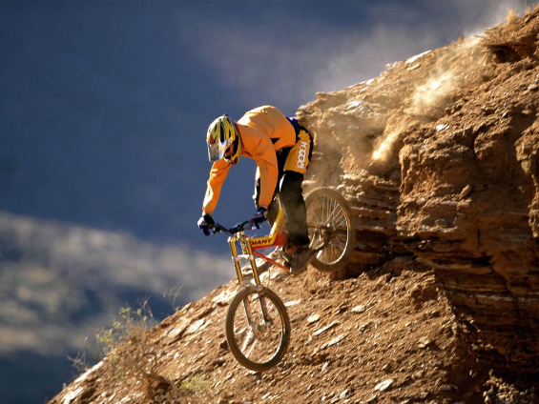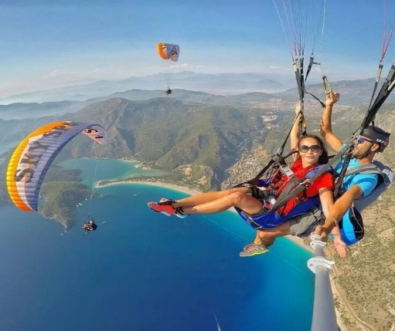
2
1

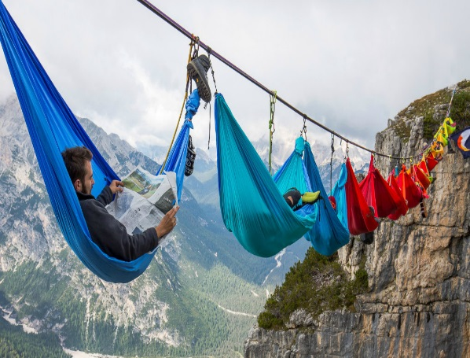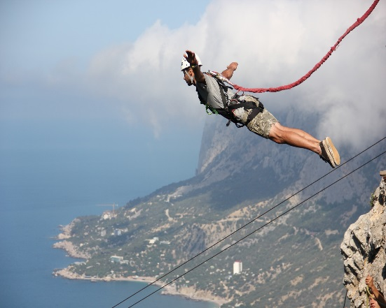
4
3
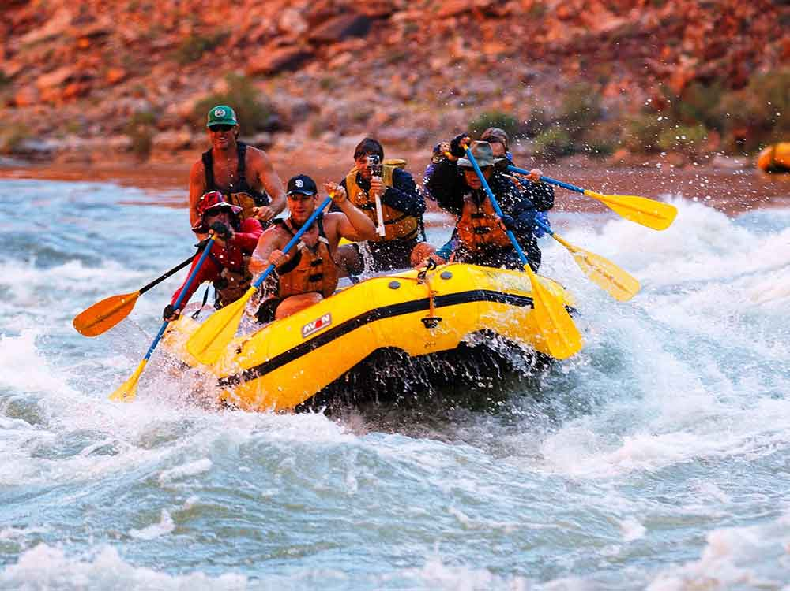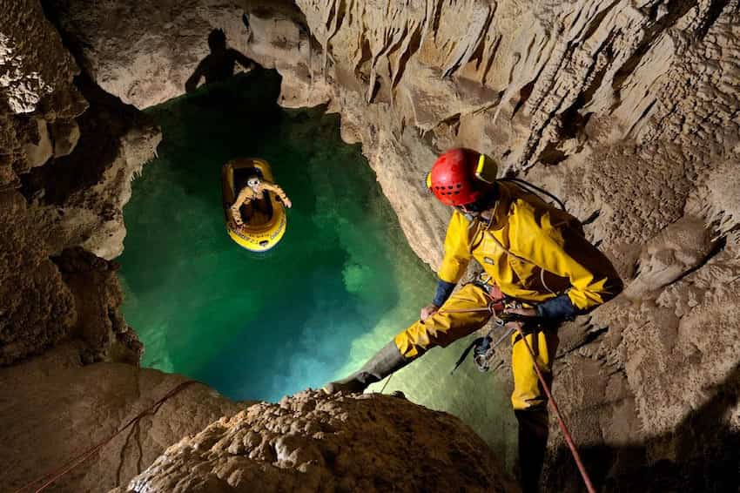
6
5

paragliding extreme hammocking
Extreme tourism

bungee jumping
rafting caving mountain biking

Task: Think of a type of extreme tourism you would like to try and write a paragraph to describe it. Mention:
- the name of the tourism;
- when and with whom you would try it;
- what you would do / see there;
- your impressions;
- physical fit for this activity;
- safety precautions;
- a backup plan in case of an emergency
- motivation which to take such risks;

Task completion algorithm:
- Choose a type of tourism that you are interested in.
- Collect as much information as possible about the chosen type of tourism.
- Highlight the main characteristics of the selected type of tourism.
- Write down some more advantages and disadvantages.
- Make sure that the information is structured and easy to understand.
- Summarize the results and justify the choice.
Evaluation criteria:
Criteria | Scores | Description
Completeness and accuracy of information | 2 | How the chosen type of tourism and its features are described in detail and accurately
Logic and consistency | 2 | A story should be structured and have a beginning, a main part, and a conclusion.
Arguments and justification of the choice | 2 | The description should demonstrate the depth of understanding and interest.
Literacy and style | 2 | Absence of spelling and grammatical errors
Creativity and originality | 2 | If the approach to the description of the chosen type of tourism is creative
Maximum number of points: 10

