Задание 1
Паспорт задания
Класс | 9
Тема | Культурный досуг
Развиваемые компетенции | Умение демонстрировать коммуникативные умения: аргументированно, чётко и ясно выражать свою точку зрения, формулировать выводы
Уровень | Высокий
Дидактические единицы | Досуг, свободное время
Формат вопроса | Задание с развернутым ответом

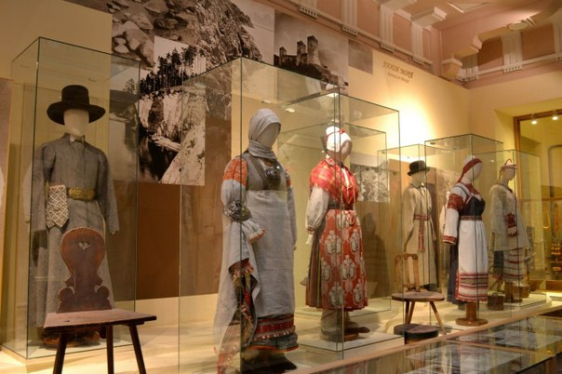
ZOOLOGICAL PARKS AND BOTANIC GARDENS
Biographical museums
HISTORY MUSEUMS
ENCYCLOPEDIC MUSEUMS
SCIENCE MUSEUMS
NATURAL HISTORY MUSEUMS
CHILDREN’S MUSEUMS
Art galleries
Virtual museums
Task: create a leaflet about a museum you would like to open. Include the following information:
- the name of the museum
- what visitors will see there
- what type of people would enjoy the museum most and why
- special events / programmes organized in the museum
- opening hours, entrance fees
- address, how to get there
Task completion algorithm:
- Use a 9th grade student’s book and information from the Internet;
2. Decide what you want to say in your leaflet - define the main idea, content, structure;
3. Identify the target audience: who the leaflet is being created for, and who will read it;
4. Choose the material for the content of the leaflet;
5. Illustrate the information you have found with drawings, diagrams, and photographs.;
6. Think over the design of the leaflet;
7. Present your leaflet

Evaluation criteria:
Criteria | Scores | Description
Artistic design | 1 | - Creativity  - Accuracy
Artistic design | 1 | - Creativity  - Accuracy
Speech expression | 3 | - Content (depth of topic disclosure, consistency, size)
Speech expression | 1,5 | - Lexico–grammatical diversity (active vocabulary and grammar of the section+ previously studied)
Speech expression | 1,5 | - Linguistic correctness (vocabulary, grammar, phonetics)
Speech expression | 1 | - Fluency of speech
Speech expression | 1 | - Artistic presentation
Maximum number of points: 10

