Revolutionising the Digital PR World with Video content
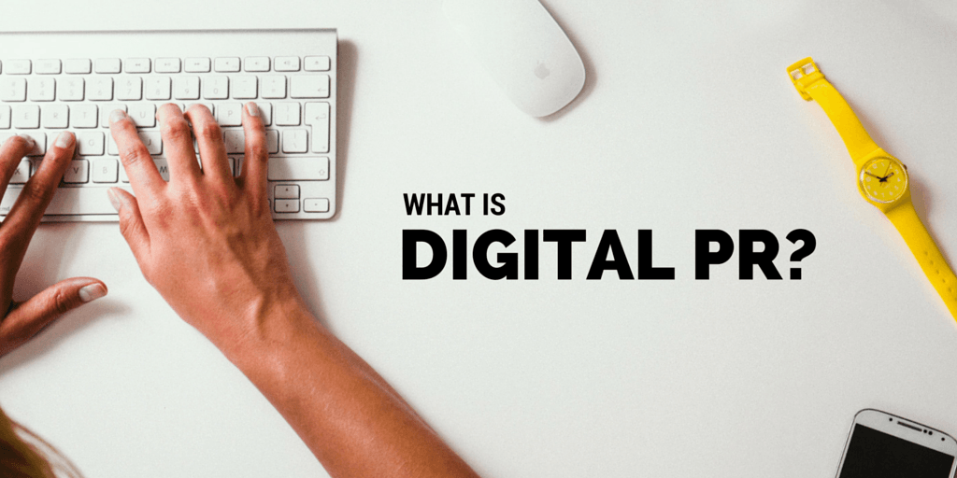
Psychologically proved is the fact that pictures are more appealing and understandable than a thousand words giving detail about the same. Decades back, newspaper editors understood the power of pictures and inculcated them in the newspapers, magazines and other publications. Years later the history is repeating itself but with a certain twist of online marketers and digital experts incorporating the blend of social media and video marketing which will ultimately lead to a grand success of Digital Public Relations (DPR). With over 52 million adults watching professional video content every month, it is quite evident to the Public Relation (PR) companies; especially to the PR companies in Delhi that online video marketing is the new breed of promoting brand image.
The professionals working in PR consultants in Delhi need to first analyse the needs and objectives of the client before making the video content. This shouldn’t be neglected as it is the most important step in initiating the DPR campaign. Immediately after this, the next important thing to do is to divide the market into sets of the audience and then to finalise the set(s) of the target audience. Product specifications and the demographic profile of the target audience are the two factors primarily affecting the content of videos for DPR.
Creativity is the core essence for the videos being made. If left untouched by this essential element, potential customers will surely not be attracted towards a DPR campaign and even might confuse it with that of the competitor’s. Out-of-the-box ideas, innovative concepts, creative script and visualisation are the ones that make a video interesting and engaging thus promoting the viewers to inquire more about the described content on the social media sites. Better contact links with the media through PR companies in Delhi further enhances the chances of communication between people and the promoter.
In this fast paced world, lengthy is mostly considered as boring instead a series of short videos is what gains more attraction. A PR professional needs to have a good repo with the creative and designing team and he/she should be quick and assertive enough while giving suggestions and sharing feedbacks. The better the PR person is able to explain the better product including more creative ideas, script and tools is sure to come out as an outcome. Moreover, it is the good coordination with the production team that can bring out customised videos for different social media platforms. If you are working in one of the PR companies in Delhi and obliging all these suggestions then don’t wait, get ready and start some real action.

