Getting the most out of PR internships
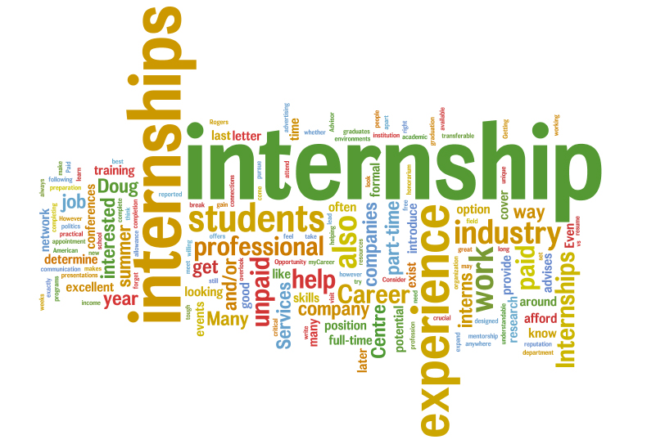

It’s that time of the year when students whether pass outs or still in their graduation period are running here and there looking for an internship in the best sort PR companies in Delhi. People tell them to get an internship for the experience but what they don’t tell is how to convert these internship opportunities as a chance of grabbing a good paying job in one of the top PR companies in Delhi. Here are a few steps that will help you in making the most out of your PR internships:

- Try to be available as much as you can
Interns with the right amount of enthusiasm and efficiency in their attitude are the ones who will be considered more eligible than the ones with overconfident or with under confident attitude. PR professionals work in a team, and while working at times, you need to volunteer for other tasks too with a smile because all this will get you the attention of the seniors which will eventually lead to seniors delegating more tasks to you giving you an opportunity to demonstrate your creative potential. Completing the tasks in a hurry will lead you nowhere but completing them with efficiency will surely guarantee your presence for the next job.
- Familiarize with the organization and staff properly
All know how tough it is to enter the industry, so better not be overexcited and instead try conversing with the other employees. But before conversing make sure you know the workings and different personalities with their level of works in the company. Most employees in PR consultants in Delhi appreciate feedbacks and suggestions but make sure to do so in a rather polite way. Different personalities have different approaches to follow so if once got rejected don’t insist for your suggestion again and again as it may irritate the seniors. PR involves long hours and high pressure of work, so it’s better to familiarize with the team thus making work more fun.
- Don’t let your focus deter
One of the key requirements for a good employee is that he/she is focused on their work and completes the work as desired by the team. Your focus on work is reflected in the questions you ask and suggestions you give so make sure to do relevant talks only. If your team has allocated you a fairly important task, then this indicates you have surely done something worth appreciating. So make sure you continue with the achievement regime because this is the stage where each step is being crucially monitored.
- Wear the positive look always
At times there are times during your internship when you might not be doing the most glamorous job, and in the beginning, it might be difficult without knowing anyone in the workplace. The key here is to stay positive and be a person who has a smile and not a grin all the time on his/her face. Keep it clear in mind your happy and optimistic approach is what will work wonders when the time comes for your seniors to assess your suitability for the long run.

