
HOW TO STUDY A VISUAL DOCUMENT ?

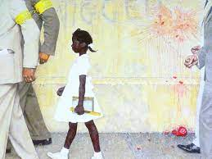
Introduction - Identify the document :
What ? → Nature of the document
Who ? → Name of the author
Where from ? → Source/ where was it published ?
When ? → Date of publication/ Historical context
What about ? → Main subject
For whom ? → Target/ Recipient
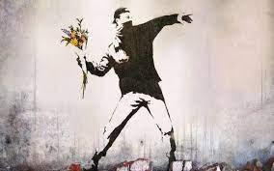
Describe - What the document shows (the explicit) :
Where ? → Where does the scene take place ?
Who ? → People and Characters
When ? → Historical period/ Time of day/ Season…
What ? → What are they doing ? What is going on ?
How ? → Composition/ Setting/ Colours/ Shades and lights…
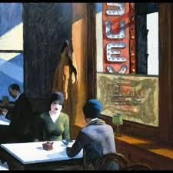
Analyze - What the document means (the implicit):
What… for ? - Your interpretation of the document
- The author’s aim/ purpose/ intention/ goal
Conclusion :
Main meaning of the document
How does it appeal to you ? Your reaction/ opinion ?


HOW TO STUDY A VISUAL DOCUMENT ?

Introduction - Identify the document :
What ? → Nature of the document
Who ? → Name of the author
Where from ? → Source/ where was it published ?
When ? → Date of publication/ Historical context
What about ? → Main subject
For whom ? → Target/ Recipient
Describe - What the document shows (the explicit) :
Where ? → Where does the scene take place ?
Who ? → People and Characters
When ? → Historical period/ Time of day/ Season…
What ? → What are they doing ? What is going on ?
How ? → Composition/ Setting/ Colours/ Shades and lights…
Analyze - What the document means (the implicit):
What… for ? - Your interpretation of the document
- The author’s aim/ purpose/ intention/ goal
Conclusion :
Main meaning of the document
How does it appeal to you ? Your reaction/ opinion ?

