Unit6-How does gentrification impact US cities ? Words worksheet
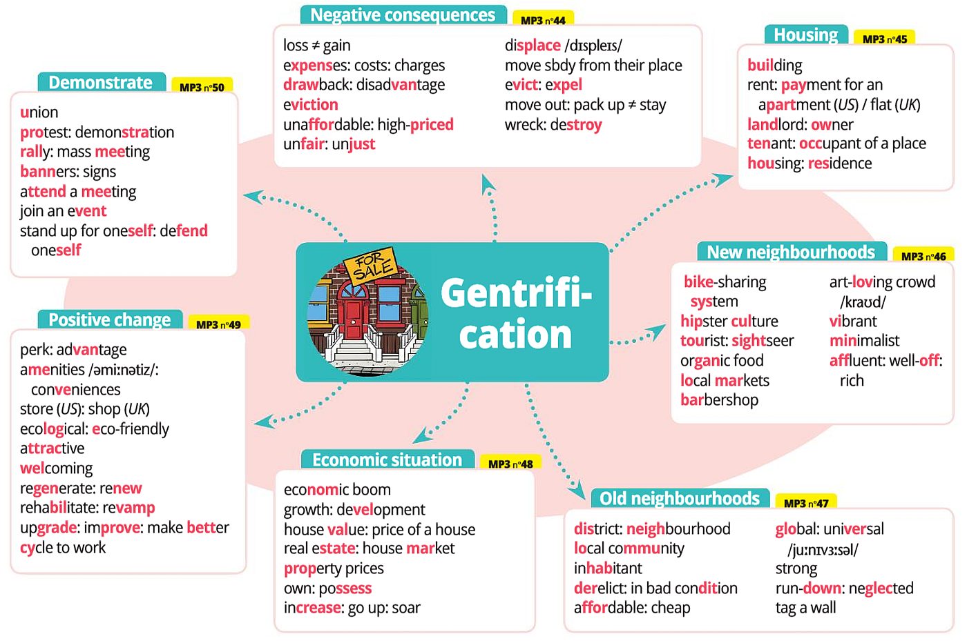
Unit6-How does gentrification impact US cities ? Words worksheet

Unit6-How does gentrification impact US cities ? Words worksheet
Lexique: Utilisez le vocabulaire en contexte.
P74 Ex1: Complétez les phrases suivantes avec des mots de la carte mentale.
a. I have been living in this … neighbourhood for years and I won’t move out!
b. This building has just been … rehabilitated, it is much more modern now.
c. Yesterday, the residents … … … attended a meeting which was about the opening of a new vegan restaurant.
d. The rent of this apartment has increased so much it is now … unaffordable for the tenants.
e. Thanks to the … … bike-sharing system , the inhabitants use less their cars to go to work.
f. One of the main drawbacks of gentriﬁcation is the … eviction of the poorer inhabitants.

Ex2: Trouvez les mots qui correspondent à ces déﬁ nitions dans la carte mentale puis écrivez un court paragraphe sur les avantages et inconvénients de la gentriﬁcation.
a. an increase in economic activity → an economic boom
b. beneﬁt → an advantage
c. a situation that does not give equal treatment to everyone → unfair
d. a large public meeting → a rally

One of the main advantages of gentrification is the economic boom it goes with in a neighbourhood because it creates job opportunities and enables many buildings to be renovated and people can enjoy new modern facilities. But at the same time the situation is harder for long-time residents because if they can’t afford their house any more,they are evicted. That’s the reason why tenants often rally to protest against this unfair situation.

Quizlet hatier-clic.fr/lmu029
Demonstrate | Economic situation | Housing
union  protest: demonstration  rally: mass meeting  banners: signs  attend a meeting  join an event  stand up for oneself: defend  oneself | economic boom  growth: development  house value: price of a house  real estate: house market  property prices  own: possess  increase: go up: soar | building  rent: payment for an  apartment (US)/  at (UK)  landlord: owner  tenant: occupant of a place  housing: residence

Positive changes | Negative consequences
perk (fam): advantage  amenities : aménagement, équipement ,infrastructure  conveniences (piece of equipment) : confort  store (US): shop (UK)  ecological: eco-friendly  attractive  welcoming  regenerate: renew  rehabilitate: revamp (rénover, réaménager)  upgrade (améliorer, moderniser): improve: make better  cycle to work | loss ≠ gain  expenses: costs: charges  drawback: disadvantage  eviction  unaﬀordable: high-priced  unfair: unjust  displace (déplacer, remplacer, supplanter)  move sb from their place  evict: expel  move out: pack up ≠ stay  wreck: destroy

Old neighbourhoods | New neighbourhoods
district: neighbourhood  local community  inhabitant  derelict: in bad condition  aﬀordable : cheap  global: universal  strong  run-down: neglected  tag a wall | bike-sharing  system  hipster culture  tourist: sightseer  organic food  local markets  barbershop: men's hairdressing salon  art-loving crowd  vibrant  minimalist  affluent (riche, aisé, prospère): well-oﬀ : rich

Unit6-How does gentrification impact US cities ? Homework worksheet p72
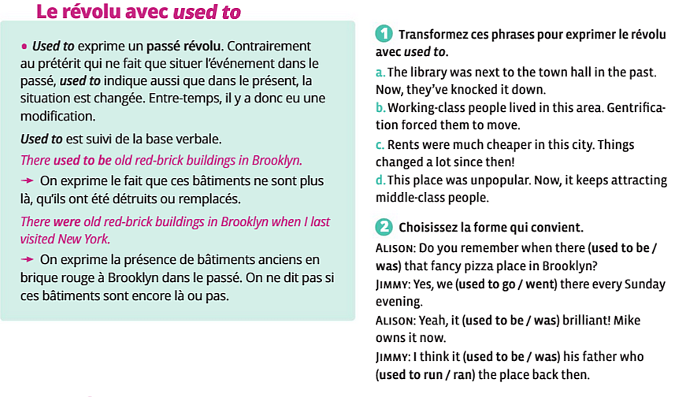
Ex1:Transformez ces phrases pour exprimer le révolu avec used to.
a. The library was next to the town hall in the past. Now, they’ve knocked it down.
→ The library used to be next to the town hall.
b. Working-class people lived in this area. Gentriﬁcation forced them to move.
→ Working-class people used to live in this area.
c. Rents were much cheaper in this city. Things changed a lot since then!
→ Rents used to be much cheaper in this city.
d. This place was unpopular. Now, it keeps attracting middle-class people.
→ This place used to be unpopular.

Ex2: Choisissez la forme qui convient.
Alison: Do you remember when there (used to be / was) that fancy pizza place in Brooklyn?
→ Do you remember when there was that fancy pizza place in Brooklyn?
Jimmy: Yes, we (used to go / went) there every Sunday evening.
→ Yes, we used to go there every Sunday evening.
Alison: Yeah, it (used to be / was) brilliant! Mike owns it now.
→ Yeah, it was brilliant! Mike owns it now.
Jimmy: I think it (used to be / was) his father who (used to run / ran) the place back then.
→ I think it used to be his father who ran the place back then.

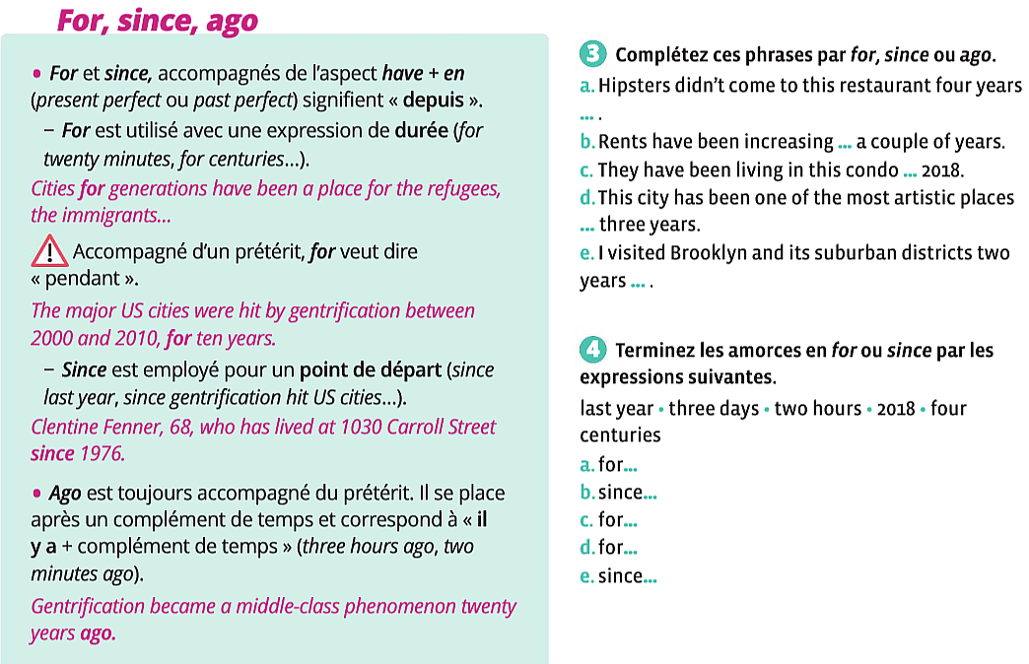
Ex3: Complétez ces phrases par for, since ou ago.
a. Hipsters didn’t come to this restaurant four years … ago .
b. Rents have been increasing … for a couple of years.
c. They have been living in this condo … since 2018.
d. This city has been one of the most artistic places ... for three years.
e. I visited Brooklyn and its suburban districts two years ... ago .

Ex4: Terminez les amorces en for ou since par les expressions suivantes.
last year • three days • two hours • 2018 • four centuries
a. for…  b. since…  c. for…  d. for…  e. since… | three days  last year  two hours  four centuries  2018

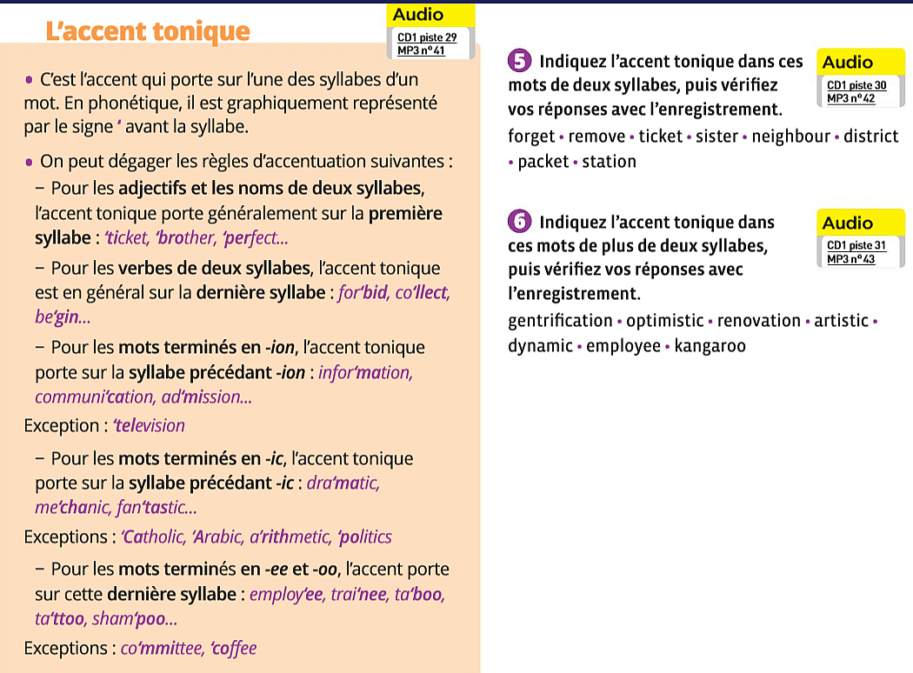
Ex5: forget • remove • ticket • sister • neighbour • district • packet • station

Ex6: gentrification • optimistic • renovation • artistic • dynamic • impress • butcher • employee • kangaroo

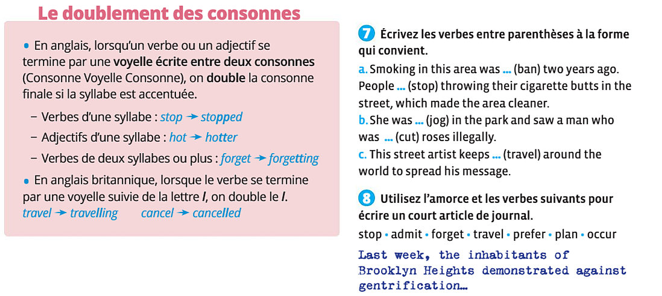
Ex7:
a.Smoking in this area was banned (ban) two years ago. People stopped (stop) throwing their cigarette butts in the street, which made the area cleaner.
b.She was jogging (jog) in the park and saw a man who was cutting (cut) roses illegally.
c.This street artist keeps travelling (travel) around the world to spread his message.

Ex8: Utiliser l’amorce et les verbes suivants pour écrire un court article de journal.
stop, admit, forget, travel, prefer, plan, occur
Last week, the inhabitants of Brooklyn Heights demonstrated against gentrification …

Last week, the inhabitants of Brooklyn Heights demonstrated against gentrification after the mayor admitted that a national bank was planning to buy and renovate a huge building near the church. So
yesterday, associations and inhabitants decided to gather in the street and they stopped in front of the town hall. There were about eight hundred people, which had never occurred before in Brooklyn
Heights. People explained the mayor they preferred to have a new school built in the area. The president of an association added that he had travelled to Europe recently and that he hadn’t forgotten the consequences of gentrification in the cities he had visited. According to him, they all look the same and have lost their identity.

