Correction French Heritage
Overall timeline / language and genealogy | Architecture | Faith | Celebrations | Culture
1718 De Bienvielle and D’Iberville founded New Orleans / Orleans in honour of The Duke of Orleans (regent in France)COLONIZATION / bilingual place  1921 : Americanization : prohibition of French language in Schools  Today : boost languages at school, especially French / French speaking events  Many Americans, living in Louisiana today, have French descendants or direct lineage | The French quarters was designed by two French engineers  But the Spanish took over and finished the job, that’s why the French Quarter has Spanish architectural inspirations.  Joan of Arc statue  Street names | French = Catholics # Americans =Protestants  Nuns came to NO and served as missionaries to spread and teach religion | Bastille Day  Mardi Gras Parade (Fat Tuesday) | Very important still today  Many words, expressions, event and food are related to the French culture

Correction Multicultural heritage
Gumbo | The Saints Football team | Multiculturalism in New Orleans
The Creole Version : a sort of soup with seafood, oysters (huitres) shrimps (crevettes), andouille sausage with rice  The Cajun version : chicken, duck or squirrel (écureuil)  Two origins : Native Indians and African Okra soup  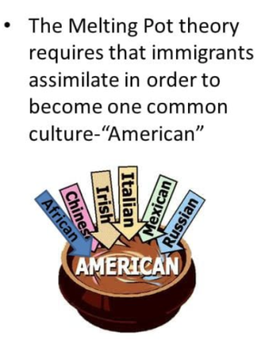  It shows the mixed heritage also call the Melting Pot | Symbol of the city / joy  Brings people together  No matter the background, people connect with the team and enjoy it  After Hurricane Katrina the Saints played a big role : energy, rebuilt the city  2010 The Saints won the Superbowl | 19th /20th centuries 2005 After Katrina Hurricane  French (Catholics) Latino workers  Spanish  African American  (freed slaves)  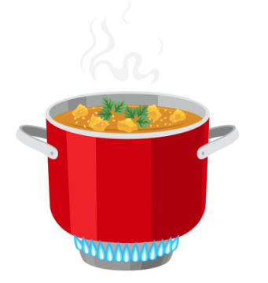  Irish and German labourers  New Orleans’s Melting Pot  French speaking Catholics were called CREOLE

Correction African Heritage
Jazz | Timeline | Influences | Congo Square
- NOLA = birthplace of Jazz  - From the late 1800s and 1900s in NOLA  - America’s original art form  - Different kinds of influences: church & gospel music, blues music, ragtime, instrumental.  - NOLA = perfect place -> active river port, large population of african Americans, mixed culture to invent this type of music (French, Spanish, Caribbean,Creole, American)  - Rhythm (drums, percussion, bass, piano) and melodic components (brass instruments or wind instruments)  - key component: improvisation  - Jazz fits NOLA and its Gumbo like stew of people.  rock ’n’ roll, in gospel and funk, and in rap, hip hop, bounce and brass band < Jazz | - 1719: first people from Africa (West) were brought to NOLA (brought by the French, 5000 survived the Middle Passage)  - 1780s: Spanish forcibly brought people from Benin and Congo  -> why? clear forests, raise crops, and build the city infrastructure.  - 1803: people with African ancestry = about 50% of the population (free and enslaved)  - Under Spanish rule: easier to be free (manumission)  - black people in the 19th c.: born in Africa (-> native languages) or born in Louisiana = black Creole (-> French or French Creole) or coming from the upper south of the USA (-> English speakers) | African culture persisted: food, music, religion  Mardi Gras (Fat Tuesday) traditions  - Skull gangs  - Krewe of Zulu Zulu grew out of social aid and pleasure clubs —that is, benevolent societies providing insurance for illness or funerals, which would hold street parades (“second lines”) for members to advertise the club.  Today, century-old Zulu krewe boasts over 1,500 riders, among them leaders in business, government, and community, and Second Lines occur somewhere in the city on practically any given Sunday.  - Faubourg Treme, among the oldest black neighborhoods in the nation | - meeting point for African slaves and laborers. -> trade goods, play music, dance & socialize  - Congo square = the most important historical sites for understanding American music, + the key role of African Americans in New Orleans in its development and diversification.

Correction Spanish Heritage
Historic Sites | Architecture | Celebrations/Atmosphere
The Cabildo was Spain’s administrative headquarter.  -The French and the Americans signed their land deal over Louisiana there in 1803. (The Louisiana Purchase)  - It was Louisiana’s state supreme court > in 1896 Plessy vs Fergusson judged there (= Segregation became legal)  The Presbytere = museum of Mardi Gras -> artefacts, outfits, history of celebrations. An ever growing collection.  Spanish Plaza (1976) -> a gift from Spain to celebrate NOLA’s Spanish connections. There are tiles with the names of all Spanish provinces.  Numerous Spanish street names to honour historical figures. | The French quarter has Iberian touches  NOLA belonged to the Spanish between 1763 and 1803 -> the city burnt down, so they rebuilt everything, hence the Spanish influenced architecture.  - Stucco replaced wood to avoid fire  - Continuous facades; buildings were placed together, with back garden hidden from street view. | - Running of the Bull < San Fermin, Pamplona, Spain but in NOLA the bulls are replaced by derby girls with baseball bats.  The architecture, street musicians, open air market or the food recall Latin America.  Perfect place to celebrate being Hispanic.

