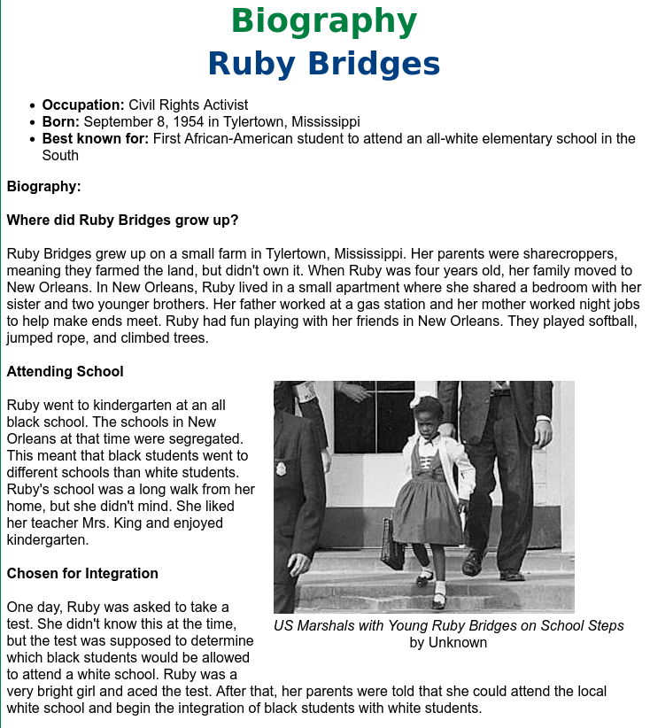
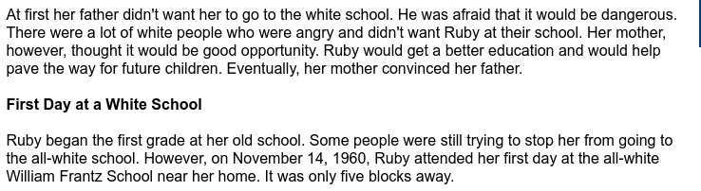
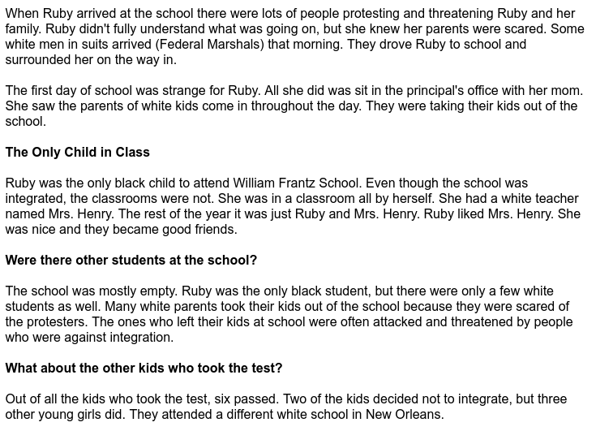
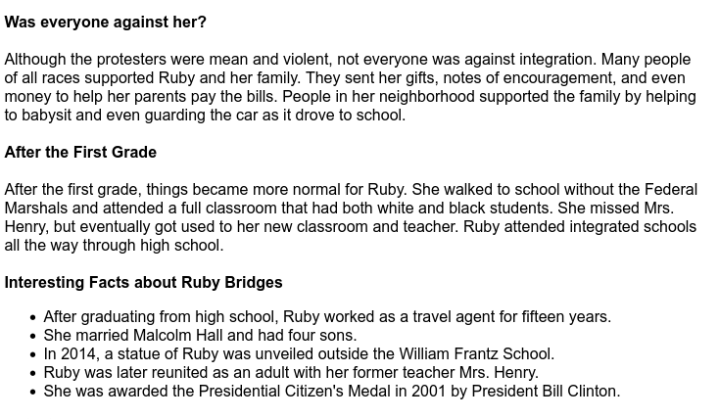

Ruby Bridges

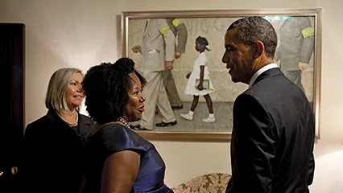

Introduction
Ruby Bridges was a child who played an important part in the civil rights movement. She was one of several African American children chosen to attend formerly all-white schools in New Orleans, Louisiana, in 1960.

Early Life
Ruby Nell Bridges was born on September 8, 1954, in Tylertown, Mississippi. She was the oldest of Abon and Lucille Bridges’ eight children. When she was 4, her family moved to New Orleans so her parents could find better jobs.

Integration
When Ruby was in kindergarten, a federal court ruled that New Orleans schools needed to become integrated, or to allow both Black and white students to attend. The school district chose several African American children to start the next school year at all-white schools. Ruby was chosen to attend the William Frantz Elementary School.
Ruby was the only African American child attending Frantz School. She was taken to and from school by four federal marshals, policemen assigned to protect her. White parents who did not want their children taught in the same school as Black children yelled at Ruby and threatened her. Most white parents also would not let their children attend the Frantz School anymore, so Ruby was the only student in her first grade class for most of the year. She and her teacher, Barbara Henry, became close friends as they worked together.
Slowly, parents became less angry and afraid and began allowing their children to return to Frantz School. The next year, all the students had returned and the school was fully integrated.

Later Life
Ruby went on to marry and have four children. In 1999 she created a charity, the Ruby Bridges Foundation, that promoted understanding and unity among schoolchildren. She also wrote a book in 1999 called Through My Eyes that tells about her experiences. Other books about her include The Story of Ruby Bridges by Robert Coles.

