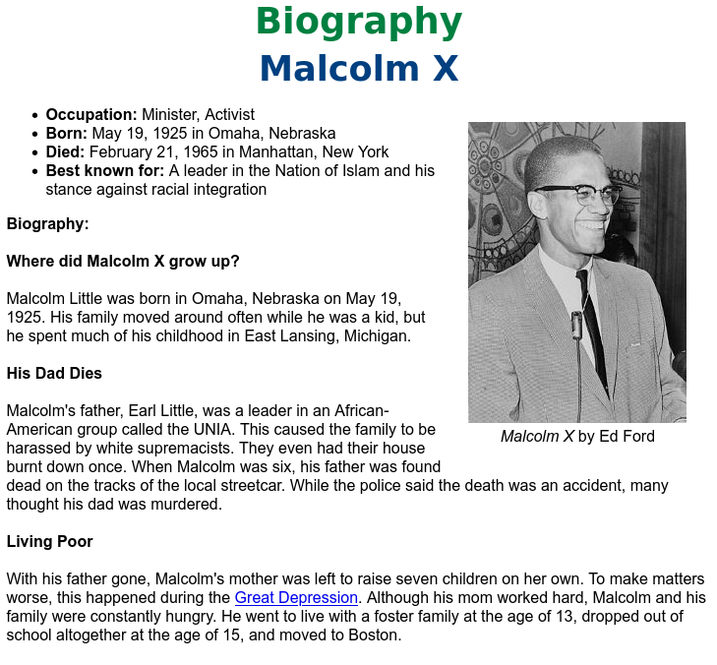
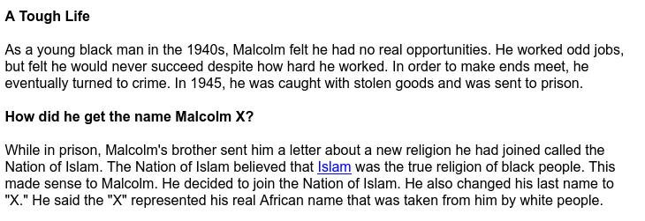

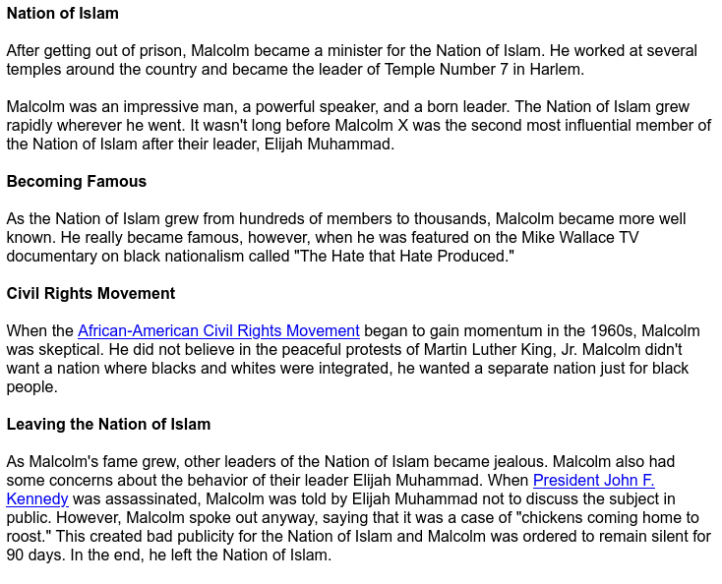
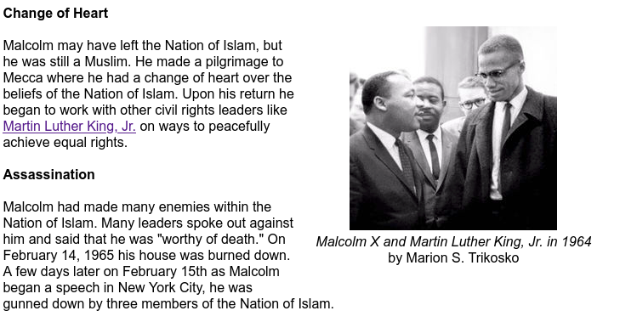

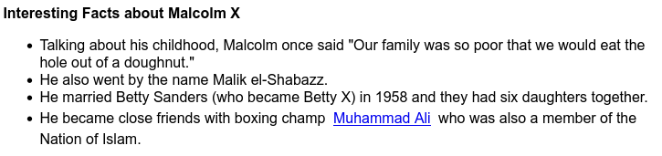

Introduction
Malcolm X was an African American religious and political leader in the 1950s and 1960s. His proud stand won him many followers but also made him many enemies.

Early Life
Malcolm X was born on May 19, 1925, in Omaha, Nebraska. His name at first was Malcolm Little. His father was a minister. The Little family moved to Lansing, Michigan, in 1929. Malcolm’s father was killed in 1931, and Malcolm had a difficult childhood. He dropped out of school after the eighth grade. As a young man he moved to New York City and became involved in crime.

Nation of Islam
Little was in prison when he learned of a group called the Nation of Islam. The Nation of Islam followed some of the teachings of Islam. It also taught that Blacks were superior to whites.
Little joined the Nation of Islam in 1952. He gave up his last name because he believed that slaveholders had given it to his ancestors. He replaced it with an X. The X stood for his unknown African family name.
Malcolm X was a gifted speaker. He won many new members for the Nation of Islam. At the time, the civil rights movement was beginning in the United States. Its leaders sought equal rights for Blacks. For example, they wanted Black children to be able to attend the same schools as white children. Malcolm X did not agree with the ideas of the civil rights movement. Instead he wanted to establish a separate Black nation. He did not rule out violent methods.

Last Years
Malcolm X left the Nation of Islam in 1964. He converted to traditional Islam and took the name el-Hajj Malik el-Shabazz. He made a pilgrimage, or religious journey, to Mecca, Saudi Arabia. He changed his views about whites.
Malcolm X’s new beliefs angered some people. On February 21, 1965, he was speaking in New York City when he was shot and killed. Three members of the Nation of Islam were convicted of his murder.

