THE TIME

- Quelle heure est-il ? Ecris les heures en anglais.

11:55 –

23:30 –

14:25 –

08:45 –

10:05 –

13:25 –

16:50-

15:15-

- Réponds à ces questions en anglais.

- What time do you get up at weekends ?

______________________________________

- What time do you finish school on Thursday ?

______________________________________

- What time do you watch TV ?

______________________________________

DAILY ROUTINES

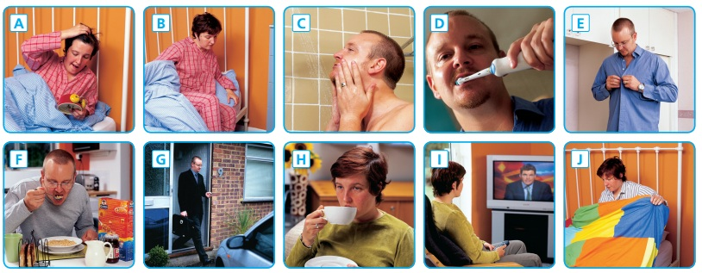
- Regarde ces images et nomme chaque activité.

A: F:
B G:
C: H:
D: I:
E: J:

- Réponds à ces questions en anglais. (/! les heures en anglais aussi ;-) )

* When do you wake up in the morning?
_____________________________________________________

* What is the first thing you do after you wake up?
_____________________________________________________

* What do you usually eat and drink for breakfast?
_____________________________________________________

* What time do you eat lunch?
_____________________________________________________

* Do you eat dinner?
_____________________________________________________

* What do you do in the evening?
_____________________________________________________

* When do you usually go to bed?
_____________________________________________________

3) Lis la routine de Lesley et re-crée l’horaire de sa journée. Sois précis.

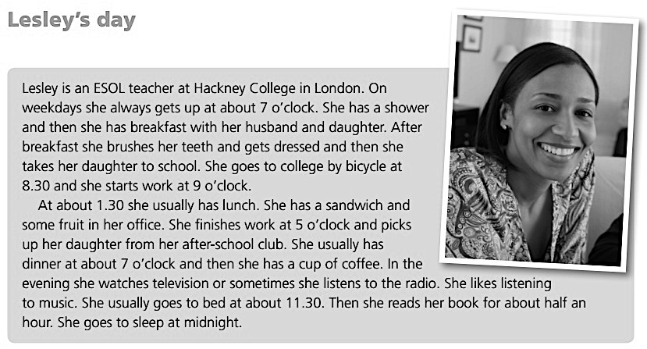

Heure ? | Activité ? (+ avec qui ? Comment ? Où ?)

SCHOOL SUBJECTS

- Observe les emplois du temps de Carol, Sam et Betty - TRUE (vrai) OR FALSE (faux)

 | MONDAY | TUESDAY | WEDNESDAY | THURSDAY | FRIDAY
  CAROL |  |  |  |  | 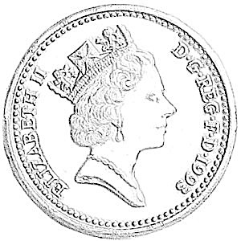
  SAM |  |  |  | 
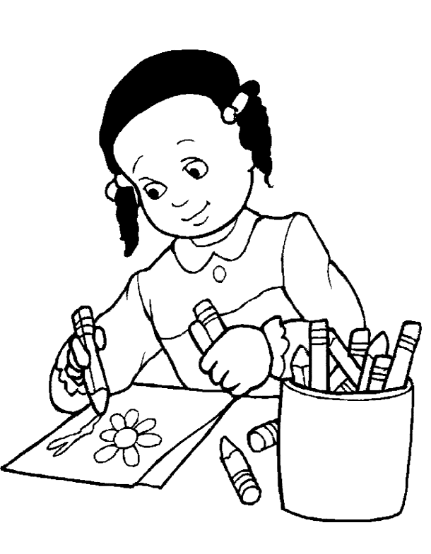  BETTY |  | 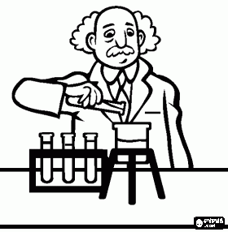

Carol has got Sciences on Wednesday  Carol and Betty have got French on Monday  Betty has got Art on Tuesday  Carol hasn’t got English on Friday | ☐ true ☐ false  ☐ true ☐ false  ☐ true ☐ false  ☐ true ☐ false | Sam’s got Music on Friday  Carol has got French on Thursday  Betty has got English on Tuesday  Sam hasn’t got PE on Thursday | ☐ true ☐ false  ☐ true ☐ false  ☐ true ☐ false  ☐ true ☐ false

- Relie les images avec leur mot en anglais. Utilise des couleurs différentes…

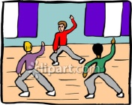

English – Maths – French – Social Studies – Science – Physical Education

- Mot caché : retrouve un maximum de cours (les mots peuvent être écrits dans tous les sens).

R I H W J V J K Q O Z K L B V S P X L R
J H D L T L T H L C D O Q L H H S L A N
Y G R T S V N S Q W A G Z G Y C V E N B
N B D R A M A F C L P A A S A B G I G E
Q M B Z K E H S G L F X I A S V R R U P
S X B U U B P M Z F M C C N I W Z G A N
N H N I K S V Z S D A O E A I K R X G F
O A T V Z W O H M L W J S N U Q V L E Q
Q G G A K H R W E C U E U B G B J T E W
R U K N M B Y D H X I E I N L L X E Z F
O S Y W F V U O L D J C U T U I I G M Q
V N J B P C S S U M B E Z W S P P S U P
D C E Y A V Z T Y T H G L C H T X O H I
X W S T S K S W Q T E W I T J T H I A Q
H R I G I L C M G L Z E Q S T E A B C A
A O W A A O G X A E N E G D T D J A V Y
N A A I A C T N Q C V Y B V D Q L P G E
K J C H J H Q A E U C X E M U A T N S K
P O J K Y J A Q W T Q S Y R L W A B R D
S P T A H T M D E Q M M F O A L C W E O

- Complète les phrases avec le bon cours.

- My favourite subject is ___________________________because I like grammar.
- My favourite subjet is___________________________ because I like football.
- My favourite subject is___________________________because I like history and maps.
- My favourite subject is___________________________because I like numbers.
- My favourite subject is___________________________because I like painting.
- My favourite subject is___________________________because I like the piano.

- Lis le texte et entoure VRAI ou FAUX.

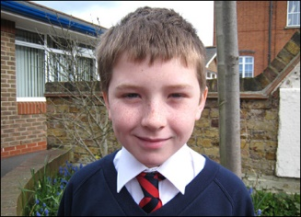
Hello! My name is Steven. I am from England. I live in Portsmouth, a city in the south. I go to school in Portsmouth. I have twelve subjects. My favourite subject is music because I like playing the piano and the guitar. I like English because I read stories and comics with my teacher. I don’t like Maths because I don’t like divisions, and I hate Science because I don’t like experiments. In my class there are two teachers Violet and Nancy, and there are twenty-five students.

- Patrick vient des Etats-Unis. T / F
- Patrick vit à Londres. T / F
- Il va à l’école à Portsmouth. T / F
- Il aime la musique. T / F
- Il déteste les maths. T / F
- Il n’aime pas les langues. T / F
- Il aime la science. T / F
- Il a 3 profs dans sa classe. T / F
- Il y a 25 élèves dans sa classe. T / F
- Il n’aime pas jouer de la guitare. T / F

AN ORDINARY DAY

Mise en situation : Grâce à Facebook, tu corresponds depuis un petit temps avec une étudiante/ un étudiant qui habite à Manchester. Vous avez décidé d’enfin vous rencontrer. Tu l’as invité(e) à loger chez toi quelques jours. Pour qu’elle / qu’il sache à quoi s’attendre, penses à ce que tu fais tous les jours et parles-en lui.

Tu ne sais pas de quoi parler? Voici quelques idées…

- How you get to school or work.
- What time school starts and finishes.
- What you do when you get there.
- What time you have lunch.
- What you usually have for lunch.
- What you like about school.
- What you do after school.
- What time you have dinner and who you have dinner with.
- What you do in the evening.
- What time you get to bed.
- …

_______________________________________________________________________________________________________________________________________________________________________________________________________________________________________________________________________________________________________________________________________________________________________________________________________________________________________________________________________________________________________________________________________________________________________________________________________________________________________________________________________________________________________________________________________________________________________________________________________________________________________________________________________________________________________________________________________________________________________________________________________________________________________________________________________________________________________________________________________________________________________________________________________________________________________________________________________________________________________________________________________________________________________________________________________________________________________________________________________________________________________________________________________________________________________________________________________________________________________________________________________________________________________________________________________________________________________________________________________________________________________________________________________________________________________________________________________________________________________________________________________________________________________________________________________________________________________________________________________________________________________________________________________________________________

ORAL EXPRESSION

Exerce-toi. Voici l’horaire scolaire de James Burton. Fais 10 phrases pour décrire son horaire.
Tu peux t’enregistrer avec le dictaphone de ton téléhone et m’envoyer le fichier par mail pour que je corrige ta prononciation.

 | Monday | Tuesday | Wednesday | Thursday | Friday
09:00 |  |  | 
09:45 |  |  |  | 
10:30-10:45 | B | R | E | A | K
10:45 |  |  |  | 
11:30 |  |  | 
12:15-13:00 | L | U | N | C | H
13:00 |  |  |  |  | 
13:45 | 
14:30-14:45 | B | R | E | A | K
14:30 |  |  |  | 
15:15 |  | 

