U.1.1 : The alphabet

- Ecoute le « Funky Alphabet ». (I bet you can, audio 2 mp3 2)
Selon toi, quelles sont les lettres les plus difficiles ?

……………………………………….……………………………………….……………………………………….

- Entraine-toi à épeller ton prénom et ton nom de famille.
Exemple : « Hello, my name is Paul ; P-A-U-L, and my surname is Fox ; F-O-X »

  - My name is …………………………………………………………… and my surname is …………………………………………… .
- Ecoute les 5 noms / prénoms dictés par ton professeur et note-les.

  - ………………………………………..
  - ……………………………………….
  - ……………………………………….
  - ……………………………………….
  - ……………………………………….
- A ton tour ! Invente 3 prénoms / noms, entraine-toi à les épeller et, lorsque ce sera ton tour, dicte-les à tes camarades.

  - ……………………………………….
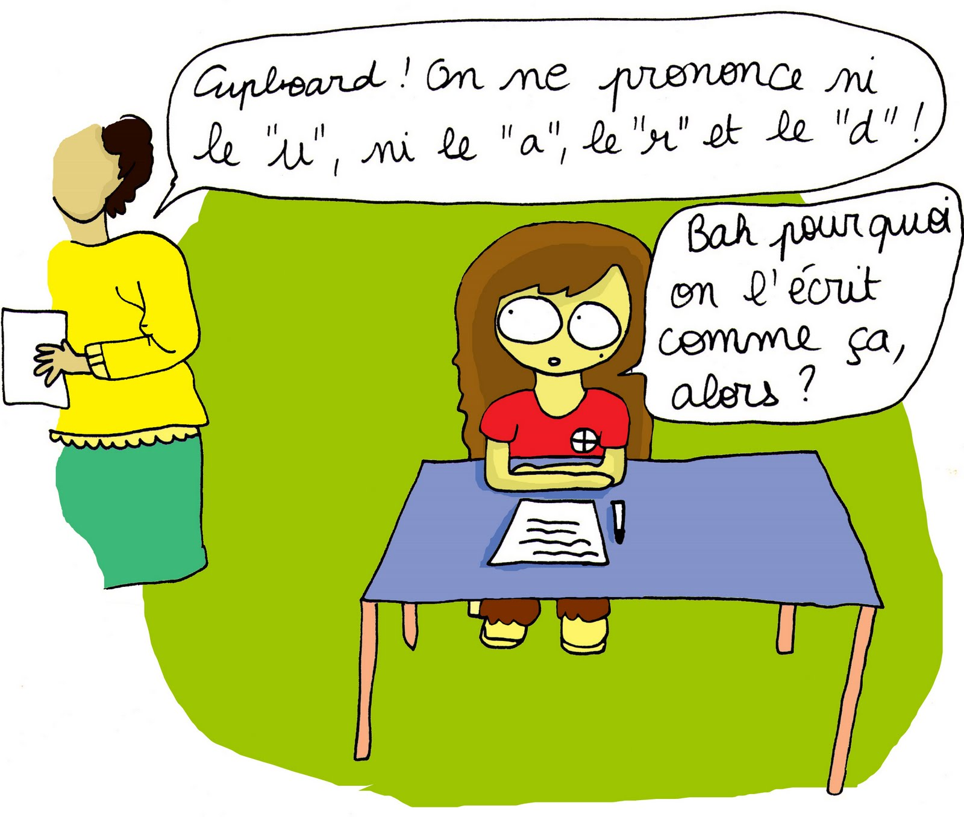
  - ……………………………………….
  - ……………………………………….

- Entoure les lettres de l’alphabet en fonction de leur prononciation.

A | B |  | C |  | D |  |  | E |  | F
ei | bi |  | ci |  | di |  |  | i |  | ef
G | H |  | I |  | J |  |  | K |  | L
gi | eich |  | ai |  | jei |  |  | key |  | el
M | N |  | O |  | P |  |  | Q |  | R
em | en |  | ou |  | pi |  |  | qiu |  | ar
S | T |  | U |  | V |  |  | W |  | X
es | ti |  | iu |  | vi |  |  | dobliu |  | ex
Y |  | Z
uai |  | dzi

U.1.2 : Useful expressions

- Translate the word or the expression thanks to the dictionary and link it with the correct letter

 | Words |  | Translation |  |  | Letter
 | Yes
 | No
 | Please
 | Thank you
 | Sorry
 | Excuse me
 | Hello
 | Goodbye
 | Good morning
 | Good afternoon
 | Good evening
 | Good night
A.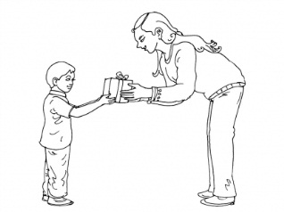 |  | B.   |  | C.   | D.  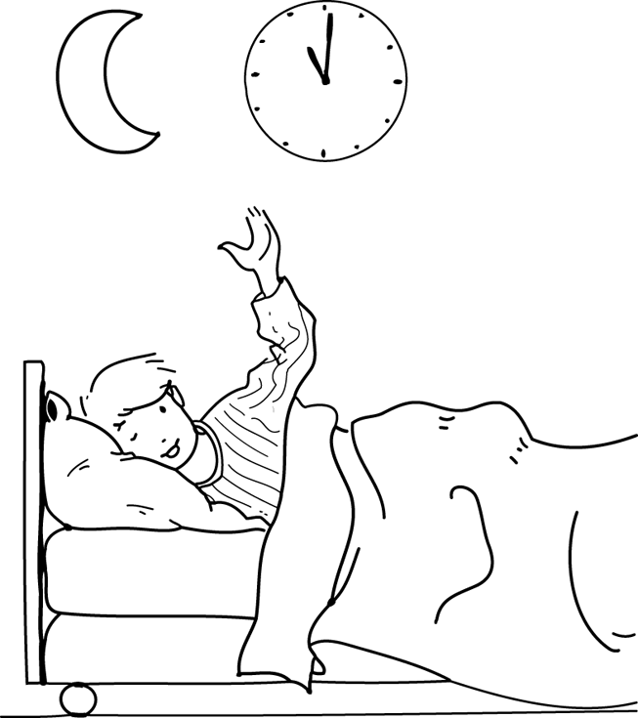
E.  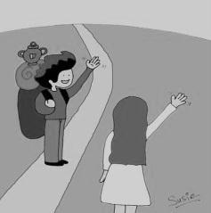 |  | F.   |  | G.   | 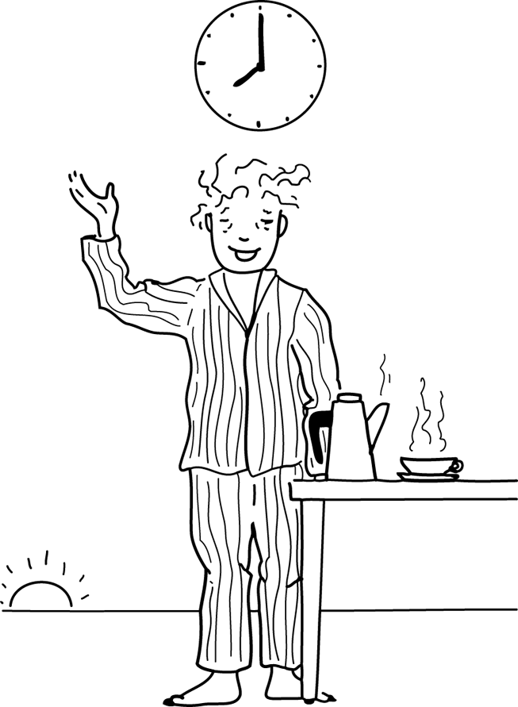  H.
I.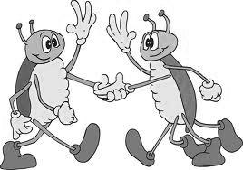 |  | J.  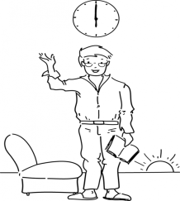 |  | K.   | L.  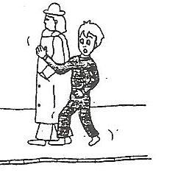

CLASSROOM LANGUAGE

Close the door ! / Switch off the light ! / Come to the board ! / Sit down ! /
Write your name ! / Raise your hand ! / Look at the board ! / Take your school diary ! /
Be quiet ! / Close your book ! / Switch on the light ! / Listen! / Stand up ! /
Open the window ! / Read! / Take a sheet of paper ! / Clean the board ! / Open your book !

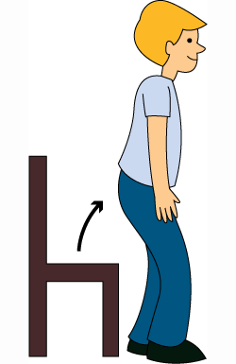

……………………………. ………………………… …………………………….

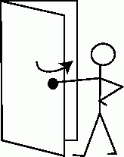
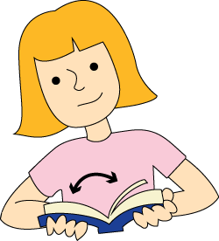
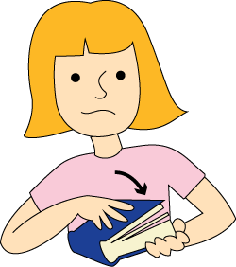

…………………………….. …………………………… ………………………….


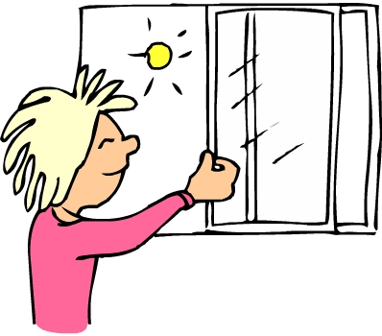


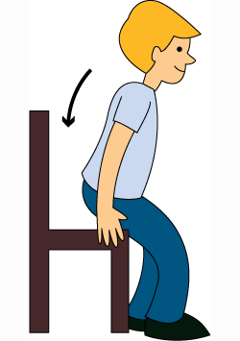
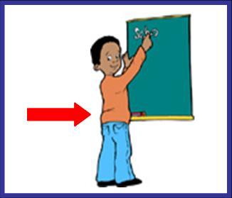
………………………….. …………………………. …………………………….


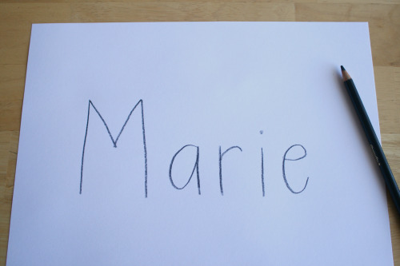

……………………………. ………………………. ……………………….

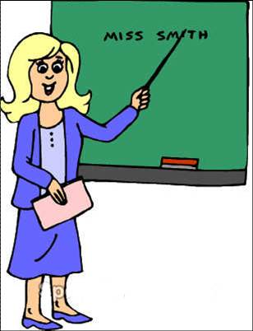

………………… ……………………… ……………………….



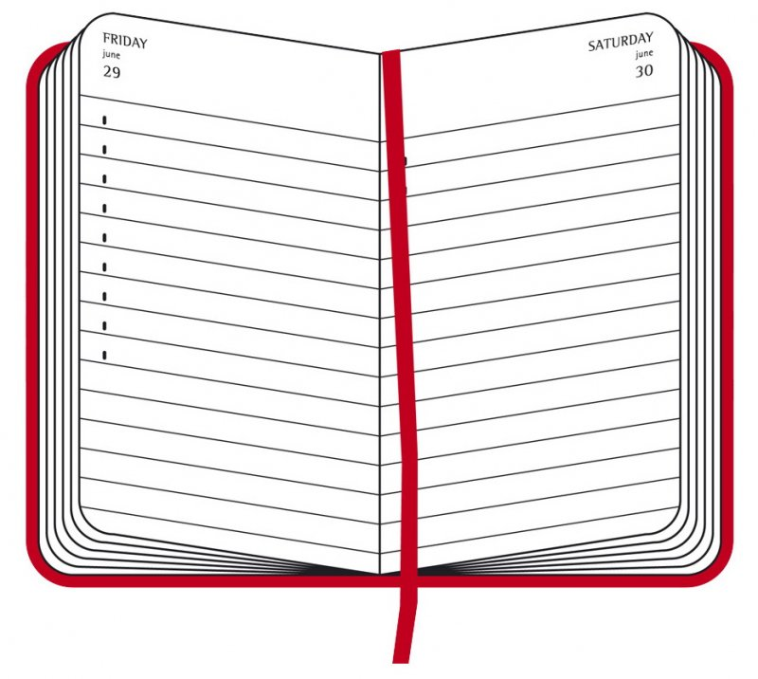




…………………….... ……………………… ……………………………..

- Play Simon says.

U.1.3 : Numbers from 0 to 20

1
2
3
4
5
6
7
8
9
10
11
12
13
14
15
16
17
18
19
20

Legende :

a | e | r | n | l | y | i | k | t | v

s | x | u | o | f | h | q | w | d | j

1
2
3
4
5
6
7
8
9
10
11
12
13
14
15
16
17
18
19
20

- Help Ben to find his place in the train. Look at his ticket and circle the correct wagon.

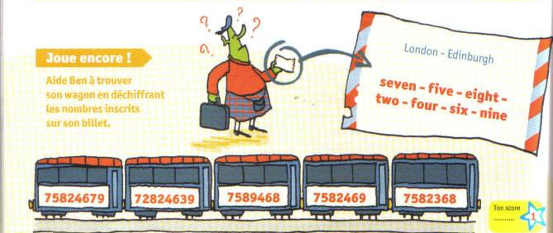

- Addition game

Throw the dices and calculate the addition.

+

+

+

+

- Write the numbers in the crossword puzzle.

Write
7

9
15

14

11

1
18

16
6

5

12
17

19

10

4

3

2

20

8
13

- How old are they ? (EO) 

- Numbers wordsearch
Match the numbers with the digits. Then, find them in the wordsearch.

N | F | O | U | R | T | E | E | N | X
E | I | G | H | T | V | V | E | I | I
E | I | N | V | L | I | E | F | N | S
T | W | G | E | F | T | I | Y | E | N
N | E | W | H | R | F | T | S | T | E
E | T | N | I | T | N | O | E | E | V
V | D | H | E | E | E | N | V | E | E
E | T | E | W | O | D | E | E | N | L
S | N | T | H | R | E | E | N | X | E
N | E | E | T | X | I | S | O | W | T

EIGHT | EIGHTEEN | ELEVEN
FIFTEEN | FIVE | FOUR
FOURTEEN | NINE | NINETEEN
ONE | SEVEN | SEVENTEEN
SIX | SIXTEEN | TEN
THIRTEEN | THREE | TWELVE
TWENTY | TWO

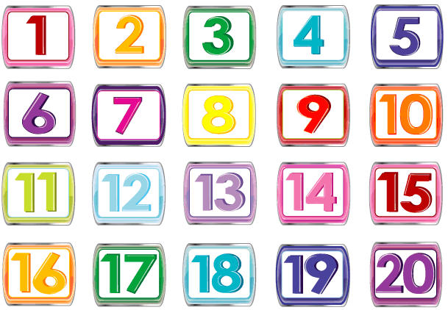

- The numbers pwp oral game 1D
- Boardgame

Finish
Rules Box
1) Roll the number cube and pick up a card.

2) If you answer the card correctly, then you can move the number of spaces on the dice.

3) Two or more players can be on the same space.

4) Continue to play until some reaches the finish, then see who will finish second, third, etc.

Numbers
0-20
9
18
Oh No! Go back to Start
10
2
12
1
Move Ahead 2 Spaces
3
16
Oh No!
Go Back
4
20
14
6
19
Skip One Turn
11
7
15
Move Back 3 Spaces
0
Super Skip
Move Ahead
13
Move Ahead 3 Spaces
5
17
8
Start

U.1.4 : Numbers from 0 to 100

Number | English
0 | zero
1 | one
2 | two
3 | three
4 | four
5 | five
6 | six
7 | seven
8 | eight
9 | nine
10 | TEN
11 | eleven
12 | twelve
13 | thirteen
14 | fourteen
15 | fifteen
16 | sixteen
17 | seventeen
18 | eighteen
19 | nineteen
20 | TWENTY
21 | twenty-one
22 | twenty-two
23 | twenty-three
24 | twenty-four
25 | twenty-five
26 | twenty-six
27 | twenty-seven
28 | twenty-eight
29 | twenty-nine
30 | THIRTY
31 | thirty-one
40 | FORTY
41 | forty-one
50 | FIFTY
51 | fifty-one
60 | SIXTY
61 | sixty-one
70 | SEVENTY
71 | seventy-one
80 | EIGHTY
81 | eighty-one
90 | NINETY
91 | ninety-one
100 | ONE HUNDRED

- Put the numbers in the right order and write them in correct English.



 | 

 | 
 | 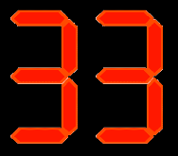
 | 

 | 
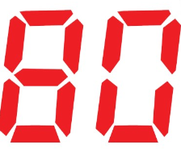
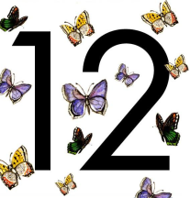 | 

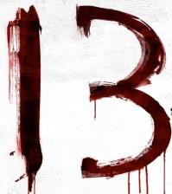

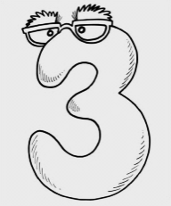



- Match the columns

a) 794 ( ) forty – seven
b) 8.471 ( ) five thousand one hundred and thirty – two
c) 5.132 ( ) seven hundred and ninety – four
d) 47 ( ) eight thousand four hundred and seventy – one
e) 470 ( ) four hundred and seventy

- Write the numbers

a) three thousand six hundred and ninety – five ____________
b) six thousand two hundred ____________
c) two thousand seven hundred and forty____________
d) seven hundred ____________
e) eighty – nine ____________

- Write the numbers in full

a) 1.315 ________________________________________________________

b) 353 _________________________________________________________

c) 2.400 ________________________________________________________

d) 867 _________________________________________________________

e)3.027 ________________________________________________________
U.1.5 : Days and dates

- Listen to these 3 famous personalities and say who is talking
(I bet you can audio 55)

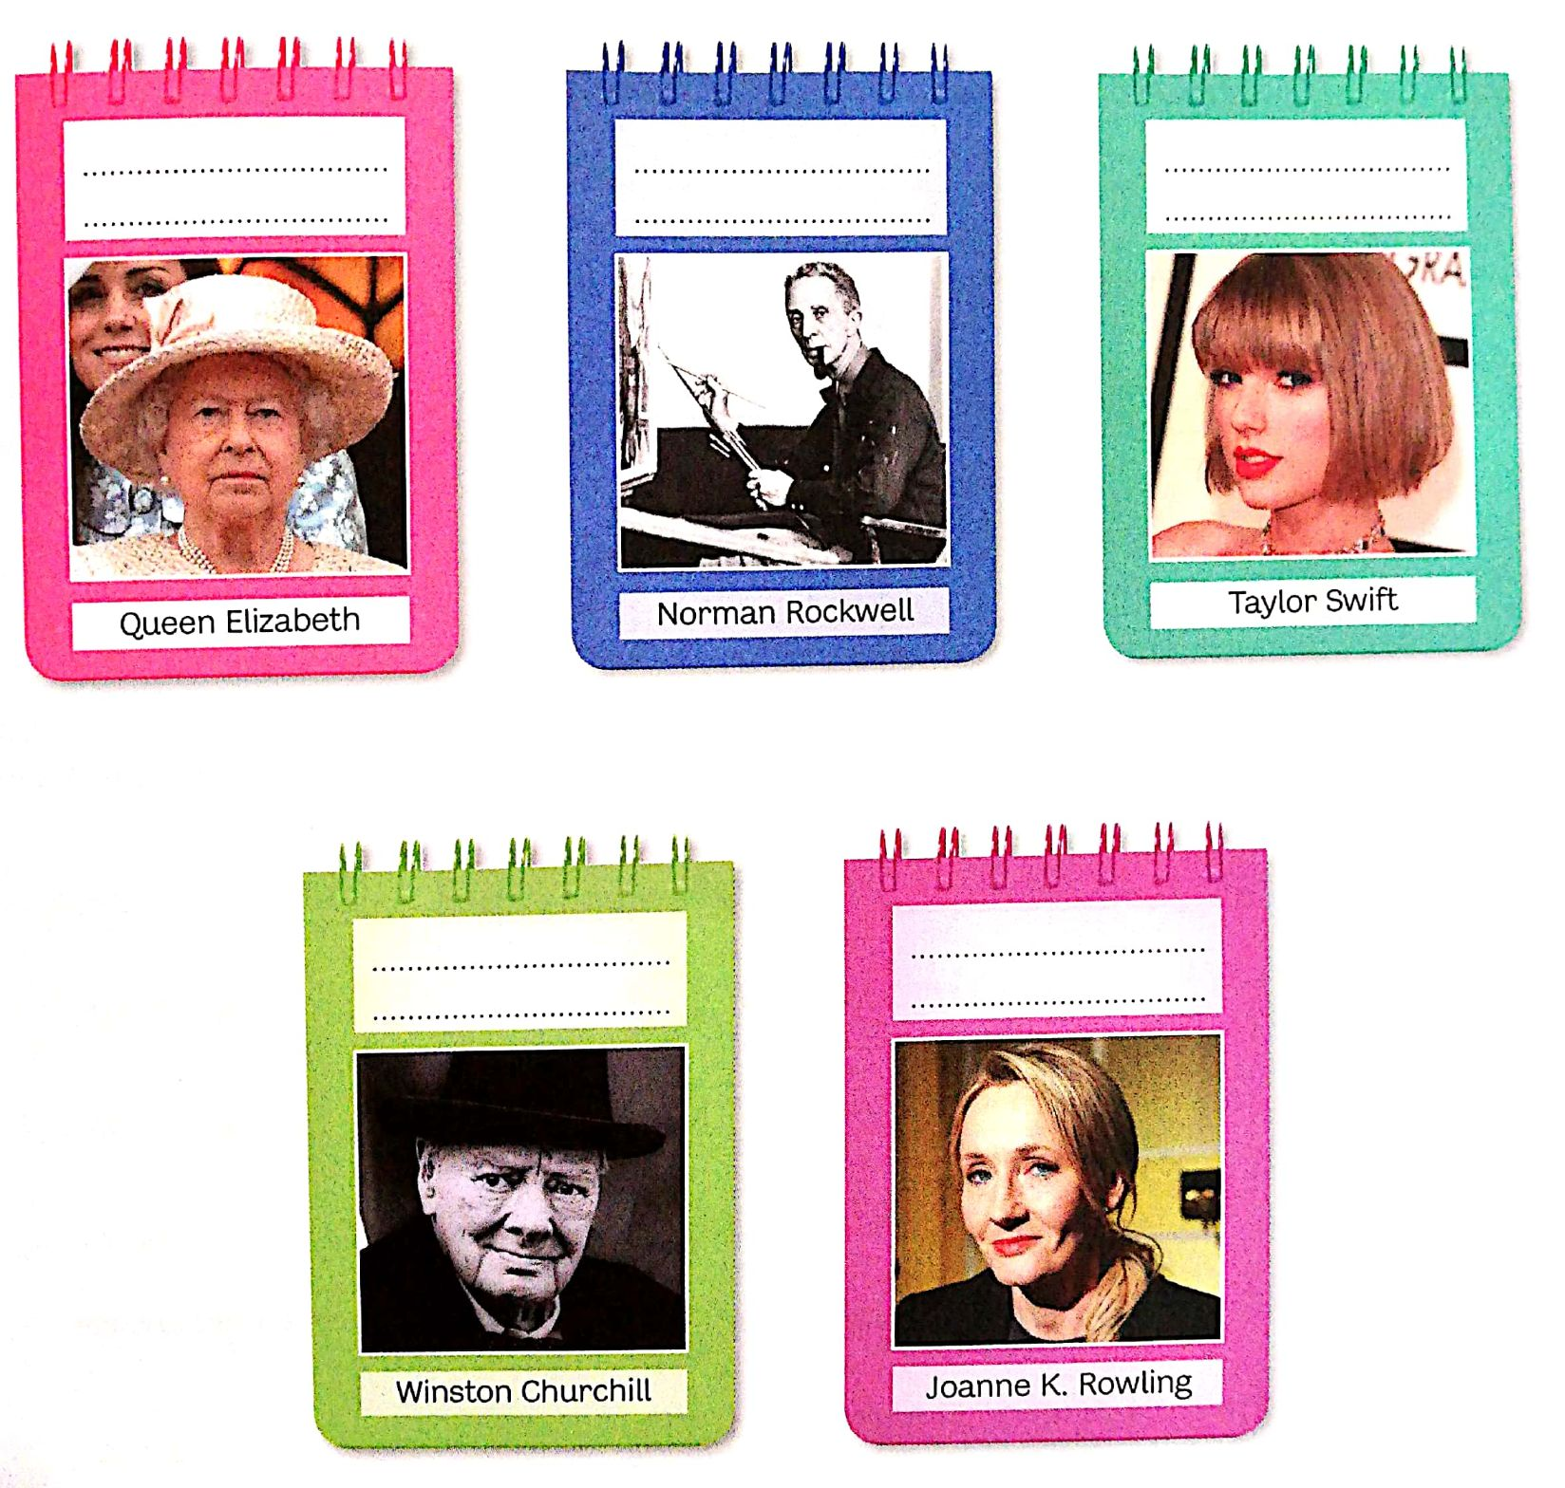
- Now, listen to other famous people and write down their birthdays.

- Ordinal numbers
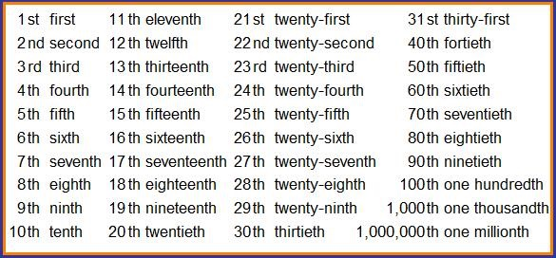

- Days and months
Months of the year
Days of the week

Monday |  | January | July
Tuesday |  | February | August
Wednesday |  | March | September
Thursday |  | April | October
Friday |  | May | November
Saturday |  | June | December
Sunday

Write the correct day.
Top of Form
- What day is before Saturday? ______________
- What day is after Wednesday?______________
- What day is after Sunday? ________________
- What day is before Tuesday? ________________
- What day is two days after Thursday?__________
- What day is before Monday? _______________
- What day is after Monday? _________________

- Write the correct month.
- What is the first month? ____________
- What is the seventh month? ___________
- What is the twelfth month? ___________
- What is the tenth month? _____________
- What is the third month? _____________
- What is the sixth month? _____________
- What is the eleventh month? __________
- What is the second month? ___________
- What is the fifth month? _____________
- What is the eighth month? ____________

- Write the dates

- Speaking activity
Take a new identity and fill the table in.

My classmate’s name | New name | Date of birth

U.1.6 : Identity

- Listen to Serhlock Holmes’s questions. (I bet you can audio 3)

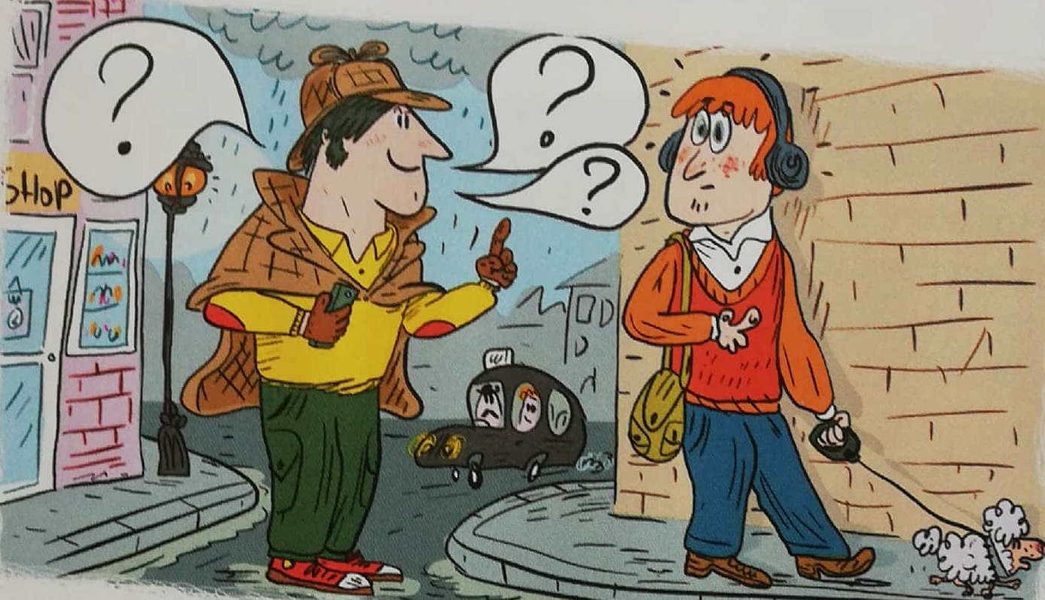

- Now, match the questions with the pictures below.

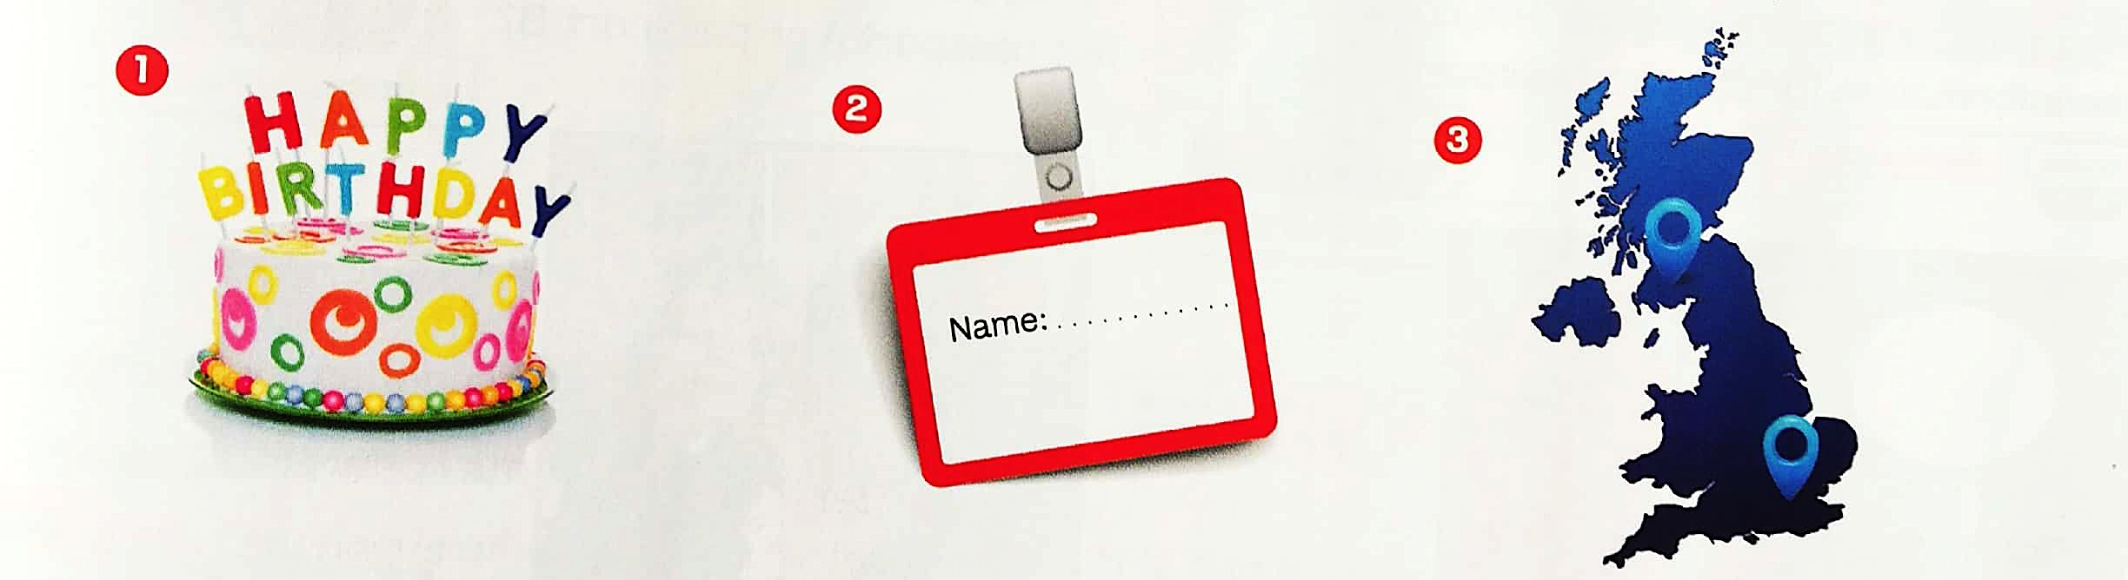

- Read the dialogue.

Hello ! My name is Peter and my surname is Johnson.
I’m English. I live in London. I’m twelve years old.
Goodbye !

- Complete the text with your personal informations.

……………………………. ! My name is …………………………… and my surname is …………………………… .
I …………… Belgian. I …………………………… in …………………………… . I’m …………………………… years …………………………… .
G…………………………… !

- Find the questions
  - your / what’s / name ? ……………………………………………………………………. ?
  - your / what’s / nationality / your ? ………………………………………………………. ?
  - do / live / where / you ? ……………………………………………………………………. ?
  - Old / you / how / are ? ……………………………………………………………………. ?
  - first / what / your/ ‘s / name ? ……………………………………………………………… ?
  - are / where / you / from ? ……………………………………………………………………. ?

- Play the detective

Fill in your ID card (passport A). Change 1 information (your name, your age or your city).
Play the detective, ask your friend questions and find the false information.
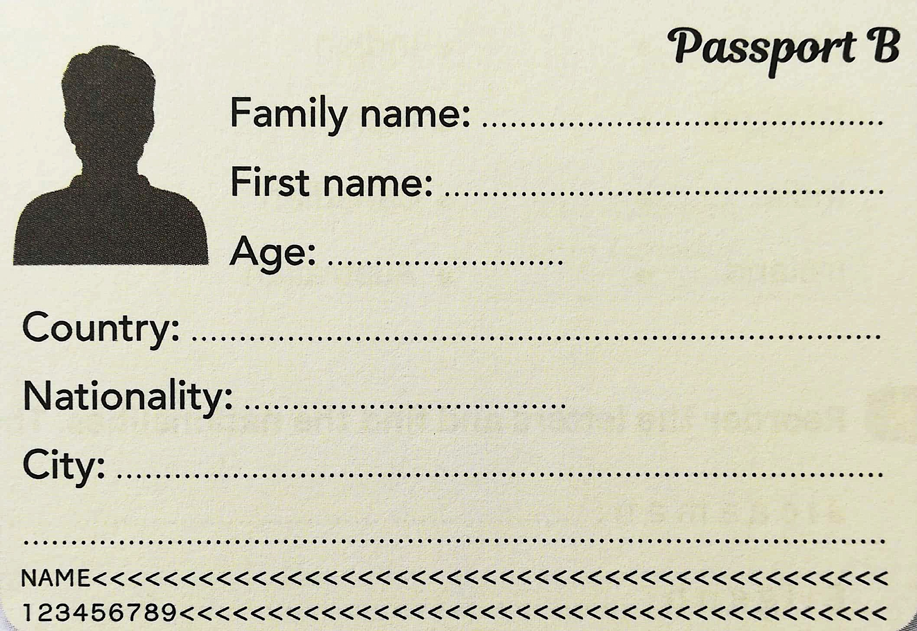
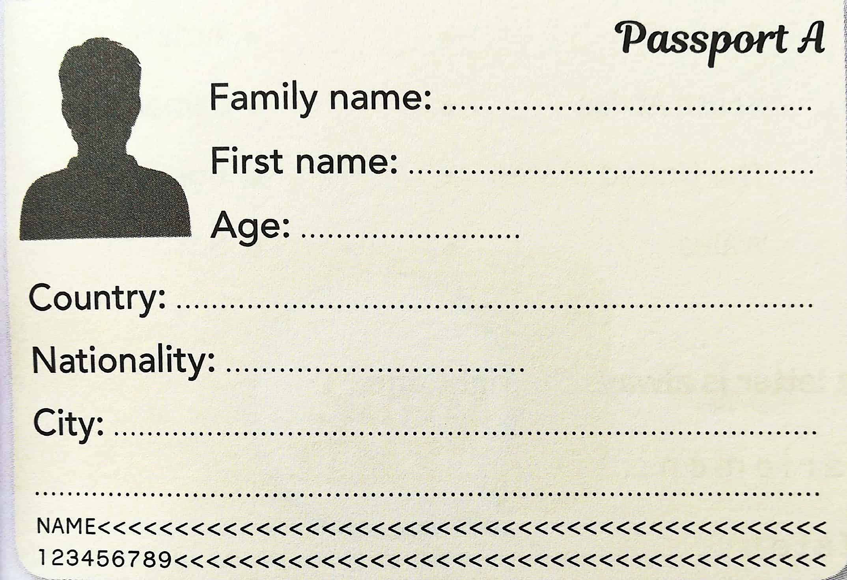

- find your twin game

pick a card. Look at your new identity, then go and ask questions in the class to find your twin.

Write here the twin pairs

- «Story time : « A new start »

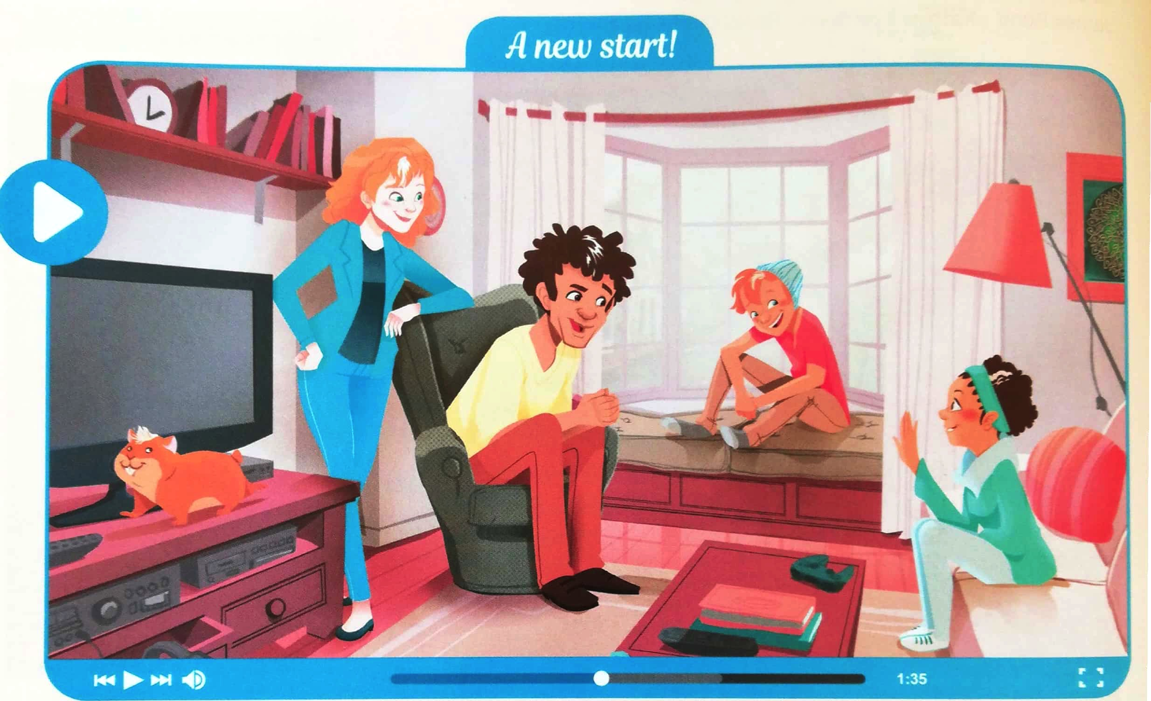

  - Get ready !

- Look at the picture and say what you can.

- Get ready to watch.

  - Pendant le visionnage, repère :
    - LES MOTS inconnus
    - L’EXPRESSION des visages
    - LE TON des voix

  - Watch the episode. (video 1)
- Tak notes about Olivier and Amelia Jones

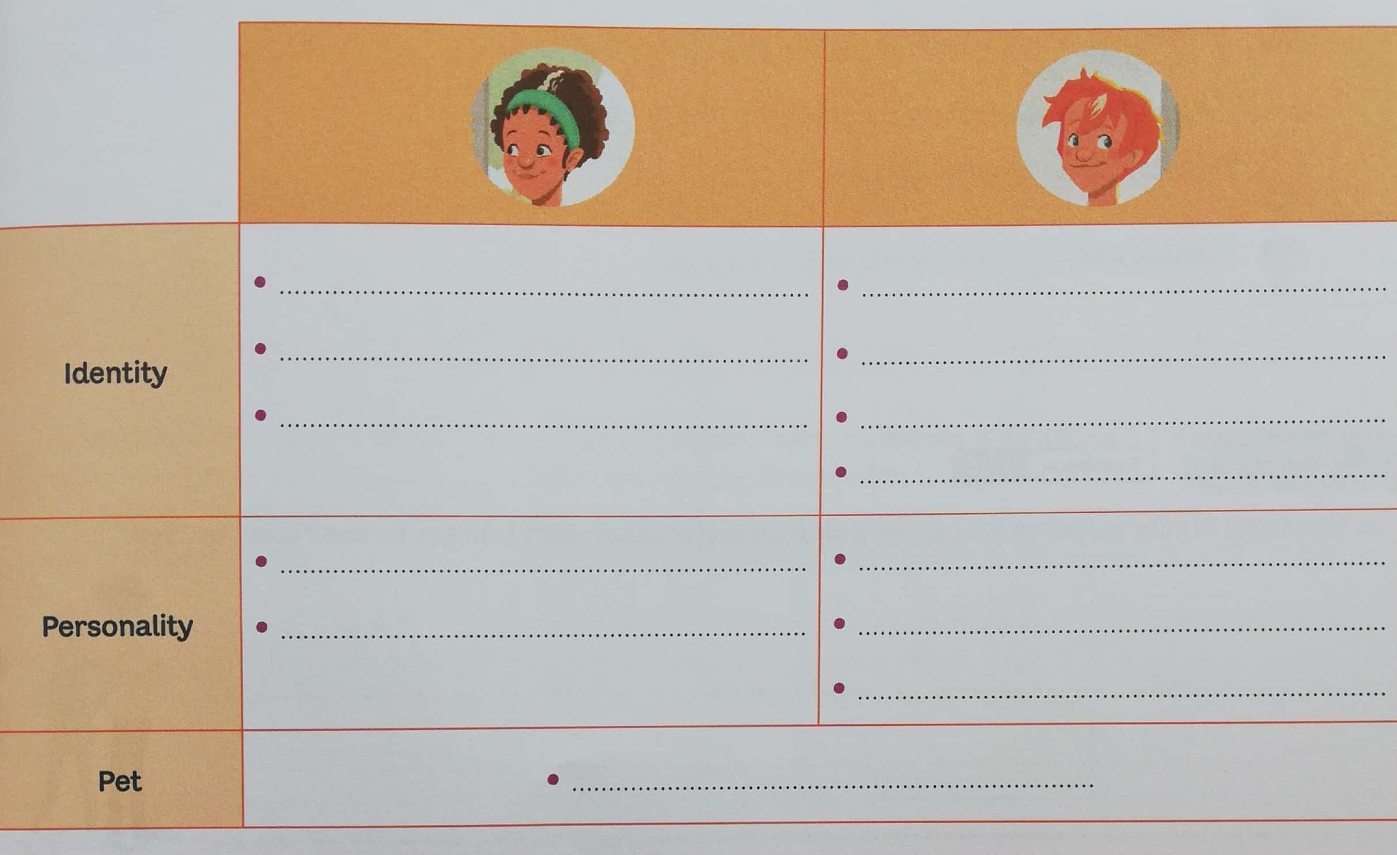
identity
personality
pet

  - Act out ! (I bet you can ; mp3 06)
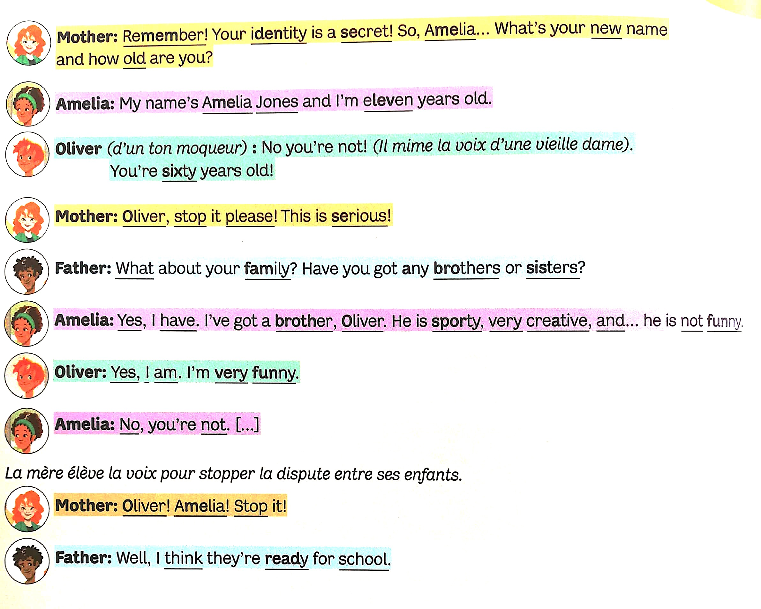

language lab grammar --> pour se présenter ou présenter quelqu’un
9. Listen and repeat the adjectives. (I bet you can audio 09)

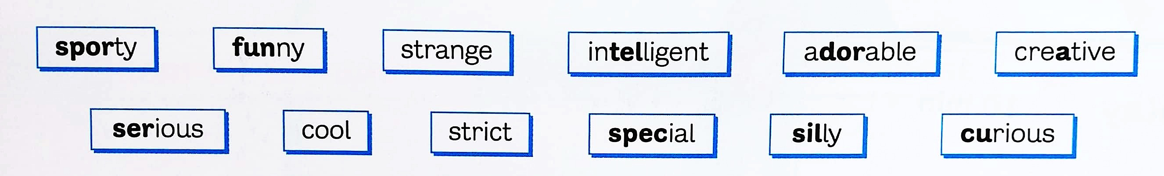

- Match the adjectives with the family photos.

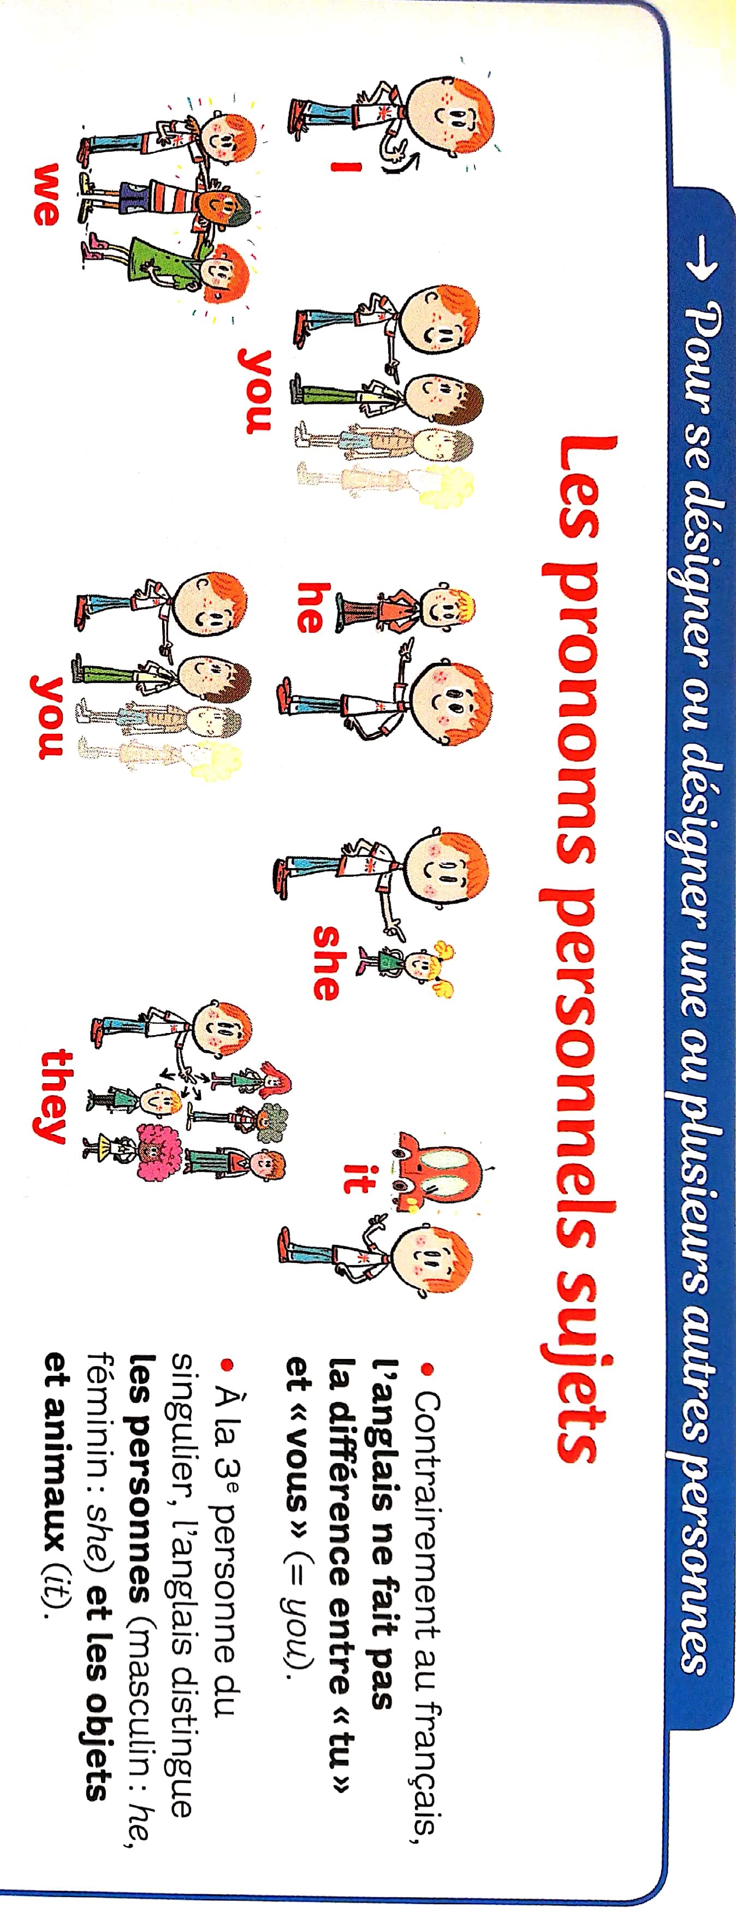
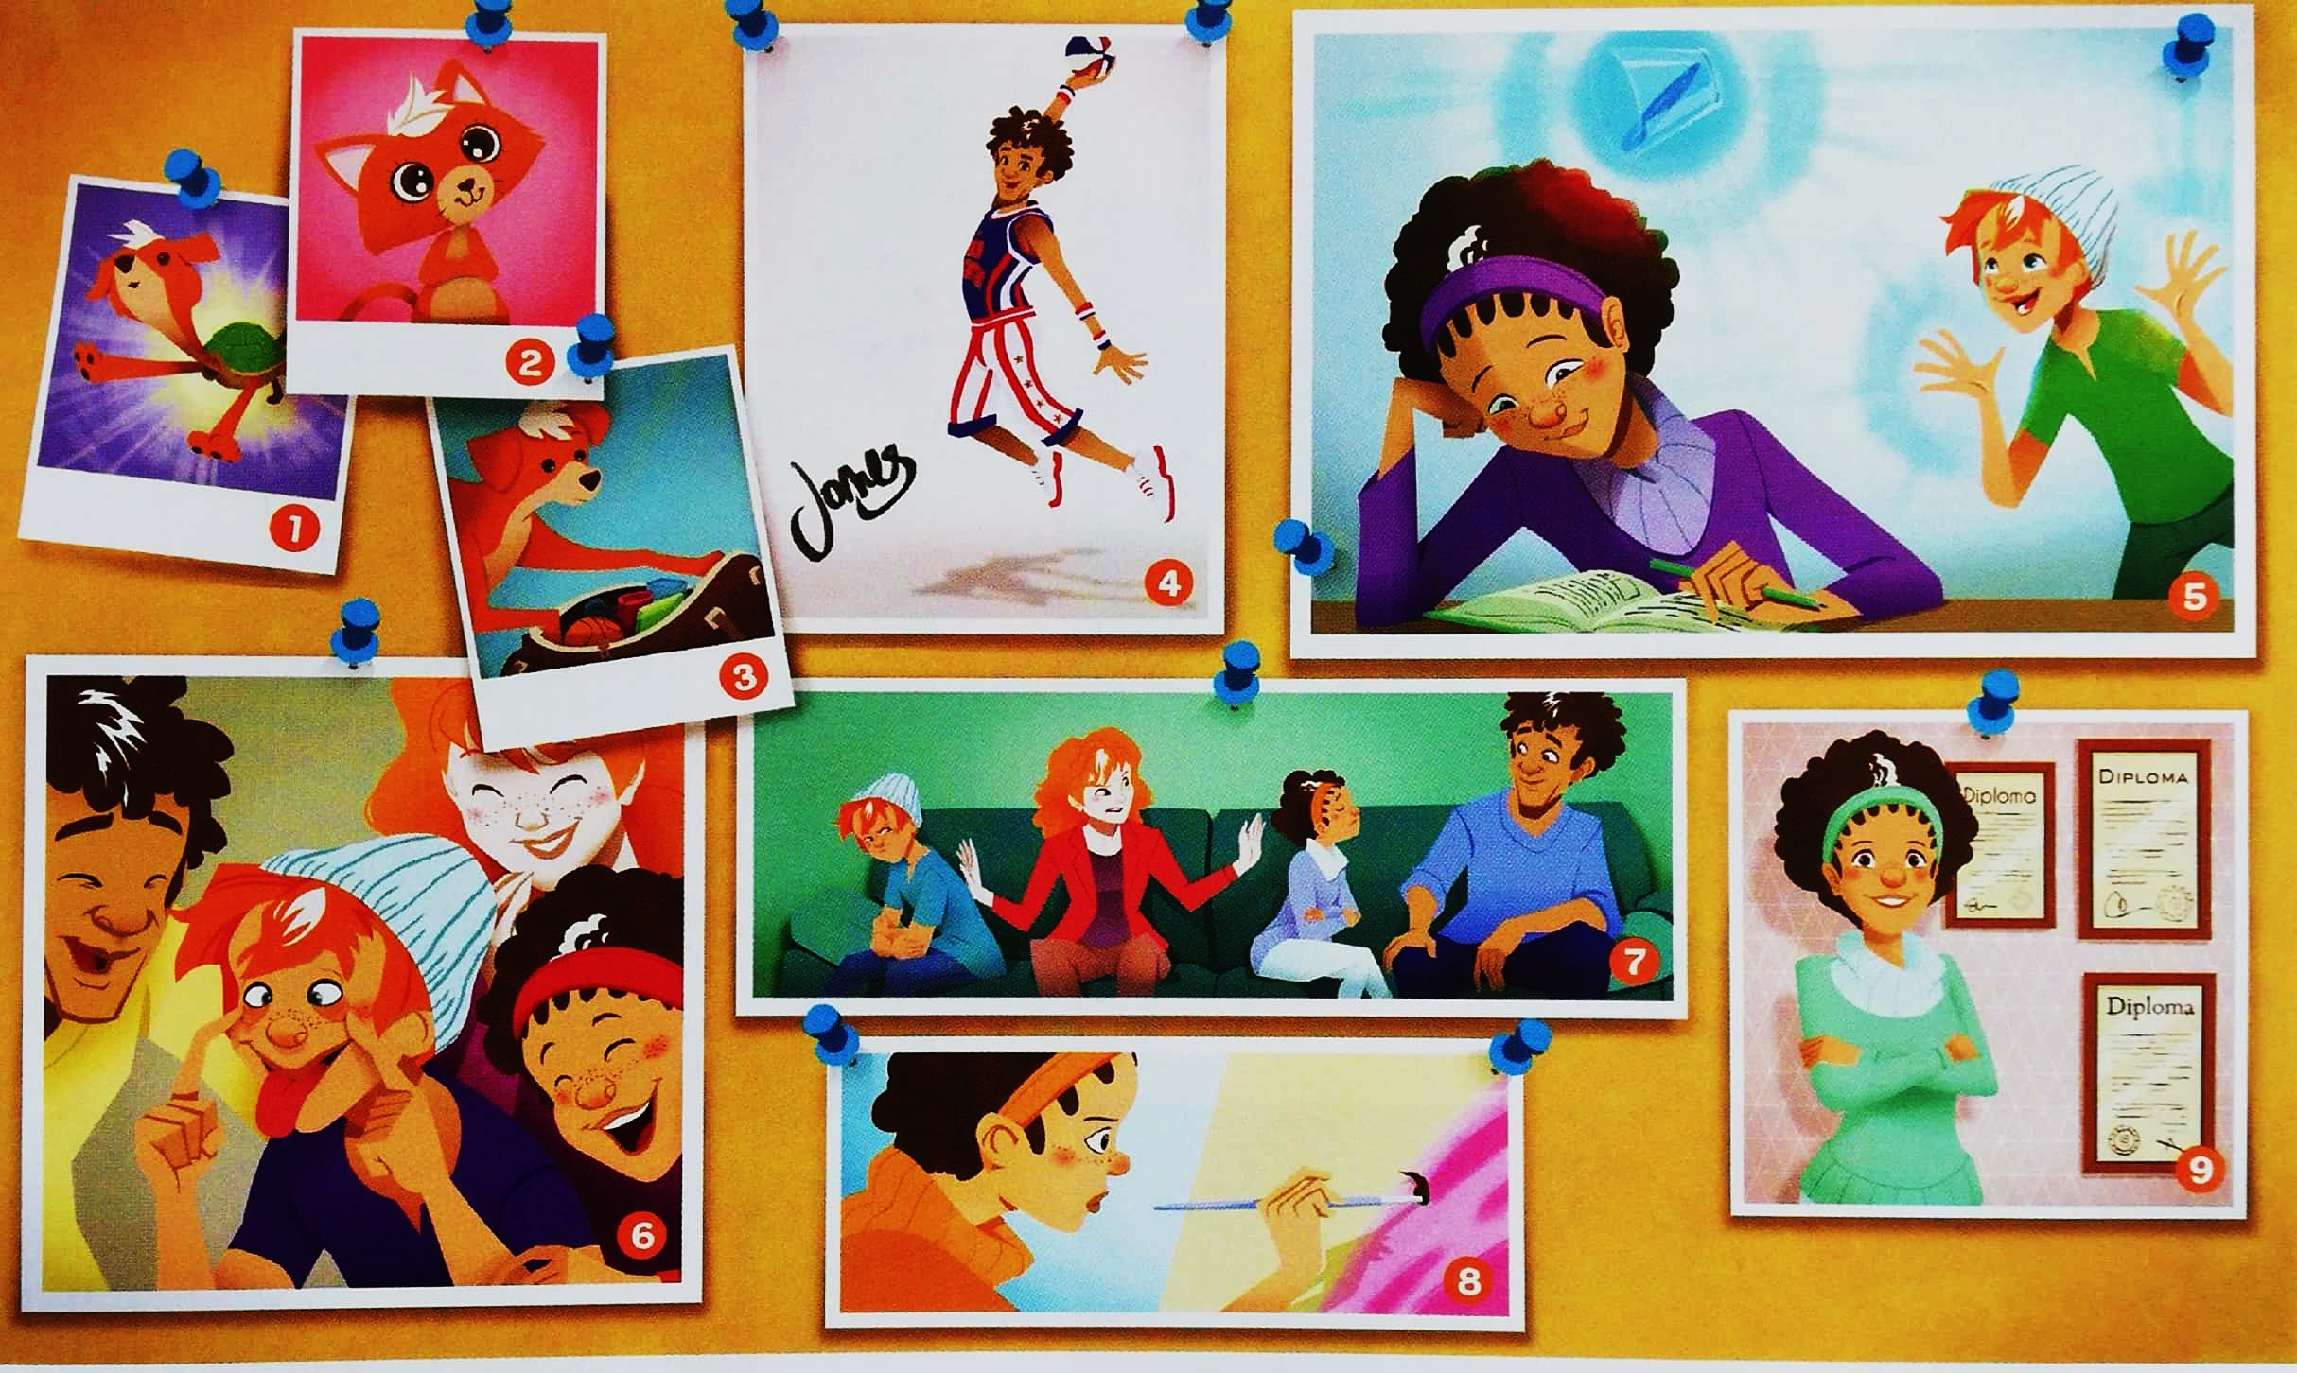

- Choose a family member and write a short presentation

Example : Olivier is funny but he is strict.

Attention : don’t use the names, use the pronouns.

Les mots que tu peux utiliser dans ta description :

- AND = et
- BUT = mais

- ....................................................................................................................................................................................................................................................

- Read the presentation to the class.

- Homework :

- Associe un adjectif de personnalité à ces personnes célèbres.

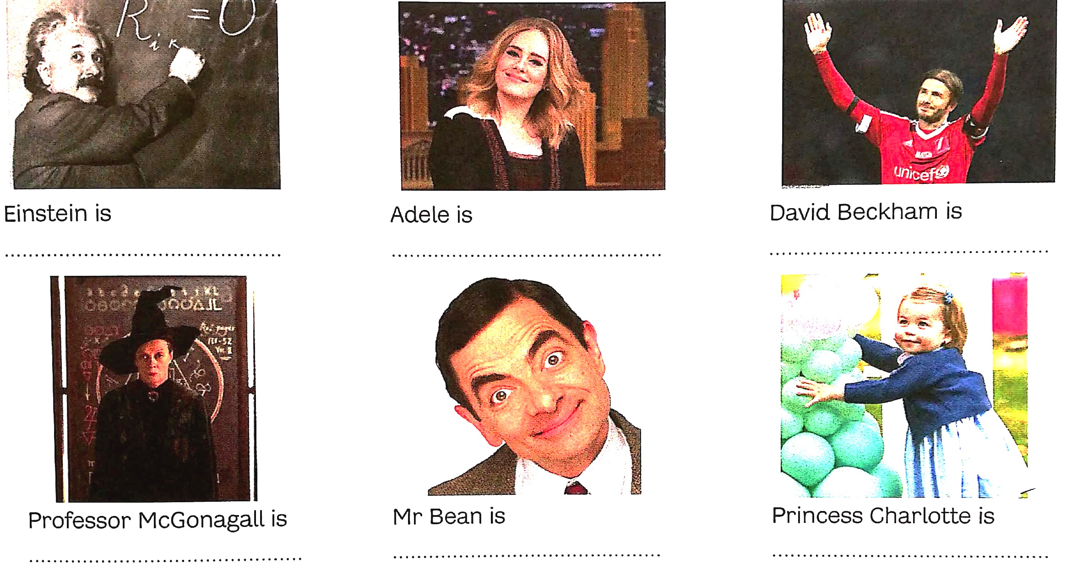

- Ecris 2 phrases sur ta personalité en utilisant les adjectifs vu précédemment. Dis ce que tu ES + ce que tu n’ES PAS .

- ..........................................................................................................................

- ..........................................................................................................................

- To be

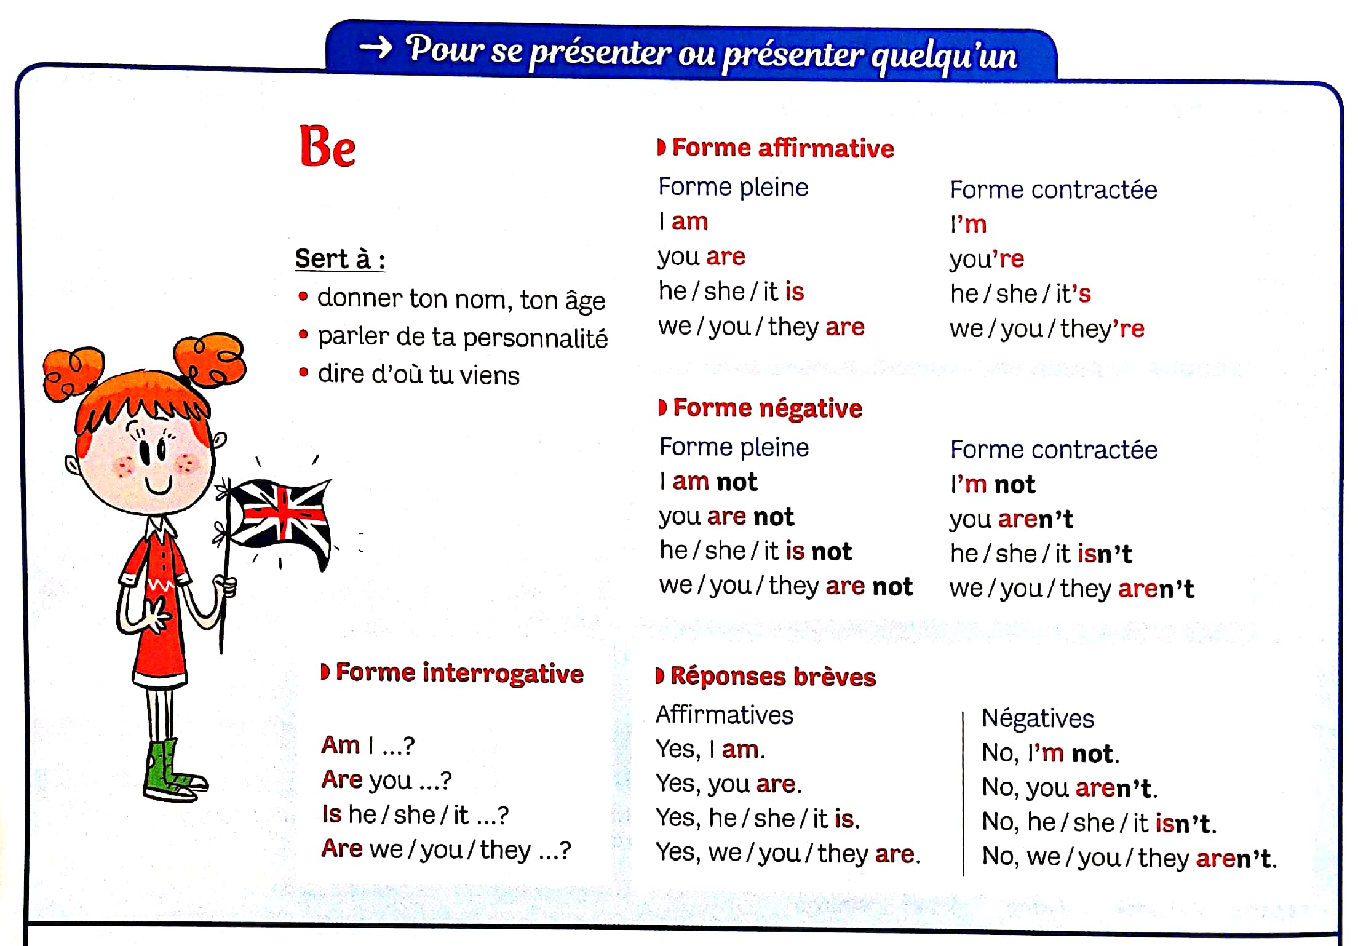

‘M NOT
IS
AREN’T
AM
ISN’T
ARE
4. Write the missing forms:

1. + Peter is young.
- ____________________________
? ____________________________
2. + ____________________________
- Our house isn’t old.
? ____________________________
3. + ____________________________
- ____________________________
? Are your classmates nice?
4. + ____________________________
- My grandfather’s car isn’t black.
? ____________________________
5. + These comics are boring.
- ____________________________
? ____________________________
6. + ____________________________
- ____________________________
? Is Jack in bed?

3. Ask questions with the verb to be and give short answers:
1. Jane/ ill? No
___________________________________
2. The students/ French? Yes
__________________________________
3. Your father/ a doctor? No
__________________________________
4. You/ with Charles? Yes
___________________________________
5. It/hot? Yes
___________________________________
6. Pam and Sue/ in class? No
___________________________________
7. The boys/ tired? Yes
___________________________________
8. Your mother/ at home? No
___________________________________
9. The books/ on the chair? No
___________________________________

2. Fill in the gaps with the negative of the verb to be:

1. Carol ____________ in class today.
2. Some of my friends ___________ as good students as me.
3. My school _______________ very big.
4. Janet ______________ with her friends now.
5. The cat ___________ with the dog.
6. Bikes __________ very fast.
7. It ___________ Peter’s birthday tomorrow.
7. Dr James _____________ in hospital today.
8. The letters ____________ on the desk.
9. I _____________ Italian.
10. My parents ______________ happy with my school marks.
1. Fill in the gaps with the affirmative of the verb to be:

1. My mother __________ a teacher.
2. Sue and Paul __________ my best friends.
3. I __________ a very good student.
4. My teachers ___________ are really nice.
5. The dog ___________ in the garden.
6. We ___________ in class now.
7. This book _________ new.
8. The children ________ in the playground.
9. The baby _________ with mum.
10. These apples __________ very sweet.
11. Pam and I __________ in the living room.

First name: ............................................
SURNAME: ............................................
Class: 1D .......

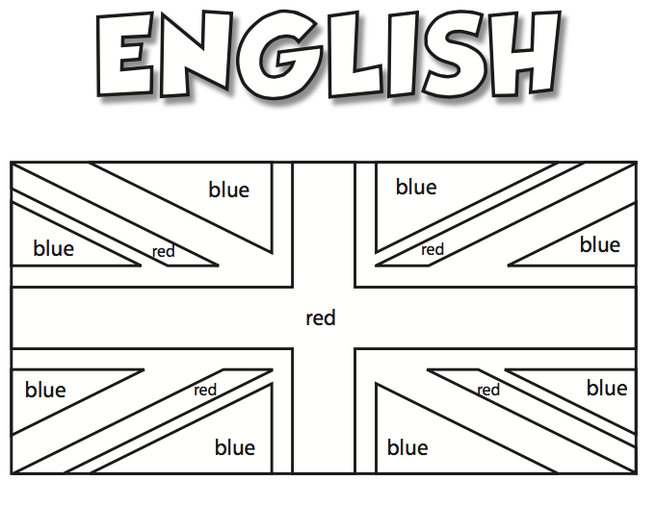

School year: .................../...................
Teacher: MRS V. DETHIER
Name : Surname : Origins : Age :

Favourite food :

Favourite
movie :

Favourite song/
Group/singer.. :

Friends :

Unit 1 : WELCOME



Je sais :

- dire bonjour
- compter jusque 100
- épeler un mot/ un prénom/...
- comprendre une consigne en classe
- comprendre l’identité de quelqu’un
- me présenter / présenter une personne
- interroger quelqu’un sur son identité
- écrire une date
Name :
Class : Date :
U.1.1 : The alphabet : test n°1.

- Listen and complete the names. (Your space workbook cd piste3)

1) C ____ A _____ L _____ _____
2) O _____ _____ V _____ _____
3) P _____ P P _____
4) D _____ N _____ _____ L
5) E M _____ L _____
6) _____ O _____ _____
U.1.1 : The alphabet : test n°1.

Name :
Class : Date :
U.1.1 : The alphabet : test n°1.

U.1.1 : The alphabet : test n°1.

U.1.1 : The alphabet : test n°1.

- Listen and complete the names. (Your space workbook cd piste3)

1) C ____ A _____ L _____ _____
2) O _____ _____ V _____ _____
3) P _____ P P _____
4) D _____ N _____ _____ L
5) E M _____ L _____
6) _____ O _____ _____
Name :
Class : Date :

U.1.3 : The numbers from 0 to 20 : test n°3 (code + CA)

Code : /10
CA : /25

Listening comprehension

- Circle the numbers you hear. /5

11 | 18 | 20 | 7 | 1
4 | 19 | 8 | 12 | 10
2 | 16 | 5 | 3 | 14
15 | 13 | 17 | 0 | 6

- Listen to these people. Write down their phone numbers. /20

HELEN
MARK
TESSA
JUDE

Vocabulary

- Match the sums with the right answer.

NINETEEN+ONE= | 11 | 4 | TWENTY-EIGHT=
19 | 2 | 12 | 16
20 | ELEVEN+SIX= |  | 17
SEVENTEEN-THREE= | 10 | 14 | EIGHT+THREE=  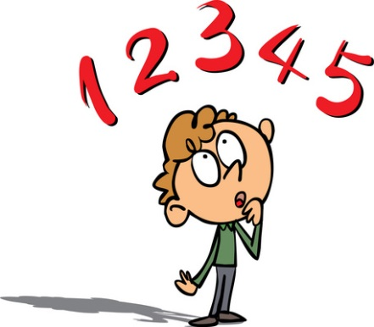

Name : /20
Class : Date :

U.1.4 : Numbers from 0 to 100 : test n° 4 (code)

Name :
Name :
Class : Date :

U.1.5 : Days and dates : test n°5 (code)

1. Complete with the correct Month:
1. ………………………………….. February ………………………………….
2. ………………………………….. October ………………………………….
3. …………………………………… July …………………………………

2. Choose the correct option:
1. ………..anuary: a.H b.J c.Y
2. Mar…………….: a. ck b. sh c. ch
3. Jun……………..: a. e b. y c. i
4. Aug………….st: a. oh b. o c. u
5. Nove……….er: a. nb b. mb c. mv

3. Choose the correct letter:
1. Thu…………day: a. re b. sh c. drs
2. We………….day: a. knes b. dess c. dness
3. Fr…………….day: a. i b. y c. ih
4. Mo………….day: a. nd b. nh c. n
5. Sat…………..day: a. ter b. tur c. thur
4. Complete with the days of the week:
T
U
E
S
D
A
Y

What’s your favourite day of the week?
..................................................................................
W hat’s your favourite month of the year?
...............................................................................

5. Listen and writhe the dates.

1
2
3
4
5

6. Write the dates.

Name :
Class : Date :

U.1.6 : A new start (story time) : test n°6 (EO)

/25

Act out the scene.

grille éval

Name :
Class : Date :

U.1.6 : Personality : test n°7 (code)

A)
/10

Curieux
Fou
Sérieux
Drôle
Sportif
Adorable
Etrange
Créatif
Intelligent
Curieux

Name :
Class : Date :

U.1.6: A new start (story time) : test n°7 (code)

B)
/10

Stricte
Etrange
Créatif
Sérieux
Fou
Drôle
Curieux
Sportif
Adorable
Spécial

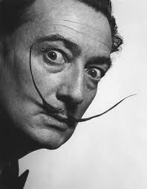  SALVADOR DALÍ  May 11, 1904 – January 23, 1989 | 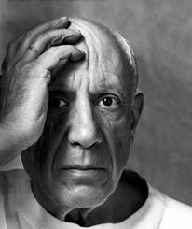  PABLO PICASSO  October 25, 1881 – April 8, 1973
  QUEEN ELIZABETH II  April 21, 1926 – | 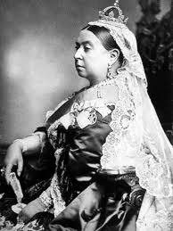  QUEEN VICTORIA  May 24, 1819 – January 22, 1901
  MADONNA  August 16, 1958 – |   JOHN LENNON  October 9, 1940 – December 8, 1980
  SHAKIRA  February 2, 1977 – |   BARACK OBAMA  August 4, 1961 –
  JOHN F. KENNEDY  May 29, 1917 – November 22, 1963 |   ELVIS PRESLEY  January 8, 1935 – August 16, 1977
  MARILYN MONROE  June 1, 1926 – August 5, 1962 | 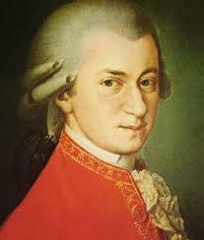  MOZART  January 27, 1756 – December 5, 1791

  BEETHOVEN  December 17, 1770 – March 26, 1827 |   PATRICK SWAYZE  August 18, 1952 – September 14, 2009
  MICHAEL JACKSON  August 29, 1958 – June 25, 2009 |   STEVE JOBS  February 24, 1955 – October 5, 2011
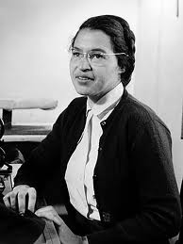  ROSA PARKS  February 4, 1913 – October 24, 2005 |   WHITNEY HOUSTON  October 9, 1940 – February 11, 2012

