NAME: _____________________________ DOSSIER DE SYNTHESE: Functional Holidays

Qualité du contenu | Cohérence de la construction du discours | Correction de la langue écrite | Richesse de la langue

Prenez connaissance des documents A, B et C et traitez le sujet suivant en anglais : Write a commentary on the three documents (about 500 words): taking into account their specificities, analyse how the three documents deal with idea of holidays
Doc A- We Live in a Tree for One Month Every Year

We are fragile, but immortal, somewhere between mayflies and unicorns. Eleven months of the years we sleep wrapped in tissue paper in big red boxes, until we are lifted and carried down, and carefully uncovered. By that time the tree is ready, covered in lights and red glass balls and golden ribbons. The tree used to be a stranger every year, a strange-smelling, god-like thing, sticky with sap, who knew things we didn’t know, but now the tree is more like us. It stays in a red dark bag in the basement most of the time.
Light comes down through the box lid. It stays on till we hear the only songs we know, and then the girl lifts them off. She has been tall enough now for so many Christmases, and she knows all of us that are worth knowing. She makes sure that we stay by our loved ones, and our friends. She makes sure that we do our jobs.
The beautiful glass king stag must hang a little hidden from view, with a green or blue light to illuminate him. Only then can his magic and beneficence filter through the house. All of the other precious ornaments must be seen, even if they are new. The old and unlovely are hidden below the window and behind the tree, but never do they stay in the box.
The new and unlovely go high, facing the window, but away from the family. They shout back to us about passerbys and dogs, which we have not seen for some time.
Angels and moons and suns and stars must go near the top. Birds must nestle in lower branches, except for the doves, which must wait on Galatea. Galatea is the angel that holds the reins of the world. She is lashed to the highest point of the tree and she watches over all of us (the reins of the world are the golden ribbons.)
The green satin rocking horse mourned and would not stop mourning the death of the blue satin rocking horse (chewed up by a dog) and while he hung sad and lonely low for ever so many years he is gone now, and no one knows how he went. After we have heard our songs two or three times through, the box is carried away, and life begins. We talk and visit, and love each other. We watch the people of the house, and the people of the street, and we cast our various magics on them. We used to talk to the new tree. We love to hear about snow, and traveling fast above streets, and about other trees, and about the moment when the old man put his hand on the tree, and shook it, and chose it for our own, and would take it home and string the lights so that the girl could go to work. And oh the strangeness of being strung with lights! The feeling of being all lit up and beribboned and becoming a world ruled by an angel!
The conversation is different now. This tree has never seen the old man, and says it has been strung with lights for as long as it can remember, so it is like talking with another old friend, an old friend we met just last year. Galatea would tug on her golden ribbons, her face growing sad, and when the old woman would take us off the tree and wrap us in fresh paper, we would cling to the branches for and whisper “goodbye—goodbye!” We do not know what changed. We do not know where the dogs went, or the blue satin rocking horse, or the old man, but this year as we go into the paper we will say just Au revoir! Auf Wiedersehen! We will think of the songs in our sleep, dear tree, until we meet again!

Reina Hardy, We Live in a Tree for One Month Every Year

DOCUMENT B- LIZ JONES’S DIARY: In which I realise why I hate holidays
I was approached by a newspaper the other day to write a piece outlining ‘The holiday that changed me’. I suppose they’ve come up with this sort of thing to fill the now empty travel pages. I sent them three ideas.
1. I went to stay at GoldenEye, Ian Fleming’s house in Jamaica, with my then boyfriend. We had a personal chef, private beach, hummingbirds and pool, but all he wanted to do was watch Euro 2000 with the blinds down. This holiday changed me, in that I realised it’s more fun to go away on your own, as a man will only get on your nerves and leave coins on side tables. (After I was sacked from Marie Claire, I took him to Florence for a long weekend, staying in the Villa San Michele, which is a former monastery. I spent most of my redundancy money, only to find we were put in a modern annexe. So this trip changed my attitude to booking: always specify the room, and if they refuse, don’t go.

2. I went to Udaipur with my then husband on a yoga course. I discovered I loathed yoga and developed ‘room envy’ when I found other journalists on the (freebie) holiday had a better suite than me. I always find men like to belittle me when we are in groups of people, viz, sitting by the pool having lunch at a long table, my husband told everyone that a mongoose had emerged from a pipe and swum in the pool. To which I replied, ‘How did its antlers fit in a drainpipe?’ Only for him to reply, ‘That’s a moose. We’re not in Canada. Tch.’ On holidays in developing countries, I’m always cast as the colonialist, given I went to a girls’ grammar and once played netball.
3. An old friend called Alex has just tweeted me. We worked on Company magazine in the 1980s. She reminded me that we went on holiday to Portugal in 1983 with another friend and my sister. I spent the entire week in a state of feverish longing for David, who was then living next door, aged 31 and handsome. I performed sit-ups by my bed every day and sunbathed topless on the roof to hone myself for my return, when he would, of course, discover he had missed me. My sister insisted we buy dozens of terracotta pots, but when we got back to Gatwick, they were all smashed. As were my hopes of getting David, who had in the interim got engaged to an air hostess.

I put a lot of work in to my response, as you can see, only to receive an email saying, ‘The editor thinks that’s all a bit negative, so we’re going to pass.’
I don’t care if I never go on holiday again. I can’t think of a single vacation I’ve enjoyed. Honeymoon in Seville: disaster. My husband turned out to be too recently qualified to drive a hire car, so I had to negotiate a mountain on the wrong side of the road. I kept screaming, ‘I’m not Jeremy Clarkson!’ During a week in New York, in bed one evening my husband attempted to perform oral sex. I sat up, aghast. ‘When you left early for yoga this morning, you went and had sex with Daphne! You’re doing this because you’ve already had sex today and you can’t do it again and because we’re on a mini break you feel obliged!’
So I don’t know why the newspaper turned my bad trips down, as that is the reality of being holed up with a man in an environment that requires you to communicate, not just leave each other Post-its on the fridge.
Holidays, you see, are like men. You dream about them, you look forward to them, then you find out they’re not a penthouse suite at all but an annexe with a view of the bins.

LIZ JONES’S You Magazine -JUNE 7, 2020

DOCUMENT C : Traveling
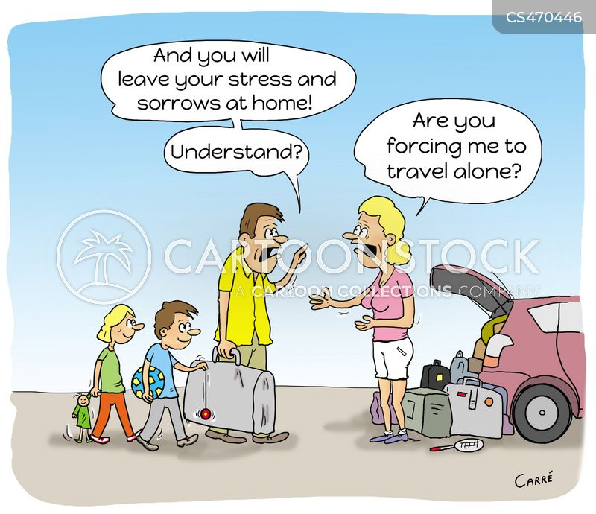

Unit 1 – DST : Holy Holidays - EURO

 | Identification du contexte ou de la situation d’énonciation | Pt score | Identification des réseaux de sens | Pt score | Identification des stratégies de communication | Pt score
C1 | J’ai identifié les détails fins ou l’implicite tout en les replaçant dans le contexte :  humour autour d’une situation récurente de stress autour des vacances alors que le but est l’inverse | 30 | J’ai identifié et analysé la logique interne du document ou dossier en distinguant le cas échéant ce qui est de l’ordre de la digression :  3 documents qui ont le même message | 30 | J’ai identifié l’articulation entre les documents, la tonalité des propos :  besoin d’appartenance  critique d’un passage obligé / cycle qui revient | 30
 | B2 + | 25 | B2 + | 25 | B2 + | 25
B2 | J’ai identifié la richesse du contexte ou de la situation d’énonciation (implicite) :  lien fait avec la notion : obligation de vacances, reconnaissance d’un certains cadre, représentation commune | 20 | J’ai identifié la cohérence globale du document ou du dossier :  vision à la fois positive et négative, image commune, construite  sorte de passage obligé  rituel qui revient continuellement | 20 | J’ai repéré l’intention en distinguant l’expression du point de vue de l’exposé de faits, et les éléments implicites de l’articulation entre les documents :  vision humoristique des différentes vacances  critique implicite de la société | 20
 | B1 + | 15 | B1 + | 15 | B1 + | 15
B1 | j’ai relevé des informations détaillées sur le contexte et établir des liens entre elles :  description de différentes situation liée aux vacances  auteurs internes dans les textes : les décorations / la journaliste  dessin à visé humoristique | 10 | j’ai relevé l’essentiel des éléments poteurs du sens :  vacances comme fait sociétal : noël, besoin de temps pour soi, pour son couple, pour sa famille  notion d’obligation | 10 | J’ai identifié l’expression de points de vue, souhaits, perspective.  J’ai identifié la nature de l’articulation entre les documents :  doc 1 = un conte, doc 2 = un article de journal  doc 3 = une caricature | 10
 | B1- | 7 | B1- | 7 | B1- | 7
A2 | j’ai relevé des informations explicites sur le/ les document(s) | 5 | j’ai compris globalement le/ les document(s) | 5 | J’ai identifié la nature du / des documents et j’ai pu les mettre en lien avec quelques éléments du contenu. | 5
 | A2 - | 4 | A2 - | 4 | A2 - | 4
A1 | j’ai relevé des informations isolées, simples et les ai articulées les unes aux autres. | 3 | J’ai construit une amorce de compréhension en relevant des mots ou des expressions. | 3 | J’ai relevé quelques données caractéristiques évidentes du / des documents. | 3
pré-A1 | j’ai relevé quelques données. | 1 | J’ai relevé des mots transparents et / ou familiers. | 1 | J’ai relevé quelques informations isolées, simples.. | 1

