Name: ______________________________________ SYNTHESE 4- BIG PHARMA

Qualité du contenu | Cohérence construction discours | Correction langue écrite | Richesse de la langue

DOCUMENT A - The Opioid Crisis in America: Too much, too little, too late
Prescription opioids have been a major contributor to addiction and overdose deaths. While in the not-too- distant past, physicians were trained to treat pain aggressively, and even to consider pain to be a fifth vital sign that must be immediately addressed, strong caution is now advised when prescribing opioids. Comprehensive mitigation strategies have been enacted, including a requirement to check databases of prior opioid prescriptions before dispensing new pain medications.
Despite the abundance of opioids in our communities, particularly when compared with other countries, there are patients who legitimately need treatment of their pain and are in danger of not receiving it. Pain should be treated as early as possible to halt its escalation. This is especially true in emergency settings, including treatment by paramedics in the prehospital environment.
Today we are experiencing a national shortage of critical life-saving medications and drugs needed immediately to mitigate suffering.2 This “too little” gap has been exacerbated by the recent hurricane event in Puerto Rico – a very important source of medical drug and device manufacturing, which has markedly diminished on account of destruction wrought by the storm, and the glacial pace of recovery and restoration. Should there be a national effort to restore pharma production in the U.S. territory of Puerto Rico? Or an effort to rebuild elsewhere? Or should we expand our efforts to purchase medications from other countries?
This emergency drug shortage crisis – including opioids – has led to challenges in reliable and consistent access to important medications in our nation’s emergency departments and hospitals as well as the prehospital setting. If not addressed more consistently nationwide, could this escalate to the point where we regularly lack the resources to treat pain and other time-sensitive conditions in an emergency situation?
Kristi L Koenig , pmc, PubMedCentral, 2024

DOCUMENT B- Here's how the Trump administration stands to shape Big Pharma prices, transparency
Amid growing concerns over high drug prices in the United States, the federal government has proposed reforms to address the cost of prescription medications. With American consumers paying significantly more compared to other developed nations, policymakers are considering measures aimed at reducing costs, improving transparency, and examining the role of middlemen in the drug pricing system.
One major initiative is targeting pharmacy benefit managers (PBMs), who act as intermediaries between drug manufacturers and consumers. A key proposal under consideration is eliminating the “safe harbor” provision for PBMs, which would require that any rebates or discounts go directly to patients, rather than allowing PBMs to retain them.
Another proposal would increase transparency around PBM pricing and rebate structures, making it easier for the public to understand the costs and markups associated with prescription drugs. Medicare is also a tool that has helped American elderly patients immensely by negotiating drug prices with manufacturers, ultimately bringing savings for pharmaceutical drugs.
Drug manufacturers are also keeping a close watch on developments within the pharmaceutical industry. Some companies are keeping an eye out for the influence of political figures like Robert F. Kennedy Jr., who pushes against vaccinations. In 2024, only 15 companies in the pharmaceutical industry generated $45.1 billion of revenue from vaccines, which is 6.7% of total revenue; as of 2024, experts saw a rapid decline in overall vaccination rates and predict that this will continue to decrease.
Beyond drug pricing, the pharmaceutical industry is also focused on research and development (R&D). Industry leaders are hopeful that the Trump administration will offer corporate tax relief, which would provide companies with more capital to invest in developing new treatments. American drug manufacturers are also closely monitoring potential changes in tariffs, particularly on imported drugs and active pharmaceutical ingredients (APIs), which could affect their cost structures.
Reagan Allen, March 20th, 2025

DOCUMENT C - Trump presidency to test public trust in Big Pharma
A second Trump presidency could be a boost for biomedical innovation, but it also risks eroding public trust in the pharmaceutical industry if science, trade and public health are sidelined.
Under the Biden administration, the US government started to negotiate down drug prices with industry for the first time. A second Trump presidency throws this and many other Biden-era healthcare policies up in the air.
“We still have to see what Trump’s polices actually are,” David Reddy, who heads the International Federation of Pharmaceutical Manufacturers and Associations (IFPMA), told SWI swissinfo.ch on the sidelines of the FT Global Pharma and Biotech Summit in London. “Regardless of political party though, everyone wants the same thing – good health and innovation.”
How Trump plans to move forward on many healthcare issues is still to be seen. It’s highly likely that lowering drug prices in a bid to reduce the financial burden on patients will be on his agenda. Vice President Kamala Harris was expected to expand Biden-era price negotiations beyond ten initial drugs, something the pharmaceutical industry argues would bite into their profits and thwart investments in innovation.
Trump hasn’t said whether he will continue in the same vein. In his first presidency, he also sought to bring down drug prices but made little headway on his proposal to use international drug price comparison to get a fair price in the US. (…) The US is the largest pharmaceutical market in the world, accounting for over 40% of global pharmaceutical sales at big companies.
But the pharmaceutical industry has other concerns with a Trump presidency. If the campaign rhetoric on science, safety and public health is any sign, Trump’s return to the White House could test public faith in the pharmaceutical industry that goes far beyond drug prices.

Jessica Davïs Pluss, swissinfo.ch, November 8, 2024
DOCUMENT D - Trump picks Robert F. Kennedy Jr. to be his Department of Health and Human Services secretary
President-elect Donald Trump has picked Robert F. Kennedy Jr. to be his next secretary of the Department of Health and Human Services. (…) Trump on Thursday announced the selection, confirming CNN’s earlier reporting, saying he was thrilled to share the pick.
“The Safety and Health of all Americans is the most important role of any Administration, and HHS will play a big role in helping ensure that everybody will be protected from harmful chemicals, pollutants, pesticides, pharmaceutical products, and food additives that have contributed to the overwhelming Health Crisis in this Country,” Trump said in a post on X. “Mr. Kennedy will restore these Agencies to the traditions of Gold Standard Scientific Research, and beacons of Transparency, to end the Chronic Disease epidemic, and to Make America Great and Healthy Again!”
Kennedy, who accepted the offer Thursday, has been one of the nation’s most prominent anti-vaccine conspiracy theorists for years and has frequently spread false conspiracy theories about the safety and efficacy of vaccines. He has been in Palm Beach, Florida, for several days following the election.
In a statement Thursday, Kennedy emphasized the importance of ridding the department of “corruption” and vowed to “provide Americans with transparency” so they can make individual health decisions.

Kaitlan Collins, Kristen Holmes and Aaron Pellish, CNN, Thu November 14, 2024

DOCUMENT E – Robert F Kennedy, Covid anti-vax demonstration, 2021
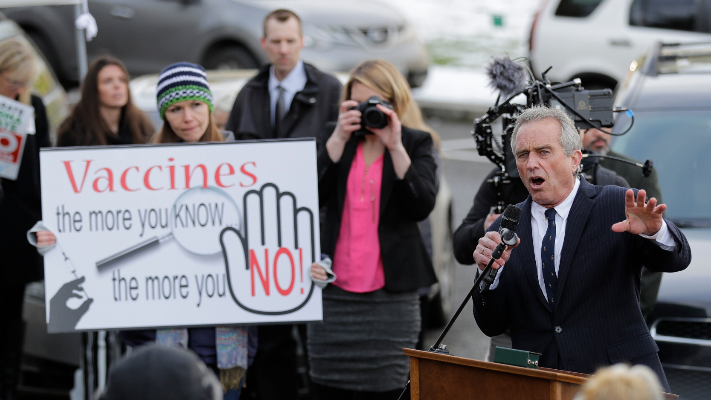

DOCUMENT F - Kennedy spends first month as health secretary downplaying vaccines and targeting food additives
Public health experts say Robert F. Kennedy Jr. is already undermining trust in federal health agencies.
https://www.nbcnews.com/health/health-news/kennedy-first-month-health-secretary-vaccines-food-additives-rcna196042
By Aria Bendix
A month into his new role as health and human services secretary, Robert F. Kennedy Jr. is beginning to make his priorities for the country clear — and confirming some public health experts’ worst fears.
Since Kennedy was sworn in Feb. 13, the agencies he leads have canceled or postponed meetings about flu shots and other vaccines and announced plans to investigate already debunked links between vaccines and autism. He has downplayed the importance of vaccination in the Texas measles outbreak while endorsing unproven remedies for the highly contagious disease.
At the same time, Kennedy has begun to act on his long-standing concerns about the U.S. food system, directing the Food and Drug Administration to tighten a rule about the use of food additives and railing against seed oils in a Fox News interview.
As a whole, these actions and statements indicate that Kennedy has not abandoned some of the fringe beliefs that made him a controversial pick. His early moves on vaccines have worried health experts, who fear he is sowing confusion that could ultimately lead to the spread of preventable diseases.
“Taking steps to make it less likely that people will get vaccinated is 100% on brand for a Robert F. Kennedy Jr.-led Health and Human Services Department,” said Andrew Kelly, associate professor of public health at California State University, East Bay. “All of this just adds to increasing apprehension, misinformation and fear around vaccines.”
In response to questions about his recent actions and his critics’ concerns, Stefanie Spear, Kennedy’s principal deputy chief of staff at HHS, referred NBC News to his earlier releases, videos and op-eds. Spear also highlighted other actions the health secretary has taken, including meeting with doctors to discuss protecting patients from surprise medical bills and hosting discussions about chronic disease among children — an issue he has said is a top priority.
Elevating unproven remedies for measles while downplaying vaccines
When the United States saw a resurgence of measles in 2019, then-Health Secretary Alex Azar stressed the importance and safety of vaccines.
“That’s not what we’re seeing from Robert F Kennedy Jr.,” Kelly said.
As the measles outbreak in Texas and New Mexico has swelled — sickening more than 290 people and killing an unvaccinated child, with another suspected death under investigation — Kennedy has touted unproven remedies and emphasized that getting vaccinated is a personal choice. He has also warned, without evidence, about harms associated with the measles, mumps and rubella (MMR) shot

