NAME: ______________________________________

Identification du contexte /de la situation d’énonciation | Identification des réseaux de sens | Identification des stratégies de communication

DOCUMENT A - January 14, 2025 - Los Angeles wildfires new

• Firefighters are facing challenging conditions in their battle against the Los Angeles wildfires, with powerful winds forecast over the next 24 hours that could cause extreme fire behavior in the blazes or turn any new spark into a raging inferno.
• The Eaton and Palisades fires are now the most destructive and second-most destructive wildfires, respectively, in Southern California history, according to Cal Fire. The total area burned by the Palisades, Eaton and Hurst fires is about 60 square miles, an area larger than Paris.
• The fires over the past week were larger and burned hotter than they would have in a world without planet-warming fossil fuel pollution, a UCLA analysis suggests. The report is clear in saying the fires likely still would have occurred in a world without climate pollution, but it concludes they would have been “somewhat smaller and less intense."
https://edition.cnn.com/

DOCUMENT B : Was LA prepared for the fires?

A political row about the city's preparedness has erupted after it emerged some fire crews' hoses ran dry.
California Governor Gavin Newsom has called for an independent investigation into the loss of water pressure to hydrants and why the Santa Ynez Reservoir was closed for maintenance and empty when the fire broke out.
Mayor Karen Bass has faced intense questions about the region's preparedness and the water issues. On Saturday, she deflected questions about her handling of the emergency, telling a news conference: "Right now, our first and most important obligation to Angelenos is to get through this crisis."
Before the fires broke out, the city of LA's fire chief warned in a memo that budget cuts were endangering the department's ability to respond to emergencies.
But LA County Fire Chief Anthony Marrone has denied that his department had been unprepared.
"I did everything in my power to make sure that we had enough personnel and resources before the first fire started," he said.

13/01/2025 https://www.bbc.com/news

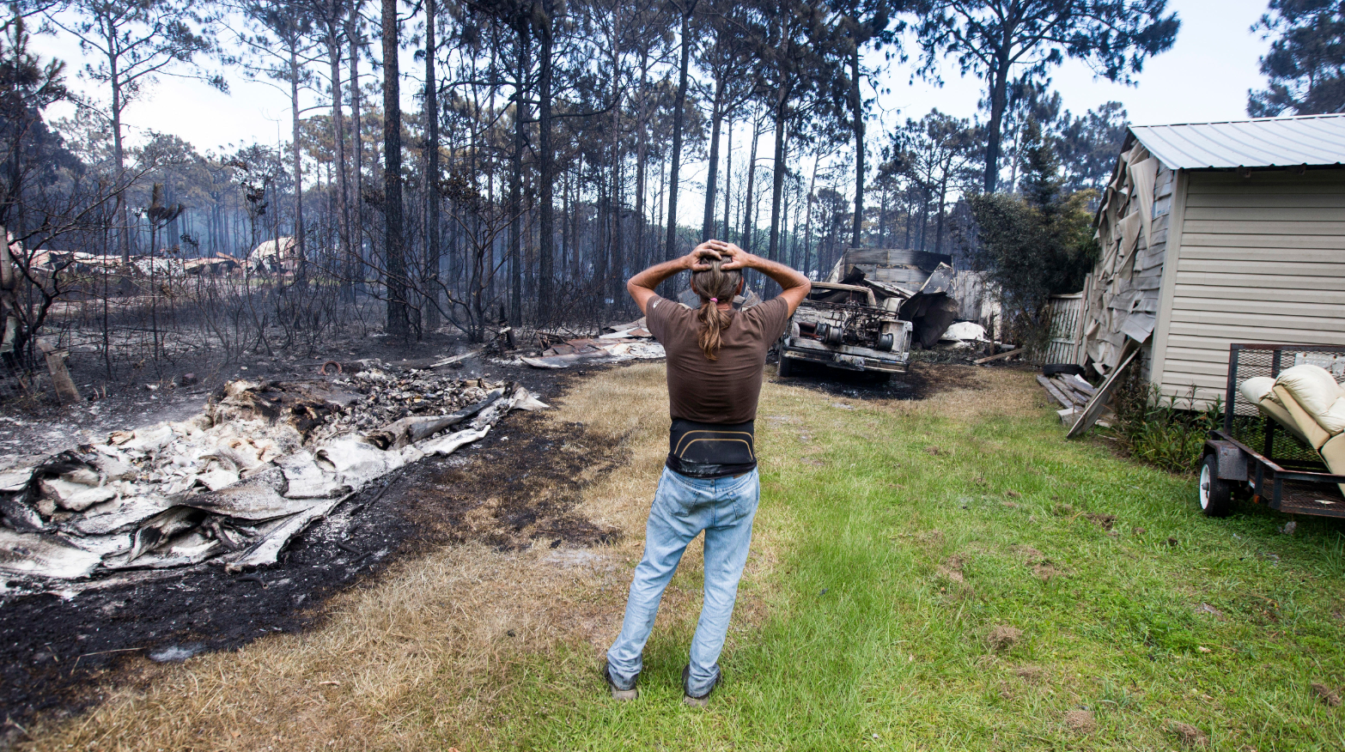
DOCUMENT C- burnt house – unknown, January 2025, LA

