NAME: ______________________________________ DST- UNIT 2 : Help don’t hurt (S08 / S07)

Identification du contexte /de la situation d’énonciation | Identification des réseaux de sens | Identification des stratégies de communication

Based on the 3 different documents, explained what issues are takled for Cyberbullying, how the different protagonists feel, what they go through and the purpose of those documents.

DOCUMENT A

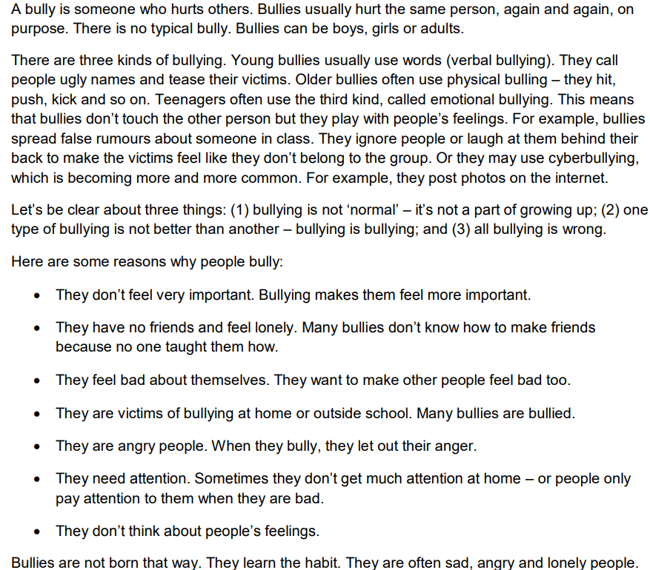

teachingenglish.org.uk

DOCUMENT B:
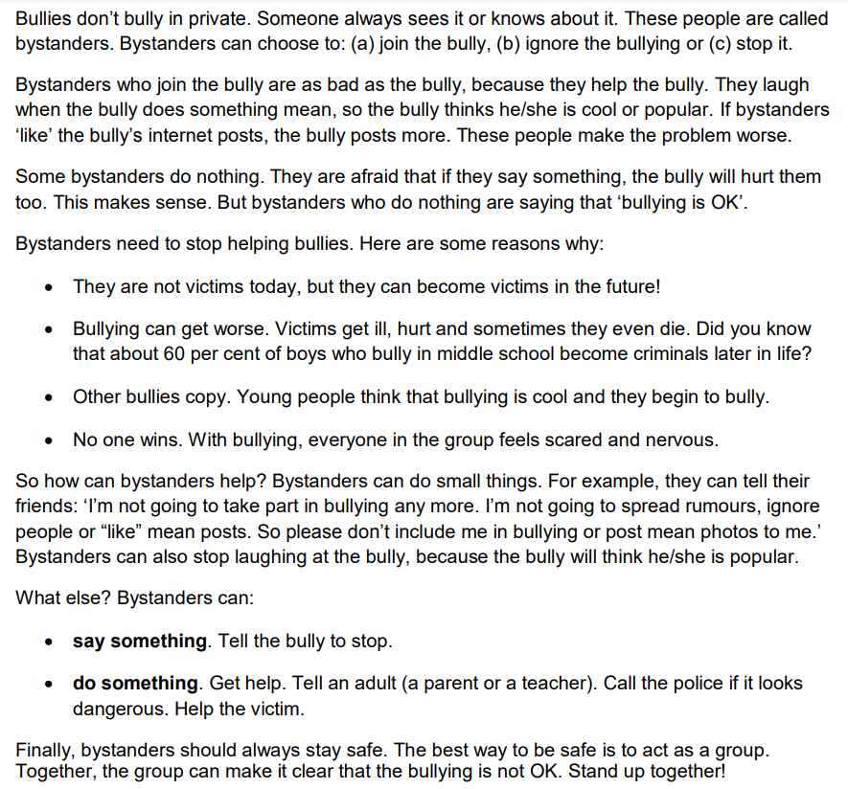
teachingenglish.org.uk

DOCUMENT C:
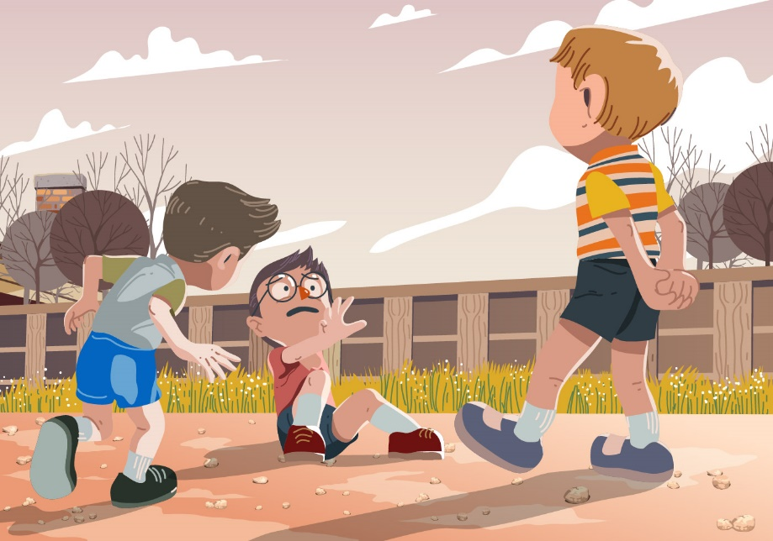

NAME: ______________________________________ DST- UNIT 2 : Help don’t hurt (S04 / S05)

Identification du contexte /de la situation d’énonciation | Identification des réseaux de sens | Identification des stratégies de communication

Based on the 3 different documents, explained what issues are takled for Cyberbullying, how the different protagonists feel, what they go through and the purpose of those documents.

DOCUMENT A:
teachingenglish.org.uk

DOCUMENT B

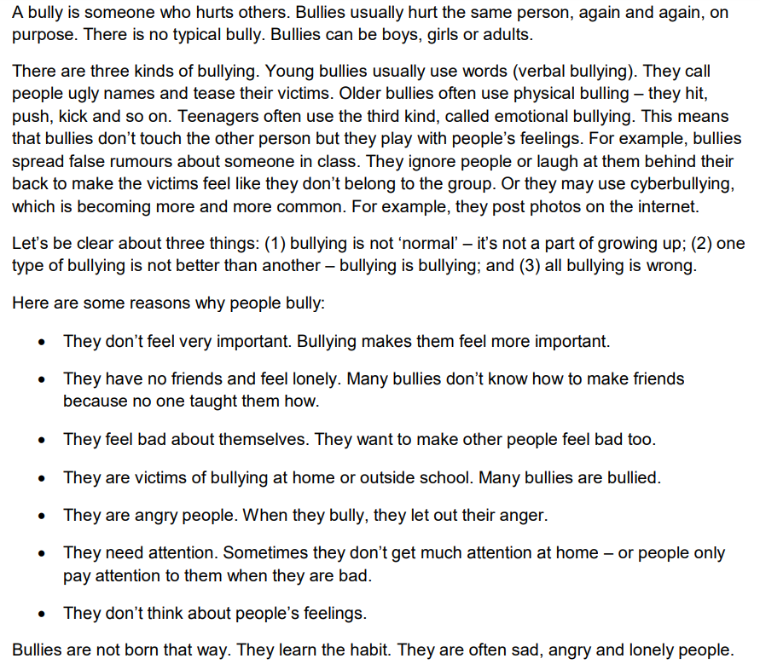

DOCUMENT C



