NAME: ______________________________________ DST- OFF LINE, ON LINE (EURO)

Identification du contexte /de la situation d’énonciation | Identification des réseaux de sens | Identification des stratégies de communication

Basing yourself on the 3 different documents, explain the issues raised by social medias.
How does it work ? What are its danger ? What does it tell about some people ?

DOCUMENT A :Social Media and Your Mental Health

The social media platform Instagram made headlines last year for suppressing likes in an effort to curb the comparisons and hurt feelings associated with attaching popularity to sharing content. But do these efforts combat mental health issues, or are they simply applying a band-aid to a wound?
It’s a small step in the right direction, says Jacqueline Sperling, PhD, a psychologist at McLean Hospital who works with youth who experience anxiety disorders, about Instagram’s recent restriction.
“Even if you remove the likes, there continue to be opportunities for comparisons and feedback. People still can compare themselves to others, and people still can post comments.”

The Risks for the Reward
Social media has a reinforcing nature. Using it activates the brain’s reward center by releasing dopamine, a “feel-good chemical” linked to pleasurable activities such as sex, food, and social interaction. The platforms are designed to be addictive and are associated with anxiety, depression, and even physical ailments.
According to the Pew Research Center, 69% of adults and 81% of teens in the U.S. use social media. This puts a large amount of the population at an increased risk of feeling anxious, depressed, or ill over their social media use.
But what makes users come back for more even when it can literally make them feel sick?
“When the outcome is unpredictable, the behavior is more likely to repeat. Think of a slot machine: if game players knew they never were going to get money by playing the game, then they never would play,” Sperling says.
“The idea of a potential future reward keeps the machines in use. The same goes for social media sites. One does not know how many likes a picture will get, who will ‘like’ the picture, and when the picture will receive likes. The unknown outcome and the possibility of a desired outcome can keep users engaged with the sites.
https://www.mcleanhospital.org, 2024

DOCUMENT B- With his comments on Taylor Swift, Elon Musk has reached a weird new low

The Tesla CEO simply couldn’t resist using his own platform to say something sexist, controversial – and downright creepy. Elon Musk may not have turned out to be the brilliant scientist we all thought he was during the Obama administration, but he did prove one theorem: it turns out money really can’t buy happiness. It also can’t buy you charisma, maturity, empathy – or the love and respect of your own children.
Yes, stop the presses: Elon Musk has once again said something so creepy (and controversial) that it’s caused his own flesh and blood to step forward and say, “look, we’re only technically related”. This time, it was the Tesla CEO offering to “give [Taylor Swift] a child” after the singer endorsed Kamala Harris for president on Instagram, following the VP’s stellar debate performance earlier this week.
“Fine Taylor … you win...I will give you a child and guard your cats with my life,” said Musk on his horrible website, in what he probably thought was a hilarious put down, but to me reads more like a threat of sexual violence.
Musk’s daughter, Vivian Wilson, later wrote a post of her own (on Twitter/X rival Threads, naturally) in which she referred to Musk’s tweet as “heinous incel nonsense” – which, to be fair to her, it absolutely was.
“I don’t really have anything to add to it, it’s just abhorrent,” she said. “I would just like to say to my audience members, don’t let people talk to you like that. It’s disgusting, it’s belittling and incredibly sexist. You deserve better.”
I swear, every week it’s something new with this guy. If I was a billionaire, you’d never hear from me again. I’d be chilling out in my life-sized replica of Optimus Prime and I’d never touch a device with a Wi-Fi connection ever again. Musk is so chronically online – so transparently needy. But then, who can blame him? (...)
Musk has said and done a lot of heinous, disgusting – sometimes even dangerous – things. We know exactly what kind of man he is. But if there was ever any doubt, the fact that his own child is just as mortified by him as the rest of us should be the thing that seals the deal.
How he can live with himself knowing that he has so thoroughly alienated somebody who he should love, protect, and accept no matter what, I truly do not know. It’s no consolation I’m sure, but unlike most children of disappointing parents, Vivian can at least take some solace in the fact that when it comes to her feelings about her father, she’s far from alone.

Ryan Coogan https://www.independent.co.uk/ Friday 13 September 2024

DOCUMENT C - Social media addiction
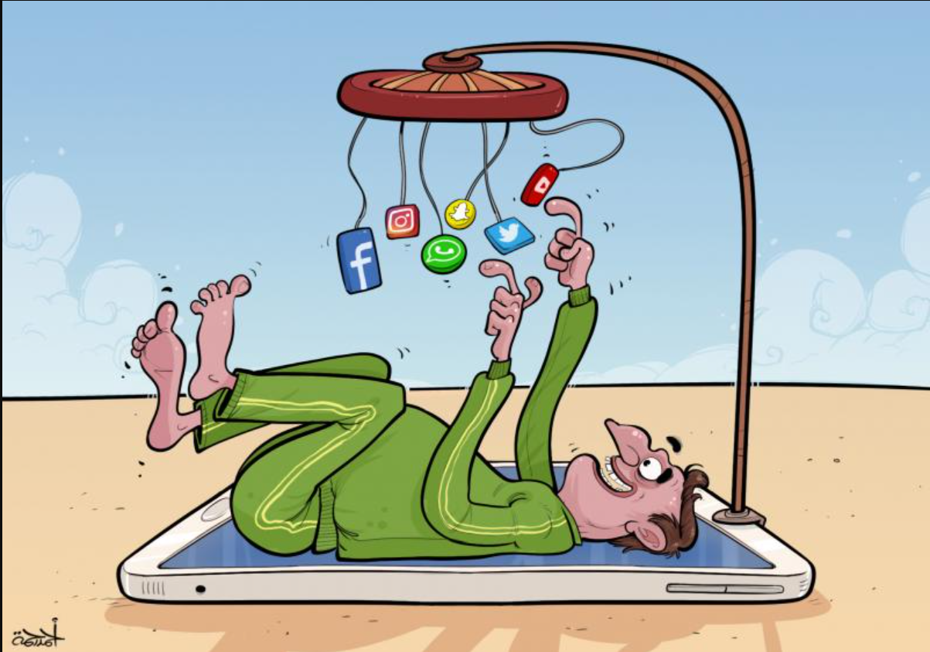
Rahma, Cartoons, 22 April 2021

writes Ryan Coogan https://www.independent.co.uk/ Friday 13 September 2024

NAME: ______________________________________ DST- OFF LINE, ON LINE

Identification du contexte /de la situation d’énonciation | Identification des réseaux de sens | Identification des stratégies de communication

Basing yourself on the 3 different documents, explain the issues raised by social medias.
How does it work ? What are its danger ? What does it tell about some people ?

DOCUMENT A :Social Media and Your Mental Health

The social media platform Instagram made headlines last year for suppressing likes in an effort to curb the comparisons and hurt feelings associated with attaching popularity to sharing content. But do these efforts combat mental health issues, or are they simply applying a band-aid to a wound?
It’s a small step in the right direction, says Jacqueline Sperling, PhD, a psychologist at McLean Hospital who works with youth who experience anxiety disorders, about Instagram’s recent restriction.
“Even if you remove the likes, there continue to be opportunities for comparisons and feedback. People still can compare themselves to others, and people still can post comments.”

The Risks for the Reward
Social media has a reinforcing nature. Using it activates the brain’s reward center by releasing dopamine, a “feel-good chemical” linked to pleasurable activities such as sex, food, and social interaction. The platforms are designed to be addictive and are associated with anxiety, depression, and even physical ailments.
According to the Pew Research Center, 69% of adults and 81% of teens in the U.S. use social media. This puts a large amount of the population at an increased risk of feeling anxious, depressed, or ill over their social media use.
But what makes users come back for more even when it can literally make them feel sick?
“When the outcome is unpredictable, the behavior is more likely to repeat. Think of a slot machine: if game players knew they never were going to get money by playing the game, then they never would play,” Sperling says.
“The idea of a potential future reward keeps the machines in use. The same goes for social media sites. One does not know how many likes a picture will get, who will ‘like’ the picture, and when the picture will receive likes. The unknown outcome and the possibility of a desired outcome can keep users engaged with the sites.
https://www.mcleanhospital.org, 2024

DOCUMENT B- Is Facebook Dead?
Everyone knows Facebook as a fun website where you can catch up with friends and share photos and posts to the world. It started as the original place to make friends. Nowadays, some people say that it has become almost a clickbait with its multitude of paid articles and advertisements.
So, the question is: is Facebook dead?
On average, 1.59 billion people log onto Facebook daily and if this doesn’t tell you anything about its popularity, I don't know what will. If we look way back to 2004, the main Facebook audience consisted of almost only Harvard University students. The goal was to create a connection to the rest of the world, and it has escalated to an extreme in 2019.
Facebook in Business
As we often talk about Facebook being for personal use, many people may think that it is not of interest to them anymore. However, what about in business? Facebook in business is a very new but very effective tool to promote your company online. More and more businesses now use Facebook to create social ads to interact with existing customers, but also to attract new people. It is a great platform to get to know your potential future customers or clients. However, you will not get users to conform by magic. If you think you can create a business page and everything will fall into place on its own, you are most certainly mistaken. For Facebook to be effective for your business, you need to know your target audience; if you are targeting the wrong people, you will not receive any profits. Facebook can only guide you and provide you with tools and features that could be used effectively to promote your business. As for the most part, you need to invest plenty of time in the social platform to get the results you want. Even for us marketers, Facebook is sometimes a mystery! Some ads work and some don’t; it’s all about the right timing and content.
We believe that Facebook is great for businesses in many ways, especially for start-ups and smaller companies.
JBL for assembledigital.agency, 2021

DOCUMENT C – Friends
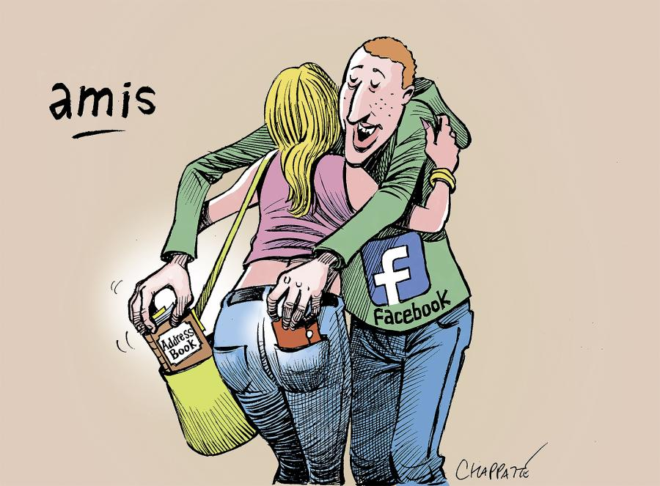
Chappatte, Globalcartoon, April 15 2018

