NAME: ______________________________________ DST- OFF LINE, ON LINE (rattrapage)

Identification du contexte /de la situation d’énonciation | Identification des réseaux de sens | Identification des stratégies de communication

Basing yourself on the 3 different documents, explain the issues raised by social medias.
How does it work ? What are its danger ? What does it tell about some people ?

Document A - 'Tradwife' lifestyle trends on social media and the internet is divided

Content featuring “tradwives” – women who value being a traditional wife, subscribing to homemaking and conventional gender roles – has flooded social media in recent years and, as the trend rises, American women are facing more scrutiny over their lifestyle choices.
Notable tradwives like 22-year-old former model Nara Smith and TikTok star Estee Williams can be seen cooking, cleaning and showcasing their picture-perfect lives as stay-at-home moms.
Ivy Van Dusen, another social media influencer, juggles her domestic duties as a mom to two boys with content creation, running a TikTok page with more than 119,000 followers. She says that even when she was studying broadcast journalism in college, she had always dreamed of motherhood.
“My brand is embracing motherhood and enjoying motherhood,” said Van Dusen, a self-proclaimed tradwife. “A lot of people, unfortunately, have this negative view of the way people used to live,” she said. “I was really close with both my grandmothers and even my great grandmother, and they were just the coolest women. When I hear homemakers, when I hear traditional women, I think of really amazing women.”
However, a recent study published by Global Network on Extremism and Technology found that tradwife content on less-regulated platforms, like YouTube and X, formerly known as Twitter, could steer social media users toward radical far-right content and misinformation, especially on current issues involving abortion rights, transgender individuals and vaccinations.
For Abby Roth, an Orthodox Jew who calls herself a classical wife and mother, social media has allowed her to share her conservative values. Roth, a former opera singer, stepped away from her life on stage and often talks about the expectations women have about career and family on her YouTube channel with 115,000 subscribers.
“A lot of women are told that they're going to find their fulfillment through their careers,” Roth said. “If you look at somebody's tombstone, it's going to say ‘wonderful daughter, wonderful mother, wonderful wife.’ It's not going to say, ‘wonderful CEO.’”
Like Van Dusen, Roth says she is not against moms who work. Despite understanding that single mothers and dual-income households are a reality, Roth advocates for women to reexamine their role in the economy.
“I think for a lot of women, work is not necessary. It's a preference,” Roth said. “Life is too short not to do the things that are going to bring you joy.”
But many women may not think they have to choose. Dr. Karen Tang, a board-certified OB-GYN, surgeon and book author, has been married for nearly 20 years and has three children.
“There's a lot of criticism [on social media], like ‘who's raising your kids right now? Why did you have kids if you can't raise them?’” said Tang. “No one would say that to a man.”

BySally Hawkins, Knez Walker, Zach Fannin, and Aria Young June 24, 2024, https://abcnews.go.com/

DOCUMENT B :Social Media and Your Mental Health

The social media platform Instagram made headlines last year for suppressing likes in an effort to curb the comparisons and hurt feelings associated with attaching popularity to sharing content. But do these efforts combat mental health issues, or are they simply applying a band-aid to a wound?
It’s a small step in the right direction, says Jacqueline Sperling, PhD, a psychologist at McLean Hospital who works with youth who experience anxiety disorders, about Instagram’s recent restriction.
“Even if you remove the likes, there continue to be opportunities for comparisons and feedback. People still can compare themselves to others, and people still can post comments.”

The Risks for the Reward
Social media has a reinforcing nature. Using it activates the brain’s reward center by releasing dopamine, a “feel-good chemical” linked to pleasurable activities such as sex, food, and social interaction. The platforms are designed to be addictive and are associated with anxiety, depression, and even physical ailments.
According to the Pew Research Center, 69% of adults and 81% of teens in the U.S. use social media. This puts a large amount of the population at an increased risk of feeling anxious, depressed, or ill over their social media use.
But what makes users come back for more even when it can literally make them feel sick?
“When the outcome is unpredictable, the behavior is more likely to repeat. Think of a slot machine: if game players knew they never were going to get money by playing the game, then they never would play,” Sperling says.
“The idea of a potential future reward keeps the machines in use. The same goes for social media sites. One does not know how many likes a picture will get, who will ‘like’ the picture, and when the picture will receive likes. The unknown outcome and the possibility of a desired outcome can keep users engaged with the sites.
https://www.mcleanhospital.org, 2024

DOCUMENT C - What Trad Wives Don’t Want To Talk About

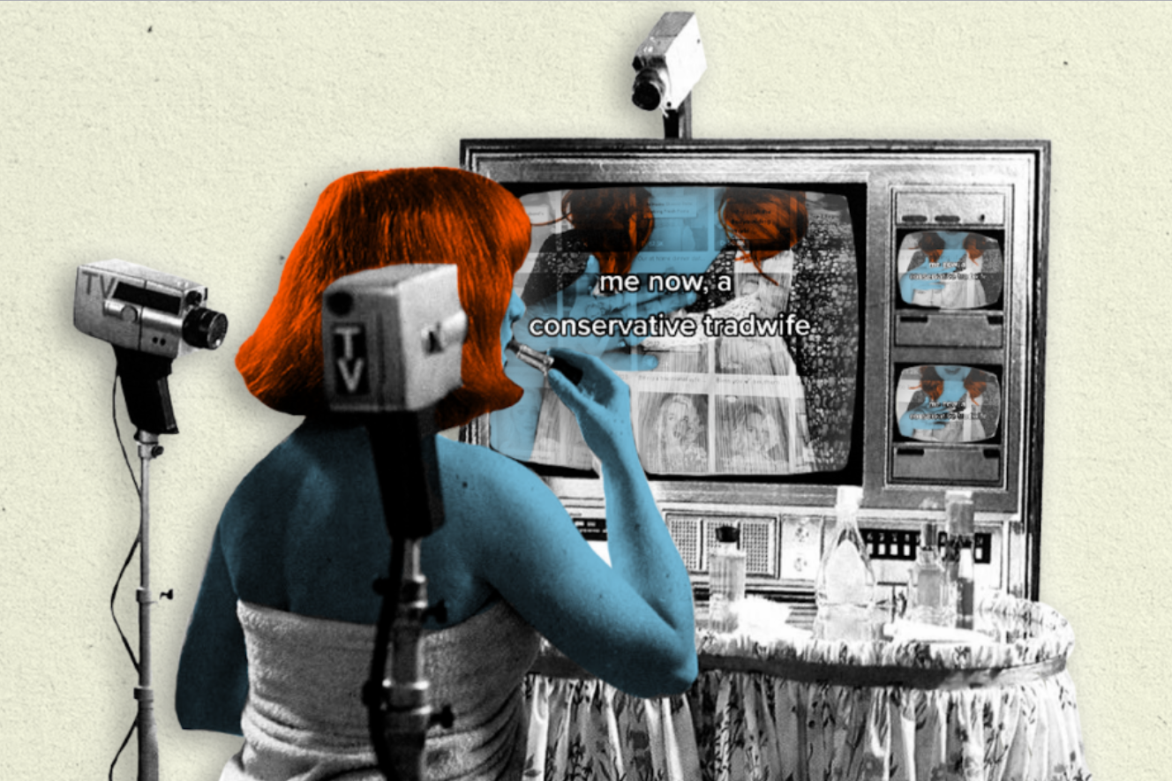
Madeline English, grainofsaltmag.com, April 9, 2024

