Unit 4 - Ain't No Angels -

Passé dans le présent: You know about the Melting Pot and Ellis Island. But have you ever heard about Angel Island?
What was it like to be an Asian living in the US ?

1- Asian immigration
1a- Chinese immigration to the US: travail de repérage sur le text
Travail de rédaction lettre à une personne restée au pays => choisir un évènement qui a amené la personne à émigrer
(eventuellement Kahoot => vérification des connaissances ou tout à la fin)

https://www.pbs.org/opb/historydetectives/feature/chinese-immigration/
angel island: document 1a
appropriation puis repérage en3 mots clés (date, event, jobs, feeling...) 1850 - 1880 - 1962
écriture de 3 lettres: une sera compté, une autre sera bonus et une ne comptera pas (à condition que les 3 aient bien été écrites)
100 /150 mots 1 pt
letter 1 pt
respect the era 1pt
at least 2 events linked to this era 2 pt
explain the reason why you write / your point of view 2 pt
express your feelings 1 pt
lexicon 5 pts
grammar 5 pts

1b- Railroad workers remembers, www.abc7news.com, history of the historical society America
travail sur la vidéo :
ttps://abc7news.com/transcontinental-railroad-chinese-rail-workers-history-of-the-historical-society-america/903452/

1c- Growing up in Oklahoma: rédaction d'un point de vue autre ou de la suite

1d- The Chinese Exclusion Act : kahoot, travail sur la question

2- Angel island
2a- Traces of the past : photo + poem: describe the momebnt and the surrounding, read the translation and guess why it was built,
list the verbs used in the poem and explain what i reveals about the immigratn's lives

travail sur les 2 doc: attribution d'un texte au hasard, pair work on rentre dans le rôle, on s'invente la suite puis on se sépare et on partage les expériences (groupe doc b et c)
2b- David, 8 years old : "paper son"
ecture du texte 2b- liste des différentes étapes

début rédaction autour de "Paper son": rédaction des pensées, expressions des sentiments.
Binôme rouge: David
binôme vert: David's father
binôme bleu: the Caucasian officer who works on Angel island

2c- Don Lee: my arrival and my interrogation

2d - Us immigration history preserved on Angel Island, AP Archive, 2009 (video) : cO
Video You tube: cf question dans drive ou en bas
https://www.youtube.com/watch?v=cW6f96SgknY

+ https://cyark.org/projects/angel-island-station/video

annexe: annexe: https://www.youtube.com/watch?v=cW6f96Sgkn

3- Remembering Angel Island
3a – The Angel Island Immigration Station today : parage impression sur le batiment, sur les mots écrits => pourquoi , que représent il?

3b- Historical testimonies in poems, www.ked.com, March 16, 2014 : devoir de mémoire (texte let's meet up p177)

4- A forgotten past
4a- tableau Roger Shimomura, American Infamny, 2008
4b- testimony : George Takei's life in an internment camp : https://www.youtube.com/watch?v=PP3lWftprjQ
4c- life in camp : Roger Shimomura, An American Diary Series, 2002-2003 remettre les légendes dans l'ordre, faire faire exercice de rédaction

Ain't No Angels -

Passé dans le présent: You know about the Melting Pot and Ellis Island. But have you ever heard about Angel Island?
 | What was it like to be an Asian living in the US
At the end of the Unit, I will be | - know more about the Asian immigration  - learn about how Japonese American were treated during WWII  - remember old memories
What vocabulary will I need ? | - immigration  - feeling  - war
What grammatical structure will I need ? | - preterite V-Ing  - present perfect  - make supposition
What documents will be used ? | 1- knowing more about Asian immigration  1a- The Reason for Chinese immigration to the US  1b- Railroad workers remembers, www.abc7news.com, history of the historical society America  1c- Growing up un Oakland's Chinatown  1d1- The Chinese Exclusion Act (text)  1d2- The Chinese exclusion Act - questions  2- Angel island  2a- Traces of the past  2b- David, 8 years old : "paper son"  2c- Don Lee: my arrival and my interrogation  2d - Us immigration history preserved on Angel Island, AP Archive, 2009 (video)  3- Remembering Angel Island  3a – The Angel Island Immigration Station today  3b- Historical testimonies in poems, www.ked.com, March 16, 2014  4- A forgotten past  4a- tableau Roger Shimomura, American Infamny, 2008  4b- testimony : George Takei's life in an internment camp  4c- life in camp : Roger Shimomura, An American Diary Series, 2002-2003
What will I learn about ? | - how immigration of the West occured  - how Asian immigratns were treated  - the importance of memory and the work done around it
Final Task | You will meet an Angel descendant and interview him in order to write a school article

Instructions for your Final Task :

1) You will hold a discussion with someone from the class but you will not be told who before hand

2) You will have a go in front of the class for both role: an eldery remembering and a young student in want of informations to write an article

3) You will need to make your conversation natural and plausible

4) your memories will need to be based on one of the elements seen in class.

Video You tube: https://www.youtube.com/watch?v=cW6f96SgknY

The Ellis island of the west

annexe: https://www.youtube.com/watch?v=cW6f96Sgkn

railroad

https://abc7news.com/transcontinental-railroad-chinese-rail-workers-history-of-the-historical-society-america/903452/

1a- Chinese immigration

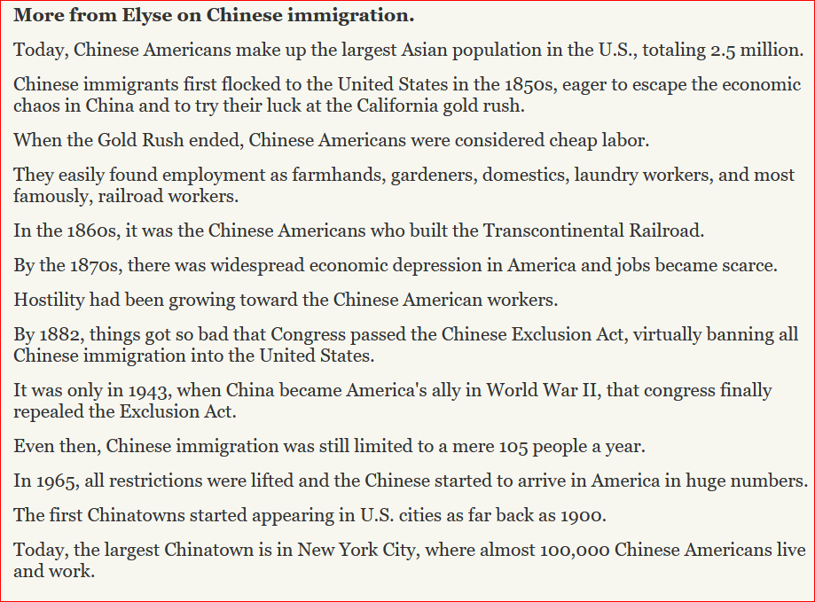
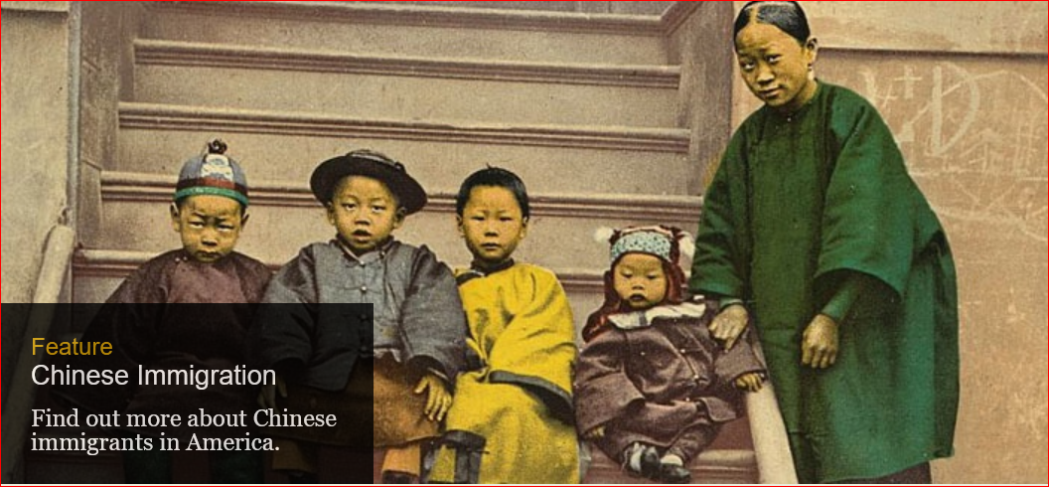
1b- script Chinese Railroad workers

STANFORD, Calif. (KGO) -- It is an American success story -- the linking of the east and west by railroad in the 1860s. However many of the people who built it weren't Americans but Chinese, and now there's an effort underway to better tell their story.
It has been more than 146 years since this group of rail workers gathered in front of two trains at Promontory Summit in Utah. The famous photo was taken to celebrate the linking of the Central Pacific and Union Pacific Railroads with the "Golden Spike."
What this picture doesn't show are the people who played a huge part in building the railroad. Two researchers at Stanford University are focusing in on them.
Gordon Chang and Shelley Fisher Fishkin are looking for answers about the Chinese who worked the railroad.
"We're trying to recover the history of the 10 to 12,000 Chinese who came to America to build the Central Pacific Railroad. Their labor was absolutely key to the railroad being completed," said Fishkin.
"We know very little about who they were, their names even, what they experienced, how they were recruited, how they lived and worked and died on the railroad and what happened to them subsequently," said Chang.

STANFORD, Calif. (KGO) -- It is an American success story -- the linking of the east and west by railroad in the 1860s. However many of the people who built it weren't Americans but Chinese, and now there's an effort underway to better tell their story.
It has been more than 146 years since this group of rail workers gathered in front of two trains at Promontory Summit in Utah. The famous photo was taken to celebrate the linking of the Central Pacific and Union Pacific Railroads with the "Golden Spike."
What this picture doesn't show are the people who played a huge part in building the railroad. Two researchers at Stanford University are focusing in on them.
Gordon Chang and Shelley Fisher Fishkin are looking for answers about the Chinese who worked the railroad.
"We're trying to recover the history of the 10 to 12,000 Chinese who came to America to build the Central Pacific Railroad. Their labor was absolutely key to the railroad being completed," said Fishkin.
"We know very little about who they were, their names even, what they experienced, how they were recruited, how they lived and worked and died on the railroad and what happened to them subsequently," said Chang.
"Their story is hard to tell because they left no written records themselves. There is not a single letter or journal or even remittance envelope in the hand in one of these workers that has yet surfaced in the U.S. or China," added Fishkin.
Generations of racism and discrimination left the story of the Chinese laborers largely untold -- until now.
Sue Lee, with the Chinese Historical Society of America, said, "This is an attempt to educate people about the importance of the transcontinental, that it joined the country, that it provided a highway, if you will, between east and the west but it was also was a gateway to the orient."
The Chinese Railroad Workers in North America project is piecing together what really happened. So far, there isn't a lot go on, just family stories, old photos and drawings and documents from the railroad's builders.
Stanford University founder Leland Stanford was among them.
The researchers are working with the Chinese Historical Society of America. Video provide by the CHSA shows archaeologists sifting through the past for items that might tell them exactly where the Chinese came from and how they lived.
The society is also collecting oral histories for the project.
But they aren't just looking for Chinese descendants to tell the story of the "Iron Road." They are also looking for clues in the diaries or letters of others who worked on the railroad.
"We are trying to reach out to historians of Mormons, because many Mormons worked on the rail lines, Irish, and others, so we're hopeful that maybe one of those elusive diaries will turn up," added Chang.
The project hopes to know more about the Chinese workers by 2019. Just in time for the 150th anniversary of the completion of the transcontinental railroad.
Think you can help? Click here to visit the project's website.
Written and produced by Ken Miguel

1c Growing up in Oklahoma
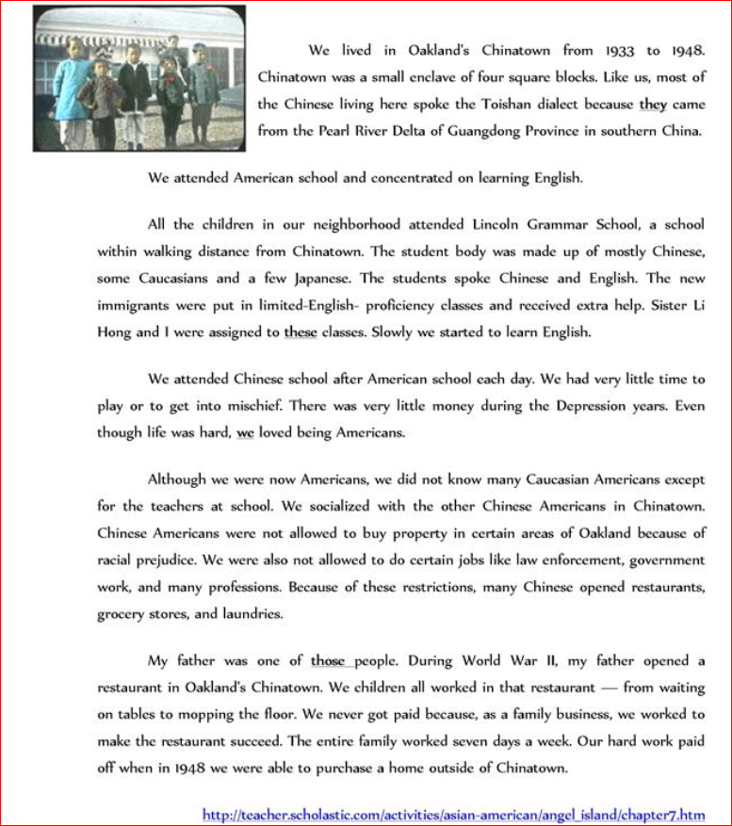

1d- Chinese exclusion Act

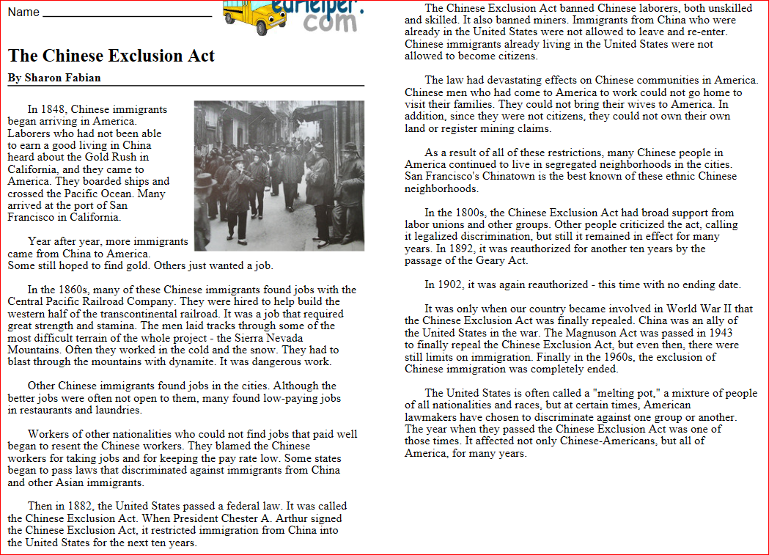

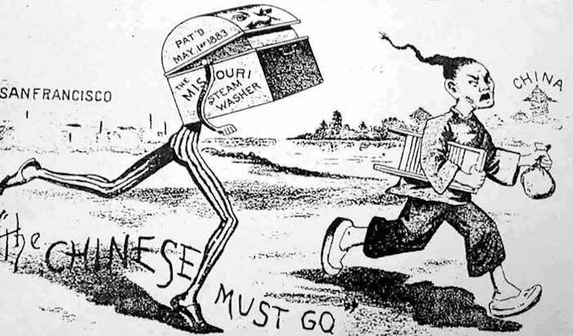

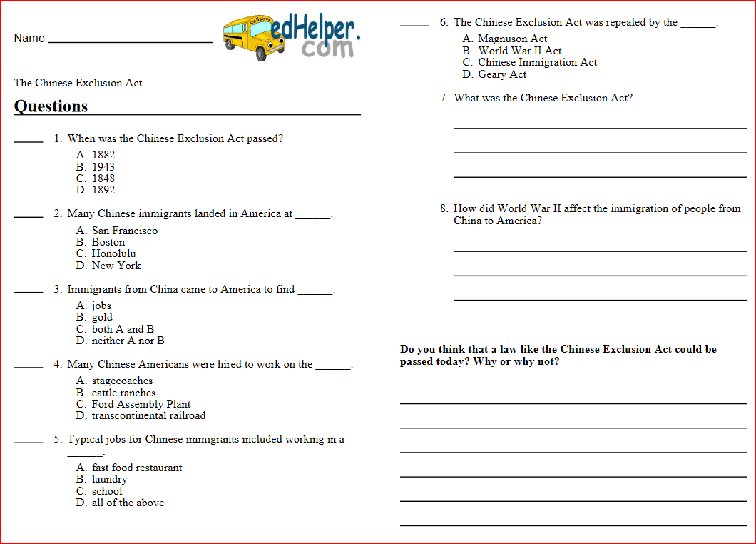

2a- Traces from the past
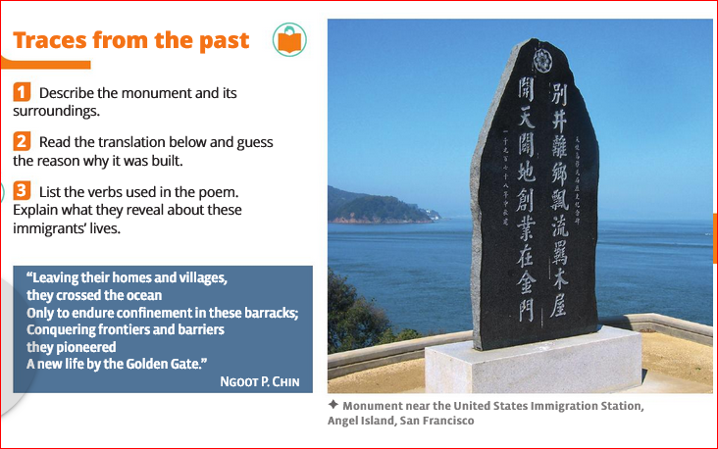

2b -

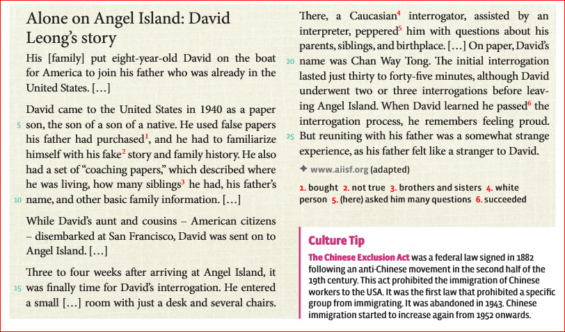

2c-

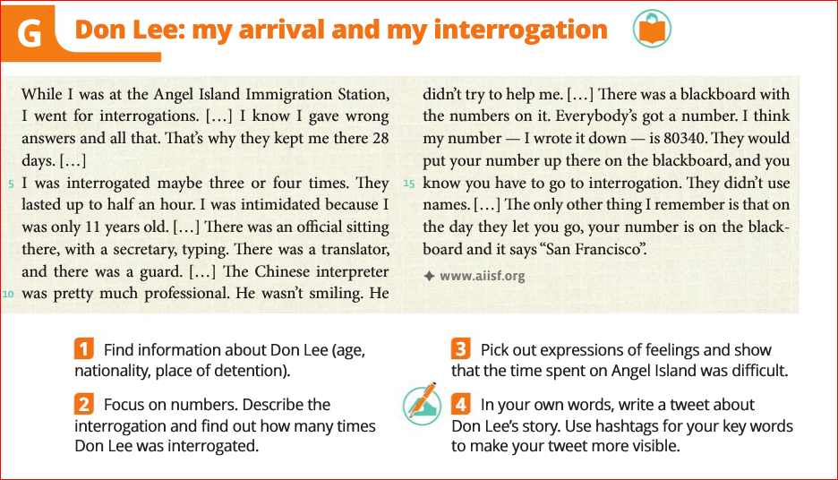

3a- historical testimonies:
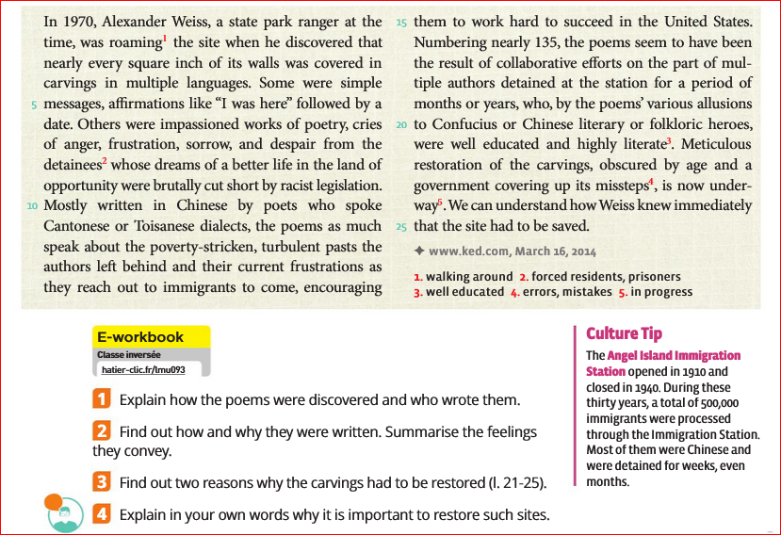

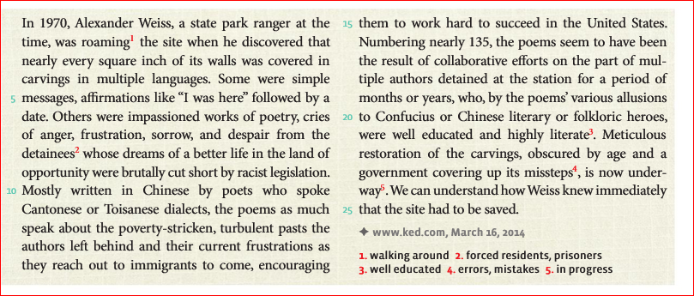
3b- travail sur la vidéo

https://www.youtube.com/watch?v=cW6f96SgknY

video:
annexe: https://www.youtube.com/watch?v=cW6f96Sgkn

4- cf scan vieyx manuel

idée DST:
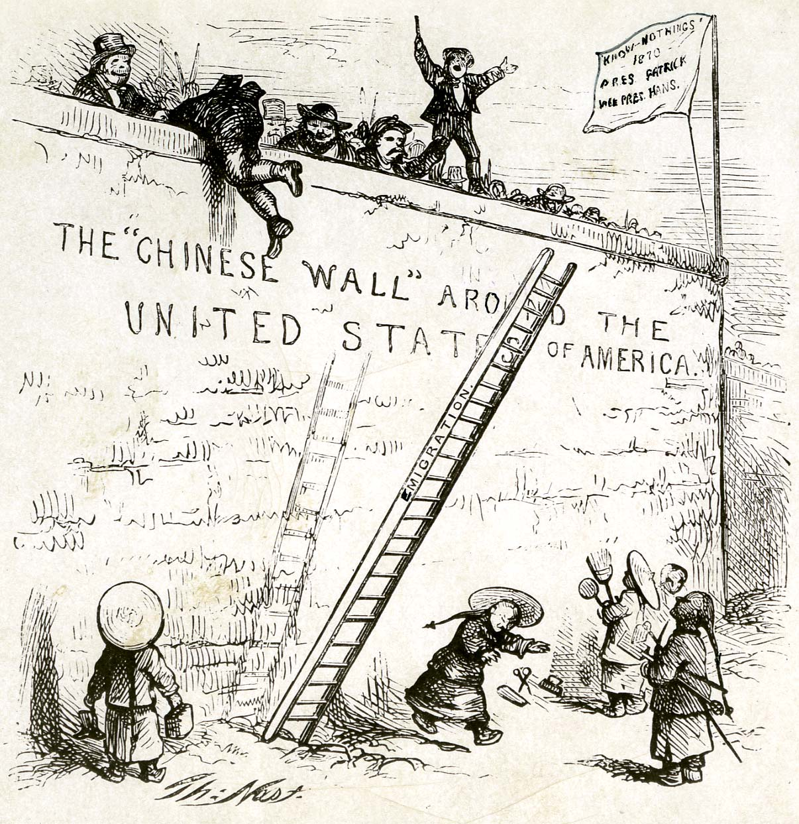
- rédaction des souvenirs en question après TF

Unit 4- Ain't No Angels TF
You will meet an Angel descendant and interview him in order to write a school article

 | Qualité du contenu | Pt score | Expression orale en interaction | Pt score | Correction  de la langue écrite | Pt score | Richesse  de la langue | Pt score
C2 | j'ai rendu de fines nuances de sens en rapport avec le sujet complexe.J'ai su développé et articuler les arguments de mes camarades et les miens. | 30 | J'ai interagi avec aisance et spontanéité et contribué habilement à la construction de l’échange, y compris en exploitant des références (inter)culturelles et  sur un sujet complexe. | 30 | J'ai utilisé avec une bonne maîtrise tout l’éventail des traits phonologiques de la langue cible, de façon à être toujours intelligible, même sur un sujet complexe. | 30 | J'ai employé de manière pertinente un vaste répertoire lexical incluant des expressions idiomatiques, des nuances de formulation et des structures variées  même sur un sujet complexe. | 30
C1 | J'ai traité le sujet et produit un écrit fluide et convaincant, étayé par des éléments (inter)culturels pertinents, en démontrant un usage maîtrisé de moyens linguistiques de structuration et d’articulation de l'ensemble des arguments donnés. | 20 | J'ai interagi avec aisance et contribuer habilement à la construction de l’échange, y compris en exploitant des références (inter)culturelles. | 20 | J'ai utilisé avec une assez bonne maîtrise tout l’éventail des traits phonologiques de la langue cible, de façon à être toujours intelligible. Les rares erreurs de langue ne donnent  pas lieu à des malentendus. | 20 | J'ai employé de manière pertinente un vaste répertoire lexical incluant des expressions idiomatiques, des nuances de formulation et des structures variées. | 20
B2 | J'ai traité le sujet de façon claire, détaillée et globalement efficace.  J’ai bien exploité les éléments que l’on m’a donné pour écrire mon interview. J’ai écris une histoire pertinente et intéressante | 10 | J'ai argumenté et cherché à convaincre. J'ai réagi avec pertinence et relancé la discussion, j'ai posé des questions intéressantes, mes réponses étaient développées et travaillées. | 10 | Mon accent subit l’influence d’autres langues mais n’entrave pas l’intelligibilité.  Mes erreurs de langue ne donnent pas lieu à malentendu. | 10 | J'ai produit un discours et des énoncés assez fluides, l’étendue de min lexique est suffisante pour permettre précision et variété des formulations. | 10
B1 | j'ai traité le sujet de façon intelligible et relativement développée. Je me suis appuyé sur le récit qui m’a été fait pour faire mon interview. J’ai chercher à développer les idées, à m’appuyer sur le contenu du cours | 5 | J'ai engagé, soutenu et clos une conversation simple sur des sujets familiers. J'ai fait référence à des aspects du cours de façon pertinente et approfondies. | 5 | Je m’exprime de manière intelligible malgré l’influence d’autres langues.  J'ai une bonne maîtrise des structures simples. | 5 | J'ai produit un discours et des énoncés dont l’étendue lexicale relative nécessite l’usage de périphrases et répétitions. | 5
A2 | jai traité le sujet, ma production est courte (moins de 150 mots) et l'argumentation est trop superficiellle. | 3 | J'ai répondu et réagi de manière simple. Je n'avais pas beaucoup de travaillé le sujet, mes connaissances étaient limitées | 3 | Je m'exprime de manière suffisamment claire pour être compris, mais la compréhension requiert un effort de mes  interlocuteurs. | 3 | J'ai produit un discours et des énoncés dont les mots sont adaptés à l’intention de communication, en dépit d’un répertoire lexical limité. | 3
A1 | J' ai simplement amorcé une production écrite en lien avec le sujet. | 1 | La communication repose sur la répétition et la reformulation. | 1 | J'ai utilisé un répertoire très limité d’expressions et de mots mémorisés de façon compréhensible. | 1 | J'ai produit des énoncés intelligibles malgré un lexique très limité.

Points score | 0 | 1-3 pt |  |  |  | A1 : 4-7 pt |  |  | 8-9 pt |  |  | 10-11 pt |  |  | A2 : 12-15 pt |  |  | 16-19 pt |  |  | 20 et + | A2 / B1
NOTE s/ 20 | 0 | 1 | 2 | 3 | 4 | 5 | 6 | 7 | 8 | 9 | 10 | 11 | 12 | 13 | 14 | 15 | 16 | 17 | 18 | 19 | 20

STANFORD, Calif. (KGO) -- It is an American success story -- the linking of the east and west by railroad in the 1860s. However many of the people who built it weren't Americans but Chinese, and now there's an effort underway to better tell their story.
It has been more than 146 years since this group of rail workers gathered in front of two trains at Promontory Summit in Utah. The famous photo was taken to celebrate the linking of the Central Pacific and Union Pacific Railroads with the "Golden Spike."
What this picture doesn't show are the people who played a huge part in building the railroad. Two researchers at Stanford University are focusing in on them.
Gordon Chang and Shelley Fisher Fishkin are looking for answers about the Chinese who worked the railroad.
"We're trying to recover the history of the 10 to 12,000 Chinese who came to America to build the Central Pacific Railroad. Their labor was absolutely key to the railroad being completed," said Fishkin.
"We know very little about who they were, their names even, what they experienced, how they were recruited, how they lived and worked and died on the railroad and what happened to them subsequently," said Chang.
"Their story is hard to tell because they left no written records themselves. There is not a single letter or journal or even remittance envelope in the hand in one of these workers that has yet surfaced in the U.S. or China," added Fishkin.
Generations of racism and discrimination left the story of the Chinese laborers largely untold -- until now.
Sue Lee, with the Chinese Historical Society of America, said, "This is an attempt to educate people about the importance of the transcontinental, that it joined the country, that it provided a highway, if you will, between east and the west but it was also was a gateway to the orient."
The Chinese Railroad Workers in North America project is piecing together what really happened. So far, there isn't a lot go on, just family stories, old photos and drawings and documents from the railroad's builders.
Stanford University founder Leland Stanford was among them.
The researchers are working with the Chinese Historical Society of America. Video provide by the CHSA shows archaeologists sifting through the past for items that might tell them exactly where the Chinese came from and how they lived.
The society is also collecting oral histories for the project.
But they aren't just looking for Chinese descendants to tell the story of the "Iron Road." They are also looking for clues in the diaries or letters of others who worked on the railroad.
"We are trying to reach out to historians of Mormons, because many Mormons worked on the rail lines, Irish, and others, so we're hopeful that maybe one of those elusive diaries will turn up," added Chang.
The project hopes to know more about the Chinese workers by 2019. Just in time for the 150th anniversary of the completion of the transcontinental railroad.

