Exploring Lala Land

Ville, village, quartier
 | What makes Los Angeles unique?
At the end of the Unit, I will be
What vocabulary will I need ? | - immigration  - feeling  - description
What grammatical structure will I need ? | - preterit + prétérit -ING  - advice
What documents will be used ?
What will I learn about ? | The different aspect of LA, its rich history
Final Task : EE

Instructions for your Final Task :

faire un leaflet et puis rédaction en classe en prenant en compte les différents éléments

1- Discover LA
vidéo: CO classique

fun facts: travail sur le texte : retrouver les titres, puis appropriation en vue d'un kahoot

2- LA and the Chinese immigration
2a- chinatown (photo file) : trouver son binôme (photo découpée en 2 ou 3, une seule personne a le droit de parler : d'abord 3 mots puis 3 phrases
s'assurer qu'une personne a le droit de parler pour chaque photo (file photo)

2b- The Chinese Exclusion Act, Sharon Fabian, edHelper.com, 2022
appropriation du texte raison pour immigration, conséquence et résultats: Chinese expclusion act

2c -How Chinese migrants in Los Angeles Chinatown gained self-reliance, Dartmouth college, phys.org, February 15 2024
travail appropriation du texte, explication spécificité des immigrants de LA, ont pu contourné l'interdiction et s'installer pour de vrai dans la ville.
Ont su fondé une communauté auto-suffisante tout en garantissant un lien avec les Américains et donc avoir leur place

3- LA and the Entertainment Industry
3a- Forgotten dream, activity inspired by https://freeenglishlessonplans.com/
read and guess more about the text
find the meaning of the words
write the story: faire faire la ½ puis distribué et donner la fin à un autre groupe
faire les histoires entière, vote pourla meilleur histoire

3b- 10 Totally Legit Ways to See a Star in LA, How To Guarantee Seeing A Celebrity In LA, thereallosangelestours.com, May 14, 2024
Lecture des conseils puis exercice de rédaction sur ce qui est à faire : ub ciinseil a été une réussite et c'est bien passé, et un 2nd s'est mal passé, 150 mots à chaque fois, ramassé, corrigé ou noté

3c- "You are the star", Thomas Suriy, 1983, Hollywood

With Richard Pryor, Laurel and Hardy, Humphrey Bogart, Lauren Bacall, James Dean, Marilyn Monroe, Woody Allen, Judy Garland, Mickey Rooney, Shirley Temple, W.C. Fields, John Wayne, James Cagney, Edward G. Robinson, Jack Lemmon, Bruce Lee, the Marx Brothers, and more, as well as characters such as Errol Flynn's Robin Hood, Charlie Chaplin's Tramp, Superman, Woody Woodpecker, Elizabeth Taylor's Cleopatra, Richard Burton's Marc Anthony, King Kong, et christopher Lee as superman
présentation d'un personnage au moins reconnu sur le mur, et si pas trouvé, donné la liste et leur en attribuer d'office
réflexion autour de la signification de ce mural : You are the star => nous regarde, rôle inversé

// possible avec le selfie d'Ellen DeGeneres

4- LA and the Criminal Issues
LA riots, History.com Editors, updated- April 20, 2021 : découpage du texte, un binôme reçoit une partie du texte et se l'approprie sous forme de notes ou de mind map.
Les textes sont ramassés, les binômes se mélange, à charge de retrouver les explications entières du texte puis travail de rédaction autour des titres
confrontation avec le texte original

5- LA and the Environmental Concerns
vidéo: 3 info min https://www.youtube.com/watch?v=bm3CFAlB0fA
BBC news

Dear Los Angeles: How is climate change affecting you? BBC News, 2016
En faire un leaflet avec conseil donné.
Explications qui doivent être claires et illustrées (pourront être réutilisé pour la TF)

2c -
How Chinese migrants in Los Angeles Chinatown gained self-reliance
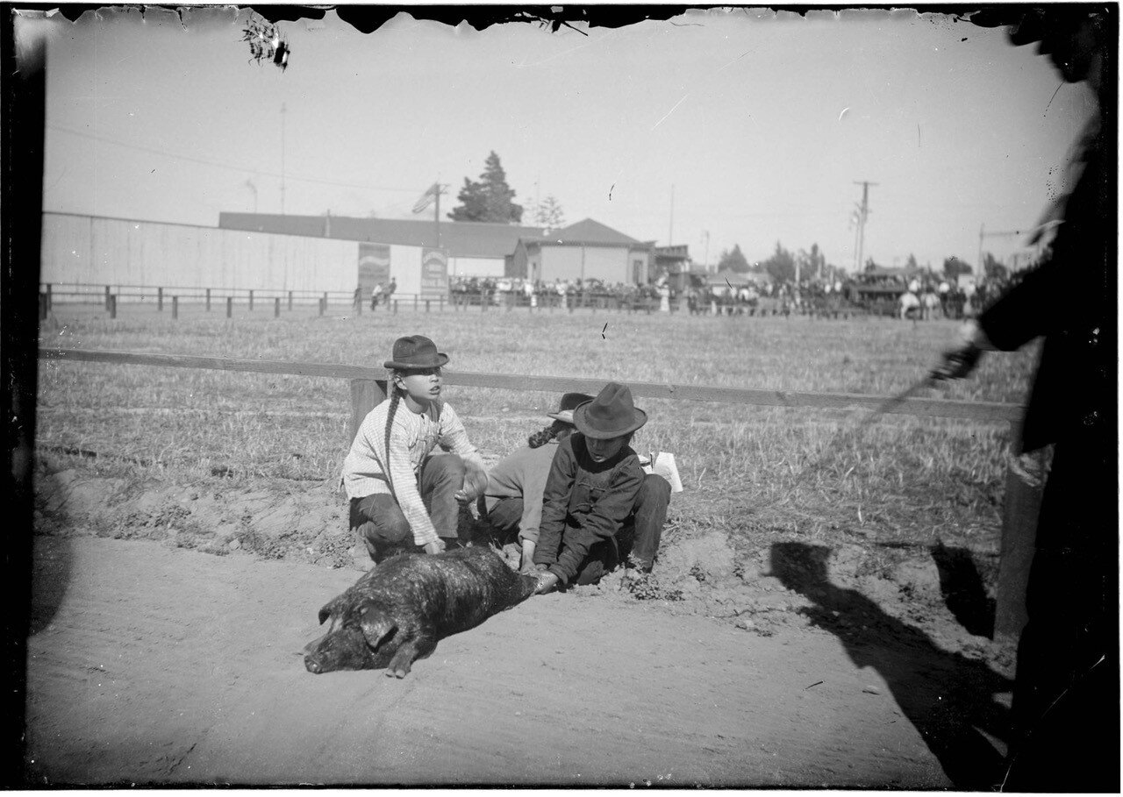
Chinese men holding down a pig in a fenced area in or new Los Angeles Chinatown, circa 1881-1910. Credit: Lisa See Collection, Huntington Digital Library

In the late 1800s and early 1900s, anti-Chinese sentiment in the United States was high, as working-class laborers in the country viewed Chinese workers as a threat. Prior research has found that during that period, approximately 400,000 Chinese migrants came to the U.S., many of whom went to California to build the Transcontinental Railroad. Following the project's completion, competition for jobs grew tougher, and passage of the Chinese Exclusion Act in 1882 banned Chinese laborers from immigrating to the U.S.
But in Los Angeles Chinatown, Chinese migrants established a work- around to the racist policies, forging their own economy through pig raising and pork distribution, according to recent research. The study, featured on the cover of the January 2024 issue of American Antiquity, reports on the resilience and self-reliance of Chinese migrants "under structural racism."
"Our research revealed some basic discrepancies between the archaeological data and mainstream historical narratives," says lead author Jiajing Wang, an assistant professor of anthropology at Dartmouth. "What has been recorded in historical narratives was written by the people in power, so the records don't say much about the real-life struggles of early Chinese migrants."
As the study reports, the team knew from their research involving old newspaper archives that white hog farmers in California used barley and wheat, not rice, to feed their pigs. Pork was also sourced from the Midwest; however, in Chicago, pigs were fed corn. At least four Chinese-owned butcher shops had been documented in the area according to co-author Laura Wai Ng's research on Chinese Exclusion Act case files and other archival records. Chinese butchers would enter into partnerships with other workers to qualify as "merchants," which made them exempt from the Chinese Exclusion Act. The historical records also show that the butcher shops provided banking and other services.The team compared their results to what is known about pig husbandry practices in China, especially South China where these immigrants came from, and found that the practices were quite similar.
In South China, pigs were fed leftover food, rice bran—a rice byproduct, and rice leaves, as part of their diet. Archival records document that some Chinese individuals were growing rice in northern California in the early 1900s, illustrating that there may have been a network between the Chinese persons who were growing rice and raising pigs.
Earlier research has found that the majority of pig bones found in Los Angeles Chinatown were from the less-prized part of the pig, demonstrating that the more expensive cuts were probably sold outside the area while the cheaper cuts were eaten by the Chinese migrants who were raising the pigs.
"The archaeological data shows that Chinese migrants had been getting their own food, growing rice and raising pigs, and maintaining their traditions, despite the racist environment," says Wang.
"With fresh pork, they had created a self-reliant food system and network that provided jobs, banking, housing, and immigration services to the community," says Ng.

How Chinese migrants in Los Angeles Chinatown gained self-reliance, Dartmouth college, phys.org, February 15 2024

3a- Forgotten dream, activity inspired by https://freeenglishlessonplans.com/

A FORGOTTEN DREAM

A- Look at the pictures and guess what the story might be about

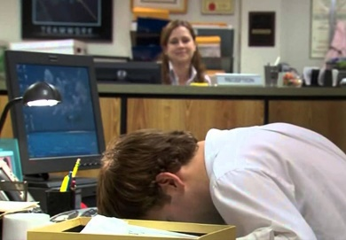 | 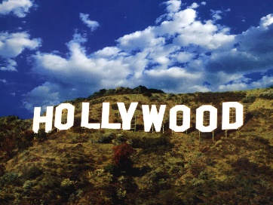 | 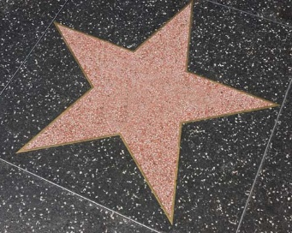

B- Read the story. Were your predictions correct?

Jim couldn’t stand his job. All he did all day was sit at his desk and pretended to work while watching the heavy rain outside his window. He was meant to be selling insurance on the phone, but he wasn’t very good at it. In fact, he had sold very few contracts. This was because all he had ever wanted to do was be an actor in Hollywood. He had loved acting when he was a teenager, but instead of going to America he studied Business and he put off looking for fame. “I’ll look into that when I have finished Uni” he said to himself. This was his biggest regret in life. On his way into work that day, his 15-year-old car broke down. Standing in the rain trying to change the tire he made up his mind. He wasn’t going to carry on like this. He was going to make a big change…

C- Propose a definition for all the highlighted expressions

D- Answer the questions in groups.
- What is Jim’s big dream?
- Why do you think Jim didn’t decide to become an actor after Uni?
- What do you think makes him change his mind?
- What big change do you think he is going to make?
- What will happen at the end of the story?

E- Continue the story. You may use these questions to help you.
What does he decide to do next?
How will he change his life?
What does he do to help him realize his dreams?

F- you have received a story: write the end. You may use these questions to help you.
Does he finally reach his goals?
How does he feel about his situation?
Does he ever think about his old life?

G- Vote for the best story

Forgotten dream, activity inspired by https://freeenglishlessonplans.com/

10 Totally Legit Ways to See a Star in LA
Some people have become obsessed by a celebrity and it can be very unhealthy. The news is full of stories of stars who’ve been stalked by overly-fanatical fans, so I’m definitely not encouraging that kind of stuff in How to Guarantee Seeing a Celebrity in LA! The first thing to know about famous people is that they’re just people, exactly like you and me. If you do come across someone famous while you’re in Los Angeles, please be respectful. Remembering that they live here and that, though seeing them may be a big deal for you (and maybe millions of others), they’re just going about their everyday life.
Nevertheless, there are likely actors, artists or singers that you like, and in whom you’ve become interested, perhaps because you’ve grown-up with them or they’ve touched you in some significant way, and it can be very rewarding to see them in the flesh.

How NOT to See a Celebrity

Before I delve into how to guarantee seeing a celebrity here, let me start by letting you in on a secret. I can guarantee that you WON’T see someone famous while doing any of the celebrity homes minivan tours that run from Hollywood Boulevard. No self-respecting celebrity is going to let themselves be seen by them if they can help it (and they can – that’s why they’ve got security). Legitimate stars don’t want to encourage the tour operators to hound them anymore than they already do! In fact, if you follow this guide, you’ll not only see the celebrity but probably hear from them too.

1. GO TO A HOLLYWOOD WALK OF FAME STAR DEDICATION CEREMONY

Celebrities are obliged to go to the unveiling of their own star on the Walk of Fame and they usually bring along a few of their friends. You can just show up at the ceremony, where they give a speech, sign autographs and take selfies with fans. There are dedication ceremonies on an almost weekly basis. These ceremonies are usually in the morning.

2. GO TO A RED-CARPET MOVIE PREMIERE GALA
TCL Chinese Theatre, El Capitan Theatre and various other movie theatres around town hold film premieres, where most of the cast of will show up to give speeches, sign autographs and take selfies with fans. They’re free to attend and always fun. It’s one of the best ways to guarantee seeing a celebrity in LA.

3. GO TO AN IMPRINT CEREMONY AT THE TCL CHINESE THEATRE
What could be more Hollywood than seeing your favorite star putting their hands and feet into wet concrete? Several times a month there’s an imprint ceremony in the famous forecourt of the Chinese Theatre. Even for the biggest stars getting honored in this way is a big deal.

4. GO TO A TELEVISION SHOW TAPING
A lot of TV shows tape in front of a live audience. It’s free, it can be a lot of fun and you can see how the sausage is made, but you need to sign up online.

5. GO TO THE THEATRE
Los Angeles may not be a theater town, like New York or London, but we do have a lot of great theater here, believe it or not, and a lot of very famous actors have appeared in their plays.

6. GO TO A FILM OR TV SHOW SCREENING
Every week there are movie and Television show screenings, followed by Q and A’s, at venues If you go to one you may be able to ask your favorite actor that burning question you’ve always wanted answered. And they’ll have to respond.

7. GO TO A CONCERT
There are concerts, featuring the very biggest artists out there, in Los Angeles all the time.

8. GO TO A SPORTS MATCH
We’ve got a LOT of great sports teams or franchises here in Los Angeles. Why not catch a game? All of the teams also have celebrity fans, who’ll often show up to games, and you’re guaranteed to see the team’s stars.

9. GO TO A FAMOUS AUTHOR’S BOOK-SIGNING
If the stars you’re interested in are writers (and some writers, such as J.K. Rowling, are big stars) then why not go to an author book-signing or reading ? Libraries and bookstores all have events of this type on a regular basis.

10. GO TO A HALL OF FAME INDUCTION & PERFORMANCE AT THE GRAMMY MUSEUM
Every month the Grammy Museum, in downtown, holds events to honor music artists, which you can attend. It also hosts the annual Grammy Awards Show itself, which obviously has a huge host of the biggest stars performing.

How To Guarantee Seeing A Celebrity In LA, thereallosangelestours.com, May 14, 2024

THE LA RIOTS

Doc 4: LOS ANGELES RIOTS
pur présentation au tableau:

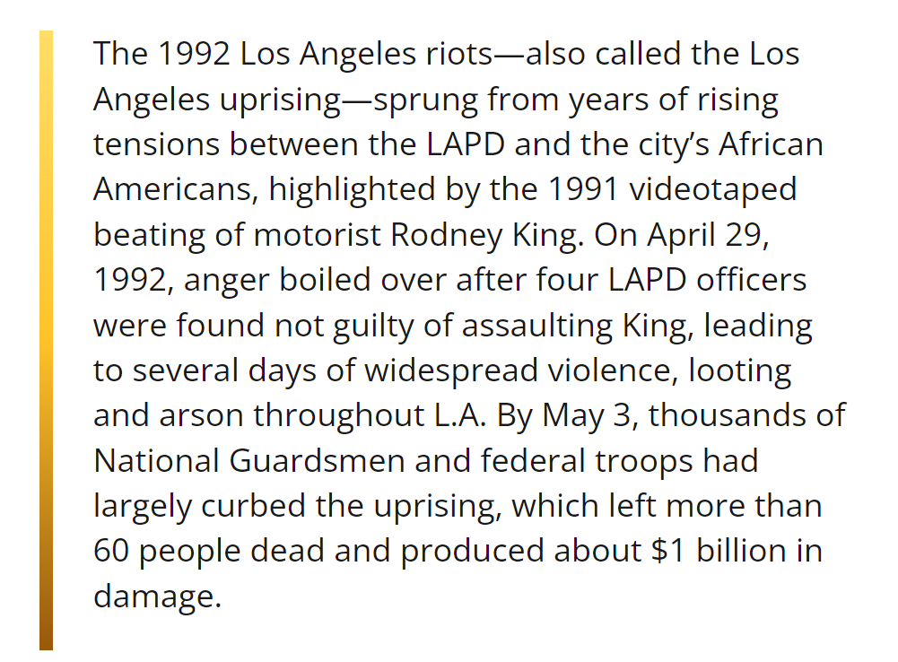
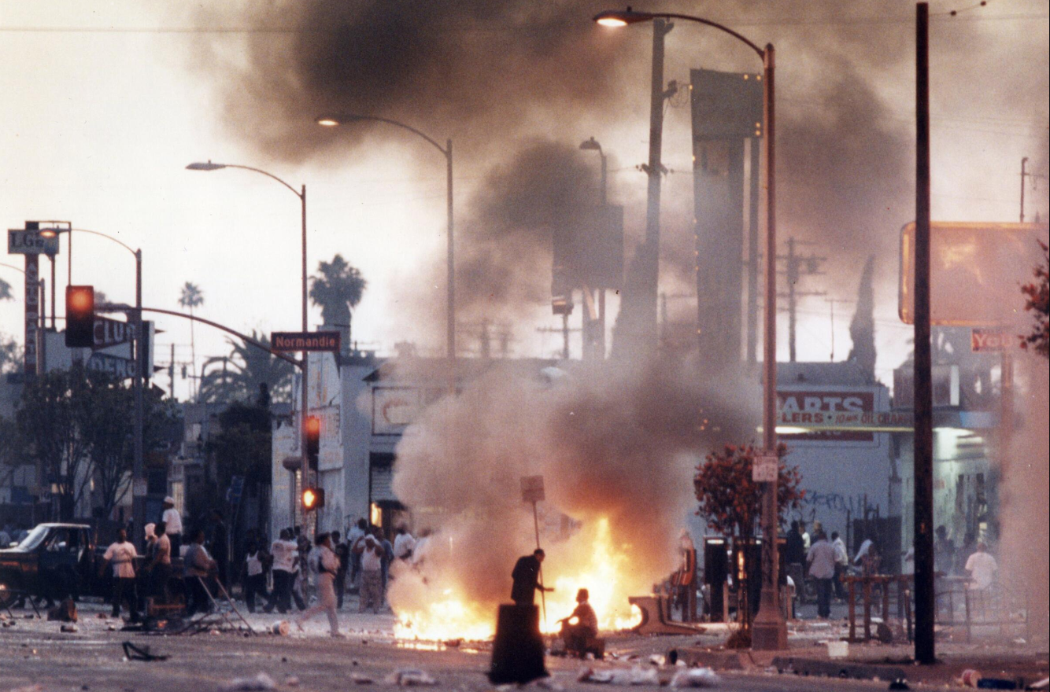
The Rodney King Beating

The L.A. Riots

Violence Spreads Rapidly

Los Angeles Begins to Recover

Aftermath of the L.A. Riots

LAPD Slowly Reforms

LA riots, History.com Editors, updated- April 20, 2021

pour impression:

The Rodney King Beating

The 1980s brought rising unemployment, gang activity, drugs and violent crime to the poorer neighborhoods of Los Angeles. Aggressive efforts to exert control by the Los Angeles Police Department fostered a belief among minority communities that its officers were not held liable for abusive police actions.
Early on March 3, 1991, an intoxicated parolee named Rodney King led police on a high-speed car chase before stopping in Lakeview Terrace. His subsequent beating, was caught on video by Lakeview resident George Holliday, who forwarded it to local station KTLA. Within days, the footage of police repeatedly hitting a Black man with batons was airing on all major networks, drumming up nationwide outrage against the officers involved.
On March 15, LAPD Sergeant Stacey Koon and officers Laurence Powell, Timothy Wind and Theodore Briseno were indicted for assault in the King beating, with Koon and Powell also charged with filing false police reports. The African American community endured another blow the following day, when 15-year-old Latasha Harlins was shot and killed by Korean grocer Soon Ja Du over a disputed shoplifting.
Shortly afterward, L.A. Mayor Tom Bradley formed the independent Christopher Commission to investigate operations within the LAPD. In July, the commission published a report that detailed repetitive use of excessive force and recommended a new system of accountability.
End of November it was announced the trial for the four officers in the King beating would be moved from Los Angeles County to predominantly white Ventura County. In February 1992, the trial commenced with a 12-member jury that included one Latino, one Asian American and one half-African American.

Fostered: favorisé
intoxicated : ivre
parolee : libéré sous conditionnelle
footage : image
indicted : inculpé
shoplifting: vol à l'étalage

The L.A. Riots

At about 3:15 p.m. on Wednesday, April 29, the jury released their verdict: All four officers were acquitted of charges in the King case, save for a mistrial on one charge against Powell of excessive force.
The response was immediate, as protesters took to the streets. Hundreds of people gathered at the Los Angeles County Courthouse to protest the verdict. By 5:30 p.m., the unrest had grown violent near the intersection of Florence and Normandie Avenues in South L.A., where locals attacked passing motorists and forced overwhelmed LAPD officers to retreat.
A news helicopter captured footage of white truck driver Reginald Denny being pulled from his rig and beaten nearly to death, with no signs of police assistance. Minutes later, a Latino driver named Fidel Lopez endured a similar attack.

rig: cabine sur la plate-forme

Violence Spreads Rapidly

In a matter of hours, neighborhoods across South and Central Los Angeles were in flames as rioters firebombed thousands of buildings, smashed windows, looted stores and attacked the Parker Center police headquarters in downtown L.A. By the end of the day, California Governor Pete Wilson had declared a state of emergency and ordered the activation of reserve National Guard soldiers.
The citywide unrest showed little signs of abating on April 30, prompting the suspension of rapid transit, mail service, schools and professional sports games. Many businesses closed, leaving residents to wait in long lines for food and gas, while other store owners, like bands of armed Korean merchants, chose to engage the looters.
Although some 2,000 National Guardsmen had reached the city by 8:00 that morning, a lack of proper communication and equipment prevented effective deployment until later in the afternoon.
May 1, the third day of continued rioting, was marked by the televised appearance of King, who asked for the mayhem to stop, quietly pleading, “Can we all get along?”
That evening, President George H.W. Bush also took to the airwaves to denounce both the “senseless deaths” of the riots and the police brutality that inspired them, and to announce the dispatch of thousands of federal officers to Los Angeles.

Firebombed: bombe incendiaire
looted: piller
abating: ici, de calme
looters : pillards
mayhem: ici chaos
took the airwaves: fit une apparition télévisée

Los Angeles Begins to Recover

By May 2 the disorder had largely quelled. An estimated 30,000 people marched at a peaceful rally for Korean merchants, and volunteers began cleaning up the streets. Meanwhile, arraignments began for some 6,000 alleged looters and arsonists.
Highway exits reopened and police began recovering stolen merchandise the following day, the only significant trouble coming when National Guardsmen shot a driver who attempted to run them over.
On May 4, Mayor Bradley lifted the citywide curfew, and residents attempted to resume day-to-day activities with schools, businesses and rapid transit resuming operations. Federal troops stood down on May 9 and the National Guard soon followed, though some soldiers remained until the end of the month.

quelled: réprimé
arraignments : mises en accusation
alleged : supposé
looters : pilleurs
arsonists: pyromane

Aftermath of the L.A. Riots
The final tally for the L.A. riots included 2,000 injuries, 12,000 arrests and 63 deaths attributed to the uprising. Upwards of 3,000 buildings were burned or destroyed and 3,000 businesses were affected as part of the $1 billion in damages sustained by the city, leaving an estimated 20,000 to 40,000 people out of work.
At the conclusion of the riots, elected officials set about putting the city back together through a combination of federal grants, collaborations with financial institutions and tax proposals.
Governor Wilson and Mayor Bradley tapped Major League Baseball Commissioner Peter Ueberroth to lead the “Rebuild L.A.” effort, which attracted nearly $400 million in corporate investments and set in motion a series of grassroots movements to foster job training and community involvement.

tally: ici, comptes
sustained : ici, infligé à
grants : subventions
tapped: ici, chargé

LAPD Slowly Reforms

Attention was also focused on the culpability of the city’s law enforcement. On May 11, former FBI Director William H. Webster was named to head an investigation into the LAPD response during the riots.
In October, the commission issued a report that criticized both the LAPD and City Hall for being unprepared and slow to handle the response to the riots. It issued a list of recommendations, including redeploying desk officers into community patrols and upgrading the city’s communications and information systems.
Critics of the LAPD earned some vindication in 1993 when officers Koon and Powell were sentenced to 30 months apiece for violating King’s civil rights. In April 1994, King was awarded $3.8 million in a civil lawsuit against the city.
Although the LAPD demonstrated improvements with community-based programs, it resisted implementing most of the recommendations of the 1991 Christopher Commission. It wasn’t until the Rampart Scandal of the late 1990s, which exposed widespread corruption within an LAPD anti-gang unit, that serious change was enacted.
In 2000, the city of Los Angeles entered a consent decree with the U.S. Department of Justice that allowed an independent monitor to oversee reforms. After taking over as LAPD chief in 2002, William Bratton was credited with taking steps to overhaul and improve the perception of the department. In 2013, Department of Justice oversight of the LAPD was fully lifted. However, a 2020 report by the Lawyers’ Committee for Civil Rights found that thousands of non-traffic infractions issued by police in California were being disproportionately enforced on Black and Latino residents.

Widespread: répandu
enacted : engagé
oversee - overhaul - oversight: surveiller, superviser
lifted: levé
enforced: ici, à l'encontre
History.com Editors, Updated: April 20, 2021

texte complet:

The Rodney King Beating
The 1980s brought rising unemployment, gang activity, drugs and violent crime to the poorer neighborhoods of Los Angeles. Aggressive efforts to exert control by the Los Angeles Police Department fostered a belief among minority communities that its officers were not held liable for abusive police actions.
Early on March 3, 1991, an intoxicated parolee named Rodney King led police on a high-speed car chase before stopping in Lakeview Terrace. His subsequent beating, was caught on video by Lakeview resident George Holliday, who forwarded it to local station KTLA. Within days, the footage of police repeatedly hitting a Black man with batons was airing on all major networks, drumming up nationwide outrage against the officers involved.
On March 15, LAPD Sergeant Stacey Koon and officers Laurence Powell, Timothy Wind and Theodore Briseno were indicted for assault in the King beating, with Koon and Powell also charged with filing false police reports. The African American community endured another blow the following day, when 15-year-old Latasha Harlins was shot and killed by Korean grocer Soon Ja Du over a disputed shoplifting.
Shortly afterward, L.A. Mayor Tom Bradley formed the independent Christopher Commission to investigate operations within the LAPD. In July, the commission published a report that detailed repetitive use of excessive force and recommended a new system of accountability.
End of November it was announced the trial for the four officers in the King beating would be moved from Los Angeles County to predominantly white Ventura County. In February 1992, the trial commenced with a 12-member jury that included one Latino, one Asian American and one half-African American.

The L.A. Riots
At about 3:15 p.m. on Wednesday, April 29, the jury released their verdict: All four officers were acquitted of charges in the King case, save for a mistrial on one charge against Powell of excessive force.
The response was immediate, as protesters took to the streets. Hundreds of people gathered at the Los Angeles County Courthouse to protest the verdict. By 5:30 p.m., the unrest had grown violent near the intersection of Florence and Normandie Avenues in South L.A., where locals attacked passing motorists and forced overwhelmed LAPD officers to retreat.
A news helicopter captured footage of white truck driver Reginald Denny being pulled from his rig and beaten nearly to death, with no signs of police assistance. Minutes later, a Latino driver named Fidel Lopez endured a similar attack.

Violence Spreads Rapidly
In a matter of hours, neighborhoods across South and Central Los Angeles were in flames as rioters firebombed thousands of buildings, smashed windows, looted stores and attacked the Parker Center police headquarters in downtown L.A. By the end of the day, California Governor Pete Wilson had declared a state of emergency and ordered the activation of reserve National Guard soldiers.
The citywide unrest showed little signs of abating on April 30, prompting the suspension of rapid transit, mail service, schools and professional sports games. Many businesses closed, leaving residents to wait in long lines for food and gas, while other store owners, like bands of armed Korean merchants, chose to engage the looters.
Although some 2,000 National Guardsmen had reached the city by 8:00 that morning, a lack of proper communication and equipment prevented effective deployment until later in the afternoon.
May 1, the third day of continued rioting, was marked by the televised appearance of King, who asked for the mayhem to stop, quietly pleading, “Can we all get along?”
That evening, President George H.W. Bush also took to the airwaves to denounce both the “senseless deaths” of the riots and the police brutality that inspired them, and to announce the dispatch of thousands of federal officers to Los Angeles.

Los Angeles Begins to Recover
By May 2 the disorder had largely quelled. An estimated 30,000 people marched at a peaceful rally for Korean merchants, and volunteers began cleaning up the streets. Meanwhile, arraignments began for some 6,000 alleged looters and arsonists.
Highway exits reopened and police began recovering stolen merchandise the following day, the only significant trouble coming when National Guardsmen shot a driver who attempted to run them over.
On May 4, Mayor Bradley lifted the citywide curfew, and residents attempted to resume day-to-day activities with schools, businesses and rapid transit resuming operations. Federal troops stood down on May 9 and the National Guard soon followed, though some soldiers remained until the end of the month.

Aftermath of the L.A. Riots
The final tally for the L.A. riots included 2,000 injuries, 12,000 arrests and 63 deaths attributed to the uprising. Upwards of 3,000 buildings were burned or destroyed and 3,000 businesses were affected as part of the $1 billion in damages sustained by the city, leaving an estimated 20,000 to 40,000 people out of work.
At the conclusion of the riots, elected officials set about putting the city back together through a combination of federal grants, collaborations with financial institutions and tax proposals.
Governor Wilson and Mayor Bradley tapped Major League Baseball Commissioner Peter Ueberroth to lead the “Rebuild L.A.” effort, which attracted nearly $400 million in corporate investments and set in motion a series of grassroots movements to foster job training and community involvement.

LAPD Slowly Reforms
Attention was also focused on the culpability of the city’s law enforcement. On May 11, former FBI Director William H. Webster was named to head an investigation into the LAPD response during the riots.
In October, the commission issued a report that criticized both the LAPD and City Hall for being unprepared and slow to handle the response to the riots. It issued a list of recommendations, including redeploying desk officers into community patrols and upgrading the city’s communications and information systems.
Critics of the LAPD earned some vindication in 1993 when officers Koon and Powell were sentenced to 30 months apiece for violating King’s civil rights. In April 1994, King was awarded $3.8 million in a civil lawsuit against the city.
Although the LAPD demonstrated improvements with community-based programs, it resisted implementing most of the recommendations of the 1991 Christopher Commission. It wasn’t until the Rampart Scandal of the late 1990s, which exposed widespread corruption within an LAPD anti-gang unit, that serious change was enacted.
In 2000, the city of Los Angeles entered a consent decree with the U.S. Department of Justice that allowed an independent monitor to oversee reforms. After taking over as LAPD chief in 2002, William Bratton was credited with taking steps to overhaul and improve the perception of the department. In 2013, Department of Justice oversight of the LAPD was fully lifted. However, a 2020 report by the Lawyers’ Committee for Civil Rights found that thousands of non-traffic infractions issued by police in California were being disproportionately enforced on Black and Latino residents.

History.com Editors, updated: April 20, 2021

Fostered: favorisé - intoxicated : ivre - parolee : libéré sous conditionnelle - footage : image - indicted : inculpé - shoplifting: vol à l'étalage
rig: cabine sur la plate-forme
Firebombed: bombe incendiaire - looted: piller abating: ici, de calme - looters : pillards - mayhem: ici chaos- took the airwaves: fit une apparition télévisée
quelled: réprimé - arraignments : mises en accusation - alleged : supposé - looters : pilleurs - arsonists: pyromane
tally: ici, comptes - sustained : ici, infligé à - grants : subventions - tapped: ici, chargé
Widespread: répandu - enacted : engagé - oversee - overhaul - oversight: surveiller, superviser- lifted: levé- enforced: ici, à l'encontre

