MALTESE HISTORY

Unit N

Malta During the Two World Wars

Form 5

Unit N.1 - Malta and the First World War (1914-1918)
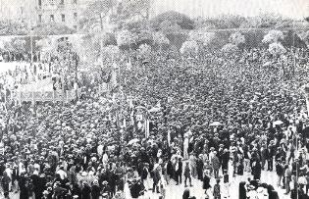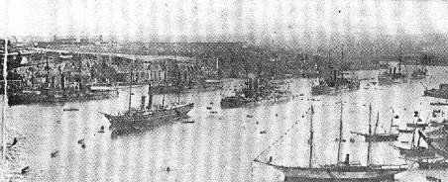
1. An anti-Kaiser demonstration in 1914. 2. Ships in Grand Harbour during World War I.

Malta’s Contribution in the First World War
During the First World War (1914-18) Malta was never attacked by the enemy. Malta’s harbours were used by the allies as a naval and military base against the Central Powers ( Germany, Austria-Hungary, Turkey and Bulgaria). The Maltese contributed very little in the actual fighting during the war, except in April 1915 when there was the Gallipoli Campaign against Turkey. During that attack about 800 volunteers were grouped into the Maltese Labour Battalion to dig trenches for the allies at Gallipoli.
During the war the Grand Harbour became busy with all sorts of activities. Malta’s harbour became the headquarters of the British fleet. The harbour warehouses were used to store ammunition and all sorts of military equipment. The harbour swamped with warships and transport vessels for repairs at the dockyard. The hospitals, barracks and some schools were turned into military hospitals for thousands of injured and sick soldiers brought from the warfront. Malta became known as the Nurse of the Mediterranean.
During the war the dockyard workers were increased from 3,500 to 14,000. In 1916, under the leadership of Henry Ear, a former follower of Manwel Dimech, the dockyard workers set up the first trade union in Malta (the Government General Workers Union. This union had 4,000 members in 1917. In 1917 they organized a demonstration in Valletta and held the first strike in Malta. The British Government had to give them a 50% rise in their wages.

Effects of the War on the Maltese
During the war German submarines attacked allied ships in the Mediterranean. These attacks caused scarcities of most imported food items in Malta: wheat, flour, oil, cheese, meat, sugar, wood and kerosine. Scarcities led to a rise in prices and in the cost of living. The price of bread trebled between 1914 and 1918. The increase in the price of bread hit worst the lower classes who already had low wages. Meanwhile, the Government had to make new taxes to make up for income lost from customs duties. The new taxes introduced hit mostly the middle and upper classes: a tax on cinema tickets and a succession duty on wills. After the war the Maltese hoped that prices would go down. But some of the results of the war could not be solved all at once. These conditions were to cause serious political and social unrest in many parts of Europe and in Malta as well.
After the war thousands of dockyard workers were the first to loose their job. By March 1919, dockyard workers went down from 15,000 to 8,000. The fear of unemployment united the working classes to set up the Camera del Lavoro. In 1921 this organization organized itself into a political party with the name of Labour Party (L.P.). To make matters even worse, those who found themselves without work found almost impossible to emigrate because the US, Canada and Australia refused to give working permits to Maltese emigrants.
Following the armistice of November 1918 that ended the First World War, Dr Filippo Sciberras, a leading Nationalist politician made an appeal to the Maltese politicians meet and formulate a constitution that would give the Maltese self-government. His appeal led to the formation of a National Assembly with more than 250 delegates. The first meeting was held in February 1919 at La Giovane Malta Nationalist Party Club, Valletta. Sciberras was as elected as its President. The Assembly was made up of representatives from the political parties, the Chamber of Advocates, the dockyard trade union, the clergy, the nobles, the business community, the notaries, the university students and the press.
In the meantime, between February and June 1919, the political situation went from bad to worse. While the Maltese political leaders were demanding self-governmen, the press invited the people to protests against the new taxes. Here the press helped to further turn public opinion against the British. Most of the ten newspapers published at that time were anti-Britis (e.g. La Voce del Popolo, Unjoni Maltija, Malta Għadha Tagħna and Il-Ħmar). The newspapers that were most inclined towards the British were The Daily Malta Chronicle and The Malta Herald. Heavy unemployment, low wages and high prices further angered the lower classes. In May 1919 the university students held a protest when their degree courses in law and medicine were lengthened by another two years. When the leaders of these students were taken to Court a large crowd entered Valletta to give them support. It happened also that at this critical moment Malta was without a Governor because Lord Mathuen had left Malta in April. Until a new Governor arrived, General Hunter-Blair served as acting-governor.

Unit N.2 - The Military Fronts during World War I

Task 1: Use a highlighter marker to mark the major areas where most of the fighting took place.
Task 2: Discussion: Using the map as your source, give reasons why the Allies won whereas the Central Powers lost the war.
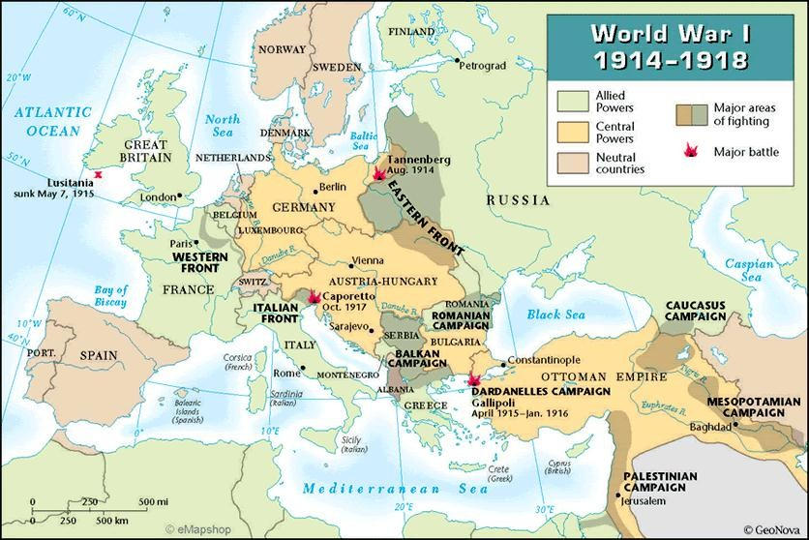

Unit N.1 – Malta and the First World War

- Malta did not suffer direct attacks by the enemy during World War I. (True/False) (1)
- Identify and correct the mistake in the following statement:
Malta’s economy was badly affected by Italian submarine raids on allied ships in the Mediterranean. (1)
- How did Malta help the Allies during World War I? Give two examples.

(2)

- How was the Grand Harbour used by the British during the war?
(1)

- How were the Maltese involved in the Gallipoli Campaign of 1915?
(1)

- Suggest two reasons why dockyard workers obtained a 50% wage increase during the war?

(2)

- How was Malta called during the war and why was it called so?

(2)

- Identify two problems in Malta that were still not solved when the war ended in 1918.

(2)

- Identify the connection between Manwel Dimech and the setting up of the Labour Party in 1921?
(2)

- How do we know from the text that the Maltese became more interested in political and constitutional developments once the war ended. Identify two reasons.

(2)

- Between February and June 1919 the political situation went from bad to worse. Which of these developments helped to bring about this situation:
  - rise in unemployment
  - increase in foreign trade
  - meeting of the National Assembly
  - the resignation of the British Governor
  - anti-British stance in some newspapers
  - discharges of workers from the dockyard
  - introduction of new taxes
  - changes in University degree course
  - the granting of responsible government
  - the setting up of the Malta Union of Teachers (MUT) in 1919 (3)
(Total 20 marks)

Unit N.3 - The Military Fronts during World War II

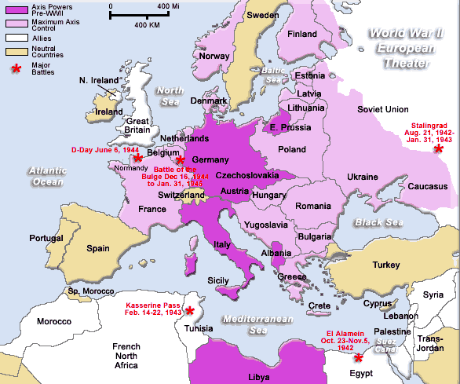Discussion Task

Using the map as your source, Give reasons to show the Contribution which Malta gave the victory of the Allies in
the Mediterranean and North Africa between 1940 and 1943.

Unit N.4 - Malta during the Second World War (1940-1943) (1)

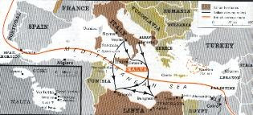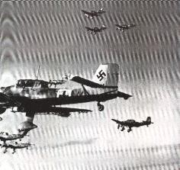

During the Second World War Malta undergone a second siege that lasted from 1940 to 1943. Italian and German bombings caused hardship and damage to people living close to the Grand Harbour towns.

Why did Italy attack Malta in June 1940?
Malta was a base of the British Mediterranean fleet and had one of the best dockyards in the Mediterranean. From Malta, the British could attack Italian convoys on their way from Sicily to Italian North Africa (Tripoli). Dictator Mussolini and the fascists wanted to include Malta in a new Italian Mediterranean Empire. Malta suffered its first air raid at the dockyard and the airfields (Luqa, Hal Far, Ta’ Qali) the day after Italy declared war on Britain on 10th June 1940.

How was Malta defended during the war?
At the beginning of the war, Malta’s defenses consisted of anti-aircraft guns, searchlights, four Gladiator fighter aircraft (named Faith, Hope and Charity) and a radar station. The Italians air force had 200 aircraft in Sicily with which to attack Malta. Once attack on Malta started, the Royal Air Force brought more aircraft from Gibraltar and Egypt to defend Malta (hurricanes, swordfish planes, flying boats, Wellington bombers, Spitfires).

How was Malta attacked by the Axis powers?
In Dec. 1940, the Italians were losing the war in North Africa. The Germans came to help their Italian allies in North Africa. The German air force (Luftwaffe) stationed 150 aircraft with which to attack Malta. By that time Malta was defended by some 60 fighters. The Germans bombings caused the greatest damages. They sank the aircraft carrier Illustrious in Grand Harbour and damaged the Royal Theatre.
The year 1941 was going badly for the British in the Mediterranean. They were losing many ships because of attacks by Italian and German submarine and aircraft attacks. Field Marshall Rommel, one of Germany’s most brilliant generals in the war, came very close to Egypt. The Germans occupied Crete from which they attacked British convoys on their way to Egypt. The Axis powers were preparing ‘Operation Sea Lion’ - the invasion of Malta from Sicily. But the invasion was postponed when Hitler decided to attack Russia instead (22nd July 1941). In July 1941 the Italians made a bold attack upon the Grand Harbour using E-Boats. The attack failed but one e-Boat hit and destroyed the Breakwater’s iron bridge.
In the early months of 1942 the island was raided almost incessantly. Fighter aircrafts had to be flown from aircraft carriers far away from Malta. By July 1942 there were over 200 fighters defending the island. Convoy ships carrying food, weapons and feul were shipped to Malta from Britain or Egypt. These convoys were attacked as soon as they approached Sardinia and Sicily. The famous Convoy of Sta Marija, (codenamed Operation Pedestal) reached Malta on 15th August 1942. Without this convoy, the British would have been forced to surrender the islands to the enemy.
What contribution did the allied base at Malta give to the victory by the Allies?On 15th April 1942, a brief message came from King George VI to Governor Lord Gort: ‘To Honour her brave People I award theGeorge Cross to the Island Fortress of Malta to bear witness to a Heroism and Devotion that will long be famous in History.’

Unit N.4 - Malta during the Second World War (1939-1945) (2)
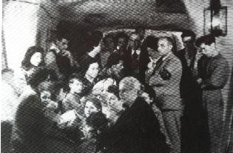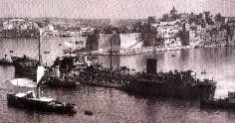

When did the war over Malta come to an end?
By Oct. 1942 the Axis air forces lost the battle for Malta. The British victory at the Battle of El Alamein in Oct. proved decisive. In November 1942 American troops landed in Morocco. By May 1943 all North Africa was in won back by the allies. British air-raids from Malta on axis convoy ships on their way to North Africa helped the allies to win the war in North Africa.
The Allies planned and started the invasion of Sicily from Malta in 1943. Once Sicily was occupied, the strategic value of Malta as an air base declined. The enemy could no longer attack allied ships in the Central Mediterranean.
In 1944 US President Roosevelt visited the island on his way from Teheran Conference to congratulate the Maltese for their heroic resistance against the enemy. The British Government announced that self- government would be given again to Malta after the war. On 8th September 1944 the Italian fleet surrendered in the Grand Harbour.

Why did the Axis powers fail to take Malta?
There were reasons why the Axis powers failed to conquer Malta, namely:
- The Italian and German commanders did not have a consistent plan: by bombardment, starving the population or by a direct invasion).
- Axis plans against Malta were changed too frequently. This gave the British time to strengthen Malta’s defenses.
- The axis powers failed to invade the island in 1941 when Malta’s defenses were weakest.
- The Maltese and the British fought on and endured all hardships heroically without losing morale.

How was life for the Maltese during the war?The Grand Harbour towns were the greater part of the population lived were heavily bombed and damaged by air attacks. Within a few months hundreds rock cut shelters were dug in the soft limestone. Most of these shelters were dug by muscle power. By May 1941 there were shelters to accommodate some 185,000 people. Most of the dockyard workshops were moved into caverns dug in the rock.
War damage was greatest in the harbour towns. There were 35,000 homes destroyed or damaged in Valletta and the Three Cities. A number of important historical buildings were in ruins as well. The population of Valletta and The Three Cities never recovered after the war. War damage resulted in a great shortage of housing for several years after the war. The British Government gave Malta £20 million as compensation for the ‘War Damage’.

Every day life in general was disrupted by incessant enemy air-raids. Many streets were blocked for days with rubble when whole blocks of houses collapsed when hit by bombs. Commerce was disrupted but there was no unemployment. Men between 18 and 41 were liable for service in the armed forces. Savings and wages were high. But wealth was concentrated in the hands of those with goods to sell, mostly farmers. The Government tried to stop black market and profiteering.
During most of 1942 the Maltese were slowly starving because there was not enough food and fuel for cooking. Daily food rations and Victory Kitchens were opened to feed the population. Civilian victims of the war numbered 1,490. But the morale of the population never broke down. One important result of the war was to bring the Maltese and the British much closer together.

Unit N.4 - Malta during the Second World War - 1

- Fill in the table by giving one important event that took place in Malta in relation to the war. (8)

 | Year | Event
(a) | 1940
(b) | 1941
(c) | 1942
(d) | 1943

- Give two reasons why Malta was attacked by the axis forces.

(2)

- Mention two ways how Malta was defended by the allies.

(2)

- Mention two ways how the axis powers tried to force the British surrender Malta.

(2)

- Give two reasons why the axis powers failed to take Malta.

(2)

- Mention four effects of the war on the everyday life of the Maltese.

(4)

(Total: 20 marks)

Unit N.4 - Malta during the Second World War - 2
Write a sentence to explain the meaning of the following terms in connection to Malta during the Second World War

1 | Victory Kitchens
2 | Food rationing
3 | Blackout
4 | Lascaris War Rooms
5 | Operation Sea Lion
6 | Operation Pedestal
7 | Convoy
8 | Pill Boxes
9 | Sirene
10 | Black market

(Total 20 marks)

Unit N.5 - Malta during the Second World War in Pictures

Source Investigation

Write your own captions to describe these photograph sources about World War II in Malta. The first two are given as an example. (Total = 20 marks)
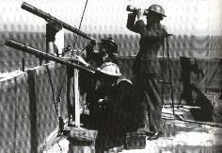
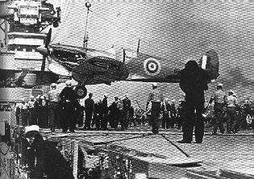
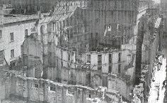
1. An anti-air raid watch out. 2. Sending fighter planes 3.
for the defense of Malta.

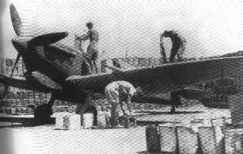
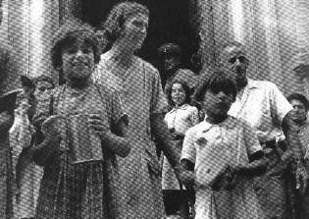
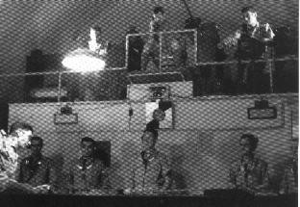

4. 5. 6.

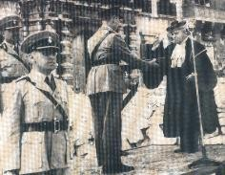
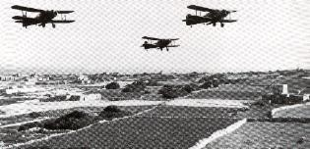
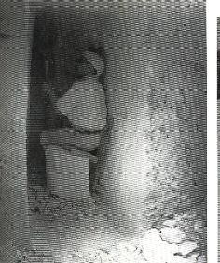

7. 8. 9.

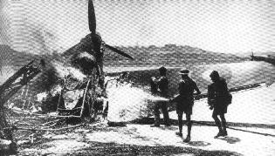
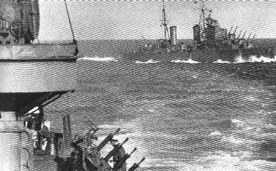
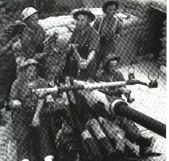

10. 11. 12.

Unit N.6 – Long Term Consequences of the Two World Wars on Malta

Classify these long-term consequences of the First World War on Malta as:
political (P), social (S) or economic (E). (6)

1 | There was a sharp rise in the price of some food items such as bread.
2 | The Maltese leaders met to prepare a draft self-government constitution.
3 | Rundowns from the Dockyard resulting in a sharp rise in unemployment.
4 | Many Maltese emigrated to the US and other English speaking countries.
5 | Many people took part in demonstrations against the British Government..
6 | The British Government introduced new taxes to help increase its revenue.

Classify these long-term consequences of the Second World War on Malta as:
political (P), social (S) or economic (E). (14)

1 | Valletta and Cottonera declined in population since many of their former residents preferred to stay in the remoter villages.
2 | A baby boom was registered between the years: 1945-1954.
3 | Unemployment led to widespread poverty among the lower classes.
4 | Malta lost much of its strategic position as a naval base in the British Empire.
5 | The Maltese were granted responsible government with a new Constitution in 1947.
6 | There was an acute shortage of housing due to the wartime bombings.
7 | Women acquired the right to vote.
8 | A rise in unemployment due to rundowns by the British Services Departments.
9 | The Government laid the foundations of the welfare state to reduce poverty.
10 | The political parties reorganized themselves and resumed their political activities.
11 | Mass emigration to English speaking countries with the Government’s backing.
12 | The strengthening of trade unionism with the setting up of the GWU in 1943.
13 | Hundreds of workers discharged from the Dockyard.
14 | The War Damage Commission reported on the economic cost of the war on Malta.
(Total 20 marks)

Unit N.7 – Malta During the Two World War – Essay Questions

Read carefully the following essay titles and answer any ONE in about 200 to 300 words. Essays carry 20 marks each.

PAPER 2A

- What were the main economic and social effects of the Second World War on Malta and the Maltese? (SEC)
- Why were Maltese Governments so concerned with economic issues in the decades after the
Second World War? (SEC)
- What part did Malta play during the Second World War? How did this effect the people? (SEC 2012)
- What part did Malta play during the First World War? Account for some of the social and economic effects of that war upon the Maltese. (Annual Paper 2009)

PAPER 2B
  - Malta was closely affected by the First World War. Describe in brief:
    - the economic effects on the Island (8)
    - the social effects on the Maltese population (6)
    - the political effects (SEC 1995) (6)
  - Describe life in Malta in the 1940-43 period under four of the following headings:
    - aerial bombings by the Axis Powers
    - life in the shelters
    - the threat of famine
    - the Illustrious episode
    - award of the George Cross (5 x 4) (SEC 1998)
  - Discuss briefly:
    - how Malta served the Allied cause in World War II (10)
    - how the war affected different aspects of Maltese life.(10) (SEC 1998)
  - In 1945 World War II ended.
    - Describe the political situation in Malta at the time. (6)
    - What did the Maltese ask for in the period after 1945? (8)
    - How did they go about it and what were the results? (6) (SEC 1997)
  - Describe the economic and social effect of:
    - the First World War (8) (b9 the Second World War (12) (SEC 2009)
  - Discuss Malta’s role during the Second World War. Explain under the following headings:
    - the attack on the Illustrious
    - daily life during the war
    - the ‘Santa Maria Convoy’
    - the political effects of the war
    - the economic and social consequences of the war (5 x 4) (SEC 2012)
  - Discuss the political, social, economic and cultural effects of World War II on the Maltese. (Annual Paper 2010)

13

