NAME: ______________________________________ DST – A MONARCHIE FOR THE 21ST CENTURY ?

Qualité du contenu | Cohérence de la construction du discours | Correction de la langue écrite | Richesse de la langue

Show how the three documents reflect British people’s diverse perceptions of the monarchy and the impact of those perceptions on national cohesion.

DOCUMENT A: With Queen Elizabeth's death, republicans sense their chance

LONDON, Sept 9 (Reuters) - During Queen Elizabeth's 70-year reign, republican rumblings surfaced on occasion, but the affection and respect she enjoyed meant that the movement to do away with the monarchy struggled to make a lasting impression.
Now, with her death and the accession of her less popular son Charles, republicans believe
5 that the end of the 1,000-year-old institution could be a step closer.
"The queen is the monarchy for most people. After she dies the future of the institution is in serious jeopardy," Graham Smith, chief executive of campaign group Republic, said earlier this year.
"Charles may inherit the throne, but he won't inherit the deference and respect afforded [to]
10 the queen."
Smith and like-minded anti-monarchists argue that the royal family has no place in a modern democracy, and is staggeringly expensive to maintain.
Royal officials say the institution costs each Briton less than 1 pound ($1.15) annually, but Republic says its true cost to the nation each year is about 350 million pounds.
Michael Holden, reuters.com, 9 September 2022.
DOCUMENT B
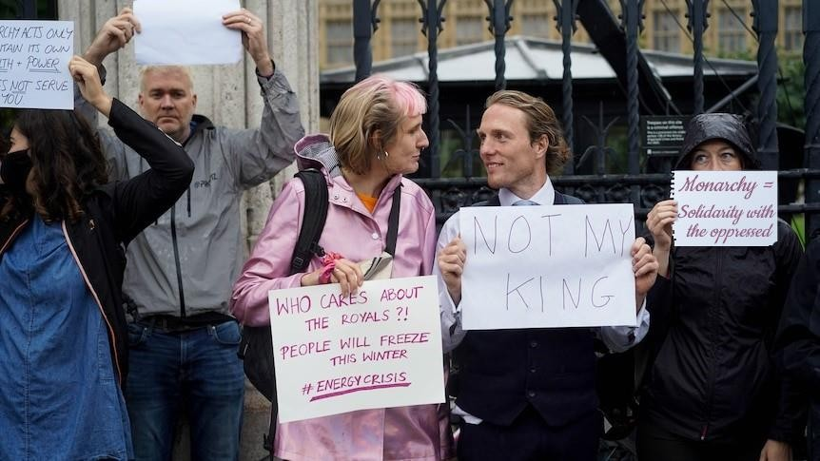

Barrister¹ Paul Powlesland, holding a "Not my King" sign, says the events of this week have turned him into a republican.
Tim Leslie, ABC News, 13 September 2022
1 A barrister is a lawyer.
DOCUMENT B

British social attitudes to the monarchy
How important does the public feel it is for Britain to continue to have a monarchy? The National Centre for Social Research (NatCen)¹ has today released new data detailing trends in attitudes to the monarchy from 1983 to 2021.

The public has consistently said it’s important for Britain to continue to have a monarchy
In every year when data was collected on the British Social Attitudes survey from 1983 to 2021, a majority has said it is important for Britain to continue to have a monarchy. Between 1994 and 2021, on average, two-thirds (67%) of people in Britain have expressed this view. In 2021, 31% said the monarchy was ‘very important’, 24% said it was ‘quite important’ and 18% said it was ‘not very important’. Eleven per cent said it was ‘not at all important’ and 14% said it should be abolished.

The impact of royal successes and problems on public consent
Strong support for the monarchy reached the highest point for 20 years in 2011 and 2012, the years of HM The Queen’s first ever visit to the Republic of Ireland and her handshake with former IRA commander Martin McGuinness, as well as Prince William and Kate Middleton’s wedding and the Queen’s Diamond Jubilee. […]
Support for the monarchy has declined in recent years during a period of problems and controversies surrounding Prince Harry and his wife Meghan, Duchess of Sussex, as well as Prince Andrew. […]

An uncertain future for public support for the monarchy?
Younger people are less likely than older people to say that it is ‘very important’ that Britain has a monarchy. 14% of under 35 year olds took this view in 2021, compared with 44% of those aged 55 and over.
This may suggest a risk that support for the monarchy will decline as today’s older generation is replaced by younger cohorts. However, the gap between younger and older people was much the same in 1994 as it is now. The relative stability of the age gap reflects the fact that the older they become, the more likely they are to feel it is ‘very important’ to have a monarchy.

NatCen Social Research report, 9 September 2022.

1 An independent British social research organisation

CORRECTION

Qualité du contenu | Doc A : journal étranger – Reuters mise en doute de la continuité de la monarchie  Elizabeth II comme seule référente – long règne (70 ans)  remise en question des capacité deCharles -  prix de la monarchie  Doc B : photo / capture écran de ABC News – explication: barrister – events of ths week => mort de la reine qui provoque le changement d'opinion d'un avocat  panneau interpelle coût de la vie du quotidien vs le coût de la monarchie  Doc C : article de journal – 3 points soulignés: le désir d'une monarchie – besoin de l'adhésion du public – question quand au futur car les jeunes se sentent moins concernés
Cohérence de la construction du  discours | Doc A : différents niveaux d'argumentation – mise en cause de la personne- de la place de la monarchie ds un monde moderne - coût  Doc B : Abc news = une chaine australienne – Australie fait parti du Commonwealth => question de la place de l'Australie et de la suprémacie de la représentation monarchiste dans le Commonwealth  sous entendu = qu'un homme cultivé, fin connaisseur du système juridique puisse choisir de changer d'opinion –  conversion possible  Doc C :– independent British social research organisation => n'est soumis à aucun courant d'influence – rappel des obligations de la monarchie: au délà des chiffres besoin de se vendre et d'obtenir l'appui du public => sans public plus de monarchie  besoin de se faire une nouvelle image: les anglais étaient très attachés à la reine Elizabeth – besoin d'être associé à des moments joyeux et symbolique et pas des scandales – besoin de s'appuyer sur la jeunesse => c'est passé par William et Harry, ça devra passer par George, Charlotte et Louis  grande responsabilité qui incombe à Charles et à son fils - rappel que la monarchie ne peut se faire que son peuple – fragilité de la monarchie -remise en cause aisée – fluctuation possible

