NAME: ______________________________________

Identification du contexte /de la situation d’énonciation | Identification des réseaux de sens | Identification des stratégies de communication

DOCUMENT A - What's the latest on Los Angeles wildfires and how did they start?

Firefighters made progress over the weekend in containing the Palisades and Eaton fires but warn that the return of high winds - forecast until Wednesday - could see them spread again. They are already among the most destructive in LA's history in terms of buildings destroyed. The number of people under evacuation orders in LA County has decreased since Saturday, but the destruction is immense.
Over 12,000 structures - homes, outbuildings, sheds, mobile homes and cars -have been destroyed including 7,000 in the Eaton fire. The fires could turn out to cost up to $150bn, according to a preliminary. Many elebrities who have lost their homes.
Tens of thousands of homes are also without power.
The largest fire is in the Palisades and it has burnt through more than 23,000 acres. But over the weekend thousands of firefighters made progress in containing about 14% of it.
The blaze is moving east, threatening the exclusive neighbourhood of Brentwood, home to the Getty Center, a world-famous art museum that has now evacuated its staff.

Was LA prepared for the fires?
A political row about the city's preparedness has erupted after it emerged some fire crews' hoses ran dry.
California Governor Gavin Newsom has called for an independent investigation into the loss of water pressure to hydrants and why the Santa Ynez Reservoir was closed for maintenance and empty when the fire broke out.
Mayor Karen Bass has faced intense questions about the region's preparedness and the water issues. On Saturday, she deflected questions about her handling of the emergency, telling a news conference: "Right now, our first and most important obligation to Angelenos is to get through this crisis."
Before the fires broke out, the city of LA's fire chief warned in a memo that budget cuts were endangering the department's ability to respond to emergencies.
But LA County Fire Chief Anthony Marrone has denied that his department had been unprepared.
"I did everything in my power to make sure that we had enough personnel and resources before the first fire started," he said.

13/01/2025 https://www.bbc.com/news

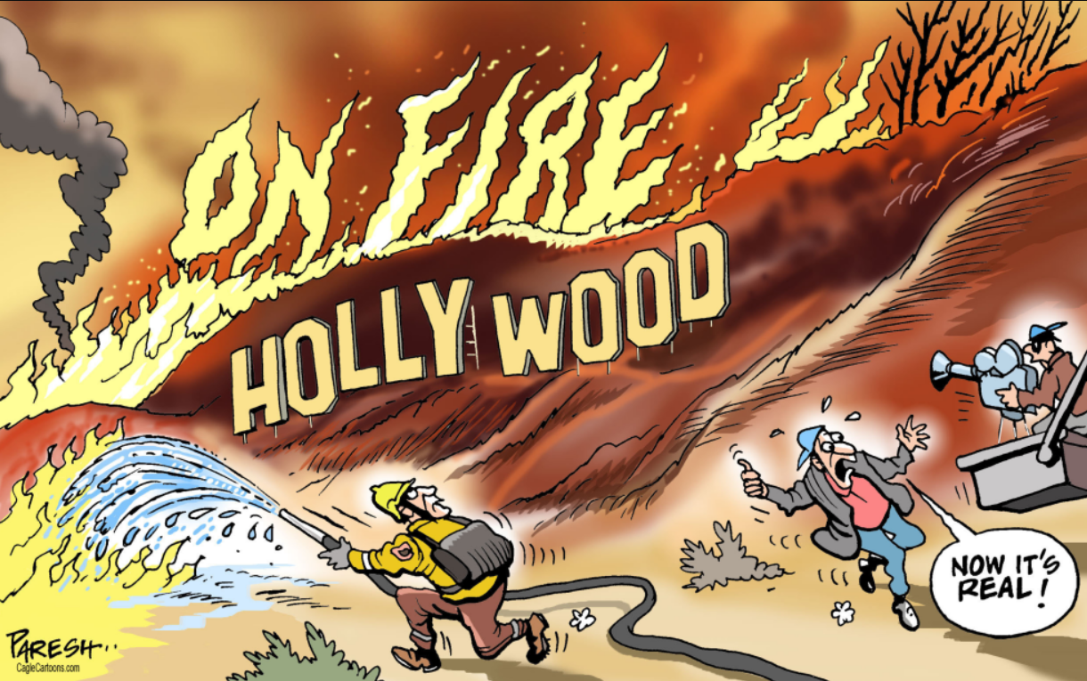
DOCUMENT B : Hollywood on fire – Paresh, Caglecartoons.Com, January 2025

NAME: ______________________________________

Identification du contexte /de la situation d’énonciation | Identification des réseaux de sens | Identification des stratégies de communication

DOCUMENT A - What's the latest on Los Angeles wildfires and how did they start?

Firefighters made progress over the weekend in containing the Palisades and Eaton fires but warn that the return of high winds - forecast until Wednesday - could see them spread again. They are already among the most destructive in LA's history in terms of buildings destroyed. The number of people under evacuation orders in LA County has decreased since Saturday, but the destruction is immense.
Over 12,000 structures - homes, outbuildings, sheds, mobile homes and cars -have been destroyed including 7,000 in the Eaton fire. The fires could turn out to cost up to $150bn, according to a preliminary. Many elebrities who have lost their homes.
Tens of thousands of homes are also without power.
The largest fire is in the Palisades and it has burnt through more than 23,000 acres. But over the weekend thousands of firefighters made progress in containing about 14% of it.
The blaze is moving east, threatening the exclusive neighbourhood of Brentwood, home to the Getty Center, a world-famous art museum that has now evacuated its staff.

Was LA prepared for the fires?
A political row about the city's preparedness has erupted after it emerged some fire crews' hoses ran dry.
California Governor Gavin Newsom has called for an independent investigation into the loss of water pressure to hydrants and why the Santa Ynez Reservoir was closed for maintenance and empty when the fire broke out.
Mayor Karen Bass has faced intense questions about the region's preparedness and the water issues. On Saturday, she deflected questions about her handling of the emergency, telling a news conference: "Right now, our first and most important obligation to Angelenos is to get through this crisis."
Before the fires broke out, the city of LA's fire chief warned in a memo that budget cuts were endangering the department's ability to respond to emergencies.
But LA County Fire Chief Anthony Marrone has denied that his department had been unprepared.
"I did everything in my power to make sure that we had enough personnel and resources before the first fire started," he said.

13/01/2025 https://www.bbc.com/news

DOCUMENT B : Hollywood on fire – Paresh, Caglecartoons.Com, January 2025

