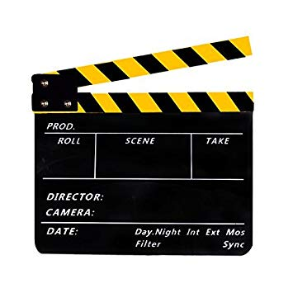
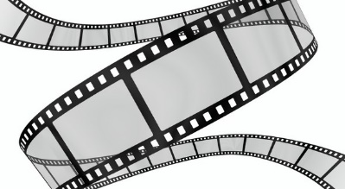
Film Glossary
Useful terminology to analyse films

- Match the following words with the right definition:
Fade-out / High angle shot / bird’s eye view / flashforward / soundtrack / omniscient point of view / ellipsis / ambiant light / wipe / reverse angle shot / subjective shot/ cut / sound effects / freeze-frame (or still) / establishing shot / close-up / full shot / dissolve / low angle shot / voice-over / flashback

- SHOTS AND CAMERA ANGLES
________________________________ = A detailed view of a person or object / shot taken at close range
________________________________ = A shot in which the camera photographs a scene from directly overhead.
________________________________ = Usually an extreme long or long shot offered at the beginning of a scene or sequence providing the viewer with the context of the subsequent closer shots.
________________________________ = A type of long shot which includes the human body in full
______________________________________ = A shot in which the subject is filmed from above (often to make the subject look small, weak or vulnerable)
______________________________________ = A shot taken from a low position looking upwards
______________________________________ = A shot taken from an angle 180° opposed to the previous shot -- that is, the camera is placed opposite its previous position.
______________________________________ = a single frame of a film repeated to give an effect like a still photograph or static image

- TRANSITIONS
_____________________________ = when the light decreases and the scene goes dark.
_____________________________ = gradual replacement of one shot by another. This kind of transition, in which the outgoing and incoming shots merge
_________________ = editing device, usually a line which travels across the screen, "pushing off" one image and revealing another.
________________ = an abrupt or sudden change or jump in camera angle, location, placement, or time, from one shot to another

- SOUND AND LIGHTING
____________________________ = the sound recorded on a film
____________________________ = sounds that are artificially produced for dramatic purposes or to enhance the illusion of reality
____________________________ = off-screen voice, character or narrator that can be heard by the audience but not by the film characters themselves
________________________________ = natural light (usually soft) around a subject in a scene
- POINT OF VIEW
_____________________________________________________ = when the narrator knows (and sees) everything occurring in a story, including character thoughts, action, places, conversations, and events
_____________________________________________________ = shot made from the perspective of one of the characters to show the audience the scene as it would look through the character's eyes (also called point-of view shot)

- FILMING TECHNIQUES
________________________________ = A filmic technique that alters the natural order of the narrative; it takes the story order back chronologically in time to a previous or past event
_______________________________ = A filmic technique, often preceded by a slow dissolve, that depicts a scene, event or shot taking place (or imagined) in a future time beyond the present time of the film
_______________________________ = the shortening of the plot duration of a film achieved by deliberately omitting intervals or sections of the narrative story or action

- Let’s practice!
Identify the camera angle and point of view in the following screen shots from the movie Oliver Twist:

CAMERA ANGLE:
POINT OF VIEW:
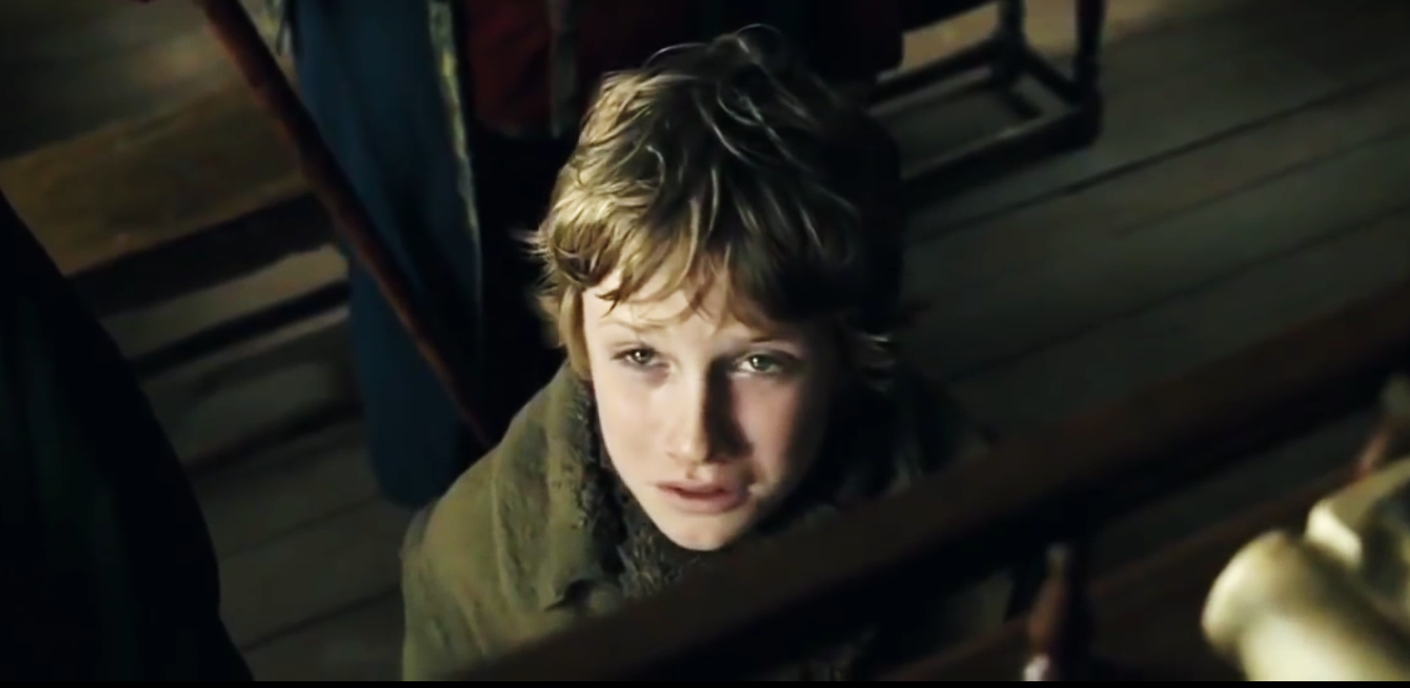

CAMERA ANGLE:
POINT OF VIEW:
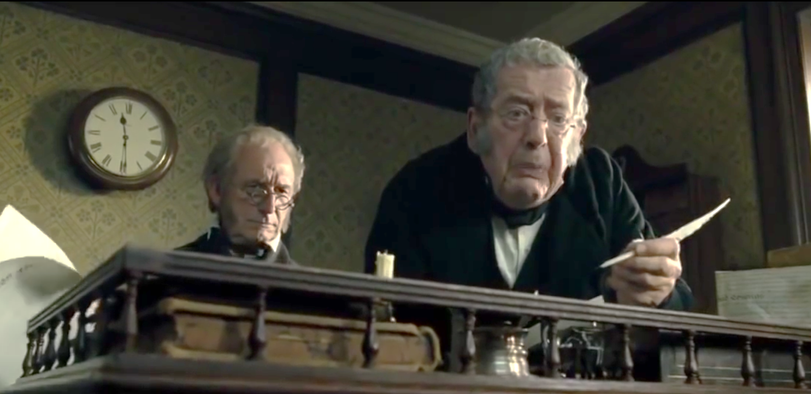

CAMERA ANGLE:
POINT OF VIEW:
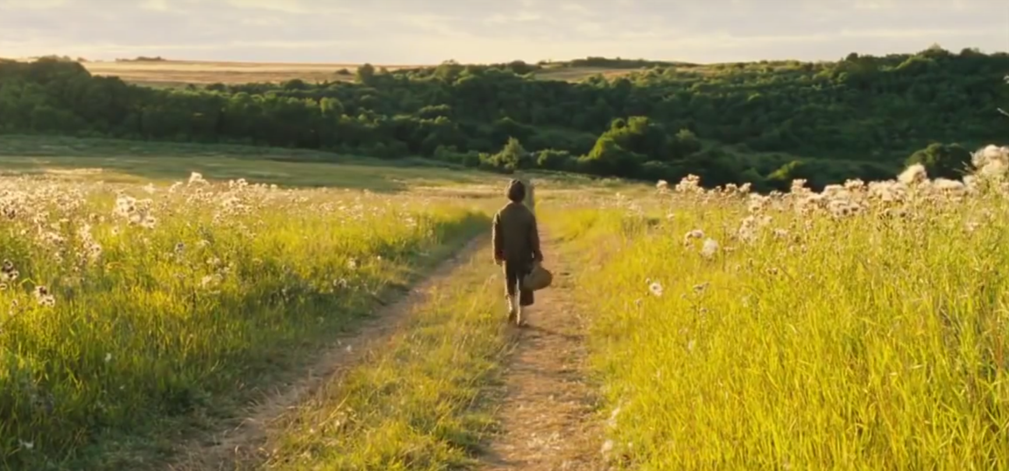

CAMERA ANGLE:
POINT OF VIEW:
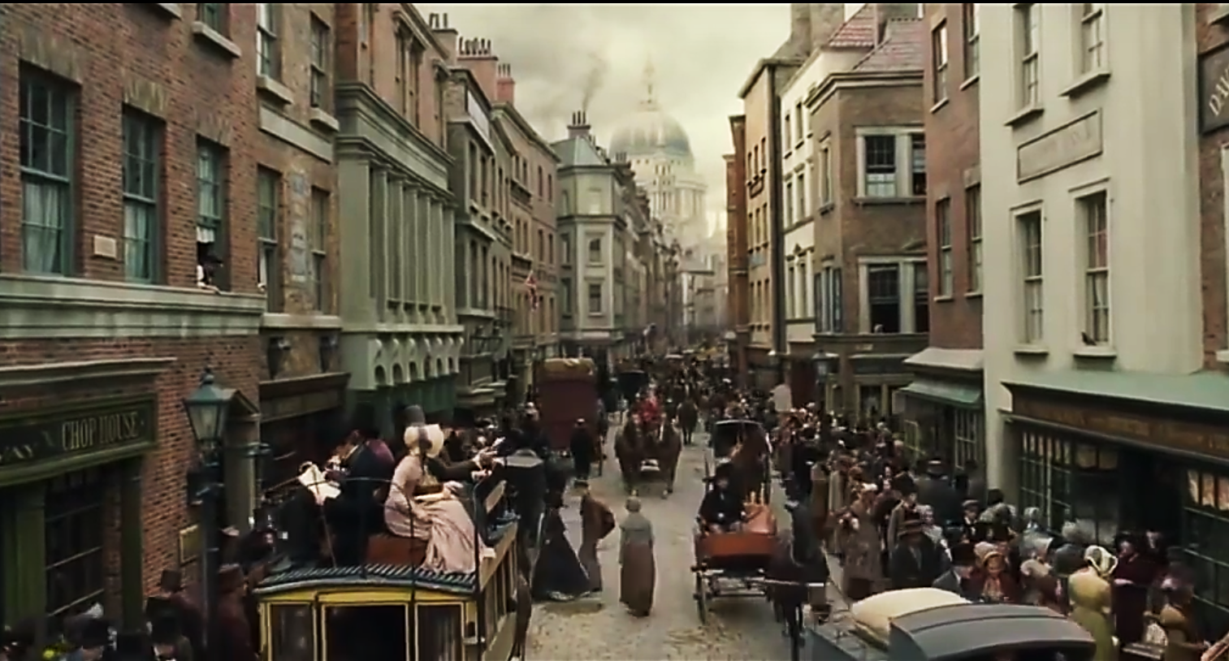
CAMERA ANGLE:
POINT OF VIEW:

