Цель и задачи проведения Недели иностранных языков:

- обучение учащихся иноязычному общению в единстве всех его функций, в подготовке их к естественной коммуникации в устной и письменной формах в основных сферах общения;
- применение новых образовательных технологий при обучении иностранным языкам;
- привитие интереса к предметной области «иностранный язык»;
- формирование положительного отношения учащихся к иностранному языку, понимания важности его изучения и потребности пользоваться им как средством общения;
- воспитание у учащихся открытости в отношении к другим культурам, понимания и уважения традиций, ценностей других народов, готовности к диалогу культур;
- развитие творческих способностей учащихся во внеурочной деятельности.

Главный принцип Недели иностранных языков – вовлечение учащихся всех параллелей, независимо от уровня их знаний иностранного, в события Недели, предлагая им задания и мероприятия посильного уровня.
С 25 февраля по 1 марта иностранный язык звучал в стенах гимназии чаще, чем обычно. И в этом нет ничего удивительного. Февраль – традиционный месяц для проведения Недели иностранных языков. Она дает возможность учащимся открыть для себя страну изучаемого языка с новой, может быть, доселе неизвестной стороны, пообщаться друг с другом в неформальной обстановке.
Дни Недели были посвящены Малой Родине: Браславу, району, Витебску, Минску, родной Беларуси. В начале Дня учащиеся могли ознакомиться на информационных стендах в фойе гимназии с географическим положением, достопримечательностями, традициями и обычаями, великими людьми нашей Малой Родины. На переменах всех увлекали виртуальные путешествия на экране телевизора. А в течение дня учащиеся отвечали на вопросы викторин по стране и родному краю. Лучшими знатоками стран стали: Емельянова Милана, Гаспарян Елизавета, Ковалык Федор, Титович Вероника, Кадаков Владимир, Ундруль Валерий, Титович Александр, Пожарская Дарья, Титович Максим, Шиман Виктор, Коновалов Александр, Хилько Полина, Белусь Вадим, Васюкович Елизавета, Медведь Татьяна, Блинов Олег, Янкович Сергей, Козусева Владлена, Храпан Анастасия, Циунель Софья, Шишло Люба, Пискун Артем, Гончаров Алексей, Либик Павел.
Учителя иностранного языка приглашали на открытые уроки и внеклассные мероприятия, которые тоже тематически были связаны с Малой Родиной и с самим языком.
Но самым полезным в общении стал первый день. Гимназический фестиваль межкультурных коммуникаций собрал всех любителей иностранного языка в актовом зале. Радует, что количество желающих поучаствовать не уменьшается. В номинации «Я – оратор» ребята размышляли, легко ли быть молодым. Гиды пригласили в путешествие по истории создания национальных костюмов в родной стране и странах изучаемого языка и открыли всем много интересных фактов. Увлекательной была презентация работ в номинации «Пресс-центр». Не могла никого оставить равнодушными тема «Чудеса нанотехнологий». Девятиклассник опубликовали в журнале «Магистр» свои мысли и находки, к которым их привело погружение в данную тему.
Участники «Фабрики звезд» радовали зрителей своими танцами и песнями между серьезными рассуждениями.
По итогам гимназического фестиваля приглашение для участия в районном этапе получают:
Мужев Никита, Гаспарян Елизавета ( номинация «Я – оратор»), Волкова Елена ( номинация «Я – гид»), группа учащихся 9 класса в составе Калтан Виктории, Шпак Ксении, Дударенок Екатерины, Короткова Владислава, Курец Анастасии, Дегтяревой Златы, Близнецовой Дарьи, Ананича Вячеслава, Селях Алины (номинация «Пресс-центр»), Липский Тимофей, Ахрамович Дарья, Беспрозванная Елизавета Максимович Ангелина, Урбанович Татьяна, Гайслер София (номинация «Фабрика звезд»).
Благодарим всех за участие в Неделе иностранных языков и желаем успехов и удачных выступлений тем, кто будет и дальше отстаивать честь гимназии.
Спасибо педагогам, кто помог учащимся проявить свои знания и творческие способности.
По результатам работы методического объединения иностранных языков на протяжении Недели можно сделать вывод о том, что
- проведение массовых мероприятий в содержательной и интересной форме создает благоприятные условия для развития лингвистической и социокультурной компетенции, формирования личных качеств учащихся;
- Неделя помогает воспитывать обучающихся в духе патриотизма и любви к родному краю, что впоследствии приводит к их активному участию в «диалоге культур» и межкультурной компетентности;
- проведение Недели иностранных языков способствует успешному ведению образовательного процесса.
Рекомендации:

1. Продолжить традицию проведения Фестиваля межкультурных коммуникаций.
2. Уделять больше внимания вовлечению гимназистов в различные проекты на иностранном языке, в том числе и Интернет-проекты.
3. Использовать различные формы организации деятельности на перерывах в рамках Недели иностранных языков.
4. Шире привлекать к участию в мероприятиях Недели учащихся старших классов.

Руководитель методического объединения
иностранных языков М.М.Доронина

Информационный стенд

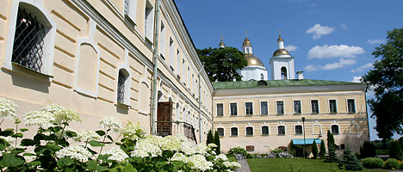
Polotsk
One of the oldest cities in Eastern Europe was first mentioned in chronicles, the Tale Of Bygone Years, in 862. Polotsk was a major trading center, and was on the way of the major trade route From the Varangians to the Greeks. The town is the "cradle" of the Belarusian statehood and culture, the capital of the first principality, home to the famous Slav educators Euphrosyne of Polotsk, Francysk Skaryna, Simeon of Polotsk. The most ancient town of Belarus cherishes its cultural heritage, including the majestic churches and Orthodox sanctities, like the restored Cross of Euphrosyne of Polotsk.
According to scientists, Polotsk is the geographical center of Europe. There is a memorial sign there and everyone can get a certificate about their stay at this special place.
Vitebsk Oblast

Miory
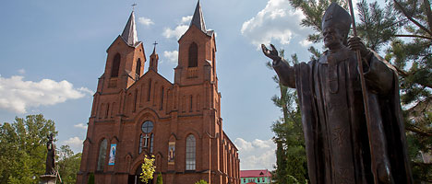
The town on the banks of the scenic Lake Myorskoye has been known from 1514 as the Mereya property of voivoda Ivan Sapiega, and then the famous Sviatopolk-Mirskyfamily. The modern-day Miory is a cozy town with the architecture of the 18th -19th centuries, and a beautiful 500-meter pier. The main landmark of the town is the neo-Gothic Roman Catholic Church of the Assumption of the Virgin Mary (Assumption Church) built in 1907, with rare icons and sculptures of the 19th century. Other remarkable landmarks are the modern-day sculpture compositions: Europe's only monument to the unborn child (1991), a sculpture of the mother of God with Baby Jesus (1998), the monument to Pope John Paul II.
238km from Minsk and 190km away from Vitebsk, Vitebsk Oblast
Belarus’ smallest town, Disna, is located in Miory District. This place got the Magdeburg rights and its Rook coat of arms in 1569. Here is the middle of the famous Western Dvina River, which the Disna River flows into.
Yelnya Landscape Reserve
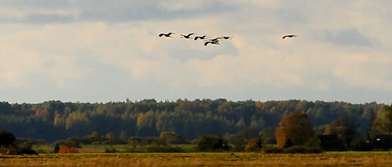
Some of Europe’s biggest high-moor bogs and glacial lakes are situated in the Belarusian Poozerye. The natural area with unique flora and fauna has an international conservation status: an important bird area (since 1981), Ramsar Site (2002), the important botanic garden (2005). A special pride of the reserve is a more than 9,000-year-old Yelnya bog that stretches about 20,000 hectares. In Autumn these places turn into a real “bird paradise”: the bog is home to more than 4,000 grey cranes and 10,000 geese. The land gives the biggest yields of cranberry.
Bird viewing, bog and eco-walks, unusual dishes and drinks made from cranberry are just a few things to see and do at the annual environmental festival Cranes and Cranberries of Miory District.
Miory District, Vitebsk Oblast
Braslav
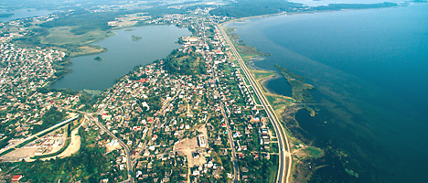
The town of Braslav, first mentioned in chronicles in 1065, lies in the very heart of Belarus’ lake disrtict: 30 lakes can be found within a radius of 30km. The town itself is surrounded by lakes. The biggest “pearl” of the area is Drivyaty, the fifth largest lake in Belarus. You can admire this natural beauty from the ancient hillfort Castle Mountain in Braslav downtown. The town which emblem bears a Christian symbol, the Eye of Providence, is also famous for its sanctuaries. Among them is the magnificent Church of the Nativity of the Blessed Virgin Mary (late 19th century), with its wonderworking Braslav Icon of the Mother of God – the Queen of Lakes, the patroness of the land.
240km from Vitebsk
The town’s new landmark seen from afar is big letters making up the name of the town BRASLAU and the image of the emblem on a hill near Lake Drivyaty. The sign with night illumination is 15 meters long.
Braslav is a center stage of numerous events: every year the town hosts the medieval festival Bryachislav’s Sword, the international cultural festival Braslav Summer Lightnings, the music and sailing festival VIVA BRASLAV, the music festival Living Sky of Braslav.
Braslav Lakes National Park
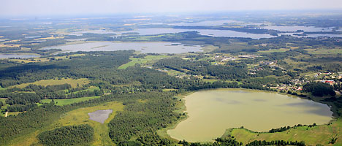
More than ten types of terrain shaped by the ancient glacier in the Belarusian lake district are among the most amazing landmarks of the region. Big and small lakes with unusual banks, winding rivers, numerous islands (there were fortresses and a monastery on some of them in ancient times), glacial hills (eskers and kames) created a favorable environment for flora and fauna. Established in 1995, Braslav Lakes National Park with the total area of about 70,000 hectares is home to more than 1,900 plant species and 312 species of vertebrate animals. This is the habitat of a lot of birds, including such rare species as bittern, black stork, white crane.
Braslav Lakes National Park offers exciting ecological routes and a safari park, as well as tours for hunters and anglers. In summer tourists are invited to take a cruise ship tour on Drivyaty Lake. More information about the park is available here.
The national park administrative center is located in the town of Braslav
Trinity Church in Vidzy
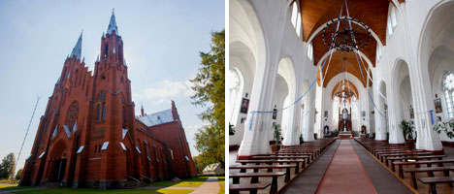
The Church of the Nativity of the Blessed Virgin Mary (Trinity Church) in the village of Vidzy is Belarus’ second largest Roman Catholic church after the church in Budslav. It is one of the highest churches in the country as its spires are 59 meters high. It is a bit smaller than the famous Roman Catholic church in Gervyaty (61 meters high). Bernardine monks established the first Catholic parish in Vidzy in 1481. The new Neo-Gothic church made of red brick was built in Vidzy in 1914. It was badly damaged during World War I. Artillery shells were built in the walls of the church to commemorate those tragic events
In 2014 the church in Vidzy celebrated its centennial anniversary. The church with soaring spires and pointed arches, sophisticated window lattice and colorful stained-glass windows is one of the most elegant buildings in the country.
Village of Vidzy, Braslav District, 40km from Braslav and 260km from Vitebsk
Postavy
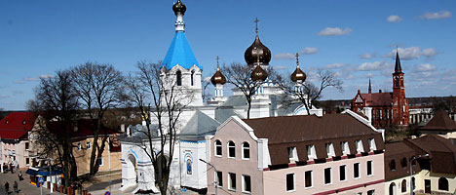
The history of Postavy (1409) is connected with the famous Tyzenhaus family who had owned the place since the 18th century. Influential figure in the Grand Duchy of Lithuania, entrepreneur and philanthropist Antoni Tyzenhaus invited architect Giuseppe de Sacco to build new stone buildings in Postavy, part of which survived till today. Tyzenhaus’ factories in Postavy produced watermarked paper for government needs, sails for ships of the Grand Duchy of Lithuania, belts decorated with gold embroidery having the same quality as Slutsk belts. Later another representative of the family, Konstantin Tyzenhaus, turned Postavy into the center of science. In different times the Tyzenhaus Palace housed a ballet school, the richest ornithology museum operated by the biology department of Vilnius University, and an art gallery.
At present the Tyzenhaus Palace (built in 1760) houses a hospital. There is a historical exposition dedicated to the glorious family and the history of World War I in the building’s cellars. Among other landmarks of Postavy are St. Anthony of Padua Church, St. Nicholas Church (1894), a monument to Konstantin Tyzenhaus.
St. John the Baptist Church in the village of Kamai
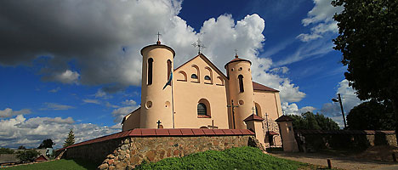
In the village of Kamai, Postavy District, there is an unusual Catholic church, one of the three Belarusian fortified churches included in the UNESCO World Heritage tentative list. However, it considerably differs from the other two temples - the Orthodox churches in Synkovichi and Murovanka. The Kamai church was built as a fortress and put up defense during the war against Sweden when its walls were damaged by cannonballs. Besides, the temple erected in 1603-1606 is one of the few Belarusian churches that have never closed down. Its central altar features a wonder-working icon of the Mother of God with Child (17th century).
Postavy District
Glubokoye
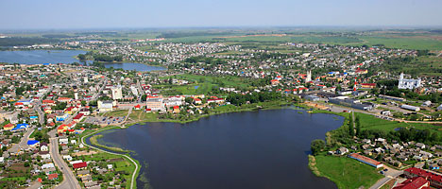
The town of Glubokoye with more than 600 years of history is called the “cherry capital” of Belarus. The first orchards were planted here by plant breeder Boleslav Lapyr who brought young trees from different countries and bred new winter-hardy varieties. The residents of the town have recently replanted the cherry orchard with 1,414 trees and founded a unique cherry festival. The architectural landmarks of Glubokoye include two temples facing each other: the Trinity Church and the Cathedral of the Nativity of the Blessed Virgin Mary (the former Carmelite church built in 1639-1654) that has the icon of the Mother of God from the Holy Mount Athos. It is interesting that the town has five lakes within its borders.
The most famous sites of Glubokoye are the bronze sculpture of a cherry tree, the monument to Baron Munchhausen, and the park dedicated to the famous people born in Glubokoye, including artist Yazep Drozdovich, founder of the Belarusian theater Ignat Buinitsky, aircraft designer Pavel Sukhoi, writer Vatslav Lastovsky, and the “father” of the modern Hebrew language Eliezer Ben-Yehuda.
160 km to the north of Minsk
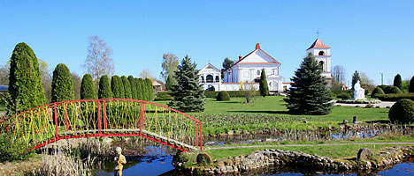
St. Anne Church in the village of Mosar
The village of Mosar, known to exist from 1514, flourished in the times of the noble family of the Brzostowskis. The spouses Robert and Anna built a magnificent palace and St. Anna Church in the 17th century. The church has survived up to the present day. When Catholic priest Josas Bulka came to Mosar in 1989, he breathed a new life into the village. He transformed the swampy surroundings into a marvelous arboretum with religious sculptures, fountains, and flowerbeds. The landmarks of the Belarusian Versailles (this is how Mosar is often called) include the famous work by Michelangelo Buonarroti The Lamentation of Christ from St. Peter's Basilica in Vatican, the highest Catholic cross in Belarus (23m), a 5-meter statue of Christ…
Priest Bulka founded the first and the only anti-alcohol museum in Belarus in a former bell-chamber. An ethnographic exposition was set up in the old barn of Mosar.
Mosar village, Glubokoye District, Vitebsk Oblast
Lepel
Historians still argue about the origin of the name of the town: the Belarusian words “lepei” (better) or “lyapits” (“to shape” because the local potters were famed for their prowess), the ancient Baltic word “lepele”, which means yellow water lilies (those are truly abundant in the water reservoirs of the land) or the word “lipa” (lime tree). The ancient town was founded in the 18th century on the bank of Lepelskoye Lake thanks to Chancellor of the Grand Duchy of Lithuania Lew Sapieha. The monument to the great political figure was erected opposite to the Catholic church of Saint Kazimierz. Lew Sapieha founded the Catholic parish and the temple in 1602 while the new building was erected in 1857-1876. Other places of interest in Lepel include the wooden church of Saint Paraskevi of Iconium, a chapel dated by 1900, a synagogue and an ancient stone house.
In the central park on the bank of Lepelskoye Lake you can find a bronze sculpture of Tsmok, a captivating dragon character of Belarusian myths, the ruler of lakes and swamps. By the way, Lepel is the first Belarusian town to become a member of the European Association of Folklore Groups.
155km from Minsk and 110km from Vitebsk, Vitebsk Oblast
Berezinsky Biosphere Reserve
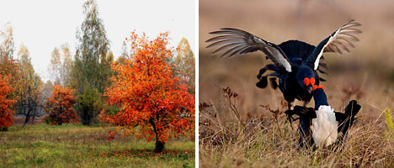
Belarus’ oldest protected territory — Berezinsky Biosphere Reserve — was established in 1925. The unique ecosystems attract thousands of tourists. In 1979 the biosphere reserve became part of UNESCO’s world network of biosphere reserves. In 2005 it was included into the international ecological network, in 2010 into the Ramsar Convention on Wetlands of International Importance, especially as Waterfowl Habitat. The biosphere reserve occupies over 80,000 hectares and comprises various types of forests, swamps, flood meadows, lakes and rivers. It is home to over 2,000 varieties of plants (78 in the Red Book of Belarus), dozens of varieties of mammals and hundreds of varieties of birds. Berezinsky Biosphere Reserve is Belarus’ only place and probably the only place in Europe where you can see bisons, bears, lynxes, wolves, and elks at once.
A project, which is unique for Belarus, is being implemented in the biosphere reserve. Houses made of wooden beams covered with reed roofs will be floatedon pontoons onto Plavno Lake. The interior will be finished using eco-friendly materials. The houses will be powered to easily glide across the lake.
The administrative capital of Berezinsky Biosphere Reserve is the village of Domzheritsy, Lepel District
Orsha
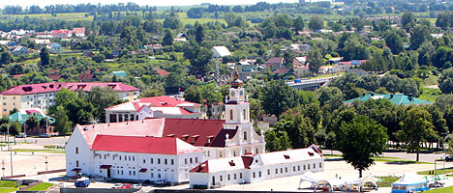
The town on the bank of the Dnieper River and the Orshitsa River was first mentioned in chronicles in 1067. Archeologists found unique chain armor with ancient Slavonic inscriptions at the place of an ancient settlement. The places of interest in Orsha include the Saint Ilya Church, the Kuteinsky Holy Theophany Monastery, the Saint Joseph Catholic Church, and certainly the magnificent compound of the Jesuit collegium that was built in the 17th century upon the instruction of Lew Sapieha. An ethnographic museum dedicated to the life of Belarusians in the 19th century has been opened in the building of an ancient water mill not far from it. The legendary multiple-launch rocket system Katyusha was first tested in combat near Orsha on 14 July 1941. A memorial complex now reminds about events of the Great Patriotic War.
The Orsha land has a long history of growing flax, which has become a symbol of Belarus, with the image now part of the national emblem. Apart from that, Orsha is sometimes called the cucumber capital of the country. Every year a cucumber festival is held there, with a monument to the famous vegetable erected in the central square of the town.
225km from Minsk
Vladimir Korotkevich Museum in Orsha
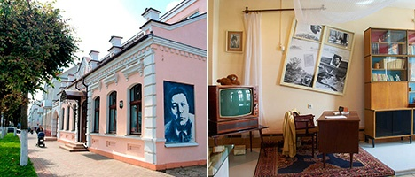
A talented writer, playwright and scenarist, publicist and translator, a representative of the old noble family and a passionate history lover, Vladimir Korotkevich is unique in the Belarusian literature. His books are among the most beloved and widely read by many generations. The biographical museum in his hometown of Orsha was opened in 2000 in a building which has a symbolic meaning. It is an architectural specimen of the 19th-20th centuries. Starting from 1925 it was used as a maternity hospital where the writer was born on 26 November 1930. Today the museum runs a number of thematic exhibitions: A Portrait of the Writer and the Man displaying a part of the study from the author’s apartment in Minsk, a hall of the literary heritage comprising a research center and a library, and an art gallery. The collection comprises a great number of items: personal belongings and manuscripts and his original drawings. Here the visitors can watch the famous movies made on the basis of Vladimir Korotkevich’s novels and scenarios, listen to the records with his voice and also the songs with his poems as the lyrics.
Vitebsk
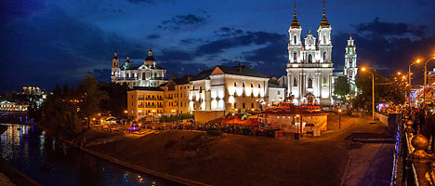
A legend has it that Vitebsk was founded by Princess Olga on the banks of the Western Dvina River and the Vitba River in 947. Centuries later it was destined to become the world’s treasury of talents: Vitebsk was the birthplace of outstanding artists Marc Chagall, Kazimir Malevich, Ossip Zadkine, Ivan Puni, philosophers Nikolay Lossky and Mikhail Bakhtin… Today Vitebsk is Belarus’ biggest cultural hub that hosts the unique festival of arts Slavonic Bazaar. The city’s major landmarks include the City Hall Square, Holy Resurrection Church, Governor’s Palace, Holy Assumption Cathedraland the famous Kirov Bridge across the Western Dvina River.
Vitebsk prides itself on Belarus’ biggest tram system that is over 110 years old.
Marc Chagall Museum
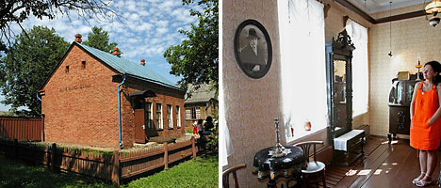
The most famous native of Vitebsk, Marc Chagall, is one of the most remarkable representatives of the global avant-garde movement of the 20th century. The famous artist created paintings and illustrations to poetry by Andre Breton, Blaise Cendrars, Guillaume Apollinaire, decorations to the Aleko ballet by Leonide Massine and the Firebird by George Balanchine, and interior of the Opera Garnier in Paris, as well as sculptures, ceramics, graphics… Being far away from Vitebsk, the painter never forgot his home town, its roofs, churches and people. By the way, people are depicted in every single painting by Marc Chagall. The Marc Chagall Museum in Vitebsk boasts one of the world’s biggest collections of the artist – over 300 original graphic works and reproductions of his most famous paintings.
11 Pokrovskaya Street, Vitebsk 11.00-18.30.
Closed on Monday, Tuesday from 1 October till 1 March; Closed on Monday from 1 March to 1 October
Besides the museum, Vitebsk has the Marc Chagall Art Center (2 Putna Street) that hosts exhibitions of the artist’s graphic works and traditional Chagall Readings bringing together researchers studying the life and works of the Belarusian genius.
Ilya Repin Museum in Zdravnevo
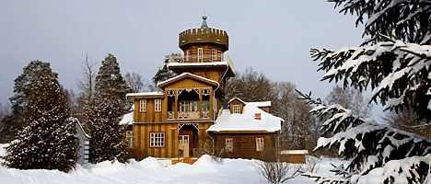
The museum of the great Itinerary artist Ilya Repin is located in the suburbs of Vitebsk. In 1892 he sold one of his most famous paintings - Cossacks of Saporog Are Drafting a Manifesto - to Alexander III and bought the Sofiyevka manor house that was renamed to its older name Zdravnevo. It was there that he created over 40 paintings (Autumn Bouquet, Belarusian, The Duel, Moon Night, In The Sun), numerous schizzos and sketches… These works, as well as photos, books and letters are on display in the museum of the restored estate. Among the most valuable exhibits are images of theChrist and the Mother of God with Baby Jesus painted for the iconostatis of the Sloboda church near which the artist’s father was buried. A linden alley planted by Repin survives in Zdravneno.
The museum often hosts soirees, exhibitions and plain-air sessions of contemporary painters.
16km to the north of Vitebsk in the direction of Ruba

Викторины

1. Questions about Belarus

1. What is the capital of Belarus? A. Grodno B. Minsk C. Brest D. Gomel

2. What is the second large city in Belarus? A. Brest B. Mogilev C. Gomel D. Grodno

3. What is the population of Belarus? A. 5 mln. People B. 10 mln. People C. 20 mln. People D. 50 mln. people

4. How far is Nesvizh from Minsk? A. 60 klm B. 80 klm C. 180 klm D. 120 klm

5. Where is Nesvizh situated? A. In Minsk region B. In Grodno region C. In Brest region D. In Vitebsk region

6. Where is Mir castle situated? A. In Minsk region B. In Grodno region C. In Brest region D. In Mogilev region

7. What is Mir famous for? A. Beautiful lake B. Long river C. Beautiful park D. Large forest

8. How long has Mir been a museum? A. Since 1992 B. Since 2002 C. Since 1998 D. Since 1996

9. What are the castles famous for? A. Their people B. Their children C. Their ghosts D. Their cats

10. What does the Black Nun like to do? A. Play hide-and-seek B. Play chess C. Play badminton D. Play tricks on people

11. What is the ghost of Black Dame? A. Barbara Radziwill B. Radziwill Sirotka C. Barbara Brylska D. Elizabeth II

12. What is the population of Minsk? A. 12 mln. People B. 1 mln. People C. 2 mln. People D. 20 mln. people

13. What is the symbol of Belarus? A. Red rose B. Shamrock C. Cornflower D. Thistle
14. How many regions are there in Belarus? A. 6 B. 5 C. 7 D. 4

15. What is the area of Belarus? A. 107 000 sq kl B. 307 000 sq kl C. 270 000 sq kl D. 207 000 sq kl

2. Belarus is mostly made up of forests, rivers and lakes. Our country has a very interesting history and people. Take up this quiz to test your knowledge of Belarus and its people.

1. How many countries does Belarus border on?
A. 3,B. 4, C. 5, D. 6
2. Which of the following slavic tribes occupied the most territory of Belarus?
A. Pechenegs
B. Polianians
C. Dulebians
D. Krivichi
3. What is the approximate population of Belarus?
A. 10 million
B. 15 million
C. 20 million
D. 25 million
4. In which city is one of the only three St. Sophia Cathedrals located?
A. Vitebsk
B. Minsk
C. Gomel
D. Polotsk
5. Where did the French army suffer defeat during Napoleon's retreat from Russia?
A. Minsk
B. Neman
C. Dvina
D. Berezina
6. In which city did a small garrison of the Red Army troops hold off the Nazi invasion in a fortress for a week in the early days of the war?
A. Minsk
B. Gomel
C. Vitebsk
D. Brest
7. Which tall, beautiful, top-ranked tennis player is from Belarus?
A. Maria Sharapova
B. Anna Kournikova
C. Maria Kirilenko
D. Victoria Azarenka
8. In the late 19th and early 20th centuries many people from Belarus, Ukraine, and also Russia immigrated to the US. Which of these people were born in Belarus?
A. Moe Dalitz
B. Bugsy Siegel
C. Lepke Buchalter
D. Meyer Lansky
9. Which of these foods is the most common traditional Belarusian dish?
A. Vareniki
B. Blini
C. Machanka
D. Draniki
10. Belarus was sometimes called by which of these names?
A. Livonia
B. Thuringia
C. Tasmania
D. Ruthenia
11. For the manufacturing of what product did Belarus become famous?
A. Automobiles
B. Steel
C. Televisions
D. Tractors
12. Which treaty, negotiated in Belarus, ended Russian participation in the first world war?
A. Treaty of Minsk
B. Treaty of Gomel
C. Treaty of Vitebsk
D. Treaty of Brest-Litovsk
13. Under the treaty ending the first world war on the Eastern front which country was to occupy almost all of Belarus?
A. Germany
B. Russia
C. Austria-Hungary
14. Which of these artists was originally from Belarus?
A. Mark Rothko
B. Andy Warhol
C. Marc Chagall
D. Igor Berezovsky
15. Which of these is against the law in Belarus?
A. Private owership of property
B. Operating an international dating agency
C. Exporting pharmceuticals
D. None of the above
16. Which large animal, widely hunted by the nobility in Belarus and neighboring countries from the 13th to the 17th century, is now extinct?
A. Belarusian deer
B. Auroch
C. Auk
D. Polish deer
17. Which American songwriter was born in Belarus?
A. Cole Porter
B. Scott Joplin
C. Irving Berlin
D. Alix Dobkin

ПРОГРАММА ОТКРЫТИЯ НЕДЕЛИ ИНОСТРАННЫХ ЯЗЫКОВ
Демонстрируется видео «Зимние забавы» учеников 5 класса
1. Ведущий 1«Здравствуйте, дорогие друзья!» «Good afternoon»- как сказали бы англичане.
Ведущий 2. А немцы бы сказали «Guten Tag». А, знаешь, как будет «Доброе утро» на польском?
В1 Добже ???. А зачем тебе знать все это?
В2 А затем, чтобы все присутствующие здесь знали, что в нашей гимназии изучаются все вышеназванные языки. Как видите, мы начали наш гимназический фестиваль с демонстрации видео.
В1 Вы принимали участие в конкурсе видеороликов по теме «Моя Малая Родина – Браслав», и работа 5-классников только что демонстрировалась перед вами. Мы будем показывать ваши видеоролики по ходу нашего фестиваля.
В2 Сегодняшнее открытие фестиваля иностранных языков как раз и собрало всех нас здесь, чтобы мы смогли пообщаться на разных языках, узнать для себя что-то новое и просто получить удовольствие от того, что мы можем и умеем говорить на чужом языке.
В1 Ну каком же чужом? Ты же прекрасно знаешь, что наши гимназисты покажут сегодня все, на что способны.
В2 И не сомневаюсь в этом! Свои умения мы покажем в 4-ех номинациях: фабрика звезд (исполнение песен и танцев), конкурсы «Я-оратор» по теме «Легко ли быть молодым?», «Я-гид» по теме «Национальный костюм», презентация газеты «Чудеса нанотехнологий».
В1 А знаешь ли ты на каком языке говорят больше всего людей на планете?
В2 На английском, конечно.
В1 А вот и нет. На китайском языке Мандарин- больше 770 миллинов людей.
А вот на английском в качестве родного – больше 330 миллионов. Но английский самый популярный язык в мире. С него и начнем. Песни “The A-Team и “Perfect” исполнит Липский Тимофей (10класс).
В2 На сцену приглашаются наши ораторы. Тема их выступлений - «Легко ли быть молодым?». Ораторов заявлено трое. Догадываешься, с кого начнем? С самой смелой девушки, конечно. Кстати, прекрасно говорящей на немецком языке: Анастасия Храпан (9А), тебе слово!
В1 А сейчас – очередь ораторствовать Гаспарян Елизавете из 8 Б.
В2 Еще один смелый в команде ораторов - Мужев Никита из 10 класса .
В1 Спасибо ораторам за их искренность и убедительность. Хотелось бы сейчас чего-нибудь песенного.
В2 Пожалуйста – Даша Ахрамович из 11A исполнит песню “Eyes Closed”
В1 Сейчас на сцену приглашаем гидов. Тема их выступления -«Национальный костюм». На этот конкурс заявлено 2 выступления, но так как одна из выступающих -Лена Волкова – на республиканских сборах и выступит после них, у нас одно конкурсное выступление от двух юных конкурсанток из 5б класса –Черкас Анастасии и Алеюн Елизаветы
В 2 а сейчас пятиклассники презентуют свое творчество о нашей Малой Родине.(презентация 5 класса)
В1 А сейчас – снова песня – в исполнении Беспрозванной Елизаветы из 11 А класса звучит песня на немецком языке “Die geile Zeit”
В2. Мы с Лерой – 11-классники, а это значит, что мы заканчиваем гимназию, и это наш последняя Неделя иностранных языков.
В1. Мы очень хотели сделать наше видео добрым и душевным. Получилось или нет- судить вам! (видео Леры и Ангелины 11 А класс)
В1 У нас много ребят, которые играют и поют для себя и близких друзей, не для конкурса. Халимов Никита-один из них. Приглашаем тебя, Никита!
В1 А сейчас – очень серьезна номинация –пресс-центр с презентацией газеты «Чудеса нанотехнологий». Заявлено 1 выступление. На сцену приглашаем группу учеников 9Б класса: Калтан Викторию, Шпак Ксению, Дударенок Екатерину, Дегтяреву Злату, Курец Анастасию, Ананича Вячеслава, Короткова Владислава, Селех Алину, Близнецову Дашу, которые расскажут нам, а какие же открытия сделаны благодаря нанотехнологиям.
В2 У нас есть еще одна конкурсная песня в исполнении музыкальной группы состоящей из учеников разных классов и даже школ. Группа гимназистов в составе братьев Либиков Павла и Антона, Пискуна Артема, солистки Шидловской Арины и ученика СШ №2 Сипко Владимира исполнит песню “Stand by me!”
В1 Для подведения итогов приглашаем Майю Мифодьевну.(вручение дипломов)
В1 Наша неделя подошла к концу.Что тебе больше всего понравилось?
В2 Атмосфера дружбы. Мы сегодня общались на иностранных языках и понимали все.
В1 Потому что все мы- друзья.
В2 А разные языки – не преграда для дружбы, и мы это сегодня с вами доказали.
В1 До свидания Good bye
В2 Auf Wiedersehen!
B1 Do vidzenia!

Никита Халимов Черкас Анастасия и Алеюн Елизавета

Открытые уроки
Технологическая карта урока учителя английского языка высшей квалификационной категории
Государственного учреждения образования «Браславская гимназия» Лукша Ольги Васильевны
Предмет: английский язык
Класс: 6
Тема урока: Загрязнение окружающей среды. Говорение
Тип урока: урок развития речевых умений учащихся
Цель (прогнозируемый результат): предполагается, что к окончанию урока учащиеся смогут рассказать об экологической ситуации в Браславе, используяпри этом лексические единицы урока.
Задачи:
- создать условия для активного речевого взаимодействия;
- способствовать развитию умений использовать в устной речи информацию, полученную при чтении и восприятии иноязычной речи на слух;
- способствовать формированию умений планировать свое коммуникативное поведение;
- организовать ситуации для развития рефлексивных способностей учащихся.
Методы: коммуникативный, интерактивный
Оборудование урока:интерактивная доска, раздаточный материал (Приложение).
Ход урока
Организационный этап.
Цель этапа - создание психологической готовности класса к уроку, введение в атмосферу иноязычного общения.
Задачи этапа: - снять эмоциональное напряжение, наладить контакт с аудиторией;
- настроить учащихся на работу;
- создать ситуацию успеха;
- создать условия для активного использования иностранного языка в устной речи.
Ход урока
- Организационный этап.
Цель этапа - создание психологической готовности класса к уроку, введение в атмосферу иноязычного общения.
Задачи этапа: - снять эмоциональное напряжение, наладить контакт с аудиторией;
- настроить учащихся на работу;
- создать ситуацию успеха;
- создать условия для активного использования иностранного языка в устной речи.
Деятельность учителя | Деятельность учащихся | Примечания  (оборудование, учебные материалы)
Приветствует учащихся, способствует осознанию учащимися основных понятий урока  Goodmorning, dearfriends!. Yesterday I watched a programme about nature. Do you like nature programmes? And the title of the film was really interesting and surprising. Let’s try to guess it. | Эмоционально настраиваются на работу, слушают, воспринимают и осознают основные понятия урока |   Слайд 1

- Этап мотивации и целеполагания.
Цель этапа - подготовка учащихся к осознанному освоению учебного материала, совместное определение целей урока и его конечного результата, мотивация на познавательную деятельность.
Задачи этапа: - создать условия дляактуализации субъектного опыта учащихся;
- создать условия для определения личностно значимых целей урока;
- содействовать формированию познавательного интереса к изучаемому материалу.
Деятельность учителя | Деятельность учащихся | Примечания  (оборудование, учебные материалы)
В ходе беседы задает учащимся вопросы, связанные с их опытом. Обращает внимание учащихся на экран и предлагает определить тему урока. Подводит к теме урока и создаетусловия для определенияучащимися личностно значимой цели урока.  Why is the ocean called plastic? Absolutely true! It’s because there is a lot of plastic in it. How do we call this situation?Put the letters in the correct order to make a word. Today at the lesson we will discuss different kinds of pollution and the goals of our lesson are on the board.What would you like to add to the success list? | Отвечают на вопросы учителя, предлагают варианты темы урока.Совместно с учителем определяют личностно значимую цель урока, используя лист успеха. |   Слайд 2    Слайд 3  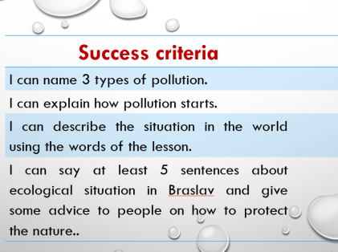  Слайд 4  Приложение,Card1

- Операционно-познавательный этап
3.1. Восприятие и понимание иноязычной речи на слух
Цель этапа: Понимание учащимися общего смысла видеофрагмента, развитие умений говорения на основе информации, полученной в ходе восприятия иноязычной речи на слух.
Задачи этапа: - создать условия для совершенствования умений восприятия иноязычной речи на слух;
- организовать ситуации для развития умений самоконтроля и самокоррекции.
Деятельность учителя | Деятельность учащихся | Примечания  (оборудование, учебные материалы)
Предлагает соотнести понятия и их определения и составить свои предложения с данными словами.  Предлагает просмотреть видеофрагмент по теме урока, выполнить задания для совершенствования навыков восприятия иноязычной речи на слух, консультирует учащихся, координирует их деятельность, организуя ситуации для рефлексии и коррекции при возникших отклонениях.  I offer you to watch this film about the plastic ocean. But before that let’s work with some words that can help us understand the video.Match the words and the definitions and make up sentences about the ocean using these words.  Let’s watch a video and find out if we were correct.  Watch the video for the second time and answer the questions on your cards.  Wonderful!. | Подбирают определения словам. предложенным на экране (LearningApps.org).  Просматриваютвидеофрагмент, определяют на слух информацию, необходимую для ответов на вопросы. | 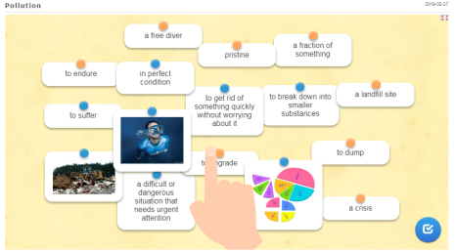  Слайд 5  https://clck.ru/FGsDX  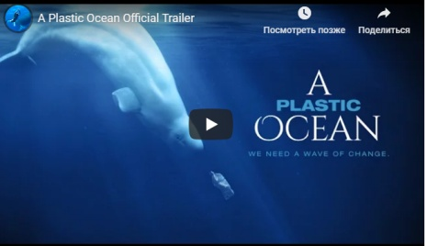  Слайд 6  Источник видео https://youtu.be/6zrn4-FfbXw  Приложение,Card2

3.2. Работа с текстом.
Цель этапа -умение учащимися определить основную мысль предложенного текстового фрагмента и использовать полученную информацию в речи.
Задачи этапа - способствовать овладению учащимися основными способами мыслительной деятельности (выделение главного, анализ, обобщение);
- содействовать совершенствованию умений говорения.
Деятельность учителя | Деятельность учащихся | Примечания  (оборудование, учебные материалы)
Объясняет задание, предлагает прочитать текст, соотнести картинки и части текста. Предлагает учащимся разделиться на пары и найти место предложения на их карточке в тексте. Координируетработуучащихся.  Предлагает учащимся найти в тексте прилагательные. образованные от предложенных слов. Обращает внимание на суффиксы прилагательных.  Раздает карточки со словами, от которых необходимо образовать прилагательные.  Предлагает выбрать место в классе, где на карточке отображен необходимый для этого суффикс. Предлагает составить предложение(я) с полученными словами по теме урока.  To find out more about pollution,let’s read short texts. Look through the information about pollution and match the paragraphs with the pictures (Ex. 2a p.92).  Great!  As you can see there are some gaps in the text. Makepairs.Take the cards with sentences and find a place in the text where you sentence is taken from.Wonderful!  Whichfactsarethemostsurprising for you? Why?  Find in the text the adjectives that are formed from the nouns in the box. (ex. 3a p. 93) | Читаюттекст, подбирают иллюстрации.Работая в парах, находят место своего предложения в тексте. Высказывают свое мнение об прочитанной информации. Отвечают на вопросы учителя.  Находят в тексте прилагательные, образованные от предложенных слов. Обращают внимание на суффиксы прилагательных.  Образуют прилагательные от слов на карточках. выбирая место в классе, где отображен необходимый суффикс. Составляют предложение(я) с полученными словами. |   Слайд 7  Текст (упр. 2а стр. 92)  Приложение,Card3  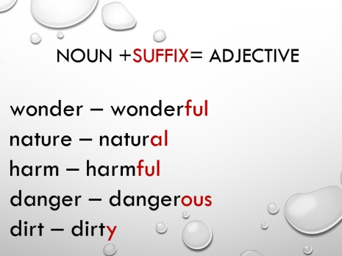  Слайд 8

3.3.Говорение.
Цель этапа – умение учащихся рассказывать о природном чуде света с использованием материала урока.
Задачи этапа - способствовать овладению учащимися основными способами мыслительной деятельности (сравнение, анализ, синтез, обобщение);
- создать условия для развития умения аргументированно выражать свою точку зрения

Деятельность учителя | Деятельность учащихся | Примечания  (оборудование, учебные материалы)
Объясняет задание, координирует работу учащихся в парах, организует коррекцию по возникающим затруднениям.  Let's work in pairs (small groups). Prepare to speak about the situation with pollution in Braslav. Usethephrasesfromthebox (ex. 5ap. 94). Is the situation dangerous? Do we have a crisis?.  Goodjob! | Работаявпарах (микрогруппах), составляютустноевысказываниенатемуэкологическойобстановкивБраславе.Используют слова урока и выражения из упр. 5а стр. 94. | 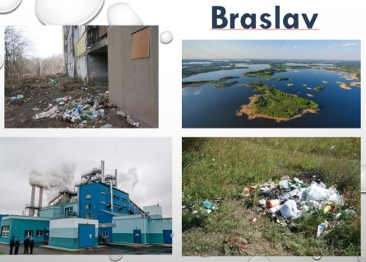  Слайд9

- Этапконтроля.
Цель этапа: - получение информации о достижении всеми учащимися планируемых результатов обучения.
Задачи этапа – создать условия для выявления качества и уровня овладения знаниями и способами действий;
- способствовать развитию умения объективно оценивать результаты своей деятельности.

Деятельность учителя | Деятельность учащихся | Примечания  (оборудование, учебные материалы)
Предлагает проверить свои знания о загрязнении окружающей среды в игре Kahoot. Предлагает вернуться к листу успеха. Организует визуальную проверку и инициирует беседу по ее результатам.  Ok, nowIhopeyouknowsome thingsaboutpollution now. Let’s get back to our goals and see if we are successful. What have you ticked? Can you name 3kinds of pollution? Etc. | Участвуют в игре Kahoot. Выбирают верный вариант ответа.  Отмечают в листах успеха уровень собственных учебных достижений.Оценивают свою деятельность. | 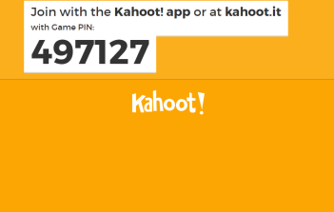  Слайд 10  https://clck.ru/FGsCs  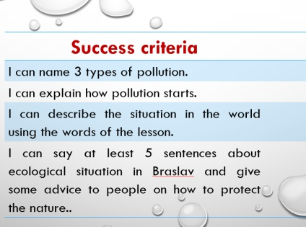  Слайд11  Приложение,Card 1

- Этап информирования о домашнем задании.
Цель этапа: - мотивация учащихся на дальнейшую работу по данной теме.
Задачи этапа:–содействовать пониманию содержания и способов выполнения домашнего задания;
- способствовать определению перспектив работы над учебным материалом.
Деятельность учителя | Деятельность учащихся | Примечания  (оборудование, учебные материалы)
Предлагает учащимся дифференцированное домашнее задание.  I offer you to think about ecological situation in our town and write an article to the environmental site. You can add some advice for people to protect the nature. | Осмысливают домашнее задание. Планируют свою дальнейшую познавательную деятельность. | 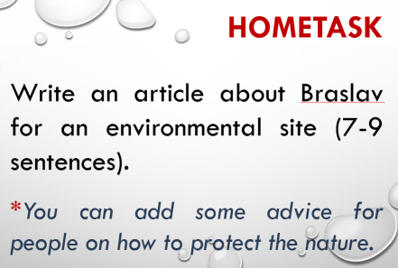  Слайд 12
- Подведение итогов учебного занятия и рефлексия.
Цель этапа: - качественная оценка работы класса в целом и отдельных учащихся.
Задачи этапа: –создать условия для анализа успешности достижения познавательных целей урока;
-организовать ситуацию для развития рефлексивных способностей учащихся.
Деятельность учителя | Деятельность учащихся | Примечания  (оборудование, учебные материалы)
Анализирует работу учащихся на уроке, оценивает их познавательную активность.  Благодарит учащихся за совместную работу.  You worked well at the lesson today! It was great to collaborate with you. So, I want to give you some calendars as presents. They are with the sight of our planet. Please, think about our lesson and remember that we should protect it. It is not only home to many animals and birds but also to us. Let’s keep our home clean and healthy! Good bye! | Задаютвопросынауточнение. |   Слайд 13  Приложение,Card 5

Приложение

Card 1

Success criteria | Put v if “YES” and x if “NO”
I can name 3 types of pollution.
I can explain how pollution starts.
I can describe the situation in the world using the words of the lesson.
I can say at least 5 sentences about ecological situation in Braslav and give some advice to people on how to protect the nature..

Card 2

Watch the video and answer the questions?
- How many tones of plastic are dumped into the ocean every year?
- Why I plastic in the ocean never going to degrade?
- What does the narrator believe is possible?
- Card 3
- Acid rain also damages the habitat of fish and other water animals.
- Factories dump waste into rivers.
- They can do harm to fish and sea birds.
- Cars and factories send harmful gases into the air.

Card 4
- ous
fame
danger
- y
mess
sand
- al
region
nation
- ful
care
colour
wonder

Card 5




Тема: «Беларусь- рай для любителей природы» Учитель: Закревсая Ч.Ч..
Класс: 6
Тип урока: урок-обобщение лексики и грамматики по теме
Цель(прогнозируемый результат):предполагается, что к окончанию урока учащиеся смогут назвать по крайней мере три места, связанные с природой, для посещения Беларуси.
Задачи:- создать условия для активного речевого взаимодействия,
- способствовать развитию умений использовать в устной речи информацию, полученную при чтении
- прививать любовь и уважительное отношение к природе Беларуси.
Оборудование урока: учебник для 6 класса English 6,Student’s book,
English 6 Workbook,раздаточный материал.
Ход урока:
1.Организационный этап:
- Good morning,dear friends! I am really glad to see you here.
I think you remember about the nature of Belarus. Let’s revise some facts about it.
Answer my questions:
Is Belarus a green country? Do you know what flora is? What is fauna?
2.Этап мотивации и целеполагания:
Let’s revise the words from the topic .Divide them into two columns: flora and fauna:
A birch, a hare, a crow, a cornflower, a hedgehog, a pine, an oak, a rabbit, a fox, a sparrow,a wolf, a pike, a rose, an owl ,a beaver, a deer, a blackbird, a spruce, a woodpecker,an elk,an ash, a tulip.
3.Операционно-познавательный этап:
3.1.Беседа по вопросам упр.9 стр.51
a). What is Belarusian nature like?
b). What animals and birds is Belarus home to?
c). What is Belarus famous for?
d. What national parks are there on the territory of Belarus?
e). Why are Belarusian people proud of their country?
f). Do Belarusian people take a good care of their nature?
3.2 Look at the pictures and say a few words about what you see there
Упр.8 стр.50 учебник английского языка
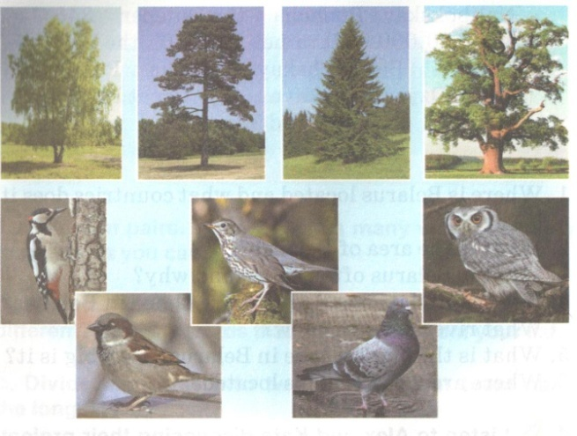

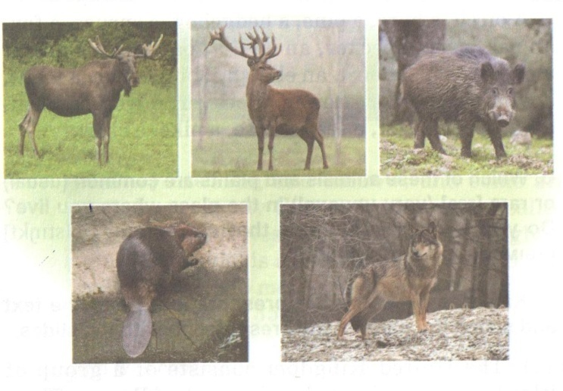
3.3. Повторение грамматики. Present Perfect and Past Simple.
Open the brackets and put the verbs into the necessary tense-form:
1.I…never (be) to Pripyatsky National Park.
2. My mother …(go) to the National Botanic Garden in Minsk last week.She …(enjoy) the plants there very much.
3. Ann …(visit) Belovezhskaya Pushcha with her parents last summer.
4. My uncle …(catch) two pikes yesterday.
5. You…ever (see) a beaver?
6.We …just (read) the text about Belarusian nature.
Translate into English:
1.Я никогда не был в национальном парке.
2. Маша ездила в Брест и посещала Брестскую крепость прошлым летом.
3. Видела ли ты медведя в зоопарке?
4. Мы смотрели фильм о природе в национальном парке на уроке биологии на прошлом уроке.
5. Я еще не смотрела этот фильм.
3.4 Говорение.Рассказ о национальных парках.
Упр.1 стр.48-49 Workbook.
4.Этап информирования о домашнем задании.
(составить рассказ о природе в Беларуси).
5. Подведение итогов учебного занятия. Рефлексия.

Класс: 11, немецкий язык. Учитель: Михнович Е.В. Технологическая карта урока
Тема: «Natur und Naturschutzgebiet»
Воспитательная цель: воспитание заботливого отношения к окружающей среде;
Образовательная цель: усвоение социокультурных знаний по теме «Заповедники Германии и Беларуси»
Развивающая цель: развитие способности пользоваться собственным жизненным, языковым и речевым опытом и знаниями для решения коммуникативных задач и понимания содержания текста по теме «Заповедники»;
Задачи урока: расширение знаний учащихся о заповедниках Германии;
Актуализация знаний учащихся о заповедниках Беларуси;
Понять в тексте для чтения основную информацию о заповеднике в Германии„Wattenmeer“

№ Этапа | Этап | Цель этапа | Содержание этапа | Режим работы | Время работы
- 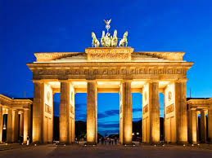 | Организационный момент | Введение в языковую среду | Guten Tag! Setzt euch bitte!  Unser Thema heißt „Natur und Naturschutzgebiet» | L – K1 | 2мин.
2. | Речевая зарядка | Развитие  лексических навыков говорения | Вводная беседа: Ich möchte mit Zitate beginnen. «Die Natur hat mit dem Menschen in die Lotterie gesetzt und wird ihren Einsatz verlieren».  Beantwortet bitte die Fragen:  Was sind Vorteile und Nachteile eines Naturschutzgebiets? | L – S1, S2 | 3 мин.
3. 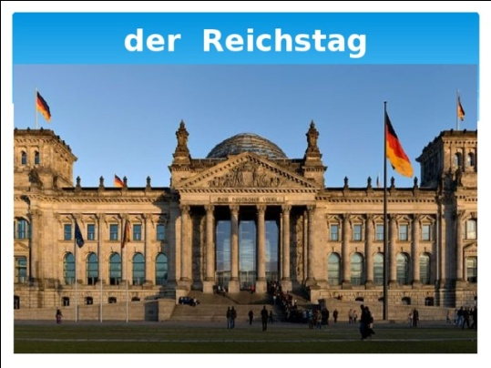 | Основной этап урока | Формирование лексических навыков говорения | UndjetztmachenwirmitdeutscheNaturschutzgebietebekannt. Sehen Sie bitte an der Taffel.  Dann macht bitte eure Bücher auf der Seite 169. Lesen wir den Text, der das Wattenmeer heißt. Wählen Sie eine passende Überschrift zu jedem Absatz.  Dann macht bitte eine Aufgabe - In welchem Text A, B, C, D oder E steht darüber geschrieben?Finden Sie im Text Antworten auf die Fragen.  Gehen wir weiter. Das Wattenmeer ist eine der großartigsten Naturlandschaften.  Welche anderen Naturlandschaften in Deutsch land, Europa oder  in der Welt kennen Sie?  Und jetzt schauen wir ein Video ein und machen Übungen zum Video. | L – S1, S2 | 20 мин.
4. | Продолжение основного этапа урока | Формирование лексических навыков говорения | In Belarus gibt es viele Naturschutzgebiete. Erzählen Sie über  ein Naturschutzgebiet.  Erzählt bitte über belarussische Naturschutzgebiete.  Und jetzt machen wir einen Quiz. | L – S1, S2 | 15 мин.
5. | Заключительный | Объяснение Д/З, рефлексия, выставление отметок. | Unsere Stunde kommt zu Ende. Ich bin mit eurer Arbeit zufrieden (nicht zufrieden). Welche Stim-mung habt ihr?  Eure Noten sind folgen-de…  Danke für eure Arbeit. Die Stunde ist aus. Auf Wiedersehen! | L – K1,  L – S1, S2 | 2мин.

Раздаточный материал:
Nationalpark Harz
Der Nationalpark Harz ist einer der größten Waldnationalparks in Deutschland. Er umfasst mit seinen 247,03 km² (ca. 158 km² in Niedersachsen und 89 km² in Sachsen-Anhalt) ungefähr zehn Prozent der Gesamtfläche des Harzes rund um den Brocken, von Herzberg im Süden bis Bad Harzburg und Ilsenburg im Norden. Der Park ist von der international anerkannt und Teil des europäischen Schutzgebietssystems Natura 2000. Etwa 96 Prozent des Gebietes sind von Wäldern, vor allem Fichten- und Buchenwäldern, bedeckt. Neben den ausgedehnten Waldgebieten nehmen Moore wegen ihrer besonderen Ausprägung eine herausragende Stellung ein. Landschaftsprägend sind ferner Granitklippen und Bergbäche.
Bayerischer Wald
Der Nationalpark Bayerischer Wald ist ein Nationalpark im Hinteren Bayerischen Wald direkt an der Grenze zu Tschechien. Er wurde am 7. Oktober 1970 als erster Nationalpark Deutschlands gegründet. Seit der Erweiterung vom 1. August 1997 hat er eine Größe von 24.250 Hektar (242,5 km²).
Geschützt werden vor allem fichtenreiche Hochlagenwälder, Bergmischwälder aus Tannen, Buchen und Fichten, Aufichtenwälder in den Tälern und einige Urwaldreste. Das Nationalparkgebiet ist noch von der ehemaligen Forstwirtschaft geprägt. Als in den 1990er Jahren der Borkenkäfer große Waldflächen befiel, wurde beschlossen, nicht einzugreifen; ein Teil der Hochlagenwälder starb. Anwohner des Nationalparks diskutierten den Beschluss kontrovers.
Alles, was gegen die Natur ist, hat auf die Dauer keinen Bestand.
Alles, was gegen die Natur ist, hat auf die Dauer keinen Bestand.
1. Salzwiesen – солончаки 2. Dünen – дюны 3. Wattflächen – приливныезоны 4. überspülen – переполнение 5. Salzgehalt – соленость 6. das Nahrungsreichtum – продовольственноебогатство 7. Seeschwalben – крачки 8. Strandwermut – полынь 9. Regenpfeifer – зуек 10. Brut- undFutterplatz - Место размножения и кормления 11. Strandläufer – кулик 12. Brandgänse утка-пеганка 13. Kiebitze – черви 14. die Sturmflut - штормовойприлив
15. Strandwermut – пляжнаяполынь 16. Strandnelke – пляжнаягвоздика 17. Strandaster – пляжнаяастра 18. die Pracht – великолепие 19. die Wildnis – пустыня 20. die Seehunde – морскиетюлени 21. jagen – охотиться 22. Haie – акулы 23. die Aufzucht –воспитание 1. Salzwiesen – солончаки 2. Dünen - дюны
3. Wattflächen – приливныезоны 4. überspülen – переполнение 5. Salzgehalt – соленость 6. das Nahrungsreichtum - продовольственноебогатство
7. Seeschwalben – крачки 8. Strandwermut – полынь 9. Regenpfeifer – зуек 10. Brut- undFutterplatz - Место размножения и кормления
11. Strandläufer – кулик 12. Brandgänse утка-пеганка 13. Kiebitze – черви 14. dieSturmflut - штормовой прилив 15. Strandwermut – пляжная полынь
16. Strandnelke – пляжная гвоздика 17. Strandaster – пляжная астра 18. die Pracht – великолепие 19. die Wildnis – пустыня 20. dieSeehunde – морские тюлени 21. jagen – охотиться 22. Haie – акулы 23. die Aufzucht – воспитание

Класс: 11, английский язык. Дидактический сценарий урока. Учитель: Доронина М.М.

Тема: Выбор профессии
Цель: развитие речевых умений учащихся в рамках указанной темы
Прогнозируемый результат: предполагается, что в конце урока учащиеся смогут рассказать о преимуществах и недостатках профессий
Задачи:
учить школьников полноценно пользоваться английским языком во всех видах речевой деятельности в рамках коммуникативной ситуации урока;
способствовать овладению учащимися основными способами мыслительной деятельности (выделение главного, анализ, обобщение);
создать условия для активного взаимодействия, развития аналитического и критического мышления;
Задачи для учащихся:
учиться высказывать свою точку зрения на английском языке;
учиться применять полученные знания на практике;
Тип урока: урок комплексного применения знаний, умений, навыков
Методы: коммуникативный, интерактивный
Оборудование урока: раздаточный и иллюстративный материал, презентация, мультимедийный проектор.
Интернет ресурсы:
Video: Darya Domracheva on life https://www.youtube.com/watch?v=LUFPj4X826A
Text: Louis B. Mayer Biography http://www.biography.com/people/louis-b-mayer-403666
Video: Interview with Londoners https://www.youtube.com/watch?v=LUFPj4X826A
Video: Your DEam Job https://www.youtube.com/watch?v=wL3CFtW8WE0

Stage | Teacher does/says | Students do/say | t | notes
Warming-up | Good morning! I’m glad to see you and hope you | Look at the photos,  -watch the video, answer | 3 |   https://www.youtube.com/watch?v=MdvTlQzsaYI - Jobs Song
 | are ready to start working. You look great today, | the teacher`s questions,
 | just ready for working hard. By the way, I have some photos to show you. What do these people have in common? | name professions
 | Name people who:
 | Are the world famous programmers\ actresses
 | Yes, you are right. All these people have one thing in common – their profession.
 | some video to show you too about different kinds of work. Look at it and count how many jobs you can hear in this video song (25).
Actualization | Now I `d like you to go to the blackboard and match the cards with the professions to their definitions. | Activity “Match the professions with their definitions” | 5
of personal
experience |  | students go to the blackboard and put definitions near the professions.
Vocabulary | Let`s practise the words Job, Profession, Career, Occupation. Look at your Pupils` sheets, ex.1 (Appendix 1). You have 2 minutes. Who will go to the board?  Let`s check, who is ready? | -do the task in their | 5 | Pupils’ handouts
Practice |  | handouts, |  | Pupils’ handouts
 |  | check each |  | Pupils’ handouts
 |  | other |  | Pupils’ handouts
Speaking Practice | Let’s talk about your future professions
Reading | Let’s Read the text in your text – books about who influences your choice of profession. | Activity “Ask your friend”  -read the text, work in pairs, each pair gets the necessary information and the main idea from the passage they read. | 3 | http://www.biography.co m/people/louis-b-mayer- 9403666
Pre-reading | You will read only a small part of the text, but you don’t know where your part is taken from. |  |  | http://www.biography.co m/people/louis-b-mayer- 9403666
 | You are to read your passage, define the main idea of the text, write it on the sticker, put the sticker on the blackboard. |  |  | http://www.biography.co m/people/louis-b-mayer- 9403666
 | Read all your main ideas and think in what order they must be put in. |  |  | http://www.biography.co m/people/louis-b-mayer- 9403666
 | Go to the blackboard and put the stickers in the right order. |  |  | http://www.biography.co m/people/louis-b-mayer- 9403666
 | (прием “Reading Train”) |  |  | http://www.biography.co m/people/louis-b-mayer- 9403666
After-reading | Write the main idea on a sticker and put it on the blackboard in the logical order | -discuss the logical order |  | (book, p.121ex.1).Activity “Reading Train”
Describing the slides | Look at the slides which are united under one title: “Choosing a career is not easy”.  One by one describe what you see on the slides | - use the active vocabulary of the lesson: nervous, backbreaking, shifts, strenuous, etc. |  | (text-book – p.116)
Listening to people speaking who influenced their choice of a profession  Watching Pre-watching While watching  After watching | - Checking the comprehension  Look at ex.3 in your pupils` sheets (Appendix 1). Match the words of each sentence and number the sentences.  - Discussion: Answer the questions in Handouts  - Feedback: Who influences your choice of profession?  Tell us in a few words about the person (people) who made the biggest influence on your choice. | -answer the teacher`s questions  -watch a video interview with Londoners https://www.youtube.com/watch  ?v=LUFPj4X826A  -answer the question: What career advice does the young man give to people?  -make sentences and arrange them in a logical way to make the summary of the interview  - discuss the recipe of a successful career success | 10 | Pupils` handout, ex.3 (Appendix 1)
Watch a video of a Dream Job interview  Watch a video of rescuing a child and sound it | -Answer my question: What is your Dream Job? Why? What are the main characteristics of a Dream Job for you? | -watch a video about a dream job and answer questions in Handouts https://www.youtube.com/watch?v=wL3CFtW8WE0 |  | Pupils’ handouts (Appendix 2)
Summing up Speech practice | - Work with speech supports  Find ex.4 in your pupils` sheets (Appendix 1), feel in the gaps as you think is the best.  At the beginning of our lesson we had some difficult questions, let`s go back to them.  Tell us about advantages and disadvantages of your future jobs.  - Home task and the results of the lesson  Write an essay on future profession. Our lesson is over. Thank you for your  work. | -fill in the gaps in the table  -tell about the advice of getting a good career  -answer the teacher`s questions  -comment on classmates` answers with the help of evaluation rubric  -evaluate their own and partners` work at the lesson  -put down their hometask | 3  7 | Pupils` sheets ex.4. (Appendix 1)  Performance assessment  (Appendix 4)

Handouts
Appendix 1: Put the words: a job, a work, an occupation, a profession, a career:
1. In their last three years at school, teenagers receive____________advice.
2. There are a lot of_______________to choose from.
3. A______________teacher helps teenagers discover their interests and make the first steps to future________________
4. A lot of teenagers have a part-time________________
5. Annabel hopes to make painting her________________ although she knows it will not be easy.
6. A special booklet provides some tips for finding– the right__________________It gives information about nearly 250________________
7. State your name, age, _______________in the box below.
8. I started ___________when I was 18.
2) It will(l).... a young person good if he or she (2)... a decision about his or her future career before leaving school. Choosing a career is not simple. While(3).... your choice you should think about your talents, what subjects you like (4)..., in what field you have already(5).... progress, whether you like(6)... things with your hands or prefer to work with your brains. In order not to(7)... a mistake you should think only of how to (8)... money in future. If you want to(9)... well in the chosen field you should be greatly interested in what you are (10)... You should (11)... some efforts to achieve success. (12)...your best to become a really good specialist and you will (13)... a fortune in the end, at least by (14)... a lot of friends.So(15)...yourself a favour.
Appendix 2: Give your friend advice on how to make a career using your knowledge of his character:
Card 1
Artem is logical, organized, clever and hardworking, he has technical thinking.
He likes to deal with machines, instruments, meters,
tools, ….
What’s his profession type?
Give him a piece of advice about his future career.
Card 2
Kate is creative, artistic and imaginative.
She likes to draw, to make new things and to write stories, to make videos.
What’s her profession type?
Give her a piece of advice about her future career.
Card 3
Lera is very communicative, well-wishing, friendly, tactful.
She likes to deal with his friends, classmates and other people.
What’s her profession type?
Give her a piece of advice about her future career.
Card 4
Sasha is modest, never showing off, but knowledgeable, creative. She likes languages and speaks fluently.
What’s her profession type?
Give her a piece of advice about her future career.
Card 5
Tim is strong, fit, likes fishing, never talks too much. He is fond of physics and maths, gets along with his classmates.
What’s his profession type?
Give him a piece of advice about his future career.
Card 6
Nick is crazy about music and parties. He likes to talk and he talks well. He never puts any effort in his studies, but he always manages to get good marks.
What’s his profession type?
Give him a piece of advice about his future career.

Appendix 3: (Game): Divide into 2 groups, choose the card with an English saying about jand find another part (the beginning or end) to your saying.
Choose a job you love | and you will never have to work a day in your life.
The person who knows how……. will always have a job, | but the person who knows why….. will be the boss.
When people go to work, they shouldn’t | have to leave their hearts at home.
Appendix 4: Evaluation На этапе подведения итогов, рефлексии использую критерии оценивания в рубриках
Oral Presentation Rubric : Discussion “Advantages and Disadvantages of My Future Job”

CATEGORY | 10-9  Exemplary | 8-6  Accomplished | 5-4  Developing | 3-2  Beginning
Task Completion | Task was completed very well (99-100%). All of the information was used properly | Task was completed well (90%). Most of the information was used properly | Task was 70-80% completed. | Task was completed poorly. A lot of information was missing or not properly used.
Organization | All ideas are excellently organized. Speech is logical, clear, correct. | Ideas are well-organized. Good use of vocabulary, pauses, intonation markers. One or two ideas may be not properly used | Little organization of ideas. Long pauses in speech which makes it hard to follow the ideas. Some thoughts are out of place or difficult for understanding. | Thoughts are poorly arranged. Absence of logic in speech
Language Control | Excellent use of grammar structiures, rich vocabulary, correct intonation and clear speech. | Good use of grammar and vocabulary, occasional and insignificant mistakes which don't interfere with the communicative purpose. | Frequent but not very significant language mistakes which can to a certain extent interfere with the communicative purpose | Difficulties in comprehension due to frequent and significant grammar, vocabulary mistakes. Profound use of mother tongue.
Communication Strategies | Excellent communication behaviour, self-correction, uninterrupted spontaneous speech, the ability to express the ideas fully. | Good communication behaviour, minor interruptions in speech, proper self-correction. | Satisfactory communication behaviour with frequent interruptions in speech, poor self-correction. | Poor communication behaviour, frequent pauses, absence of self-correction

ГИМНАЗИЧЕСКИЙ ФЕСТИВАЛЬ МЕЖКУЛЬТУРНЫХ КОММУНИКАЦИЙ


Номинация «Я – оратор». «Легко ли быть молодым?»

Никита Мужев

Is it easy to be young?
Hi everybody, I’m happy to see you. Are you happy to see me? Raise your hands who is happy today? Not very many of you are happy. Why? Is it because you worry about many things: school, relationships with friends, teachers and parents, your future career? Or because your parents have forbidden you to go out or serf your favourite Internet just because of your unsatisfactory progress at school? So, will you say that it is easy to be young after all? I won’t! Despite the fact that youth is wonderful, easy, carefree and parents are there to solve all your problems for you. That’s the first point in my argument against youth being an easy period of life. All those discussions about generation gap are not groundless. It’s easy when you have parents who always support you and take your side understanding that you are an independent person with your own thoughts and demands. But I have to share a room with 2 smaller siblings who shout, want to play just when I want to concentrate and do my homework, and when I start telling them to stop all that noise, they turn to my mother for support and she always takes their side. Another problem here is dependence on your parents practically on everything: very often we have to follow their rules without having any adequate freedom of thought or action. Doing a part-time job and making my own money is another difficulty. I can’t understand why I, being a young man of 15, willing to earn some pocket money, can’t find any job to do at the week-end or on holiday just to help my family and myself? But when I start thinking about my future globally, I worry even more! Today, there are 1.8 billion young people between the ages of 10 and 24 in the world. It is the largest cohort in human history. Meeting our needs is a big challenge and a big opportunity. But this opportunity, this youth dividend, is not a given. One point eight billion young women and young men are standing at the door of adulthood. Are we ready? Right now, too few of us are. I feel that we're facing a series of urgent crises. A crisis of demographics, education, employment. Two hundred million adolescents are out of school worldwide, about the population of Brazil. And those that are in school feel that they may not be getting the right skills. Globally, six in 10 children and young people do not meet the minimum proficiency level for reading and mathematics. And what about the lucky few who are in universities? Some of them are dropping out because they're worried that they're not getting skills that they can use to make a livelihood. And sometimes, their parents can no longer afford the fees if their children pay for their education. It's a tragedy.
And I am worried about my employment, that I might not be able to find a job. Every month, 10 million young people reach working age. It's a staggering number. Some will go on for further education, but many will enter the workforce. And our world is not creating 10 million new jobs each month. The competition is fierce for the jobs that are available. So, imagine being a young person today, ready to build a future, but opportunities are hard to find. I am also worried that I am not getting the skills that I need. The world is changing so fast for work. We're in the fourth industrial revolution. Young people want to learn future skills for future work. We want to learn digital technology and green technologies. We want to have a chance to learn modern agriculture and the trades, like construction and electricians. I personally, want to learn business and entrepreneurship, so that I can create a business of my own. And I want to have all of the skills that I'll need for the future.
And I am also worried about some of my friends who don’t know how to socialize in this world: they have hundreds of friends on social media, but when they need to find a friendly face, someone who can be there as their friend, they do not find one. I worry that their loneliness can cause bitterness and disappointment in human values and life, in general. The availability of harmful stuff is another problem of our global world. Teenagers want to try everything that is forbidden for them: alcoholic drinks, cigarettes and drugs. Don’t laugh at me, but in my opinion, enormous amount of information also makes life difficult, at least for me. Television, magazines and internet show how we should look like, where to study and what to do. This demoralizes us and causes a lot of problems and takes our time off some useful activities
I am also worried about my future family life: will I be able to create a friendly loving family, build a house and bring up really good kids?
Are you worried about the same things? And do you know how to cope with all these worries? Sometimes I think that I know the answer:
Firstly, I will build my future while I am still young. Secondly, I will build up my relationship with my parents, teachers in a friendly way– these people want me to become successful and happy and they have knowledge and experience to help me do that.
Thirdly, all young people experience hardships while pursuing their goals. Difficulties are temporary and we should work to overcome them. Nobody will do it for ourselves.
One more thing, stop worrying all the time. Just do some practical things: if you just sit and worry, that won’t lead you to anything. The beauty of being young is that you are full of ambition and energy, so do not waste them. Have you always dreamed of traveling - travel, thought of becoming an artist –do it, want to help people and start some kind of campaign - nothing is impossible, you just need wish It is worth doing if it makes you and people around you happy
100 percent of our future depends on us, because we are a real force in this world. And we're calling out for a fighting chance to build a better world no matter if it is easy or not to be young.

Гаспарян Елизавета
Is it difficult to be young? So, it`s a very interesting question for me… There are both advantages and disadvantages -everything depends on the age of a person. The main advantage, of course, is that you are young. It means, you have strength and enough energy to do everything.
Youth is an opportunity. At a young age you can communicate a lot, enjoy your beauty; first ambitions appear, and it seems that there are no limits, no problems at all.
Youth is the first love. All the doors are opened for you.
Many friends appear in youth. They support you in all your life. And it seems that the world was created especially for you. There is no reason for sadness and grief.
In the 21st century young people have a lot of responsibilities and entertainment. A lot of things were invented for us not to get bored: water parks, gadgets, videogames, smartphonesand so on; and every day this list is growing.
As you are young, a storm of emotions lives in you and you can be free as a flying bird.
The disadvantage is that sometimes we overestimate our strength. One party, another, and it seems that you can collect your thoughts for the exams. May be, it will work out… But how much energy is spent on it! Such stress for the body. Just all this can badly affect your health.
It`s also bad when people don`t take you seriously. You shouldn`t judge the person by their age, because the young are also all different. Someone becomes an adult early enough and understands everything, while others are still children.
At a young age there are other disadvantages, too. This is the lack of experience in many issues, dependent position on adults and so on. I understand that adults know a lot of things better, they can give you good advice, they protect us from mistakes. But young heads are too hot, we hurry to live.
Youth is also the time of the first errors, as well as the first victories and successes. Youth is the time of pleasure, smiles, love and dreams.
Answering the question if it is easy to be young, we, may be, don`t think about the deepest sense of this issue. Each of us simply lives, goes to school, university or works, without hammering the head with such thoughts. But sooner or later we will revise our past: fun with friends, learning something new, falling in love, a lot of wonderful moments.
Being young is not always so easy. After all, we have to discover the world, but it`s impossible without mistakes.
Well… the better side of this medal is the freshness of feelings and perspectives. Youth is a gift that happens only once. Don`t waste it!!! Value all opportunities, hopes and challenges!!!

Храпан Анастасия 9класс, немецкий язык

„Ist es einfach, jugend zu sein“. Das ist eine interessante Frage. Ich meine, Jugend ist eine tolle Zeit, wenn sich eine Person viel leisten kann, und es ist zweifellos die beste Zeit im Leben.
In vielerlei Hinsicht, gibt es in der Jugend Vorteile und Nachteile. Ich möchte mit den Vorteilen beginnen.
Vor allem, wenn wir die Jugend charakterisieren, kann man sich über solche Qualität wie an die Aktivität erinnern. Je es wird der Mensch älterer sein, desto er passiver sein wird. Es kommt dann vor, wenn die Menschen andere Sorgen haben. Das sind die Familie, die Kinder, die Arbeit.
Die Jugendlichen wollen irgendwohin gehen, sich ständig beschäftigen, sich zeigen und die unermessliche Umwelt sehen. Die Plusse der Jugend sind folgende. Ich habe Kräfte auf die edlen Schaffen. Ich habe Energie, um gut zu lernen, zu arbeiten, zu spazieren, sich für etwas Stunden auszuschlafen.
Viele Jugendliche haben gelernt aktiv zu sein und ihre Angelegenheiten selbst in die Hand zu nehmen. Die heutigen Jugendlichen genießen den Vorteil einer besseren Bildung. Schon auf der Schulbank beginnen sich heutzutage die meisten Jugendlichen auf den zukunftigen Beruf vorzubereiten. Es ist für sie sehr wichtig, die richtige Berufswahl zu treffen, weil die Jugendlichen von heute die Zukunft der ganzen Welt bestimmen werden. Von Ihnen hängt also unser Leben und unser Schicksal, die Zukunft der Menschheit in den nächsten Jahrzehnten ab.
Es ist wichtig, dass die Jegendlichen auch einen großen Wert auf die Familie, Freundschaft Glauben, Verantwortlichkeit legen. Auch die Liebe spielt eine große Rolle in ihrem Leben. Laut der Forscher, diesen geistigen Werte gegenuber stehen die materielle Werte, wie Reichtum, Egoismus und das Streben nach dem Macht.
Natürlich haben nicht alle Menschen eine gute Jugend. Jemand kontrolliert sich mit einer schlechten Gesellschaft, jemanden denkt nicht an das Leben in der Zukunft und jemand lebt überhaupt für sich.
Die Jugend hat ihre Nachteile. Der Hauptnachteil ist der Mantel an Erfahrung in vielen Lebenssituationen. Junge Menschen werden in ihrem selbständigkeiten Entscheidung begrenzt. Das Schlechte ist dass sie die Junge auf dich herabschauen, sogar können Sie Hand wirken zu. Viele Erwachsene hören nicht ihre Meinung und ihren Standpunkt. Zu den Nachteilen gehört auch, dass junge Menschen in ihrer Rechten eingeschränkt sind. Und deine Jugendhängt von deinen Eltern ab. Während dieser Zeit treffen sowohl Eltern als auch Jugendliche viele Probleme und merken, dass sie sich einander nicht mehr so nahe fühlen. Ein Grund für die auftretenden Probleme zwischen Kind und Eltern kann das Werden vom Kind sein. Aber wir sind jung und haben einen Recht, die Fehler machen. Wie Nikolay Gogol gesagt hat, „Die Jugend freut sich, dass sie eine Zukunft hat“.
Jeder musste sich an der Jugend erfreuen. Trotz der Tatsache, dass es nicht einfache Zeit im Leben ist. Diese Zeit ist voll Möglichkeiten, Hoffnung und Respektieven. Während einer Person jung ist, lebt ein Sturm von Emotionen in ihm.
Wir werden uns immer an diese hellen Momente in unserem Leben erinnern. Wie wir mit Freunden Spaß hatten, erlernten jeden Tag etwas Neues, verliebten und enttäuschten. Wir werden uns an allen Höhen und Tiefen erinneren. Während sie jung sind, lernen Sie nur das Leben kennen. Es ist wie eine Schule, die jeder beenden muss, um ein erwachsenes und unabhängiges Leben gerüstet zu sein.
Niemand weiß, was das Schicksal für uns bereitet hat und was für uns liegt. Verschwenden Sie also keine Zeit mit Computern und Telefonen. Schätze jeden Moment und denke daran, dass es einfach ist, Jugend zu sein. Sie müssen Ihre Jugend Sie müssen Ihre Jugend bewahren, denn eine solche Zeit wird es nicht mehr geben, denn eine solche Zeit wird es nicht mehr geben.

Номинация «Я – гид»
«История национального костюма»»
Елена Волкова

Hello my name is Lena. I'm a student of the 11 form of Braslav Gymnasium, which means this is my final year at school. During all these years years Belarusian and the English languages have been my 2 great passions. I have been participating in the Olympiads in both subjects and achieved certain results. I have got the 2nd diploma in the republican Olympiad in Belarusian. and I am trying to learn more and more about the language, the customs, the national costume of the Belarusians. Due to my another great passion, English, I started to understand lots of things both in the language and culture of both the English speaking countries and my own country. Our gymnasium is actively involved in international progects with American teachers working in Belarus. Due to these projects I started communicating with my pears from America and Britain. I decided to compare the main features of Belarusian and American national costumes. The results of my recearch are the following.
National costumes around the world are an important part of the image of the country and culture. A national costume is a way to show oneself on a national scale. Each country has its own traditions, history and uniqueness. And of course, each of them has its own unique national costumes. In the US there is no national costume as such, due to the multinational way of life in this country. But there are interesting features that can be considered such as, long flying skirts, cowboy hats, warm clothes in the Northern part of the country. Cowboys wore comfortable clothing appropriate to the climate, weather and work, so clothes were to be durable and reliable. In addition to that, cowboys lived for months away from home, and the working suit protected them from the heat and cold. The cowboys’ outfit from different States reflected the local flavor: the inhabitants of the South (Texas and new Mexico) looked somewhat different from the inhabitants of the South-West and North (Montana, Dakota). An important attribute of the suit was the gun.
Cowboys used to wear goatskin gloves so the lasso wouldn't rip the skin off their palms. Later leather cuffs came into use with lacing or clasps to protect the wrists from lasso tension. Cowboy’s shirts were made of durable and thick fabric. Most cowboys wore suspenders for their pants, because a tight belt didn’t fir while riding. For work a cowboy wore a Mexican vest, chaparreras - protective pants made of leather and boots with high tops. He had a cotton coloured handkerchief which covered his face from the sun and dust and a hat. The hat- from sombrero to Stetson-was a must-to-wear detail of the cowboy costume. The high Tula and wide fields protected the head and neck of the cowboy from the heat of the sun, rain and snow, besides the hat protected the rider's face from tree branches and thorns. The hat was made of durable felt, worn for a long time and served as a whip or pot of water and even for making a fire.
Cowboys chose their shoes very carefully - because they usually cost $ 15, which was half of a monthly salary. High heels kept feet in the stirrups. Cowboy boots had no laces, no buckles, and it was extremely difficult to put on such boots, but they were a pride for any cowboy. In American history, there was only one President who was a cowboy by profession. It was Theodore Roosevelt. He worked as a cowboy at the start of his career
Costumes of any country are a direct reflection of its history. The traditional folk costume is not just a piece of clothing that can be worn the way you like it, it is historical artifacts, studying which, you can come to a better understanding of the living conditions, cultural values, ethnic characteristics of our ancestors.
The Belarusian folk costume was first mentioned at the beginning of the X century. The finally classic look of the Belarusian traditional costume was fixed only in the early 20th century.
We should also take into account the fact that the Belarusian national costume used by the citizens differed from the rural version. It was also influenced by European fashion. That is why the costume of a villager is considered to be a model of the national Belarusian costume, as it preserved features of the true national identity. The Belarusian national costume was influenced by other cultures: Russian, Ukrainian, Lithuanian, Polish. However, it has kept the peculiar feature: the dominating white color thanks to which Belarusians have received their ethnic name.
You probably know that color can influence your mood and feelings, but did you know that colors mean different things in different cultures? Take white color, for example. In Western culture, white represents purity, while in Asian cultures, white is associated with funerals. In Japan, for example, a white carnation symbolizes death, and in India, some people believe that a married woman dressed in all white is inviting death and unhappiness.
In the US, the main colors in politics are red and blue. Red is used by the Republicans, blue - by the Democrats. For example, Obama prefers the blue shade of a tie, but Trump likes the red one.
In Belarus the main feature of the costume is the ornament which has characteristic features of each of the six regions of Belarus. A typical element of decoration in clothes was bright embroidery, which was dominated by geometric and floral patterns. Our national costume has a clear division into everyday and festive, male and female, pre-and post-wedding.
Men's casual suit included a shirt, decorated with embroidery and a bright belt. A straw hat (bryl) was worn in summer, a warm fur cap (ablauha) - in winter. It was made of four parts, two of which were tied at the top, and two – under the chin).Shoes – Lapti, Postol (shoes made of leather)were worn in summer, in winter our ancestors wore felt boots or valenki.
Women's clothing, even casual, had a lot of different options: casula – a white shirt with embroidery spodnice – a skirt, color pattern varied from red and green to blue and striped, apron was a compulsory item of clothing.
Young girls wore wreaths or colorful ribbons. Married women were hide their hair under a cap with a scarf or a namitka.
The belt, which was used in the men's suit, was made of expensive silk gold and silver threads. It also had a ritual, religious and social significance. It was made by masters, each belt was practically a work of art and was valued in many countries. Wearing a belt was associated with the morality of a person. The absence of a belt was seen as a violation of generally accepted norms of behavior. In ancient times, the belt often served as a symbol that showed the relationship with the world. Tying the belt meant readiness for action. The belt also served as a talisman.
Famous Slutsk belts are the national relics of Belarusians, a fine example of decorative and applied art, They have also become a historical cultural symbol and a modern brand of Belarus. Slutsk belts were woven in Belarus in the 18th century. They had a beautiful pattern and precious threads. A belt was a symbol of belonging to the elite, family traditions and, of course, wealth. It could have be one-, two-, three-, four-sides. Each side was used depending on the color of the dress and the situation. For example, for holidays a belt was tied outside with its gold or red side; in mourning the black colour was used; in daily life-green and grey. Only men had the right to weave belts. They were skilled craftsmen, whose work was well paid. The Slutsk belt could contain up to 200 grams of gold: in ancient times it was possible to buy several horses or even a small estate for such an expensive belt.


Номинация «Пресс-центр»
«Чудеса нанотехнологий»
Группа учащихся 9 класса
) Kseniya: Today you can often hear the word "nanotechnology". Nanotechnologies are changing the habitual properties of things. They transform the world and make it better. Scientists say that nanotechnology will be used in many fields: industry, energy, space exploration, medicine and other fields. For example, tiny nanorobots, capable of penetrating into any cell of the human body, will be able to cure diseases and perform very complicated operations. Thanks to nanotechnology we will have "smart houses". It means that soon we will not have to deal with boring household chores. "Smart things" and "smart dust"will take on these duties. People will wear clothes that do not get dirty, moreover, they will inform the owner that, for example, it's time to have lunch or take a shower. Nanotechnology will enable to invent computer equipment and mobile phones that can be folded like a handkerchief and carried in your pocket. In short, scientists-nanotechnologists really intend to transform human life. What is nanotechnology, Dasha?
2) Dasha: The word "nanotechnology "consists of two words —" nano "and"technology". "Nano" is a Greek word meaning one billion part of something, for example, a meter. The size of one atom is slightly smaller than a nanometer. A nanometer is less than a meter, like an ordinary pea is smaller than the whole Earth. The word "technology" means the creation of materials necessary for people. So, nanotechnology is the creation of what a person needs from atoms and groups of atoms (they are called nanoparticles) with the help of special devices. There are two ways to obtain nanoparticles. The first, more simple method of obtaining nanoparticles — is grinding material as long as the particle becomes nanoscale. The second method of producing nanoparticles is combining atoms in a nanoparticle in a variety of ways. This is a more complex way, but it is seen as the future of nanotechnology. But who knows whose idea it was to invent nanotechnologies?
3) Nastya: Nanotechnology owes much to the American scientist Eric Drexler. In his works he wrote that if the atoms are arranged in one way, we have soil, air, and if the atoms are arranged differently, we get ripe strawberries. Human civilization has achieved a lot. But still, spaceships are not fast enough to surf the Universe, some technologies are bulky, machines poison the air, and our cells age with time and the molecules of our body are destroyed Drexler offered his means to control molecules and atoms. He proposed to make machines of microscopic size and called them assemblers. Now they are called nanorobots. And jhey are so small that the human eye will not see them even if there are thousands of them.
4) Вика Yes, Nastya, these nanorobots are used in many fields of science nowadays, for example, nanomedicine. Nanomedicine is a medical application of nanotechnology. In April 2006,about 130 drugs based on nanotechnology were created. A new interdisciplinary field of medical science is appearing. Its methods are just coming out of the laboratories, and most of them still exist only in the form of projects. However, most experts believe that these methods will be fundamental in the twenty-first century. The achievements of nanomedicine will become widely available only in 40-50 years. But nanomedicine is already a major industry with sales reaching $ 7 billion. There are more than 200 companies operating in this industry. There is a possibility of using nanorobots in medicine and it will completely change the world of medicine. Nanorobots will be implanted into the body to repair or detect damages and infections. Nanomaterials have some unique properties but there is a problem of their storage and transportation, as the materials are very active and can interact with the environment. The use of nanomaterials is not very widely developed yet, since their detailed study has just begun and we are just accumulating knowledge about these materials.
5) Ксения Right you are, Vica! Nanotechnology will fill our daily lives with a variety of convenient things from ultralight building materials to repellent stains trousers. But the biggest breakthrough is expected in medicine. Medical researcher Dr. Dean Ho studies nanodiamonds, which can replace syringes and pills in the treatment of diseases, especially in the fight against cancer. Once in the bloodstream, nanodiamonds do not interact with healthy tissues until they reach cancer cells. Once inside the cancer cells, the drug is released and it eliminates the tumor. The use of nanodiamonds in the fight against cancer cells can significantly improve the effectiveness of treatment reducing the harmful side effects of traditional chemotherapy. If we can put cancer drugs in nanomaterials, they can circulate in the body for a longer time. Thus, we will not need to re-inject the patient. As we can see, several scientific disciplines come together in nanomedicine. For example, doctors work together with engineers and scientists to get innovative technologies that will revolutionize medicine. We have a person in our group who knows everything about nanotechnologies from the point of view of a physicist. Vlad, what discoveries were made in physics due to nanotechnologies?
6)Vlad: Nanotechnologies offer great prospects in the development of new materials, improvement of communication, development of biotechnology, microelectronics, energy and weapons. Among the most serious scientific discoveries are growing computers’ effectiveness, the restoration of human organs, obtaining new materials directly from the set of atoms and molecules and new discoveries in chemistry and physics which will have a revolutionary impact on the development of civilization.
The use of nanotechnology will enable to solve a number of the most important problems for humanity in the future. One of them is to meet the world's energy needs. According to forecasts, the demand for electricity will have grown by 50% by 2025. Nanotechnology will solve energy problems through the use of more efficient lighting, hydrogen batteries, solar cells.
I’d like to mention 10 things which seemed unbelievable earlier, but became quite real. As I am interested in physics and do research in this field, I understand that these discoveries are unique and widen the horizons of the Universe. They were made only 2-3 years ago, by the way:
1)Incredibly low temperatures can help to create ultra-fast electronics,
2) the brightest light is the light of a billion Suns. It has been recently created by physicists in the laboratory, actually creating the brightest artificial light on Earth,
3) Molecular black hole
4) Metallic hydrogen
5) Computer chip with brain cells can one day replace electricity with light
6)The Impossible form of matter "superfluid solid body."
7) Liquid with negative mass
8) The Crystals of time
9) Bragg mirrors will be used in advanced electronics
10) Two-dimensional magnet
7) Слава; Have you heard of a nanotechnology charger? Soon we won't need to use any wired chargers, as the researchers from the University of Wisconsin in Madison have created an amazing new nanotechnology, which works like a sponge it absorbs kinetic energy from the environment and directs it directly to your smartphone. The basis of the technology is the use of piezoelectric material that generates electricity while in a state of mechanical pressure. The official name of this device is "nanogenerator". Such nanogenerators can one day become part of every smartphone on the planet or part of the dashboard of every car, and possibly part of every pocket on our clothes — gadgets will be charged directly in it. In addition, the technology can be used on a larger scale, for example, in industrial equipment.
8) Alina: And I would like to say a few words about nanotechnologies from the point of view of a young girl who is interested in cosmetology, make-up and the things like that.Now the era of nanocomplexes has begun in cosmetology. This means that it has become possible to create substances with pre-programmed properties in the laboratory. Nanocomplexes contain biologically active substances of the nano size, each of which is delivered in a specific amount to specific layers of the skin at a certain time. Knowing what nutrients the skin of different people needs, it is possible to create nanocomplexes containing exactly those components that the skin needs. Thanks to nanocomplexes, the skin starts natural regeneration processes, restores its own structure and high energy level, enhances its protective abilities and increases vitality, as a result, the processes of premature aging slow down. By the way, cosmetics, which contains nanocomplexes, is called nanocosmetics. Nanocosmetics brings all the useful ingredients in the form of nano-complexes directly to the target. What is very important, nanocosmetics is a 100% replacement of injection techniques to maintain beauty and youth. People already use toothpaste with silver nanoparticles, creams and shampoos with silver nanoparticles, which clean and care for the skin much better.
8) Katya:And I would like to tell you about some amzing nanotechnology used for creating in films.The invention of the scanning tunneling microscope (STM) in the 1980s helped the IBM scientists to create "the Boy and his atom", the world's smallest animated film. It was done by moving individual atoms on the surface of copper.The 90-second film depicts a boy made of carbon molecules playing with a ball, dancing and jumping on a trampoline. Created from 202 frames, the animation is done on an area equal to 1/1000 the size of one human hair..
9) Zlata: So, let’s make a conclusion: Where are nanotechnologies used nowadays? In the production of hard discs of personal computers, durable and lightweight tennis balls tennis rackets, tools for cutting metals, anti-static covering for sensitive electronic equipment, special covering for the windows, providing their self-cleaning. If nanoparticles of silver are added to the fabric, it acquires disinfectant properties. Medical gowns, bedding, towels remain clean and do not lose nanoparticles during washing. Clothes with such nanoparticles will protect your body from ultraviolet radiation and overheating, and glasses will protect your eyes from sunlight. Is nanotechnology a threat to human health or the environment? Some studies have shown that nanotubes can damage the lungs in mice and rats and cause brain damage in fish. According to experts, it would be advisable to limit the impact of these nanoparticles, despite the fact that currently there is no information about their threat to human health. Another worrying fact about nanotechnologies is that their use could lead to a new industrial revolution, resulting in job losses. Moreover, nanotechnology can change the way people are perceived, as its use will help to prolong life. No one can deny that the use of mobile phones and the Internet has led to great changes in society. Who would say that nanotechnology will not have a stronger impact on society in the coming years?

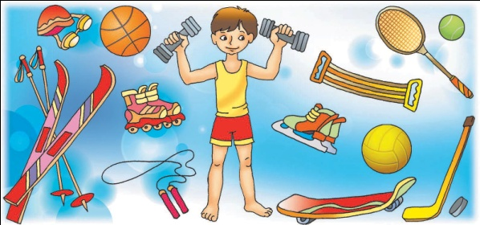

Внеклассное мероприятие по немецкому языку, 4-5-6 класс
КВН «Кто знает лучше немецкий язык?»
Михнович Е.В.
Методическая разработка.
Цель:- совершенствовать знания и умения учащихся по немецкому языку;
- увлечь учащихся изучением немецкого языка;
- представить учебный материал (лексический, грамматический, страноведческий и другой) в интересной, увлекательной, игровой форме.
Оборудование: раздаточный материал (карточки, тесты), магнитофон
Категория учащихся: 4-6 классы
Форма проведения: игра-КВН
Форма организации деятельности: внеурочная (внеклассная)
Ход мероприятия
I Вступительное слово учителя (сообщение темы и цели мероприятия)
II Основная часть (проведение мероприятия)
Выборы членов жюри. (учителя, старшеклассники)
1. Конкурс «Знакомство» (представление команд)
(Первая команда---«Die Schneeglöckchen», вторая---«Die Maiglöckchen»)
Участники показывают эмблему своей команды, а капитан представляет всех её членов, рассказывая о каждом, как зовут, в каком классе учится, как учится, чем увлекается и так далее. Команда может подготовить о себе визитную карточку: рассказ, песню, стихи, сценку, презентацию и т. д. на немецком языке. Наибольший балл- пять)
2. Конкурс «Дуэль»
В течение 2-3 минут команды по очереди называют слова по теме «Город». Побеждает тот, кто успеет больше назвать слов. Повторять слова нельзя. Количество названных слов---это количество заработанных баллов
.3. Игра «Исчезающее слово»
Учитель пишет на доске лексику не более семи слов. Учащиеся хором вместе с учителем проговаривают данные слова. Затем также произносят перевод слов. После этого ученики закрывают глаза, а учитель стирает с доски одно слово. Учащиеся открывают глаза и угадывают, какое слово исчезло. Кто первый угадал, выигрывает. Так повторяется до тех пор пока все слова не исчезнут.
4.Конкурс «Будь внимательным!»
Учитель читает текст (аудирование). После его прослушивания участники игры должны ответить на заданный по содержанию текста вопрос.
Для каждой команды звучит по два текста. За правильный ответ—два балла.
Текст №1
Heute ist Sonntag. Der Vater geht in die Bibliothek. Die Mutter geht in das Geschäft. Monika läuft auf die Eisbahn. Peter fährt in den Park. Und Lars geht ins Kino. (Wohin fährt Peter?)
Текс №2 Die Familie ist heute zu Hause. Der Vater sitzt am Tisch. Frank spielt im Garten. Die Mutter sitzt auf dem Sofa und liest. Monika steht am Fenster. Und die kleine Lene ist noch im Bett. (Wo spielt Frank?)
Текст №3 Das ist eine Klasse. Der Lehrer sitzt auf dem Stuhl. Monika liest ein Buch. Peter schreibt das Datum. Und Karin lernt ein Gedicht.(Was macht Peter?)
Текс №4 Auf dem Tisch liegen meine Schulsachen. Mein Buch ist blau. Meine Hefte sind gelb. Mein Kugelschreiber ist rot. Meine Lineal ist weiß. Und mein Tagebuch ist grün. (Wie ist mein Buch?)
5.Конкурс с болельщиками «Ловкий теннисист».
Нужна теннисная ракетка и шарик. Кто больше раз подбросит шарик. Считает сам игрок и по-немецки. Ошибаться тоже нельзя. Победитель игры может подарить свой заработанный балл любой команде.
6. Конкурс «Четвёртый лишний»
На карточках написаны логические ряды слов. Нужно найти лишнее слово. За каждое правильно найденное слово команда получает один балл.
Карточка №1
-die Schule-der Raum-die Aula-die Straße
-klein-groß-hoch-grün
-hier-dort-schön-links
-kommen-sehen-gehen-fahren
-der Koffer-die Reisetasche-der Weg-das Fernsehen
Карточка №2
-der Sport-treiben-frei-gesund
-alt-lang-sauber-hell
-das Geschäft-der Laden-der Bar-das Kaufhaus
-verbringen-erholen sich-stehen-sonnen sich
-die Katze-der Tiger-der Hund-der Papagei
7 Конкурс «Морской бой!»
8. Конкурс «Составь слово!»
Schneeballschlacht machen
9. Конкурс «Написание слов в воздухе»
Учитель в воздухе “пишет” простые слова. Ученики “читают” и записывают их в тетради. Выигрывает тот, кто справился с заданием лучше других.
10. Конкурс
Учитель называет немецкое слово, ученики должны придумать слово, начинающееся на последнюю букву предложенного слова. Например: Stadt Theater Russisch Heft и т.д.
11. Конкурс
Задание на внимательность. Pass auf! Какие числа спрятались в этих предложениях?
An der Wand steht ein Schrank.
Wir wandern und reisen.
Meine Schwester spielt Klavier.
Sie benutzt ein Wörterbuch zum Nachschlagen.
Du fährst nach Twer.
12. Конкурс
Телефонный номер. Telefonnummer.
Ведущий читает бегло номера телефонов. Задача команд – как можно быстрее и без ошибок записать диктуемые номера и произнести их
III Заключительная часть.
1. Подведение итогов игры. Награждение (грамоты, сладкие призы)
2. Заключительное слово учителя.
3. Дискотека.

