Simplify the following:
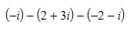
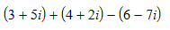
- $\sqrt{-32}$ 2. 3.

Solve each of the following equations for $x$

4. $x^{2}=-90$ 5. $x^{2}+9=-15$ 6. $-6x^{2}+17=125$

7. $-4{\left(x-7\right)}^{2}+14=-22$

Graph the following Identify the complex number graphed.
complex number.
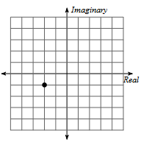
8. 1 + 4i 9.
