Complex Numbers

Questions to consider:

1. What is the complex number system?

2. What is the number $i$, and what does it represent?

3. How can we use $i$ to help us solve quadratic equations?

We have already solved quadratic equations by taking the square root of both sides of the equation.

Here is an example: $x^{2}=16$

What if we saw something like this: $x^{2}=-16$

What’s wrong?

We have a solution to this problem: _________________________

By definition, $i=$ ____________ then $i^{2}=$ _______________

Some examples – we want to break this into something we already know how to do, so get rid of the negative first (by using $i$):

a.) $\sqrt{-16}$ b.) $\sqrt{-20}$

c.) $\sqrt{-25}$ d.) $\sqrt{-50}$

Let’s use this to help us solve some equations – remember our ultimate goal is to get ${stuff}^{2}=number$

a.) $x^{2}+10=-26$ b.) $2x^{2}+12=-20$

c.) $3x^{2}-10=-46$ d.) $2x^{2}+26=-10$

e.) $-2{\left(x+4\right)}^{2}=16$ f.) $3{\left(x-2\right)}^{2}+20=-1$

The complex number system: believe it or not, every number you have dealt with is a complex number.

General form of a complex number: $a+bi$ a? b?

How can we write 3 in complex number form?

Complex Numbers $(a+bi)$

Just like we can plot the points (2, 5) and (-3, 6), we can plot a complex number on the _______________________. Label the axes.

a.) $2-3i$ b.) $-3+2i$ c.) $4i$
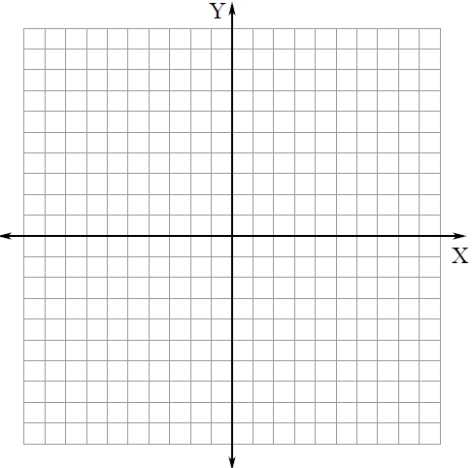

We can also add and subtract complex numbers. Even though it is not, treat $i$ like it is a ______________. First order of business is to attack the _______________.

a.) $\left(4-i\right)+(3+2i)$ b.) $\left(7-5i\right)-(1-5i)$

c.) $6-\left(-2+9i\right)+(-8+4i)$ d.) $5+\left(-3-2i\right)-(3+i)$

