Simplify the following:

- $\sqrt{-64}$ 2. $\sqrt{-20}$ 3. $5\sqrt{-100}$

Solve each of the following equations for $x$

- $x^{2}=-50$ 5. $x^{2}-7=-82$ 6. $-3x^{2}+17=113$

- $-3{\left(x+7\right)}^{2}=72$ 8. $5{\left(x-2\right)}^{2}+20=-60$

Graph the following complex numbers

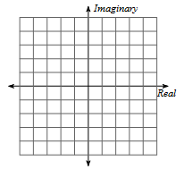
- 1 + 4i 10. -3 – 3i 11. 4- 5i
Identify each complex number graphed.
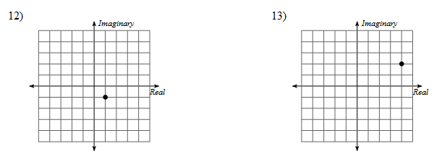

Simplify
