1-25 | 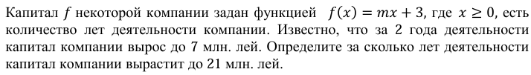
2-25 | 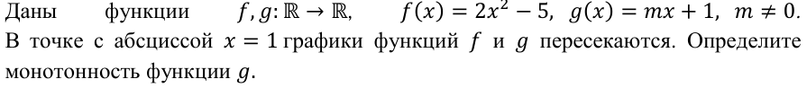
Pr-25 | 
1-24

2-24 | 
Pr-24
Сб24 | 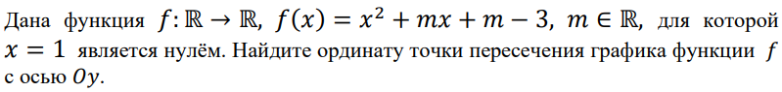
Сс24 | 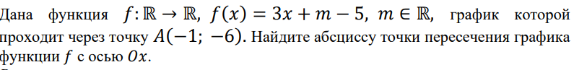
1-23 | 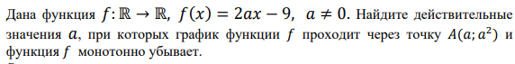
2-23 | 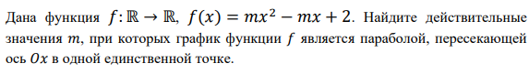
Pr-23 | 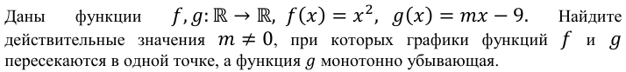
Sb-23 | 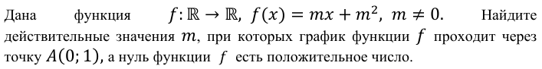
ss-23 | 
1-22 | 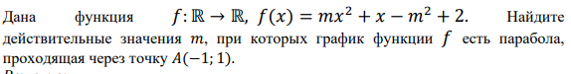
2-22 | 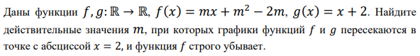
pr22 | 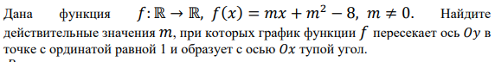
Sb-22 | 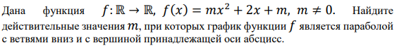
ss-22 | 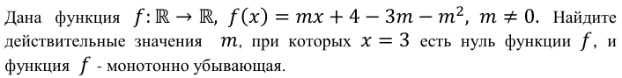
1-21 | 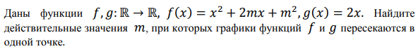
2-21 | 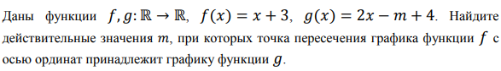
Pr  21 | 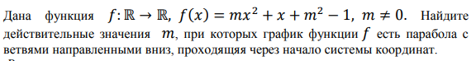
Sb  21 | 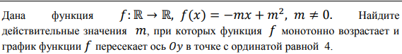
Ss  21 | 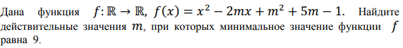
1-20 | 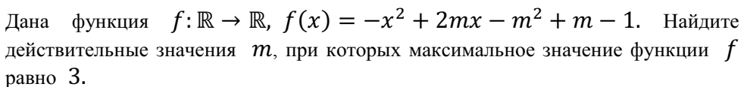
2-20 | 
1-19 | 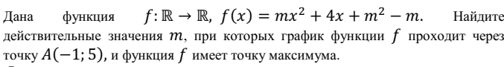
2-19 | 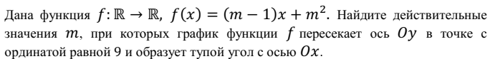
Pr-19 | 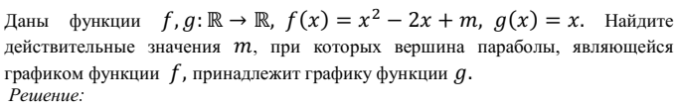
Sb-19 | 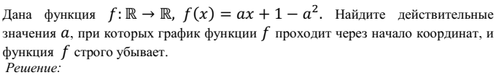
Ss-19 | 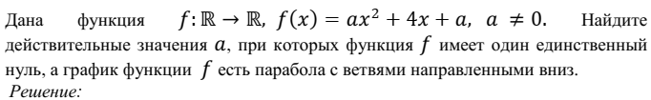
1-18
2-18
Pr-18
Sb-18
Ss-18
1-17
2-17
Pr-17
Sb-17
Ss-17
1-16
2-16
Pr-16
Sb-16
Ss-16
1-15
2-15
Pr-15
Sb-15
Ss-15
1-14
2-14
Pr-14
Sb-14
Ss-14

