Objective: To be able to identify which linear equation goes with which linear graph.
This set is self-correcting. If the dominoes are connected correctly they should form a ring, and the letters should spell “MATH line PLOT”
M  y = x | 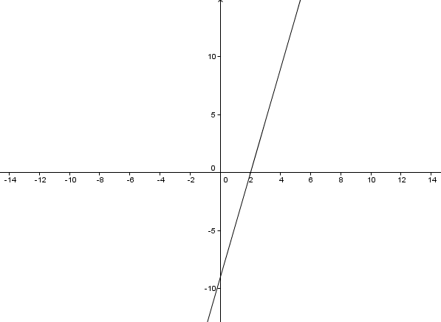 | n  y = -x | 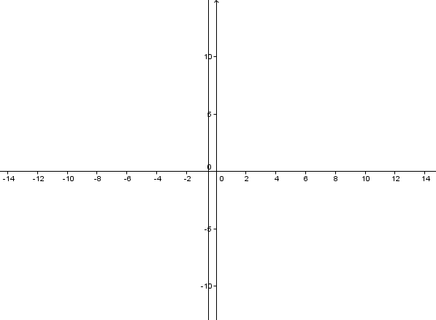
A  y = x +3 | 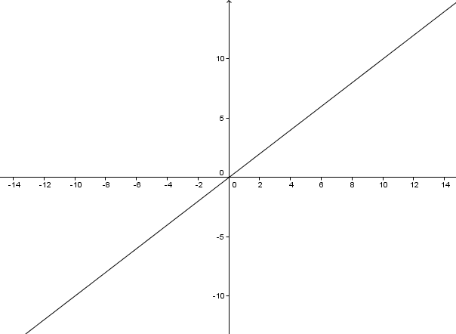 | e  y = 4 | 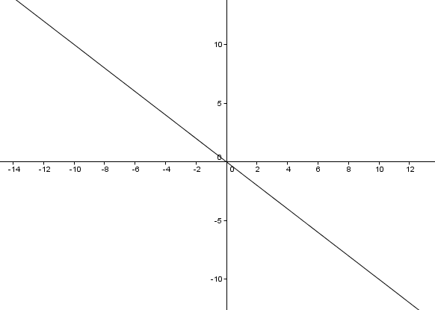
T  y = -x + 2 | 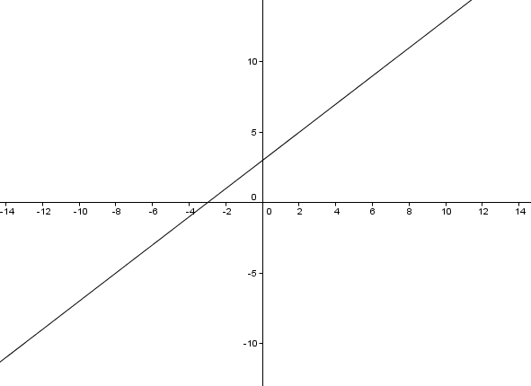 | P  y = 2x - 9 | 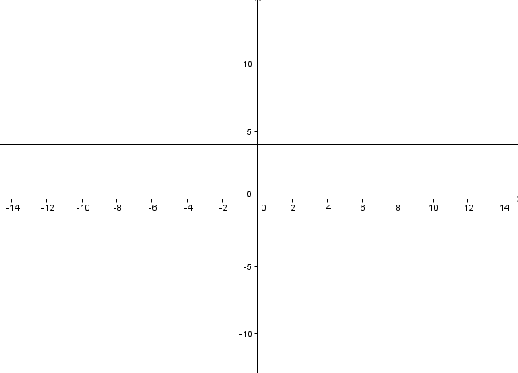
H  y = -$\frac{2}{3}$x+3 | 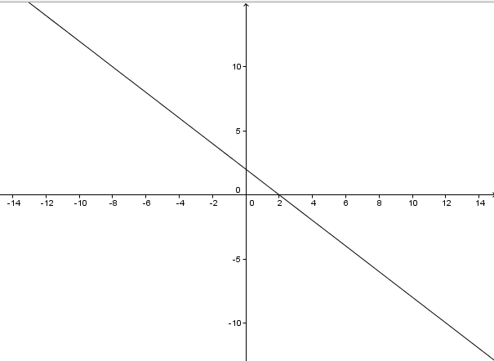 | L  y = $\frac{3}{2}$x - 3 | 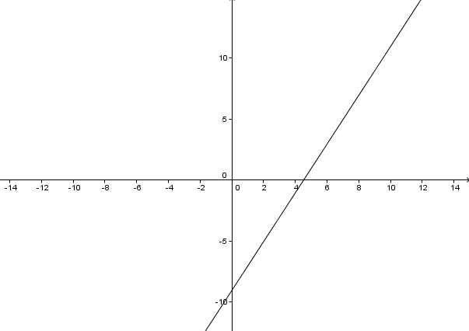
l  y = 4x - 6 | 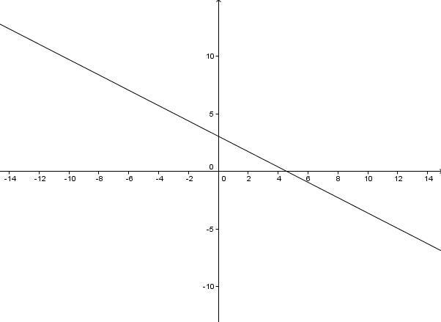 | O  y = -3x + (-1) | 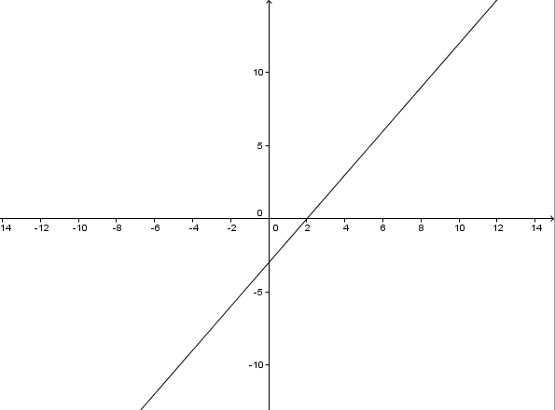
i  x = - ½ | 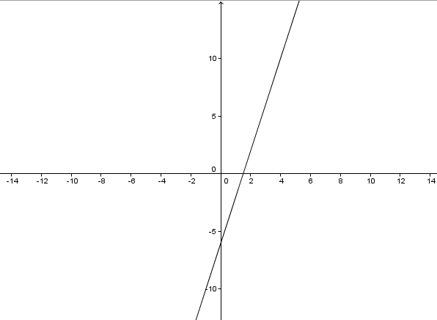 | T  y = $\frac{9}{2}$ (x-2) | 