1-25
2-25
ПР25
Сб24
Сс24
Пр24
2-24
1-24
Сс23 | 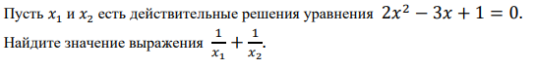
Сб23 | 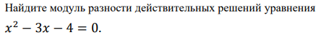
Пр23
1-23
2-23
1-22
2-22
pr22
Sb-22
ss-22
1-21
2-21 | 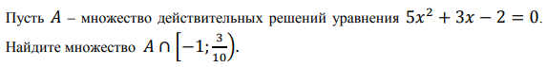
Pr21
Sb21
Ss21
1-20
2-20
1-19
2-19 | 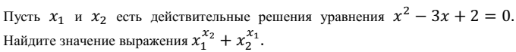
19pr | 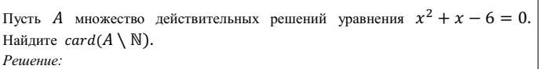
Sb-19 | 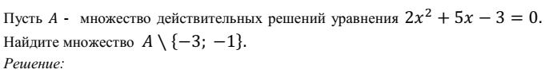
Ss-19 | 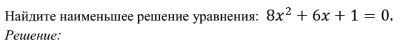
1-18
2-18
Pr-18
Sb-18
Ss-18
1-17
2-17
Pr-17
Sb-17
Ss-17
1-16
2-16
Pr-16
Sb-16
Ss-16
1-15
2-15
Pr-15
Sb-15
Ss-15
Sb-14

