NOTE: If you receive a permissions error from Google Drive, it’s most likely because your school network is blocking forms from outside users (that’s me!). Two ways around this:
- Use your cell phone hotspot if you have one to circumvent the school’s network.
- Access from home or Starbucks or McDonalds or anywhere besides school in order to make a copy on your Drive – then you’ll be able to use as you please!

Here’s a link to the folder that contains both articles (and both article KEYS for Activity 3!).
Do not share this folder directly with students as it includes answer keys!

https://drive.google.com/drive/folders/1thjuMQb0bzRZ8-iB6sg4P-bt1sZTVDTL?usp=sharing

Instructions:

- Make sure you’re logged in to your Google Drive in your browser. Chrome is best if possible.
- Click the folder at the top and choose Add to My Drive:
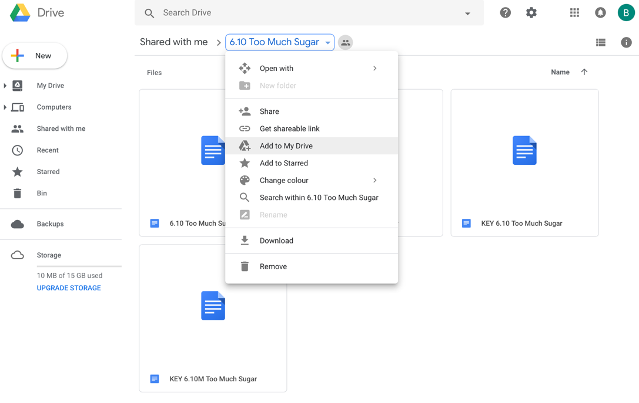
- Now these articles and keys are all in your Google Drive. You can share an individual Google Doc with your students.

