1-25
2-25
ПР25
1-24
2-24 | 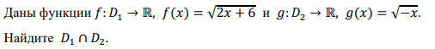
Пр24
Сб24 | 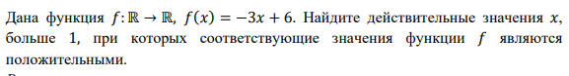
Сс24
1-23
2-23
Пр23
Сб23
Сс23 | 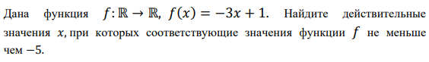
1-22 | 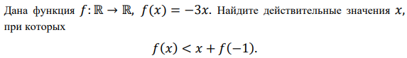
2-22
Pr  22 | 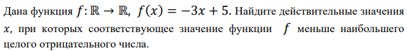
Sb-22 | 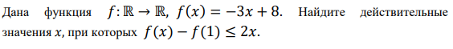
Сс22
1-21
2-21
Pr  21 | 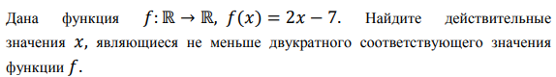  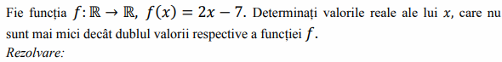
Sb  21 | 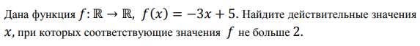  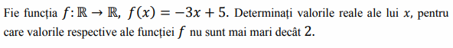
Ss  21 | 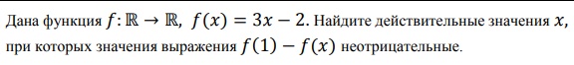
1-20
2-20
1-19 | 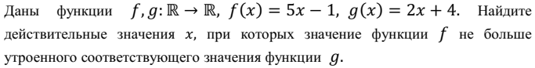
2-19
Pr-19 | 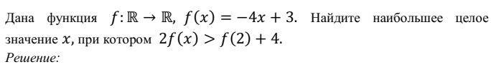
Sb-19 | 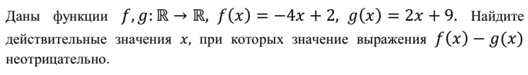
Ss-19
1-18 | Настя
2-18 | сделали
Pr-18
Sb-18
Ss-18
1-17
2-17
Pr-17
Sb-17
Ss-17
1-16
2-16
Pr-16
Sb-16
Ss-16
1-15
2-15
Pr-15
Sb-15
Ss-15 | Рита

1-14
2-14
Pr-14
Sb-14
Ss-14

