1-25 |  | 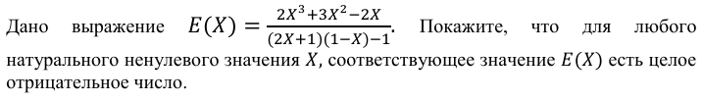
2-25 |  | 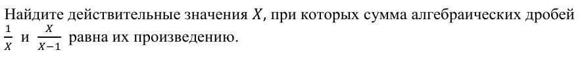
Pr-25 |  | 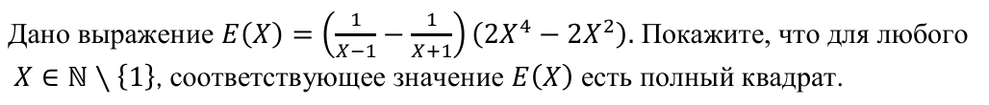
1-24 |  | 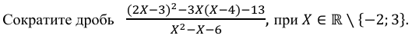
2-24 |  | 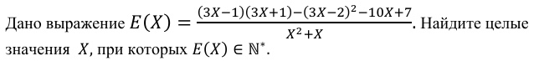
Pr24
Сб24 |  | 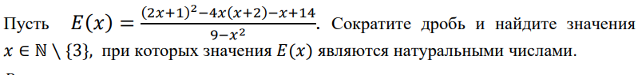
Сс24 |  | 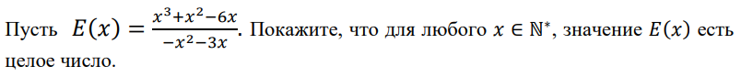
1-23 |  | 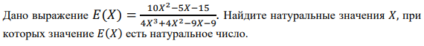
2-23

Pr-23 |  | 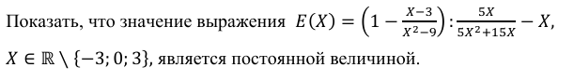
Sb-23 |  | 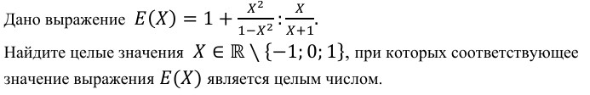
ss-23
1-22 |  | 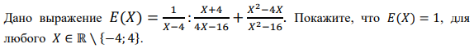
2-22 |  | 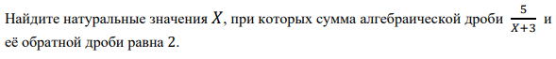
pr22 |  | 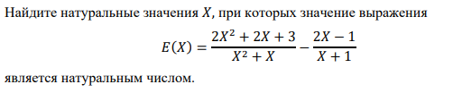
Sb-22 |  | 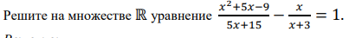
ss-22 |  | 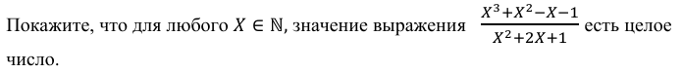
1-21 |  | 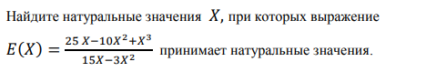
2-21 |  | 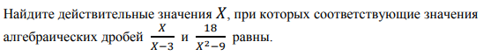
Pr  21 |  | 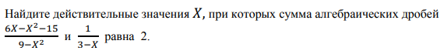
Sb  21 |  | 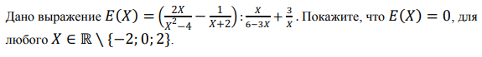
Ss
21
1-20
2-20 |  | 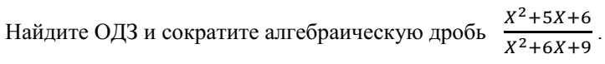
1-19 |  | 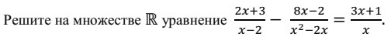
2-19 |  | 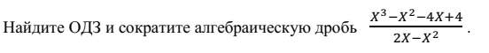
Pr-19 |  | 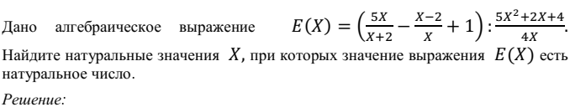
Sb-19 |  | 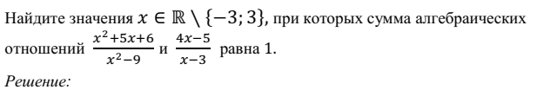
Ss-19 |  | 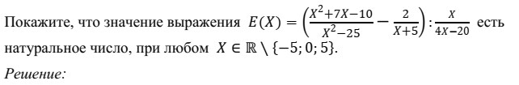
1-18
2-18
Pr-18
Sb-18
Ss-18
1-17
2-17
Pr-17
Sb-17
Ss-17
1-16
2-16
Pr-16
Sb-16
Ss-16
1-15
2-15
Pr-15
Sb-15
Ss-15

1-14
2-14
Pr-14
Sb-14
Ss-14

