HOPE by Emilijan Kiprijanovski

Hope is something  you hope for  while it ‘s hard. | 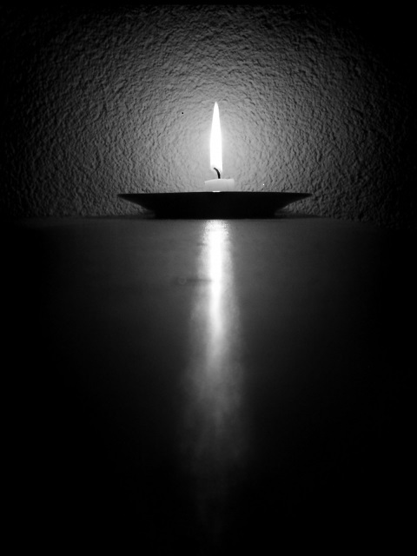
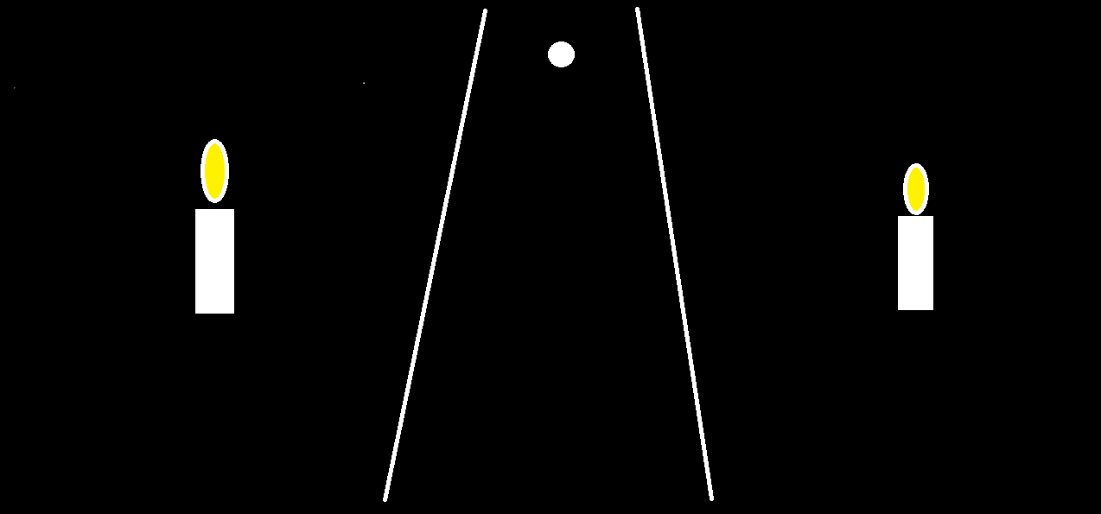 | Hope is when  you don’t give up  and when in  the dark path you see  the bright spot.
Hope is endlees  when you hope for  unitl your desire  is fulltilleed. | 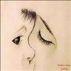
Hope is cheering you
when you are in tight,
but when you hope
everything is becoming true
very easily.

