  POLO
  Equipment
  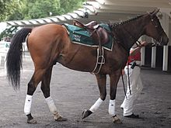
  Horse
  POLO
  Player (s)
  4
  POLO
  Famous name
  La Quinta (Argentina)
  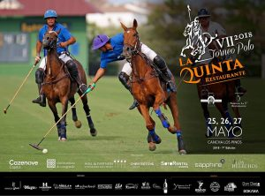
  POLO
  Pitch
  Big area of grass
  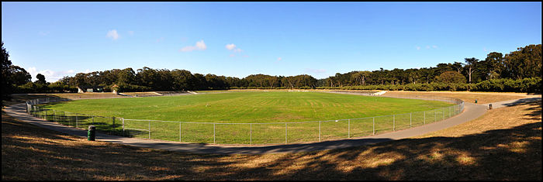
  Length : 275 metres
  Width : 145 metres

    SURF
    Equipment
    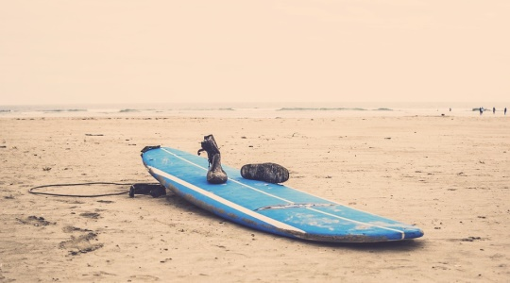
    Board
    POLO
    Players
    4
    POLO
    Famous team
    La Quinta (Argentina)
    POLO
    Pitch
    Big area of grass
    Lengh : 275 meters
    Width : 145 meters
    SURF
    Players
    1
    Individual sport
    POLO
    Players
    4
    POLO
    Famous team
    La Quinta (Argentina)
    POLO
    Pitch
    Big area of grass
    Lengh : 275 meters
    Width : 145 meters
    SURF
    Famous name
    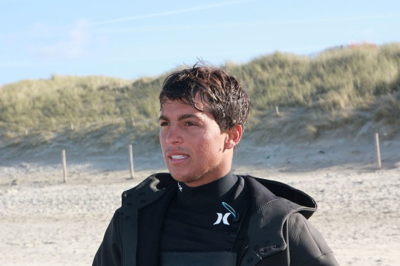
    Kai Lenny
    (from Hawaï)
    POLO
    Players
    4
    POLO
    Famous team
    La Quinta (Argentina)
    POLO
    Pitch
    Big area of grass
    Lengh : 275 meters
    Width : 145 meters
    SURF
    Pitch
    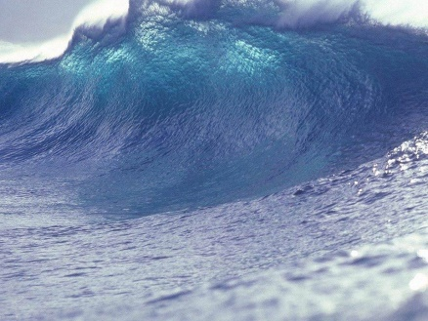
    OCEAN
    (with big waves)
    POLO
    Players
    4
    POLO
    Famous team
    La Quinta (Argentina)
    POLO
    Pitch
    Big area of grass
    Lengh : 275 meters
    Width : 145 meters

  CRICKET
  Equipment
  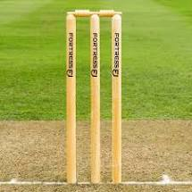
  Stumples
  CRICKET
  Players
  11
  11
  CRICKET
  Famous name
  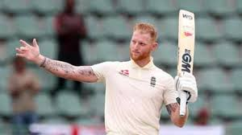
  Benjamin Andrew STOKES (born 4 June 1991) is an English international cricketer . He is regarded as one of the best in world cricket and in England history.
  CRICKET
  Ground
  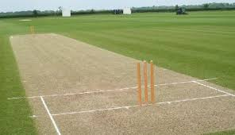
  Length : 23 m
  Width : 3,5 m

  BASEBALL
  Equipment
  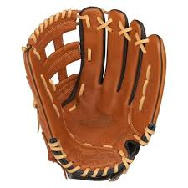
  Glove
  BASEBALL
  Players
  9
  BASEBALL
  Famous team
  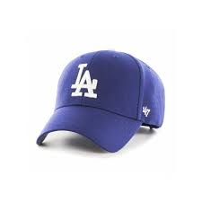
  LOS ANGELES DODGERS
  BASEBALL
  Field
  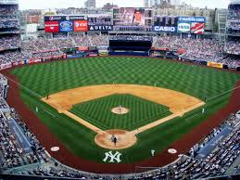
  ¼ of a circle
  CROQUET
  Equipment
  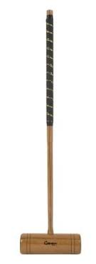
  Croquet mallet
  CROQUET
  Players
  2 to 8
  CROQUET
  Famous name
  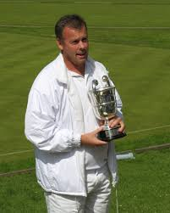
  Reg BAMFORD (born 11 October 1967 in Cape Town, South Africa) is a croquet world champion.
  CROQUET
  Pitch
  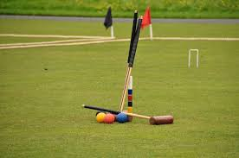
  Length : 17 metres
  Width: 14 metres
  Length : 17.5 metres Width : 14 metres

  SOCCER
  Equipment
  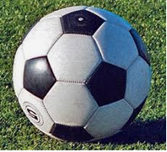
  Ball
  SOCCER
  Players
  11
  SOCCER
  Famous team
  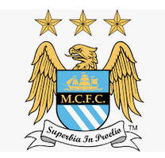
  Manchester City
  SOCCER
  Pitch
  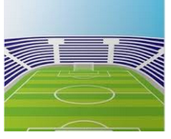
  Length :from 90 meters to 120 meters
  Width :from 45 metres to 90 metres

  FOOTBALL
  Equipment
  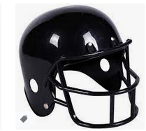
  Helmet
  FOOTBALL
  Players
  11
  FOOTBALL
  Famous team
  
  Tom Brady (USA)
  FOOTBALL
  Pitch
  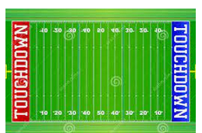
  Length 110 metres
  Width 49 metres

  RUGBY
  Equipment
  Oval ball
  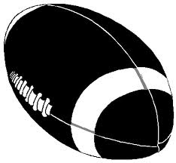
  RUGBY
  Player (s)
  15
  RUGBY
  Famous name
  All blacks
  (New Zeland)
  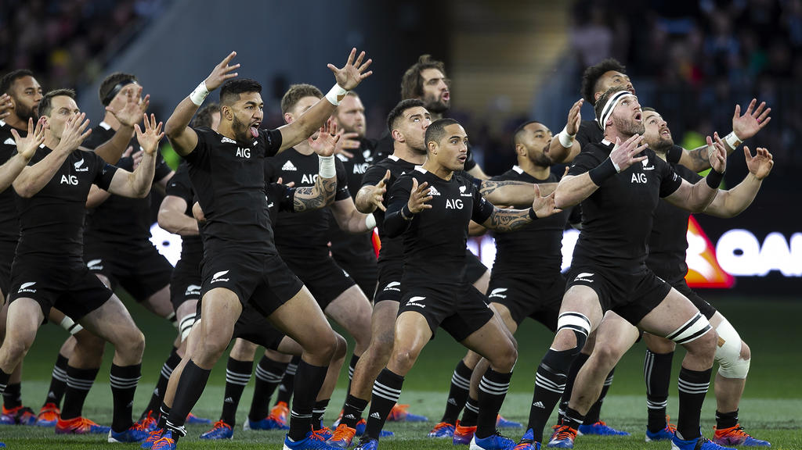
  RUGBY
  Pitch
  Big area of grass
  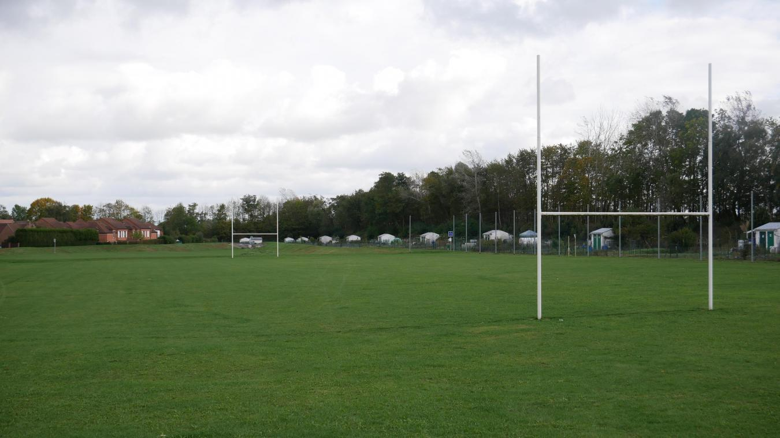
  Lengh : 100 meters
  Width : 70 meters

  Equipment
  Players
  Famous team
  Pitch

  Equipment
  Players
  Famous team
  Pitch

