CLIL Sessions Plan – Sciences
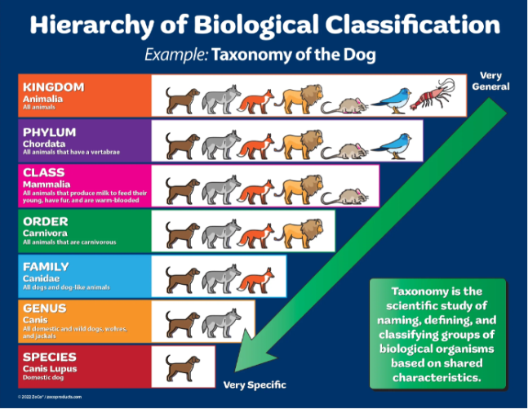
Group  CM1 –CM2 | Time : 5 sessions of 40’
Topic : Sciences – Animal classification – phylogenetic

Previous knowledge/skills
Naming some animals ; knowing human body parts and face

Aim(s)
- Connaitre les critères de tri utilisés par les scientifiques
- Connaitre quelques modalités de représentation de classification des animaux
- Réaliser des tris après avoir déterminé des critères
- Déterminer un critère d’appartenance à un groupe.

Teaching objectives | Learning outcomes
- Content  Animals : fish – magpie –fly – bee – pigeon – chimp ( monkey) - cat  – animal body parts : tail - legs – wings –antennaes- eyes –mouth – feathers- fur – members - scales – skin – internal skeleton – spine - families | - Content  Naming animals and body parts
- Cognition  Sorting out – observing -  Make families -observing the similarities  Choosing relevant criterias | B. Cognition  Sorting out – observing -  Working with other pupils
C. Communication
C.1 Language of learning (= topic specific essential vocab & grammar)
Animal names – animal body parts : fish – magpie –fly – bee – pigeon – chimp - cat
– animal body parts : tail - legs – wings –antennas- eyes –mouth – feathers- fur – members - scales – skin – internal skeleton - families
It has ……. . It has got ……………… They have ………..

C.2 Language for learning (=language needed to operate in the learning
environment or in a particular lesson – discuss, justify, explain, etc)
They are in the same group because they have ………………………….
It has ……
They are together BECAUSE they have…

C.3 Language through learning
It’s your turn.

- Culture/Citizenship
Play together - DNA - phylogenetic
Materials & resources

Worksheet 1 and 2
Pictures of animals ( 7 or 8 for each group of pupils)
Classification animal TNI et paperboard
TNI imaginary animals
Papiers affiche/ feutres/ patafix/ Cartes « vivants » du CD-Rom
Who’s who Monster ( Enseigner l’anglais avec les albums- ed. Retz)
POP UP CM1 – Ed. Belin

Teaching plan (type, timing & sequence of activities)

Session 1: English sessions
Learning body parts : POP UP CM1 act 4 stage 2 and 3

Playing who’s who Monster

Describing animals and monsters with their attributes.

It has got …. It has ….

Session 2: English session

Learning animal body parts:
https://www.youtube.com/watch?v=szEzGwsdwmg

Playing with flashcards Animal Body parts Bingo
Show me the tail , the shell, the claw, the fur, the feathers….

Pairwork: turn the picture face down and try to guess. Or play the memory game (after removing the names)

TNI imaginary animals
Describe the monsters.

Draw a monster and describe it.
Playing the who’s who monster with the monsters of the class.

Session 3: Science session

Scientists have criteria to classify animal. Because of the discover of the DNA , we know that animals have ancestors in common when they have parts of their body similar such as 4 members.

4 members for a bird… : 2 wings and 2 legs.

On trie les animaux en fonction de ce qu’ils ONT et PAS en fonction de ce qu’ils N’ONT PAS ni en fonction de ce qu’il font NI de Où ils vivent.

On ne parle plus d’amphibiens ni même de reptile en SCIENCE quand on parle de classification animale.

Fiche élève : classification.
Pair work
Mise en commun des recherches sur les animaux.
Répondre aux questions. Poils sur le papillon….
L’importance des critères les plus forts (prégnants). Le nombre de membres est plus fort que ce qui recouvre la peau (écailles, poil, plumes…)

Session 4: Science session

Warm up

Jeu de Kim au tableau avec les caractères des animaux.

Legs – wings – antennas – feathers – fur – fins – beak -

Game Play MEMO
Deal the memo game. Cut the pictures and remove the words.
Turn the pictures face down.
Try to make a pair: the picture and the name.
If you succeed ( if you win) , you keep the pair.
Then you say “It’s your turn”. Then, The pupil B plays.

Group mission
You have several animals/ Present on TNI
Monkey (Chimp) - fish – pigeon – magpie - fly – bee – cat

You have criteria. You have to organize, to show why animals are together ( in the same family) and justify.

They are together BECAUSE they have…

You have many solutions….
Explaining the material. Organizing the group work 10’

By group, pupils explain their work and justify their choice. 10’

Conclusion: What did we learn today?

Session 5: Science session French 30’

Revenir sur les critères définis pour l’observation et la classification des animaux.

Reprendre 2 façons de présenter les classifications avec des critères communs : emboitements ou arbre.

Texte récapitulatif en trace écrite.

Follow up :

Creation of Imaginary animals -> ARTS

English : describe your imaginary animal.
With other vocabulary ( horn, tail, claws, whiskers…)
Who’s who with imaginary animals of the class.

Assessment:

To be able to classify ( other) animals.
Knowing classification criteria.

Liste des critères
A imprimer pour séances 4
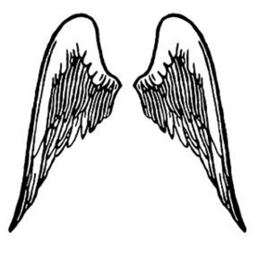  wings |   tail | 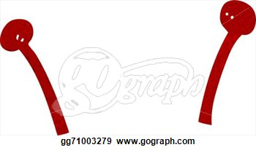  antennaes
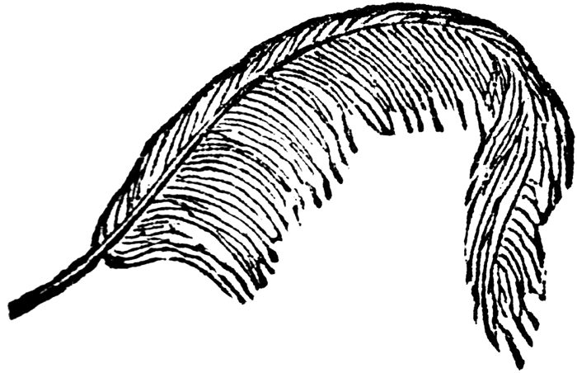feather | 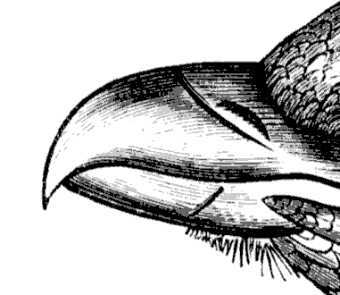  Beak | 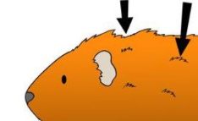  fur

Science in english : animal classificationExercise 1:
 |  | 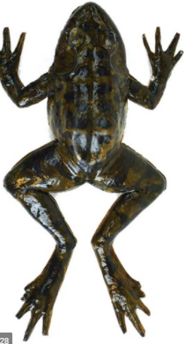 | 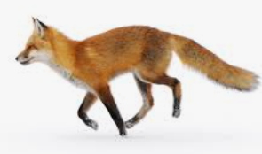 | 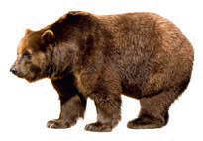 |  |  | 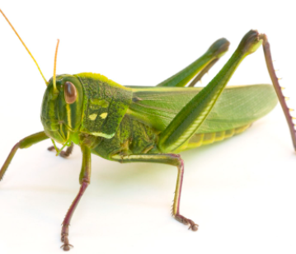 | 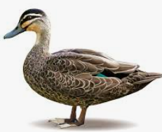 | 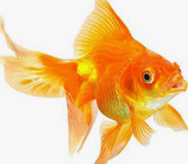
 | Owl | Frog | Fox | Grizzly bear | Butterfly | Snake | Grasshopper | Duck | goldfish
eyes
mouth
4 members
6 legs
2 antennas
(internal)
squeleton
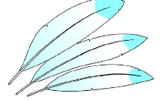
feathers

fur
skin
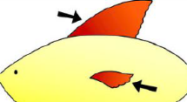
Fins


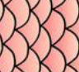
Scales or

shell
Exercise 2:
What do animals have in commun? ………………………………………………………………………………………………………………………………………………………………………
Which animals have four members ? ……………………………………………………………………………………………………………………………………………………………………
Which animals have 6 legs and 2 antennas, 2 wings? ………………………………………………………………………………………………………………………..……………..

Eyes, mouth | Internal skeleton | Fur 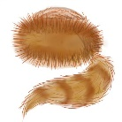
6 legs, wings, antennas | 4 members | Feathers 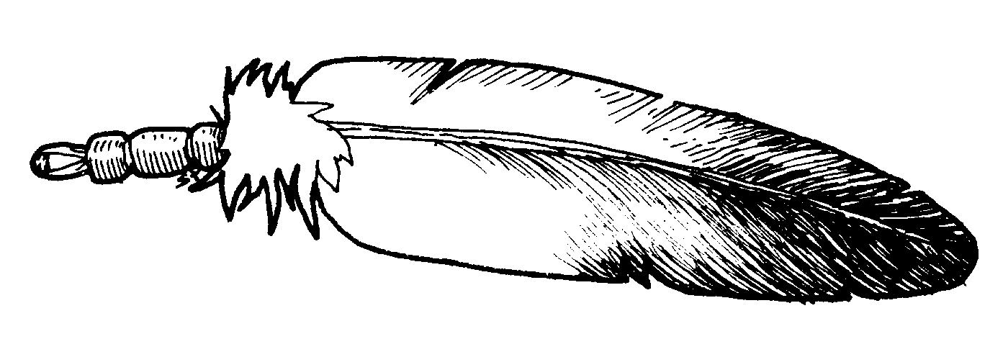

Eyes, mouth | Internal skeleton | Fur
6 legs, wings, antennas | 4 members | Feathers

Eyes, mouth | Internal skeleton | Fur
6 legs, wings, antennas | 4 members | Feathers

Eyes, mouth | Internal skeleton | Fur
6 legs, wings, antennas | 4 members | Feathers

Travail de groupe séance 4
Imprimer et retirer les noms
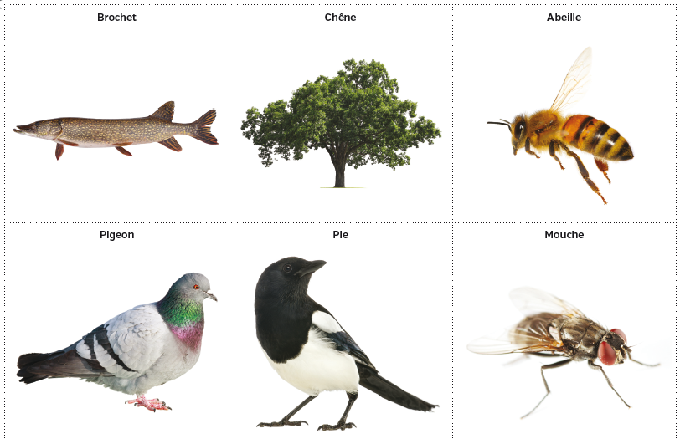

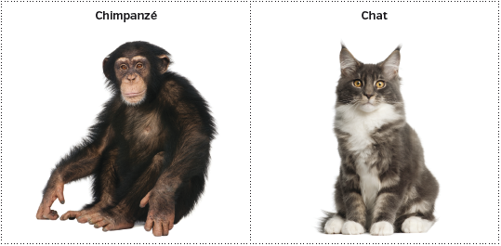

Animal classification with boxes
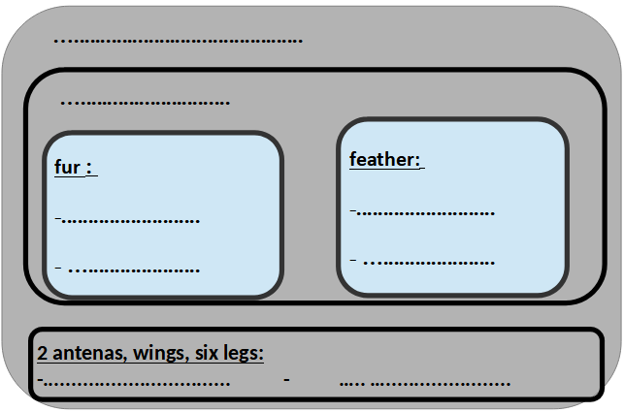
La classification animale sous forme d'arbre

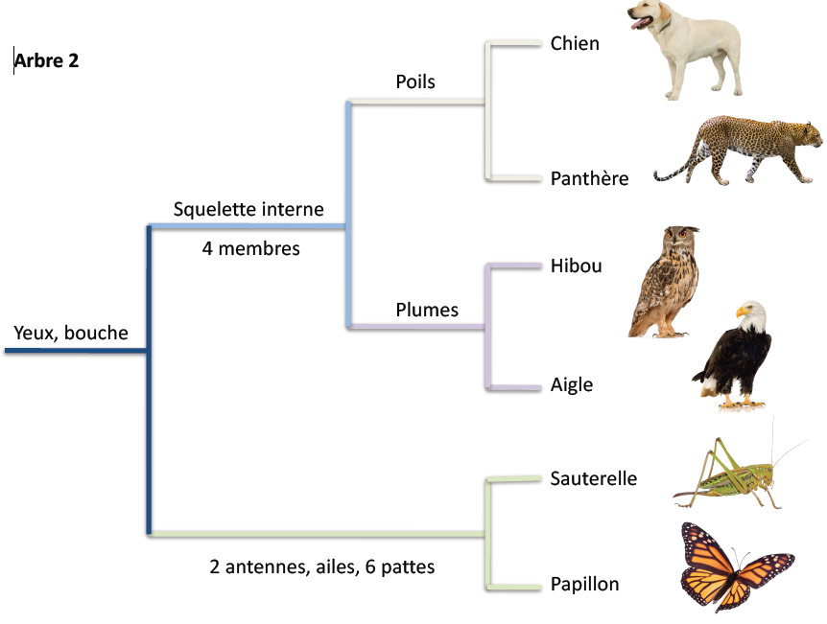

Traces écrites

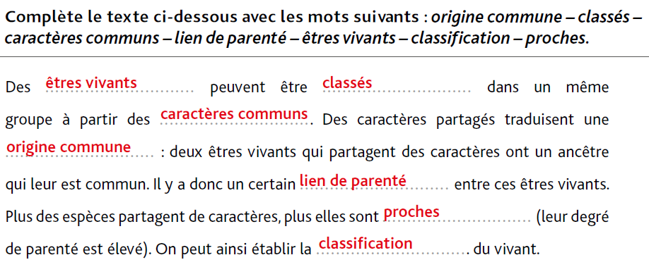

Follow up
  whiskers | tail |  | 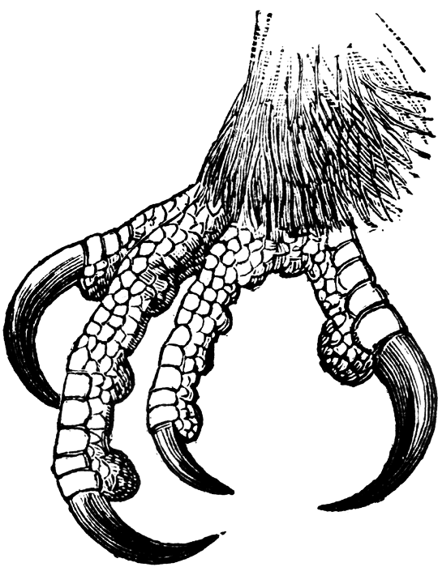  claws
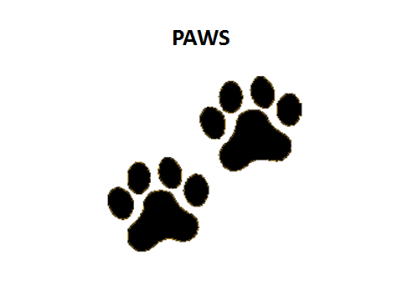  paws | wings |  | 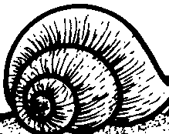  shell
feather | Beak |  | 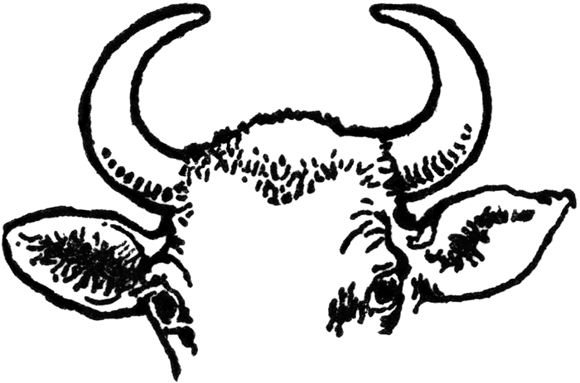  horns
  spots |  |   stripes | antennae

