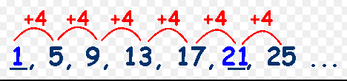




- What is the 1st term of this sequence of numbers?
- By how much is each number different from the previous?
- How would you find the next number after 25?
- Can you write a formula to find the 10th number?

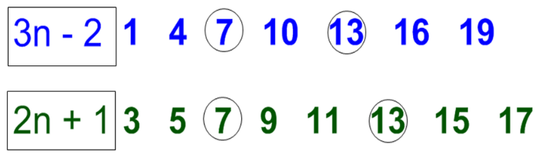


- Discuss these two sequences of numbers and their formulae
- Can you combine the two formulae to show they are both worth seven at some point in both sequences?


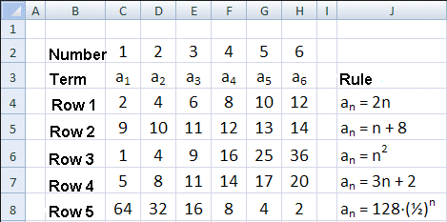


Do you understand each sequence and its formula?
After row ‘H’ could you find the next number in each sequence?

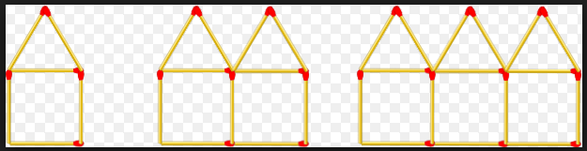

1st
3rd
2nd
A pattern is made by adding more matches to the house shapes above. The first pattern has 6 matches.
How many matches are needed for the forth pattern?
How many matches are needed for the pattern that has 100 houses?

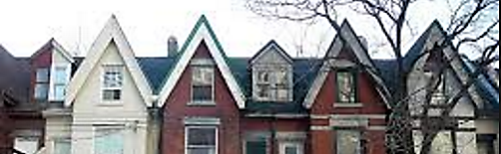

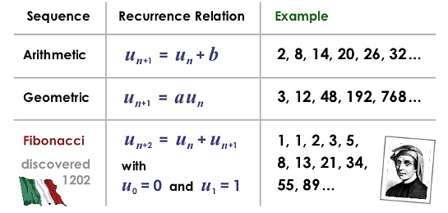
Your text here

Higher!

U₁ means the first number in the sequence
What does U_{n} mean? Or U_{n+1}? Or U_{n-1} ?


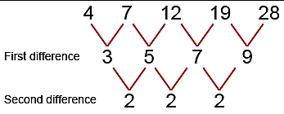

Look at this quadratic sequence starting with ‘4’.
- Can you find the next number after ‘28’?
- What comes before ‘4’?
- Is there a formula for this sequence?
Higher!


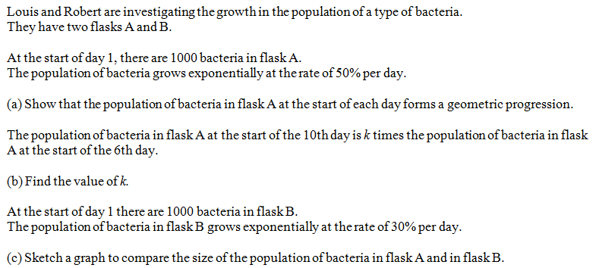

Higher!





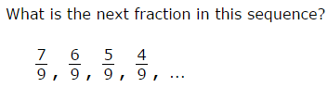
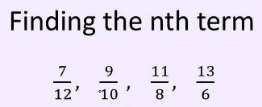

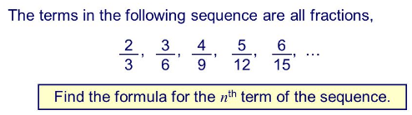

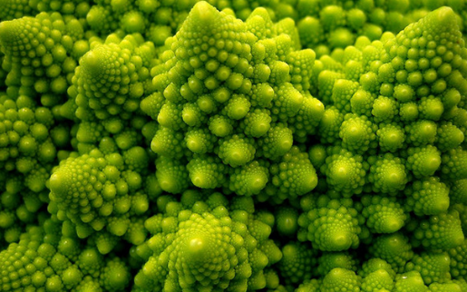
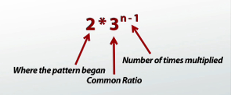

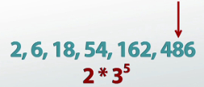
This sequence generates numbers by multiplying by 3.
Can you find the tenth value in the sequence?
Is 5218 a value in this sequence?

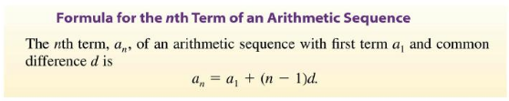


Use ‘a₁’ as 6, use ‘d’ as 4.
Write out the first eight values of this sequence.



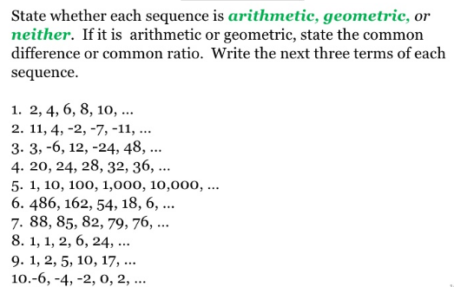


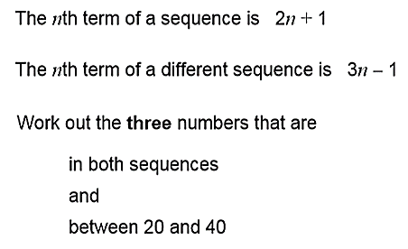

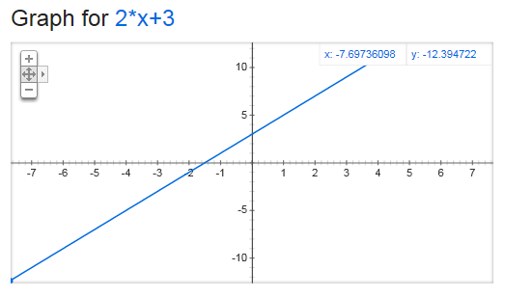


This graph is drawn along the x axis to show the value along the y axis when you put different x values into the expression 2x + 3.
How are line graphs and sequences the same?
What would the sequence 2x + 5 look like?
The line does not start at x=0…. so what is the first value in the sequence?


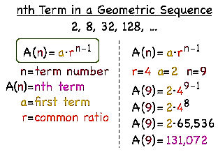

Discuss this example of a ‘Geometric Sequence’ starting with the number 2 and finding the ninth term.

4X² + 3X -2

- Start with x as 1
- Create a sequence of numbers by putting 1, then 2 then 3 etc into the expression above
- Can work out the 15th value?
- Can any value in the sequence be negative?

