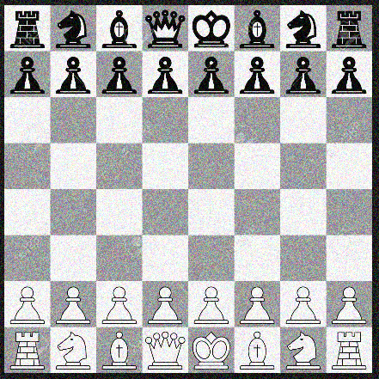

Tasks to show on a poster….

1) Draw a line between the black king and the white castle (this will be your NORTH line). Choose another playing piece on the board and show the bearing from the castle to it using your north line already drawn.

