
PYTHAGORAS’
THEOREM
PROBLEM
QUESTIONS

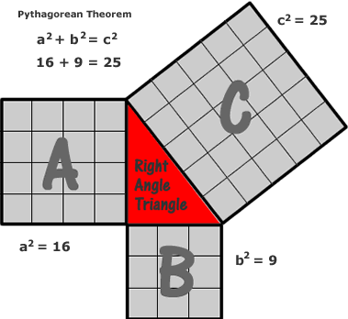

Learning Intention:

“I can apply Pythagoras’ Theorem to solve problems involving right-angled triangles.”

MTH 4-16a – I have explored the relationships that exist between the sides, or angles and sides, in right-angled triangles and can select and use an appropriate strategy to solve related problems, interpreting my answer for the context.

Instructions:

Each question has a letter:

P-Y-T-H-A₁-G-O-R-A₂-S.

Try to answer each question.

You can discuss your solutions with the people sitting at your table.

Each question has a HINT on the next page.

You should try the question before looking at the hint!



45 m
60 m
A farmer has a rectangular field, and must walk from one corner to the opposite corner to get to his tractor.
How far is this?
P



60 m
45 m
HINT – Draw a right-angled triangle with the hypotenuse as the diagonal distance from the farmer to his tractor.

P

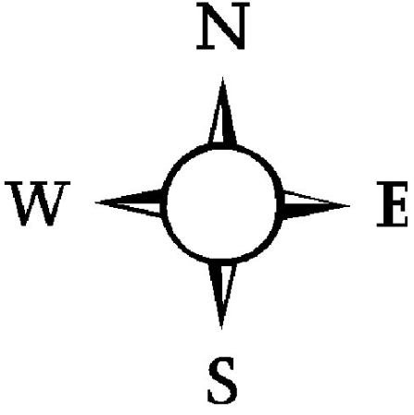
Y


A maintenance boat sails due East from a Harbour (H), to a marker buoy (B), 15 miles away. At B the boat turns due South and sails for 6.4 miles to a Lighthouse (L).

Make a sketch of the journey.

What is the distance from the Harbour to the Lighthouse?

Y

HINT - Your sketch should look like the one below…

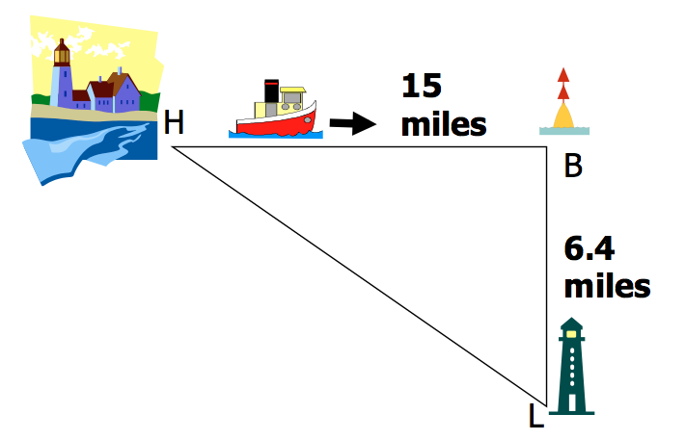

A ladder can extend to 5.7 m.

Health and Safety Regulations state that this ladder must be a safe distance of 1.3 m from the base of the wall when fully extended.

How high up a wall can the ladder reach when fully extended?
T



HINT - If you have drawn a sketch of this situation, it should look similar to the one below:
T

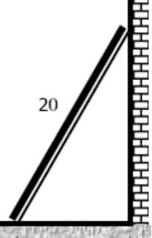
5.7 m
1.3 m

H
Andy’s television screen has width 36.6 inches and height 20.6 inches.

Andy thinks he has a 46 inch TV.

Is he correct?





36.6 inches
20.6 inches
HINT - Screen sizes are measured as a diagonal distance.

H

A₍₁₎

A plane left Edinburgh Airport. The pilot flew 70 kilometres West. He then flew 55 kilometres due North.

How far is the plane from Edinburgh Airport?



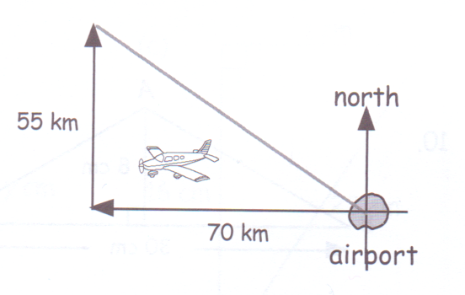
HINT – A sketch of the flight is shown below.

A₍₁₎

G
A crane needs a length of cable replaced. The length of the arm of the crane is 50 m and the height from the arm to the cable is 15 m.

How long is the cable that needs to be replaced?

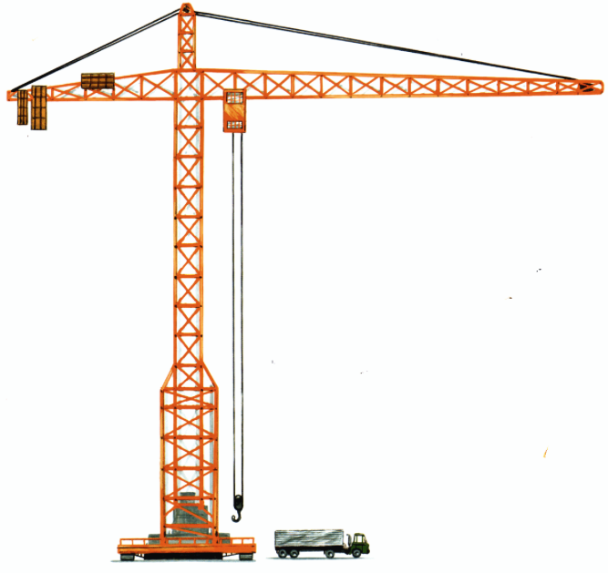
50 m
15 m

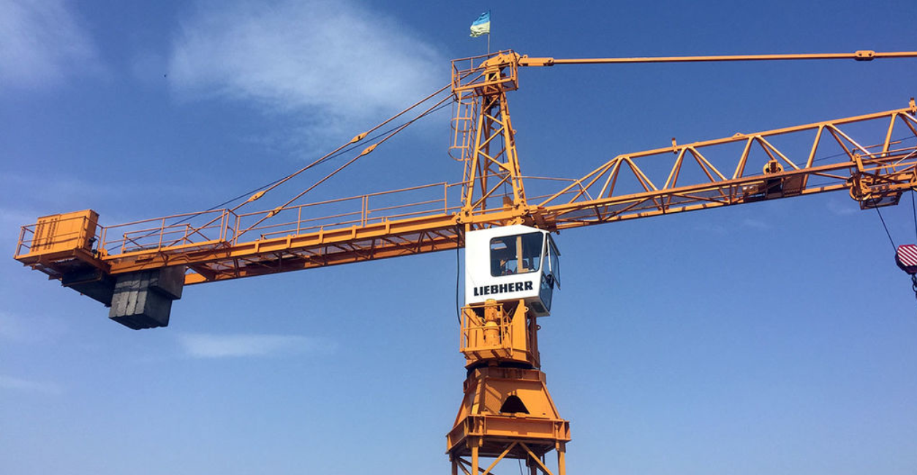

50 m
15 m
cable
HINT – A triangle like the one below will help:

G
13 cm

5 cm

Find the area of the triangle below.

O



base

13 cm

5 cm

HINT – The area of a triangle is given by A= $\frac{1}{2}$ x base x height.

Find the length of the base first.

O

10 cm

23 cm

25 cm

Is this triangle right-angled?

R



HINT – Check if Pythagoras’ Theorem “works” for this triangle.

10 cm

23 cm

25 cm

R

A₍₂₎

David has made a doorstop.

The distance between the door and the floor is 1.6 cm.

Is the doorstop big enough to hold the door open?

A diagram of the doorstop is shown with some measurements.

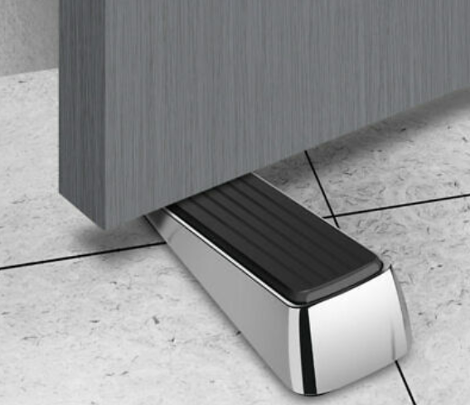

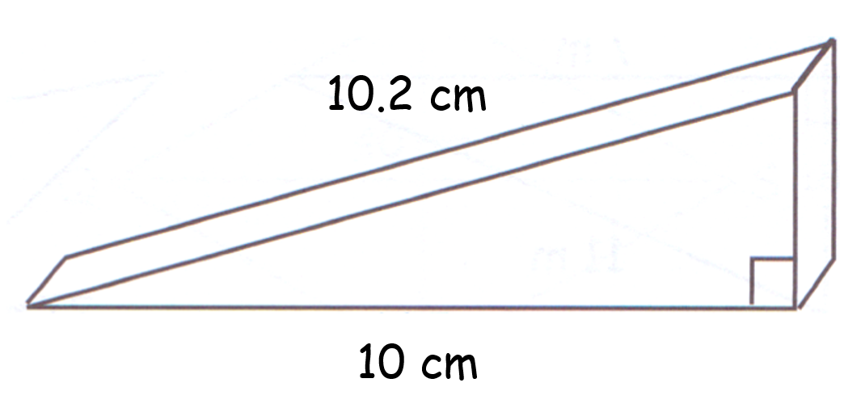

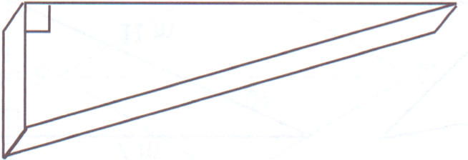
height
10.2 cm
10 cm
HINT - Find the height of the doorstop. If it is taller than 1.6 cm then it will hold the door open.
A₍₂₎

S

What is the screen size of the iPhone?


3.49 inches
1.96 inches



3.49 inches
1.96 inches
S
HINT – Remember that screen size is measured diagonally.

